[科研规范受挑战：内蒙古医院俞兰发表论文现技术性错误与图表雷同](https://mp.weixin.qq.com/s?__biz=Mzk5MDE5Mjc1Mg==&mid=2247483702&idx=1&sn=ba1737b85c8545dd00e4f430f2ea9fa4)

起风科研[起风科研](javascript:void(0);)2025-05-06 14:08:01广东

**Part.1**



**论文简介**

**标题：Long non-coding RNA HAND2-AS1 inhibits gastric cancer progression by suppressing TCEAL7 expression via targeting miR-769-5p**

**日期：**2020年9月18日

**单位与作者**：内蒙古自治区人民医院临床医学研究中心 Lan Yu(通讯作者 音译 俞兰)

**期刊：*Digestive and Liver Disease***

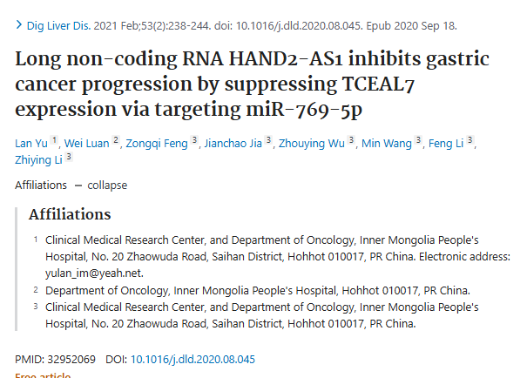

**Part.2**



**图像重复问题**

**#1 这是一组文章中的一篇，其中错误地将 miRNA 结果说成是根据使用引物进行 qPCR 测定的 U6 snRNA 水平进行归一化的：**

**1. 前向 AGAGCCTGTGGTGTCCG 2.**

**2. 反向 CATCTTCAAAGCACTTCCCT**

**这些引物不是针对 U6 的，而是针对信使 RNA LSM5 的。**

**#2 目前发现的 40 多篇文章（包括这篇在内，下同）将相同的 LSM5 引物错误地表述为 “U6 ”引物，但偶尔也会将其表述为其他靶标的引物。可能还有很多文章被我忽略或无法搜索到（例如，当引物序列出现在无法访问的补充材料中或以图片而非文字的形式呈现时）。十多年来，不同的研究小组不太可能犯同样的错误，把 snRNA U6 和 LSM5 mRNA 弄混，设计出完全相同的引物来检测错误的靶标。这些引物似乎没有一个共同的商业来源，也没有一篇原始论文被普遍引用为错误序列的来源。这说明这些论文可能还有其他共同之处。进一步调查这些论文以发现是否存在其他共性可能会有所帮助。有些论文已被撤回和/或有其他相关评论。**

**作者回应：**作为一个专注于医学基础研究的团队，我们为自己犯下如此愚蠢的错误而感到羞愧。同时，我们也发现了团队成员之间协作脱节的问题，即负责撰写 “材料和方法 ”的人根本不关心接下来的实验，而是把所有可能用于接下来实验过程的引物都写了下来；而另一方面，做相应实验的人却没有追溯到所写的部分。事实是，我们真正使用的引物在进行 PCR 之前已经被一一验证过了。我们没有对 miRNA 和 U6 进行 PCR，而是使用了公共数据库中的数据，因此没有对您提到的引物序列进行验证。因此，我们没有对您提到的引物序列进行验证。我们认为，该作者写错的引物序列可能参考了不合适的论文。坦率地说，通讯作者在投稿前没有仔细检查草稿。我们会吸取教训，加强对参考文献的重视。再次感谢！

**#3 根据作者的回应，进一步分析了两篇与本文相关的论文，发现它们在图表布局、颜色模式、轴标签、条件顺序和y轴刻度等方面存在相似性。**

The following three papers seem to be very closely related:

1. Long non-coding RNA HAND2-AS1 inhibits gastric cancer progression by suppressing TCEAL7 expression via targeting miR-769–5p (2021; Lu Y et al, this paper)
2. RETRACTED: Long Non-Coding RNA HAND2-AS1 Inhibits Growth and Migration of Gastric Cancer Cells Through Regulating the miR-590-3p/KCNT2 Axis (2020; Lu Y et al, overlapping authors)
3. RETRACTED: lncRNA HAND2-AS1 Regulates Prostate Cancer Cell Growth Through Targeting the miR-106a-5p/RBM24 Axis (2021; Wei P et al, different authors)

Figure 1 from each paper has two panels and generally uses the same layout, colour and pattern scheme. The axis labels are mostly the same. The order of conditions is the same. The y-axis scale is the same for Panel B for each.

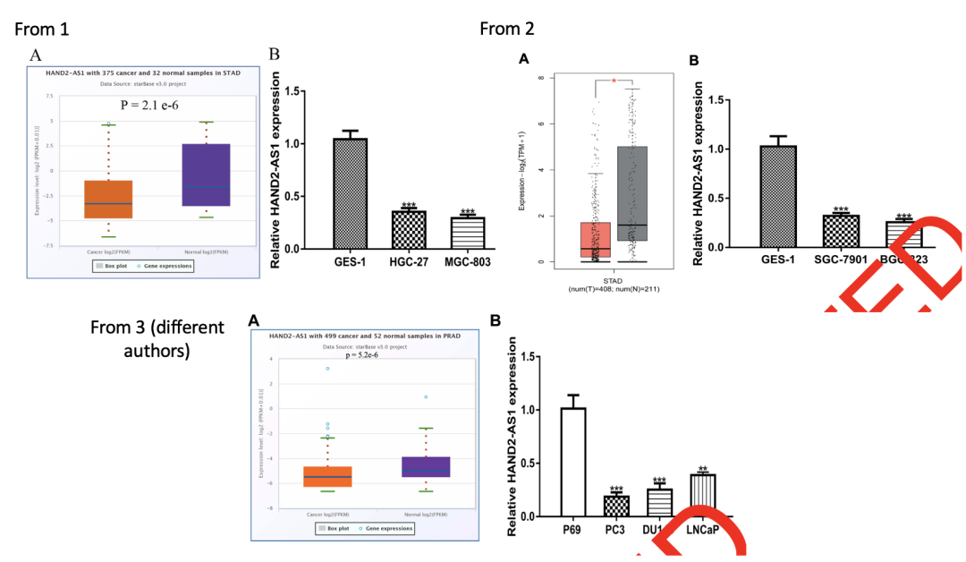

**#4 各篇文章的图2之间存在一些相似之处。**

There also may be a few similarities between the respective Figures 2 of the three articles:

1. Long non-coding RNA HAND2-AS1 inhibits gastric cancer progression by suppressing TCEAL7 expression via targeting miR-769–5p (2021; Lu Y et al, this paper)
2. RETRACTED: Long Non-Coding RNA HAND2-AS1 Inhibits Growth and Migration of Gastric Cancer Cells Through Regulating the miR-590-3p/KCNT2 Axis (2020; Lu Y et al, overlapping authors)
3. RETRACTED: lncRNA HAND2-AS1 Regulates Prostate Cancer Cell Growth Through Targeting the miR-106a-5p/RBM24 Axis (2021; Wei P et al, different authors)

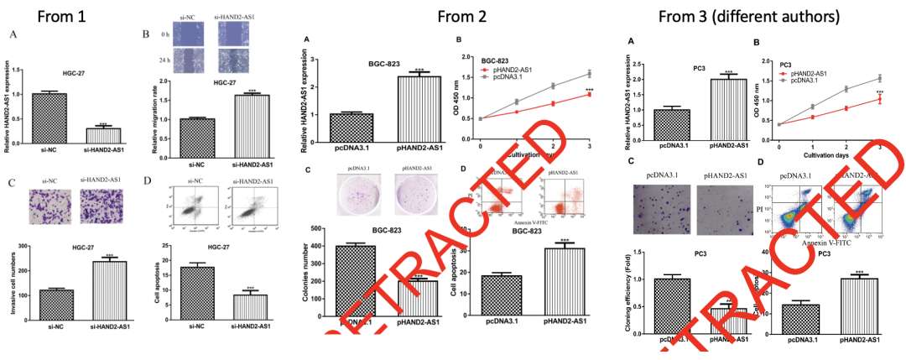

**#5 各篇文章的图3之间存在一些相似之处。**

Several similarities between Figures 3 of the respective articles might also be present.

1. Long non-coding RNA HAND2-AS1 inhibits gastric cancer progression by suppressing TCEAL7 expression via targeting miR-769–5p (2021; Lu Y et al, this paper)
2. RETRACTED: Long Non-Coding RNA HAND2-AS1 Inhibits Growth and Migration of Gastric Cancer Cells Through Regulating the miR-590-3p/KCNT2 Axis (2020; Lu Y et al, overlapping authors)
3. RETRACTED: lncRNA HAND2-AS1 Regulates Prostate Cancer Cell Growth Through Targeting the miR-106a-5p/RBM24 Axis (2021; Wei P et al, different authors)

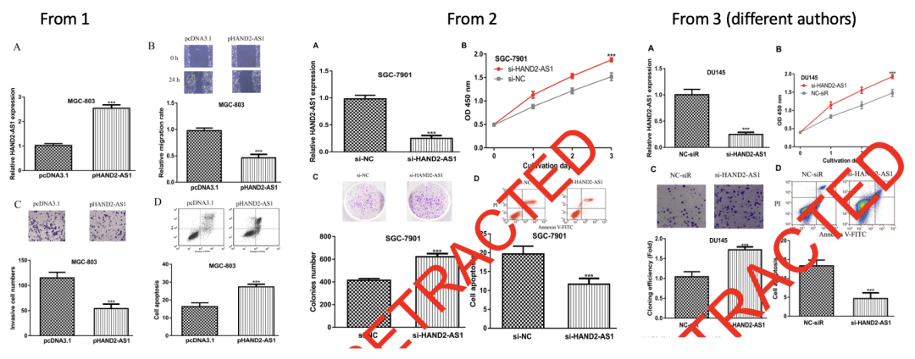

**#6 各篇文章的图4之间存在一些相似之处。**

Comparing Figures 4 from the articles:

1. Long non-coding RNA HAND2-AS1 inhibits gastric cancer progression by suppressing TCEAL7 expression via targeting miR-769–5p (2021; Lu Y et al, this paper)
2. RETRACTED: Long Non-Coding RNA HAND2-AS1 Inhibits Growth and Migration of Gastric Cancer Cells Through Regulating the miR-590-3p/KCNT2 Axis (2020; Lu Y et al, overlapping authors)
3. RETRACTED: lncRNA HAND2-AS1 Regulates Prostate Cancer Cell Growth Through Targeting the miR-106a-5p/RBM24 Axis (2021; Wei P et al, different authors)

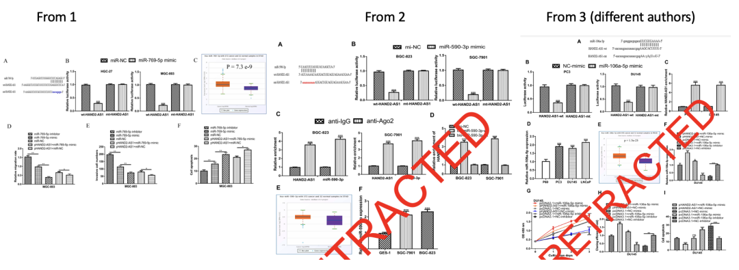

**#7 各篇文章的图5之间存在一些相似之处。**

Comparing Figures 5 from the articles:

Long non-coding RNA HAND2-AS1 inhibits gastric cancer progression by suppressing TCEAL7 expression via targeting miR-769–5p (2021; Lu Y et al, this paper)

RETRACTED: Long Non-Coding RNA HAND2-AS1 Inhibits Growth and Migration of Gastric Cancer Cells Through Regulating the miR-590-3p/KCNT2 Axis (2020; Lu Y et al, overlapping authors)

RETRACTED: lncRNA HAND2-AS1 Regulates Prostate Cancer Cell Growth Through Targeting the miR-106a-5p/RBM24 Axis (2021; Wei P et al, different authors)

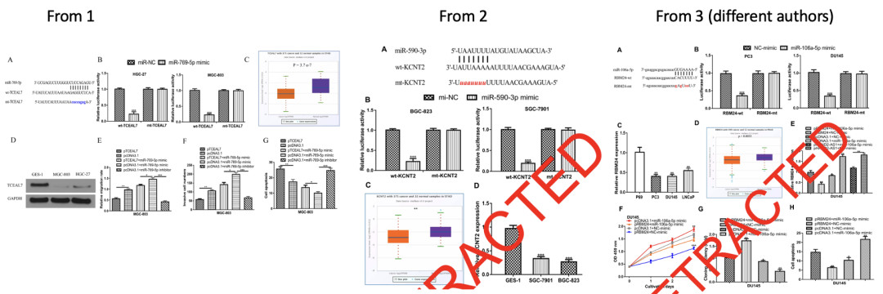

**参考信息：**

https://pubpeer.com/publications/AB306B48746D4DB2EF5E2BD00D7A41#

https://pubmed.ncbi.nlm.nih.gov/32952069/