[图片重复多人！天津医科大学总医院妇产科主任论文被质疑两年后撤回](https://mp.weixin.qq.com/s?__biz=Mzk1Nzk5NzI3Mw==&mid=2247484900&idx=2&sn=840a035f081842dc834f2ec634a9879b)

原创观观[图片观察](javascript:void(0);)2025-05-07 21:28:28广东

这篇2019年发表的Hindawi出版社的Disease Markers期刊，主要由Jun-Jie Sun , Hong-Lin Li , Su-Jie Guo , Hui Ma , Shen-Jia Liu , Dong Liu , Feng-Xia Xue 共同完成，2023年4月被爆出海量图片重复多人，近期该论文被撤回

**论文信息**

标题：The Increased PTK7 Expression Is a Malignant Factor in Cervical Cancer

作者：Jun-Jie Sun, Hong-Lin Li, Su-Jie Guo, Hui Ma, Shen-Jia Liu, Dong Liu, Feng-Xia Xue

期刊：Dis Markers

发表日期：2019年3月3日

DOI：10.1155/2019/5380197

PMID：30944666

PMCID：PMC6421733

单位：

#天津医科大学二甲医院妇产科、#天津医科大学总医院妇产科

**质疑内容**

**#1** Hoya camphorifolia comment accepted April 2023

[left] Fig 4b from "Kinesin Family Member 18A (KIF18A) Contributes to the Proliferation, Migration, and Invasion of Lung Adenocarcinoma Cells In Vitro and In Vivo" (Chen & Zhong 2019).

[right] Fig 5b.

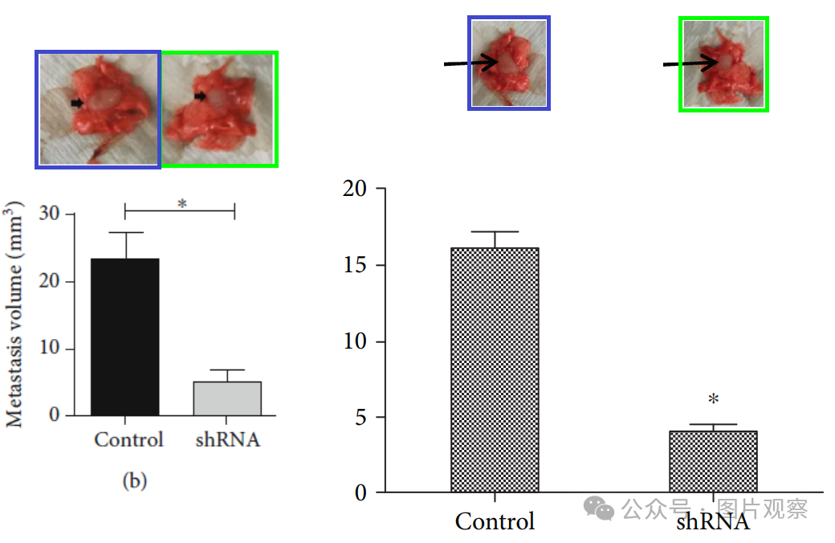

Same tumors, horizontally flipped.

**#2**Hoya camphorifolia comment accepted April 2023

Fig 5c:

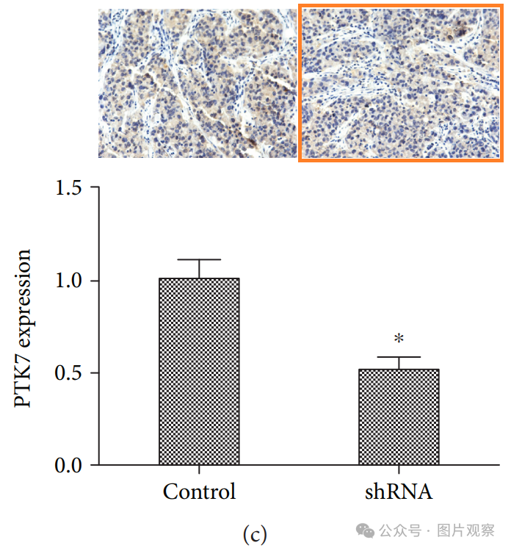

The panel marked with orange also appears in [left to right]:

Fig 6C from "Lamin B2 promotes the progression of triple negative breast cancer via mediating cell proliferation and apoptosis" (Zhao et al 2021).

Fig 6D from Zhao et al.

Fig 4c from "Kinesin Family Member 18A (KIF18A) Contributes to the Proliferation, Migration, and Invasion of Lung Adenocarcinoma Cells In Vitro and In Vivo" (Chen & Zhong 2019).

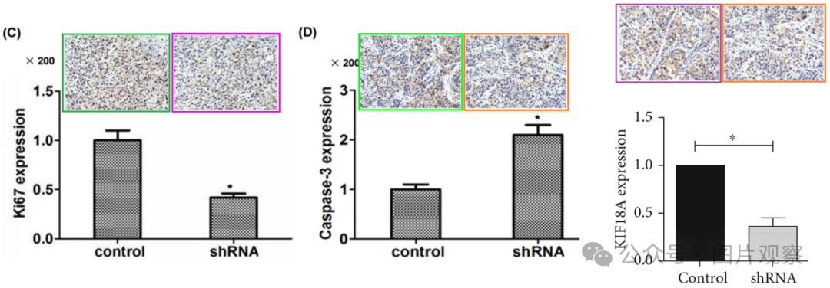

**#3** Hoya camphorifolia comment accepted April 2023

[above] Fig 3d.

[below] Fig 3c from "KIF5A Promotes Bladder Cancer Proliferation In Vitro and In Vivo" (Tian et al 2019).

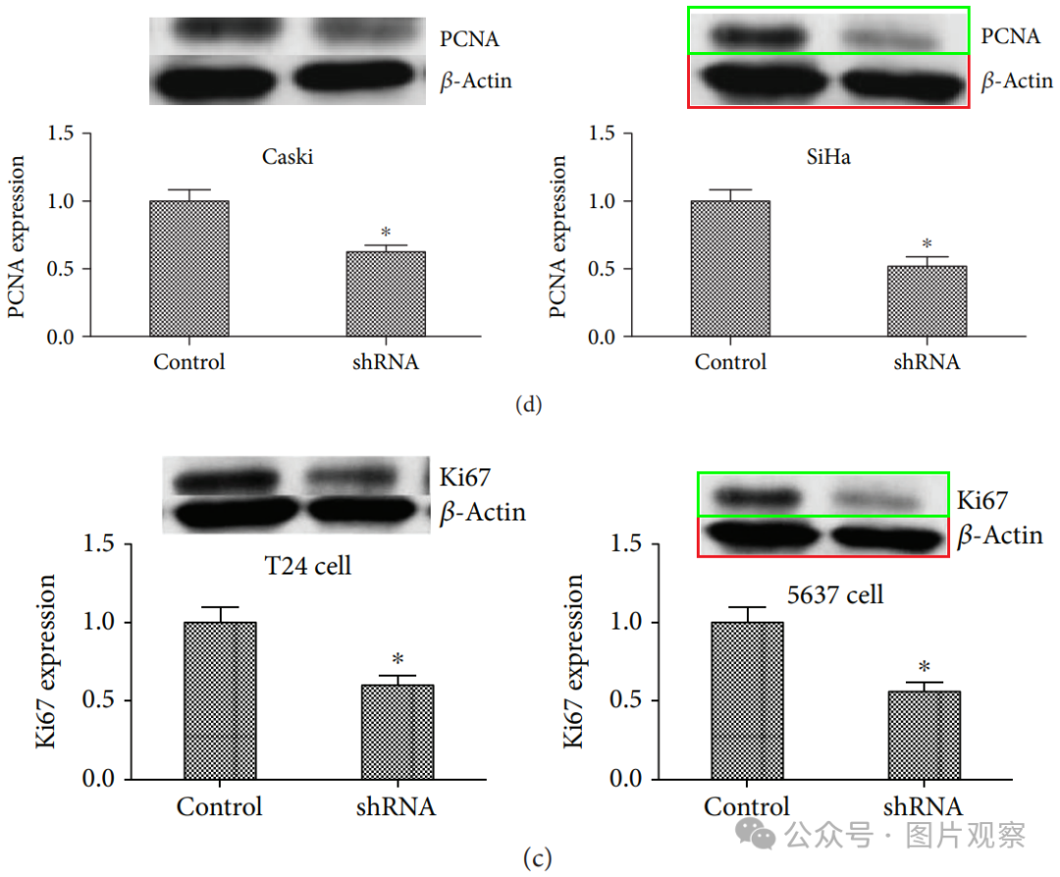

**#4** Hoya camphorifolia comment accepted April 2023

From top to bottom:

Fig 2B from "Identification of Abnormal Spindle Microtubule Assembly as a Promising Therapeutic Target for Osteosarcoma" (Lin et al 2020).

Fig 2b.

Fig 2B from "APLNR promotes the progression of osteosarcoma by stimulating cell proliferation and invasion" (Cui et al 2019).

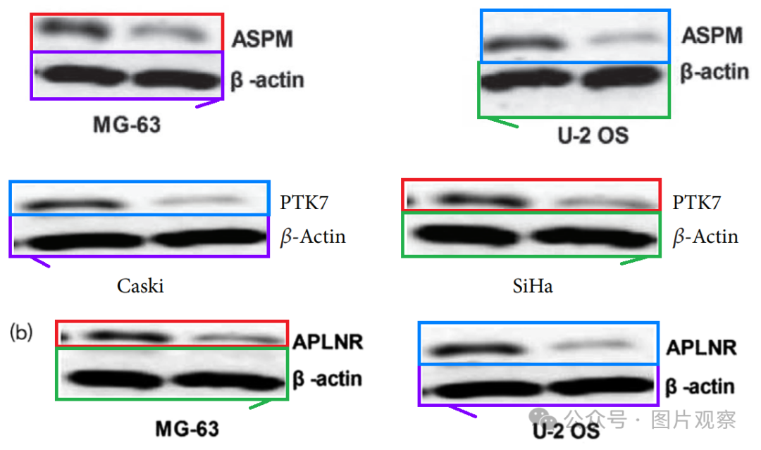

Red and blue boxes mark substantive bands, triplicated. Green and purple boxes mark loading controls, triplicated with a horizontal flip. Here, for instance, one of the control bands, with triplicates adjusted to the same scale.

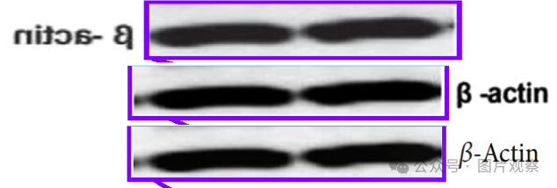

**#5** Hoya camphorifolia comment accepted April 2023

[left] Fig 3a.

[right] Fig 3A from "KIF22 promotes bladder cancer progression by activating the expression of CDCA3" (Li et al 2021).

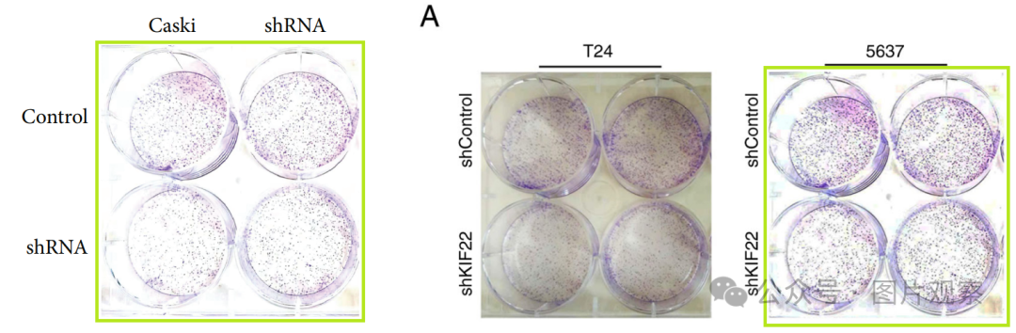

**#6**Hoya camphorifolia comment accepted April 2023

[above] Fig 5a.

[below] Fig 4A from "Kinesin family member 20B regulates tongue cancer progression by promoting cell proliferation" (Li et al 2019).

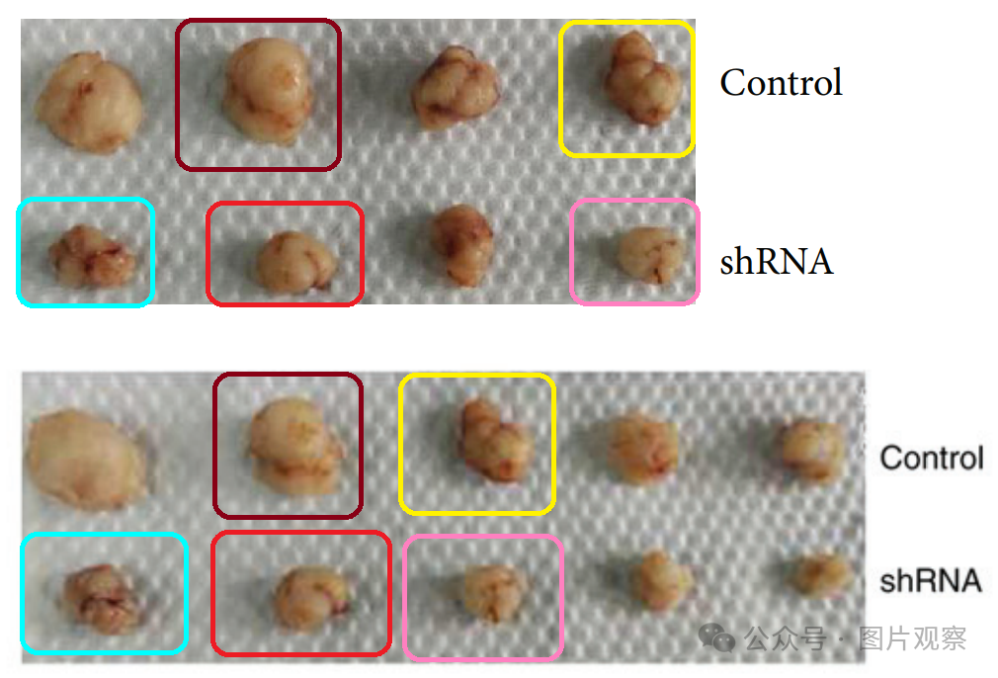

Recycled tumors.

**#7**Hoya camphorifolia comment accepted April 2023

Figs 4d, 5d. Unexpected similarities.

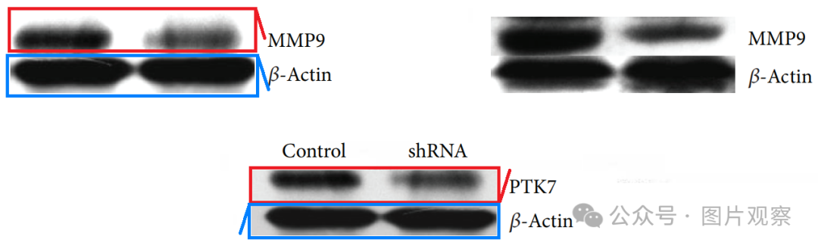

**#8** Hoya camphorifolia comment accepted April 2023

#6 [above] Fig 5a again.



#1 [right] Fig 5b again.



A later sighting: Fig 5A,B from "KIF18A is a potential prognostic factor and promotes tumor progression in oral tongue squamous cell carcinoma" (Lv et al 2022).

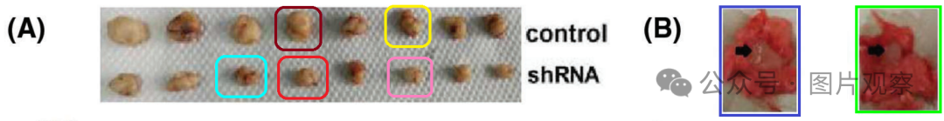



**END**



**#**

**扫码关注我们**



Don't be ashamed



专注于国内论文质疑报道

**欢迎投稿联系**