[图片、卡钳重复多人！四川省人民医院学者论文被撤稿](https://mp.weixin.qq.com/s?__biz=Mzk1Nzk5NzI3Mw==&mid=2247484900&idx=1&sn=3ac4e4941d48394d3645e0882ac2f719)

原创观观[图片观察](javascript:void(0);)2025-05-07 21:28:28广东

这篇2019年发表的Disease Markers期刊，主要由Jie Zhang , Yan-Tao Yin , Chi-Hua Wu , Rong-Lin Qiu , Wen-Jun Jiang , Xiao-Geng Deng , Zhi-Xi Li 共同完成，论文存在图片重复多人、卡钳重复等问题被质疑后撤稿。

**论文信息**

标题：AK4 Promotes the Progression of HER2-Positive Breast Cancer by Facilitating Cell Proliferation and Invasion

作者：Jie Zhang 1, Yan-Tao Yin 2, Chi-Hua Wu 3, Rong-Lin Qiu 1, Wen-Jun Jiang 2, Xiao-Geng Deng 1, Zhi-Xi Li 2

期刊：Dis Markers

发表日期：2019 年 11 月 20 日

DOI：10.1155/2019/8186091

PMID：31827645

PMCID：PMC6886328

单位

1. #中山大学孙中山纪念医院小儿外科

2. #四川省人民医院小儿外科

3. #四川省人民医院乳腺外科

**质疑内容**

**#1** Phyllosticta caprifolii comment accepted March 2021

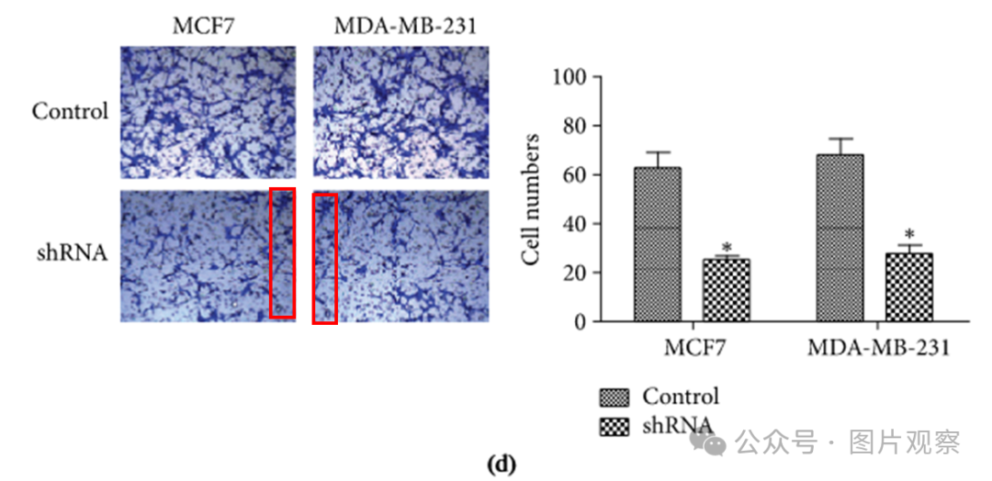

**#2**Hoya camphorifolia comment accepted April 2023

[left] Fig 4b from "APLNR promotes the progression of osteosarcoma by stimulating cell proliferation and invasion" (Cui et al 2019).

[right] Fig 4b.

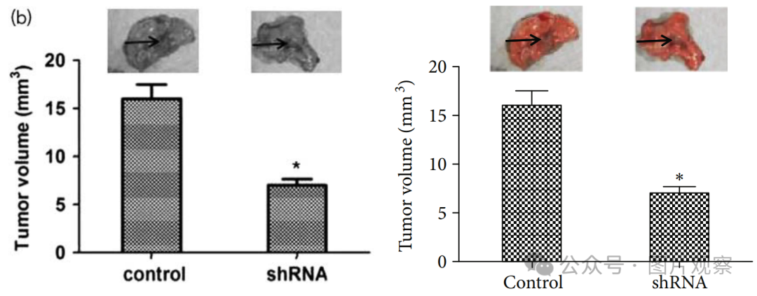

**#3** Hoya camphorifolia comment accepted April 2023

Clockwise from upper left:

Fig 3c from "APLNR promotes the progression of osteosarcoma by stimulating cell proliferation and invasion" (Cui et al 2019).

Fig 3c from "Kinesin Family Member 18A (KIF18A) Contributes to the Proliferation, Migration, and Invasion of Lung Adenocarcinoma Cells In Vitro and In Vivo" (Chen & Zhong 2019).

Fig 3c from "Identification of Kinesin Family Member 2A (KIF2A) as a Promising Therapeutic Target for Osteosarcoma" (Wang et al 2020a).

Fig 3c.

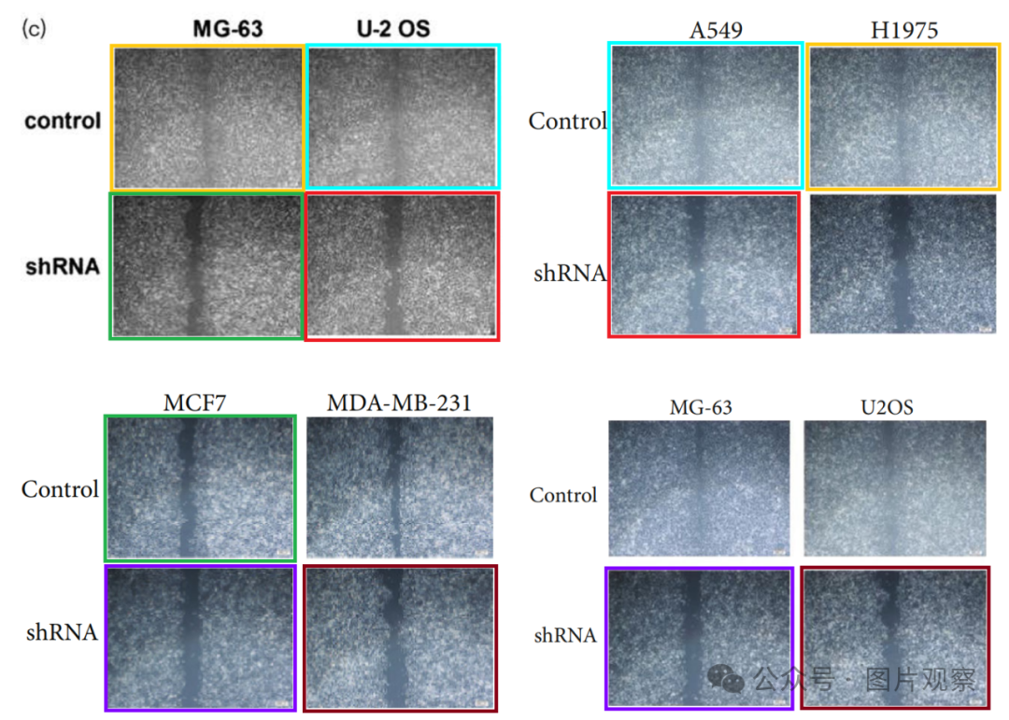

**#4** Hoya camphorifolia comment accepted April 2023

Clockwise from left:

Fig 4c.

Fig 4C,D from "CYPA promotes the progression and metastasis of serous ovarian cancer (SOC) in vitro and in vivo" (Qi et al 2019).

Fig 5b,c from "SMYD2 promotes cervical cancer growth by stimulating cell proliferation" (Sun et al 2019).

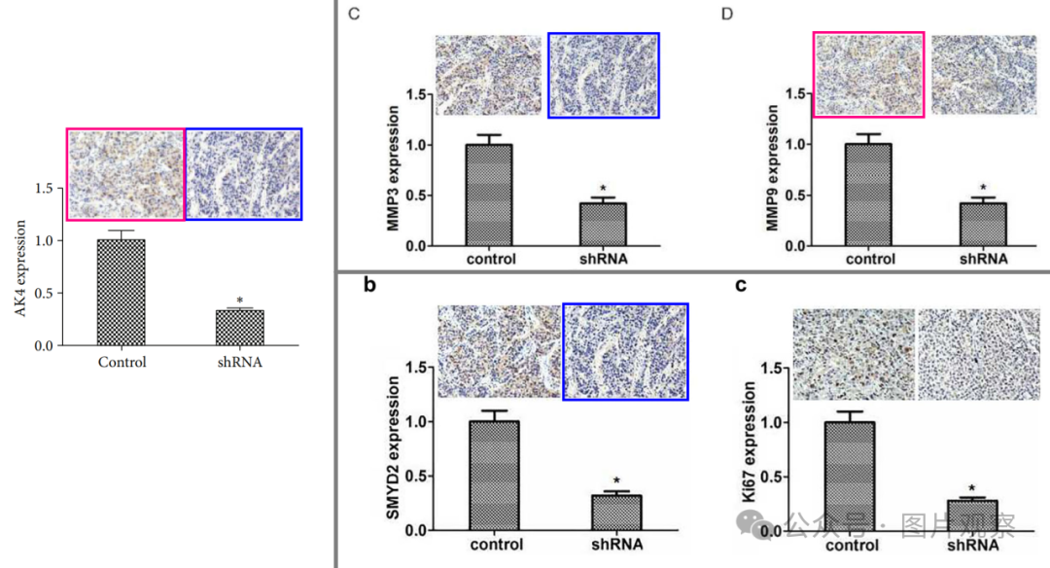

**#5** Hoya camphorifolia comment accepted April 2023

[left] Fig 4a from "KIF5A Promotes Bladder Cancer Proliferation In Vitro and In Vivo" (Tian et al 2019).

[right] Fig 4a.

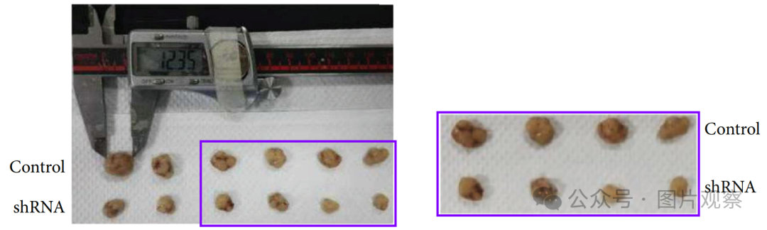

Is further comment necessary?

UPDATEs are always necessary. Another sighting of the calipers! Fig 5A from "ASPM predicts poor prognosis and regulates cell proliferation in bladder cancer" (Gao et al 2020):

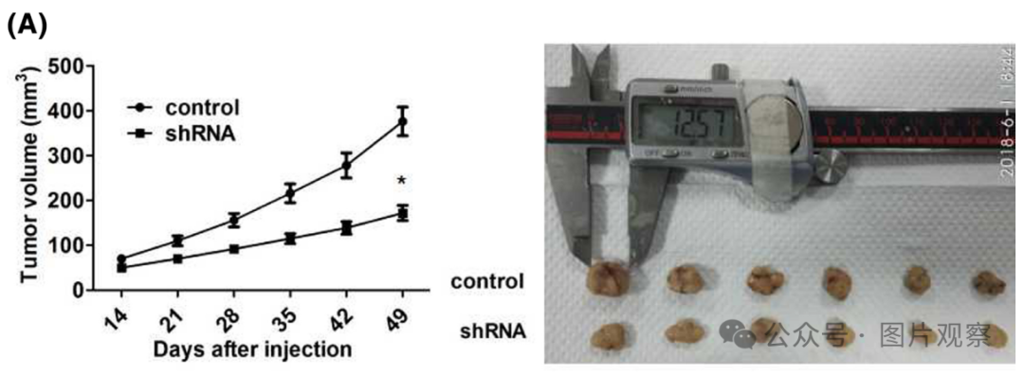

**#6** Hoya camphorifolia comment accepted April 2023

[left] Fig 3a.

[right] Fig 4A from "ASPM predicts poor prognosis and regulates cell proliferation in bladder cancer" (Gao et al 2020).

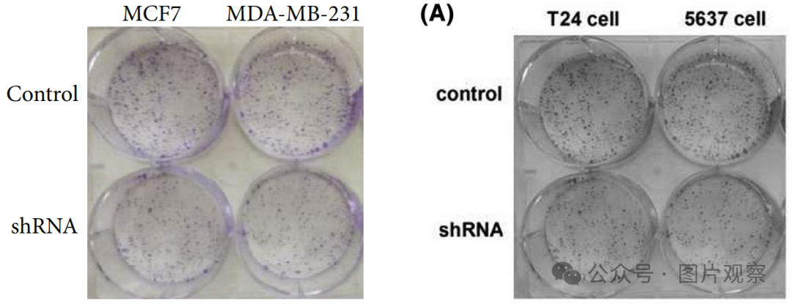

**#7** Hoya camphorifolia comment accepted April 2023

#5

Another sighting of the calipers and tumors! Fig 5A from "KIF23 enhances cell proliferation in pancreatic ductal adenocarcinoma and is a potent therapeutic target" (Gao et al 2020):

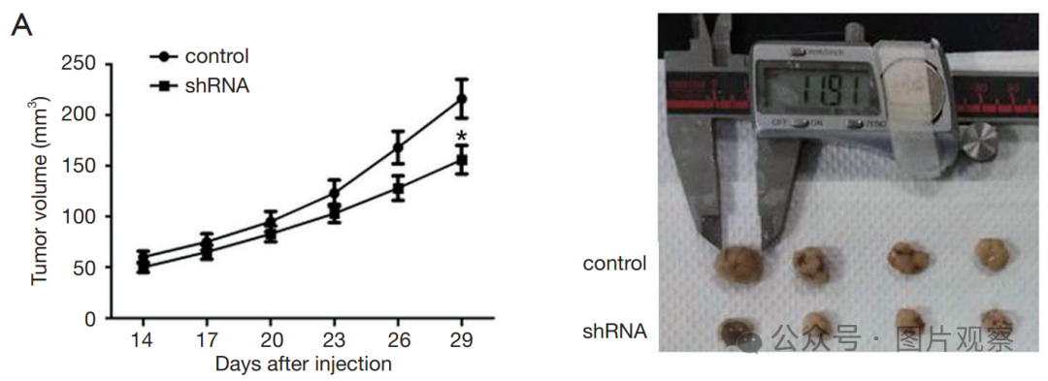

Fig 5a from "KIF20B Promotes Cell Proliferation and May Be a Potential Therapeutic Target in Pancreatic Cancer" (Chen et al 2021).

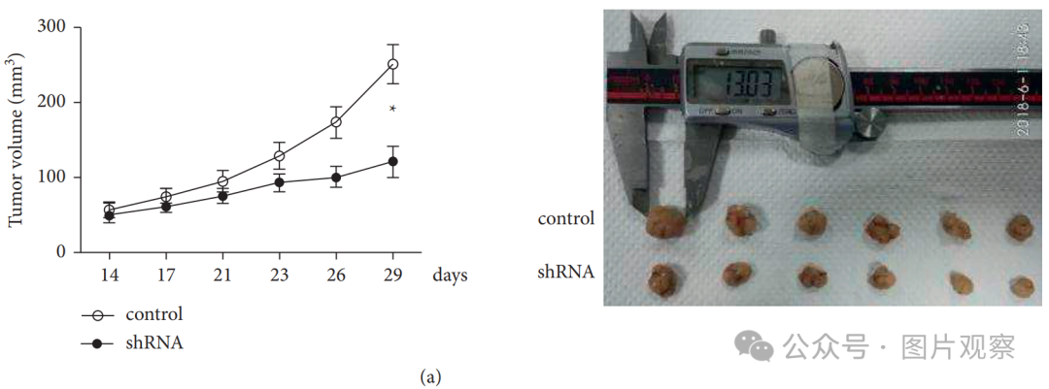

**#8** Hoya camphorifolia comment accepted April 2023

Top to bottom:

Fig 3d from "KIF15 Promotes Proliferation and Growth of Hepatocellular Carcinoma" (Sun et al 2020).

Fig 2b.

Fig 3B from "Kinesin family member 15 can promote the proliferation of glioblastoma" (Wang et al 2022)

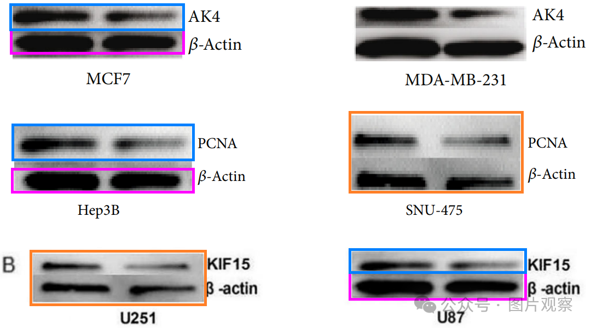

**撤回**

目前该论文引用12次



Specifically:

Figure 2b: The Immunoblot assay bands corresponding to AK4 and β-actin expression in the MCF7 cells have been duplicated in Figure 3b (right) of [2], and Figure 3d (left) of [3], while labelled as other proteins identified in other cell types.

Figure 3a: The image of the cell cultures is identical to the culture plates shown in Figure 4a in [4], where the colonies are labelled as different cell types.

Figure 3c: Multiple duplications of the 3 wound closure assay images (except the image on the top right) across several publications. The top left panel can be seen in Figure 3c (bottom left) of [5], while the bottom panels are duplicated in Figure 3c (bottom) of [6].

Figure 3d: The bottom right section of the MCF7 shRNA image is identical to the bottom left section of the MDA-MB-231 shRNA image.

Figure 4a: The tumors are present in Figure 4a of [7] as the 8 tumors on the right side of the figure. Some of these tumors can also be seen in Figure 5 of [4, 8] and [9] in a different arrangement.

Figure 4b: The images of the 2 tumors have been duplicated in Figure 4b of [5].

Figure 4c: A duplicate of the immunohistochemistry image on the right has been found in Figure 4c (right) of [10] and Figure 5b (left) of [11]. The panel on the left has also been duplicated in [10] as Figure 4d (left). All the figures above attribute the immunohistochemistry images to different tissue types.

作为调查的结果，本文的数据和结论被认为是不可靠的。

作者被告知撤回该论文的决定，但没有提供回应。



**END**



**#**

**扫码关注我们**



Don't be ashamed



专注于国内论文质疑报道

**欢迎投稿联系**