[中山大学Carbohydrate Polymers被质疑](https://mp.weixin.qq.com/s?__biz=MzUxODcwODMzMw==&mid=2247484149&idx=1&sn=f3175d684c4c4e16bf4947ab105702de)

原创一只鱼[严肃科研](javascript:void(0);)2025-05-05 17:41:15四川

**“**秉持严谨、深入、持续、开放与创新的态度，尊重他人成果，携手交流共进，推动科研发展。**”**

**Research Frontline**

**科研前线**

01

—

**问题论文**

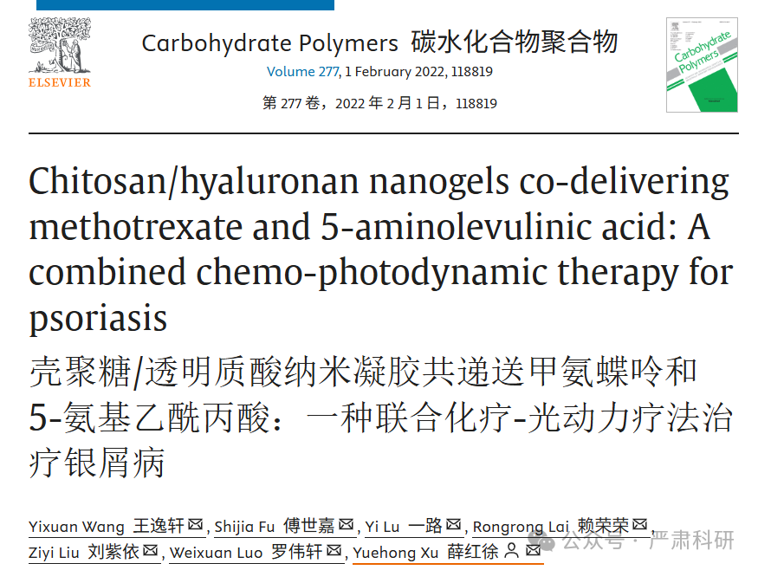

**标题：**Chitosan/hyaluronan nanogels co-delivering methotrexate and 5-aminolevulinic acid: A combined chemo-photodynamic therapy for psoriasis

**期刊：**Carbohydrate Polymers

**单位：**中山大学药学院

**发表时间：**2022年2月1日

**DOI:** 10.1016/j.carbpol.2021.118819

**研究摘要：**

Psoriasis does not respond adequately to the monotherapy, tailoring combined strategies for synergistical treatment remains challenging. We fabricated chitosan/hyaluronan nanogels to co-load methotrexate (MTX) and 5-aminoleavulinic acid (ALA), i.e., MTX-ALA NGs, for a combined chemo-photodynamic therapy for psoriasis. Compared with MTX-ALA suspension, the NGs enhanced the penetration and retention of MTX and ALA through and into the skin in vitro and in vivo (*p* < 0.001). NGs enhanced the cellular uptake (*p* < 0.001), protoporphyrin IX conversion (*p* < 0.001), and reactive oxygen species generation (3.93-fold), subsequently exerted the synergistical anti-proliferation and apoptosis on lipopolysaccharide-irritated HaCaT cells with the apoptosis rate of 78.6%. MTX-ALA NGs efficiently ameliorated the skin manifestations and down-regulated the proinflammatory cytokines of TNF-α and IL-17A in imiquimod-induced psoriatic mice (*p* < 0.001). Importantly, MTX-ALA NGs reduced the toxicities of oral MTX to the liver and kidney. The results support that MTX-ALA NG is a convenient, effective, and safe combined chemo-photodynamic strategy for psoriasis treatment.  
银屑病对单药治疗反应不足，制定联合治疗策略具有挑战性。我们制备了壳聚糖/透明质酸纳米凝胶，共载甲氨蝶呤（MTX）和 5-氨基卟啉酸（ALA），即 MTX-ALA NGs，用于银屑病的联合化疗-光动力治疗。与 MTX-ALA 悬浮液相比，NGs 在体外和体内增强了 MTX 和 ALA 通过和进入皮肤的渗透和滞留（p < 0.001）。NGs 增强了细胞摄取（p < 0.001）、原卟啉 IX 转化（p < 0.001）和活性氧生成（3.93 倍），随后对脂多糖刺激的 HaCaT 细胞产生了协同抗增殖和凋亡作用，凋亡率为 78.6%。MTX-ALA NGs 有效改善了皮肤表现，并下调了咪喹莫特诱导的银屑病小鼠的促炎细胞因子 TNF-α和 IL-17A（p < 0.001）。重要的是，MTX-ALA NGs 降低了口服 MTX 对肝脏和肾脏的毒性。结果表明，MTX-ALA NG 是一种方便、有效且安全的银屑病治疗联合化疗-光动力策略。

02

—

**具体说明**

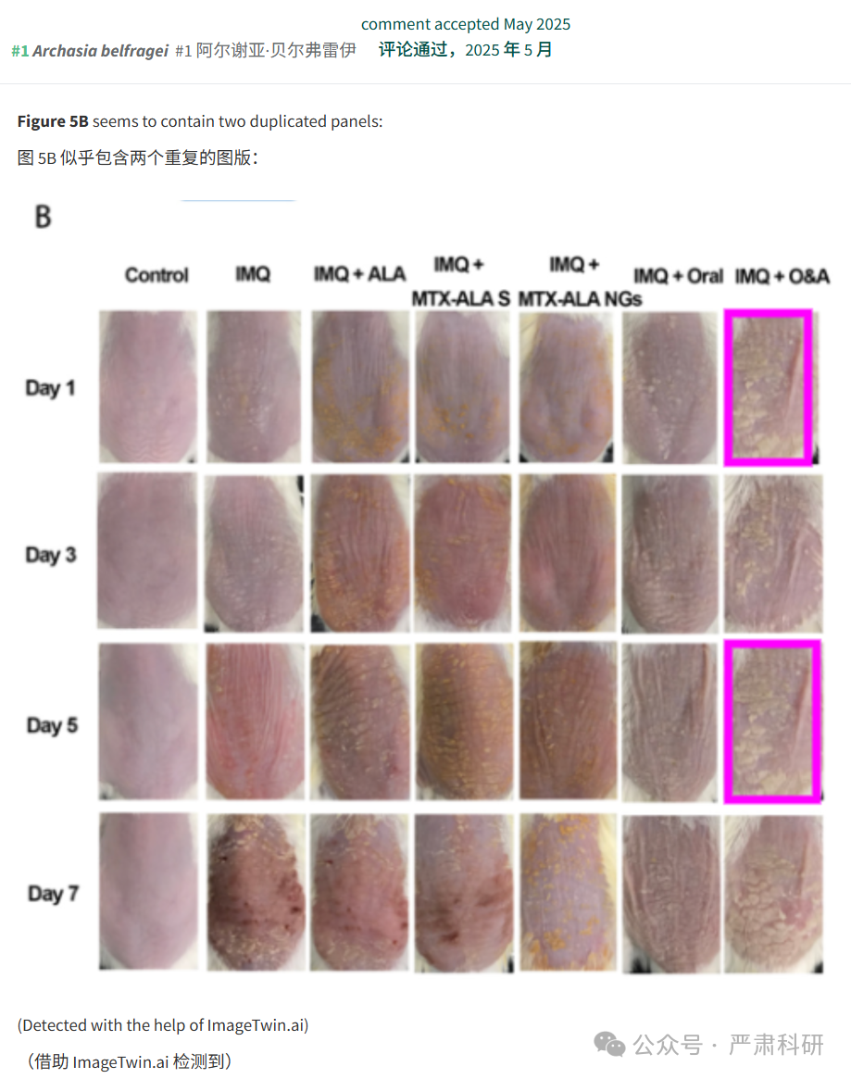

**参考信息  
https://www.sciencedirect.com/science/article/abs/pii/S0144861721012066?via%3Dihub**

**https://pubpeer.com/publications/A47DEB10AAFD360C5091124E0CFF3C#0**

本平台对于科研问题的探讨，始终保持严谨、深入、持续、开放和创新的态度。所有推文信源，均来源于pubpeer、For Better Science等网站公开质疑。我们从来没有、也永远不会主动查重论文并去pubpeer上质疑。我们尊重他人的研究成果和贡献，通过交流和合作，共同推动科研领域的进步和发展。