[吉林大学中日联谊医院Cell Cycle被质疑后撤稿](https://mp.weixin.qq.com/s?__biz=MzUxODcwODMzMw==&mid=2247484131&idx=1&sn=ad217ee3c0353d6d4315bbafd91c089a)

原创一只鱼[严肃科研](javascript:void(0);)2025-04-29 21:27:32四川

**“**秉持严谨、深入、持续、开放与创新的态度，尊重他人成果，携手交流共进，推动科研发展。**”**

**Research Frontline**

**科研前线**

01

—

**问题论文**

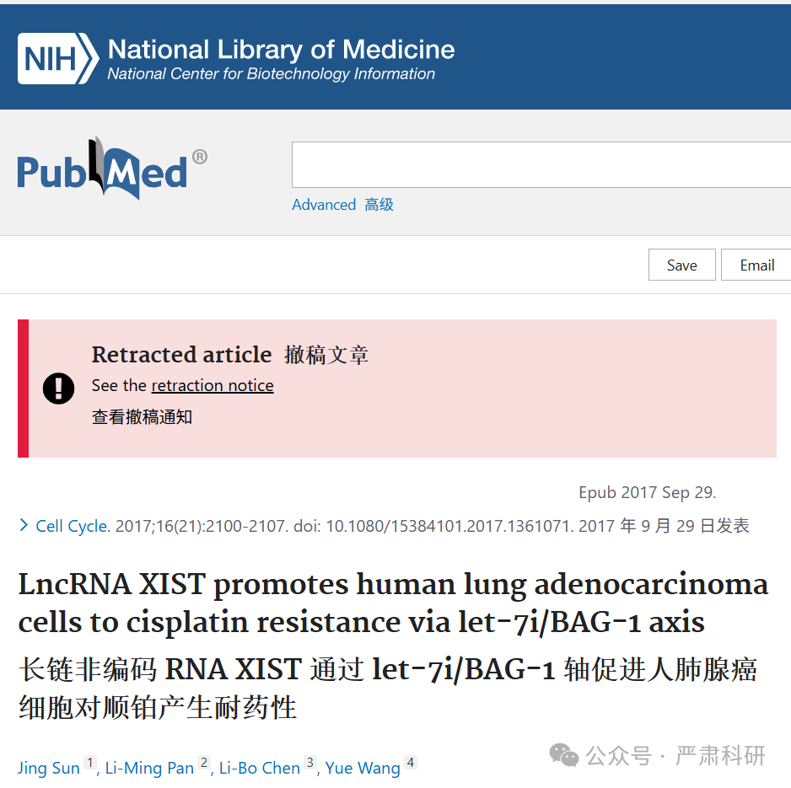

**标题：**LncRNA XIST promotes human lung adenocarcinoma cells to cisplatin resistance via let-7i/BAG-1 axis

**期刊：**Cell cycle (Georgetown, Tex.)

**单位：**吉林大学中日联谊医院

**发表时间：**2017年9月29日

**DOI:** 10.1080/15384101.2017.1361071

**研究摘要：**

Long noncoding RNAs (lncRNAs) have been identified as oncogenes or tumor suppressors that are involved in tumorigenesis and chemoresistance. LncRNA XIST expression is upregulated in several cancers, however, its biologic role in the development of the chemotherapy of human lung adenocarcinoma (LAD) has not been elucidated. This study aimed to observe the expression of LncRNA XIST in LAD and to evaluate its biologic role and clinical significance in the resistance of LAD cells to cisplatin. LncRNA XIST expression was markedly increased in cisplatin-resistant A549/DDP cells compared with parental A549 cells as shown by qRT-PCR. LncRNA XIST overexpression in A549 cells increased their chemosensitivity to cisplatin both in vitro and in vivo by protecting cells from apoptosis and promoting cell proliferation. By contrast, LncRNA XIST knockdown in A549/DDP cells decreased the chemoresistance. We revealed that XIST functioned as competing endogenous RNA to repress let-7i, which controlled its down-stream target BAG-1. We proposed that XIST was responsible for cisplatin resistance of LAD cells and XIST exerted its function through the let-7i/BAG-1 axis. Our findings suggested that lncRNA XIST may be a new marker of poor response to cisplatin and could be a potential therapeutic target for LAD chemotherapy.  
长非编码 RNA（lncRNA）已被鉴定为参与肿瘤发生和化疗耐药性的癌基因或肿瘤抑制因子。LncRNA XIST 的表达在多种癌症中上调，然而，其在人类肺腺癌（LAD）化疗发展中的生物学作用尚未阐明。本研究旨在观察 LAD 中 LncRNA XIST 的表达，并评估其在 LAD 细胞对顺铂耐药性中的生物学作用和临床意义。qRT-PCR 结果显示，与亲本 A549 细胞相比，顺铂耐药性 A549/DDP 细胞中 LncRNA XIST 的表达显著增加。在 A549 细胞中过表达 LncRNA XIST，无论是在体外还是在体内，都能通过保护细胞免受凋亡并促进细胞增殖来增加其对顺铂的化疗敏感性。相反，在 A549/DDP 细胞中敲低 LncRNA XIST 会降低化疗耐药性。我们发现 XIST 作为竞争性内源 RNA 抑制 let-7i，从而控制其下游靶标 BAG-1。我们提出 XIST 负责 LAD 细胞的顺铂耐药性，并通过 let-7i/BAG-1 轴发挥其功能。 我们的研究发现，长链非编码 RNA XIST 可能成为顺铂耐药性不良反应的新标志，并可能成为 LAD 化疗的潜在治疗靶点。

02

—

**具体说明**

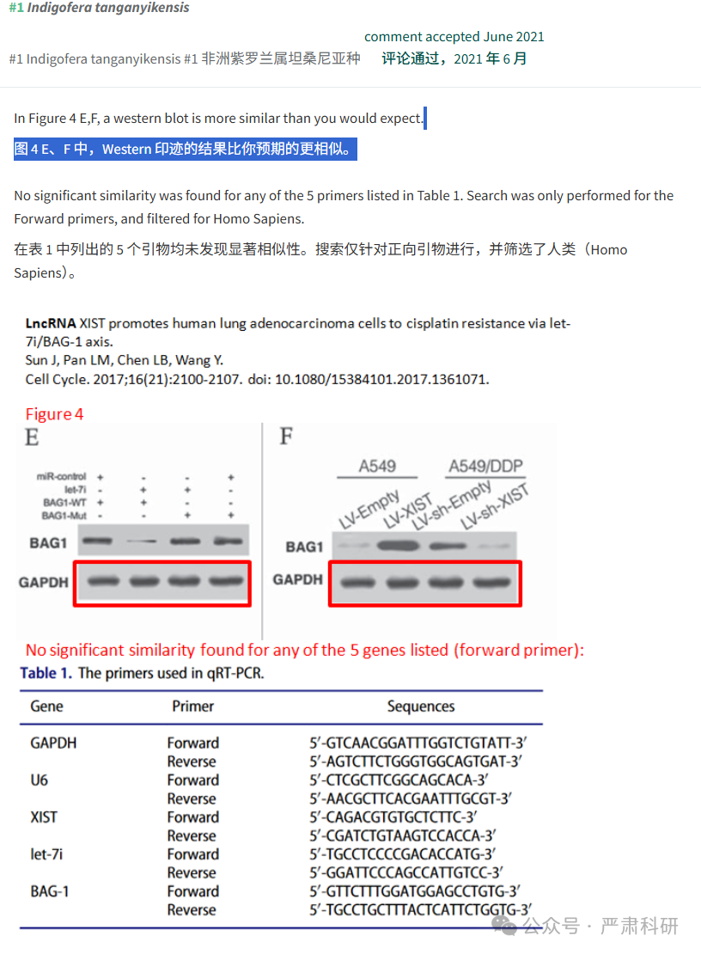



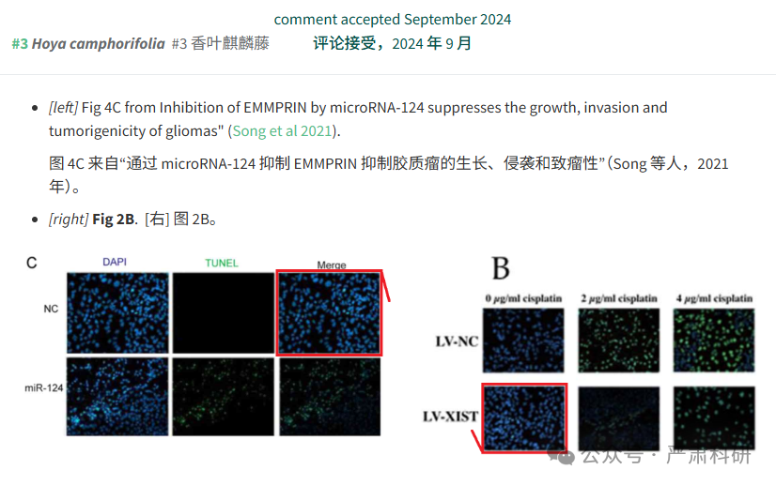

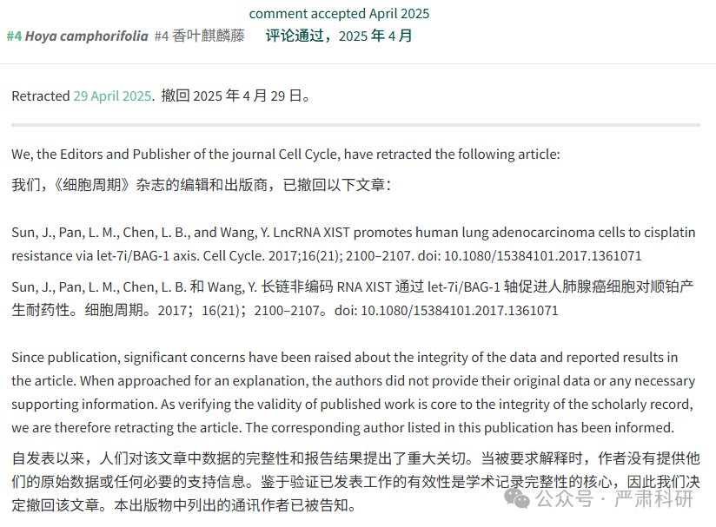

**参考信息  
https://pubmed.ncbi.nlm.nih.gov/28961027/**

**https://pubpeer.com/publications/D09F632A9CB345788E2DAD3083A5C4#0**

本平台对于科研问题的探讨，始终保持严谨、深入、持续、开放和创新的态度。所有推文信源，均来源于pubpeer、For Better Science等网站公开质疑。我们从来没有、也永远不会主动查重论文并去pubpeer上质疑。我们尊重他人的研究成果和贡献，通过交流和合作，共同推动科研领域的进步和发展。