[集美大学Marine Drugs图片被质疑，作者已回复](https://mp.weixin.qq.com/s?__biz=MzUxODcwODMzMw==&mid=2247484122&idx=1&sn=ba34541d57de4e81c786b05b0c04ca23)

原创一只鱼[严肃科研](javascript:void(0);)2025-04-28 23:40:20四川

**“**秉持严谨、深入、持续、开放与创新的态度，尊重他人成果，携手交流共进，推动科研发展。**”**

**Research Frontline**

**科研前线**

01

—

**问题论文**

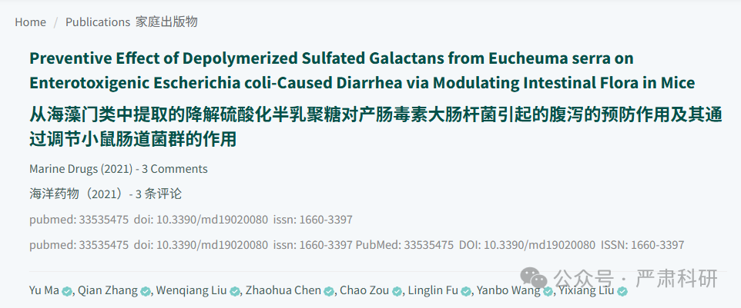

**标题：**Preventive Effect of Depolymerized Sulfated Galactans from Eucheuma serra on Enterotoxigenic Escherichia coli-Caused Diarrhea via Modulating Intestinal Flora in Mice

**期刊：**Marine Drugs

**单位：**厦门集美大学8浙江工商大学

**发表时间：**2021年2月1日

**DOI:**10.3390/md19020080

**研究摘要：**

In this work, the preventive effect of depolymerized sulfated polysaccharides from *Eucheuma serra* (DESP) on bacterial diarrhea by regulating intestinal flora was investigated in vivo. Based on the enterotoxigenic *Escherichia coli* (ETEC)-infected mouse diarrhea model, DESP at doses ranging from 50 mg/kg to 200 mg/kg alleviated weight loss and decreased the diarrhea rate and diarrhea index. Serological tests showed that the levels of inflammation-related factors were effectively suppressed. Furthermore, the repaired intestinal mucosa was verified by morphology and pathological tissue section observations. Compared with the model group, the richness and diversity of the intestinal flora in the DESP group increased according to the 16S rRNA high-throughput sequencing of the gut microbiota. Specifically, *Firmicutes* and *Actinobacteria* increased, and *Proteobacteria* decreased after DESP administration. At the family level, DESP effectively improved the abundance of *Lactobacillaceae*, *Bifidobacteriaceae*, and *Lachnospiraceae*, while significantly inhibiting the growth of *Enterobacteriaceae*. Therefore, the antimicrobial diarrhea function of DESP may be related to the regulation of intestinal microbiota.  
在这项研究中，通过调节肠道菌群，研究了从麒麟菜（Eucheuma serra）中提取的解聚硫酸多糖（DESP）对细菌性腹泻的预防作用。基于肠毒素性大肠杆菌（ETEC）感染小鼠腹泻模型，DESP 在 50 mg/kg 至 200 mg/kg 的剂量范围内减轻了体重减轻，降低了腹泻率和腹泻指数。血清学检测显示，炎症相关因子的水平得到了有效抑制。此外，通过形态学和病理组织切片观察验证了修复的肠道黏膜。与模型组相比，根据肠道微生物群 16S rRNA 高通量测序，DESP 组的肠道菌群丰富度和多样性增加。具体来说，厚壁菌门和放线菌门增加，而变形菌门减少。在科水平上，DESP 有效提高了乳杆菌科、双歧杆菌科和链球菌科的丰度，同时显著抑制了肠杆菌科的生长。 因此，DESP 的抗微生物腹泻功能可能与肠道微生物群的调节有关。

02

—

**具体说明**

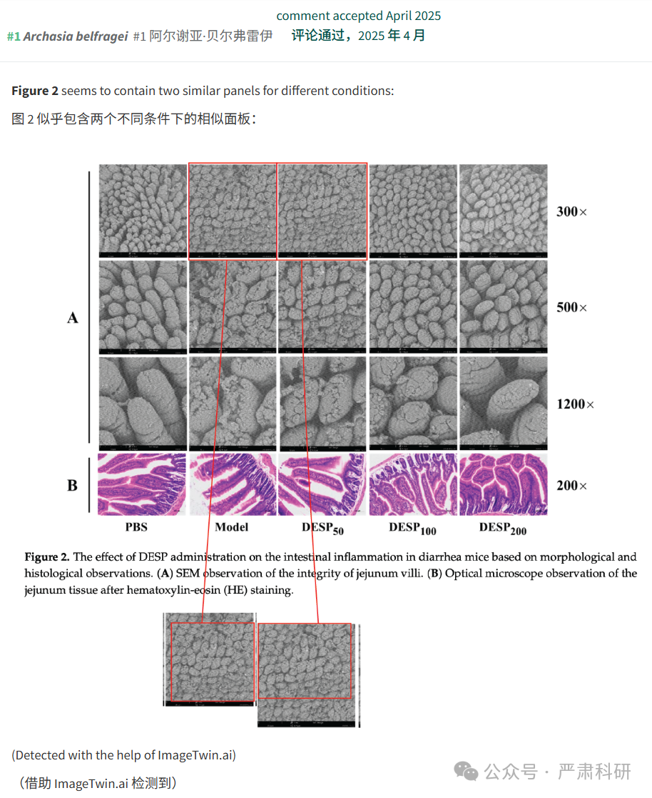

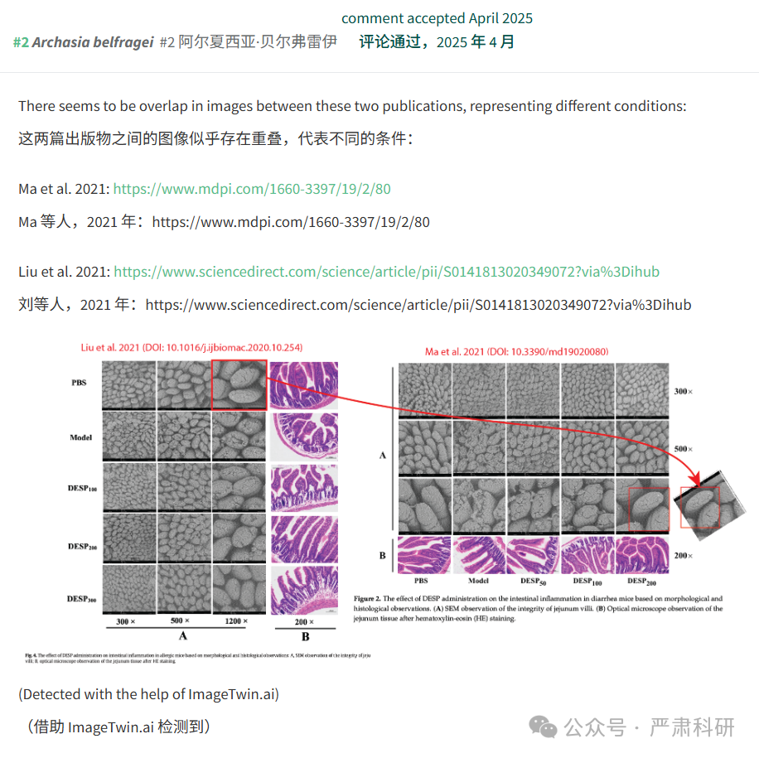

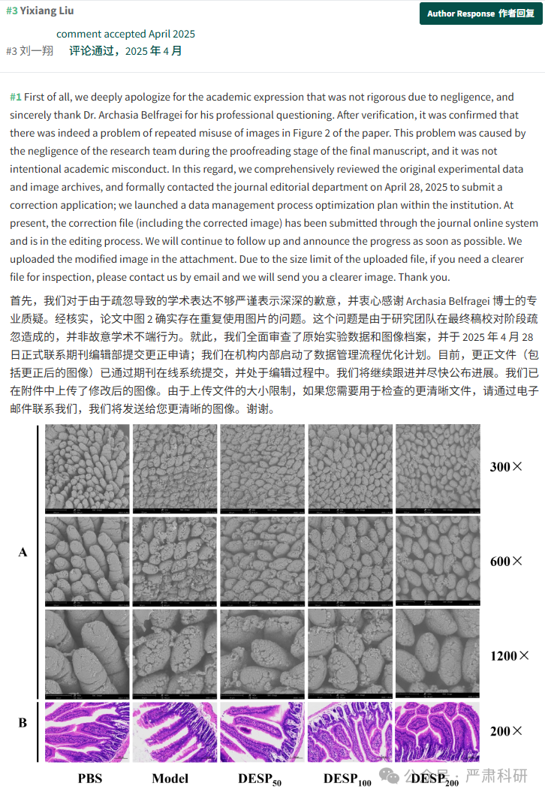

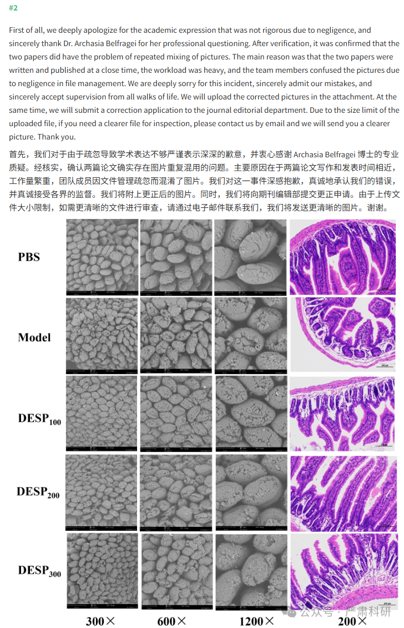

**参考信息  
https://www.mdpi.com/1660-3397/19/2/80**

**https://pubpeer.com/publications/1C981C211385DDE68FD07DAD09F431#0**

本平台对于科研问题的探讨，始终保持严谨、深入、持续、开放和创新的态度。所有推文信源，均来源于pubpeer、For Better Science等网站公开质疑。我们从来没有、也永远不会主动查重论文并去pubpeer上质疑。我们尊重他人的研究成果和贡献，通过交流和合作，共同推动科研领域的进步和发展。