[与同团队早期发表论文多处图像重叠，湖北医药学院太和医院的论文被撤稿](https://mp.weixin.qq.com/s?__biz=MzkwMjY4ODQ5Mw==&mid=2247497193&idx=5&sn=79c3e4f0a18383f51384ce19b10942a7)

R2[Reviewer 2](javascript:void(0);)2025-04-29 01:01:21浙江

一

点击蓝字关注我们



**论文信息**

2013年8月1日，湖北医药学院太和医院的G Wang（第一作者） & J J Wang（第一作者&通讯作者）在Cell Death & Disease（中科院一区 IF=8.1）期刊上在线发表题为"The JAK2/STAT3 and mitochondrial pathways are essential for quercetin nanoliposome-induced C6 glioma cell death"(JAK2/STAT3和线粒体途径对槲皮素纳米脂质体诱导的C6胶质瘤细胞死亡至关重要)论文。

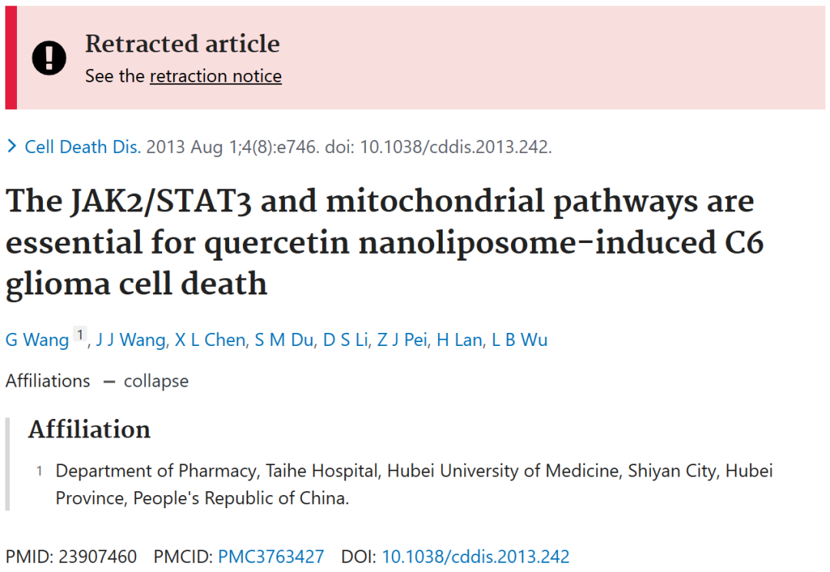





**质疑信息**

* **图1A, B, C，D都存在重叠面板。**

Figs 1A, B, C. Reused panels.

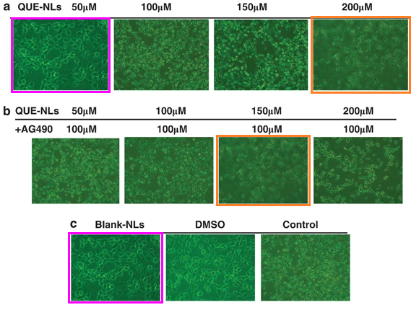

Fig 1D. Overlap marked.

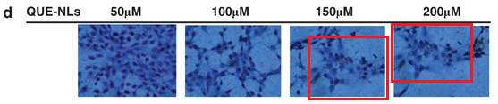

* **图4a,b和7e存在重叠面板。**

Figs 4a,b and 7e. Panels appear repeatedly, with different labels each time.

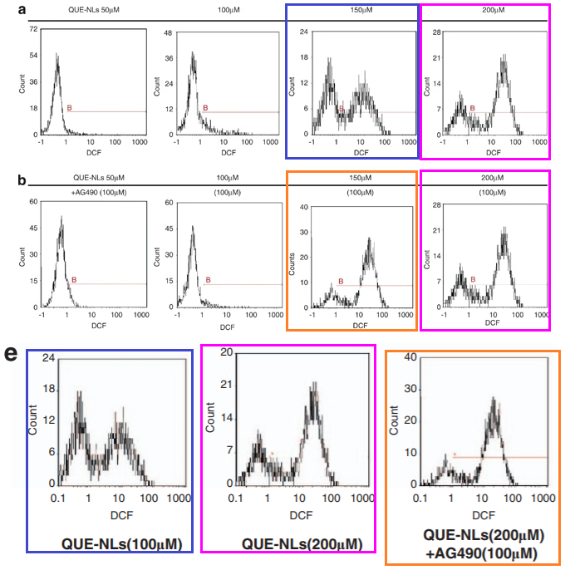

* **图4a,b和7e存在重叠面板。**

Some images in this paper also appear in a different paper with some common authors. In several cases the images are described differently, although in two cases they are described the same.

Figure 2A, International Journal of Nanomedicine (2012), doi: 10.2147/ijn.s26935

Figures 1a, 1b, 1c, Cell Death and Disease (2013), doi: 10.1038/cddis.2013.242

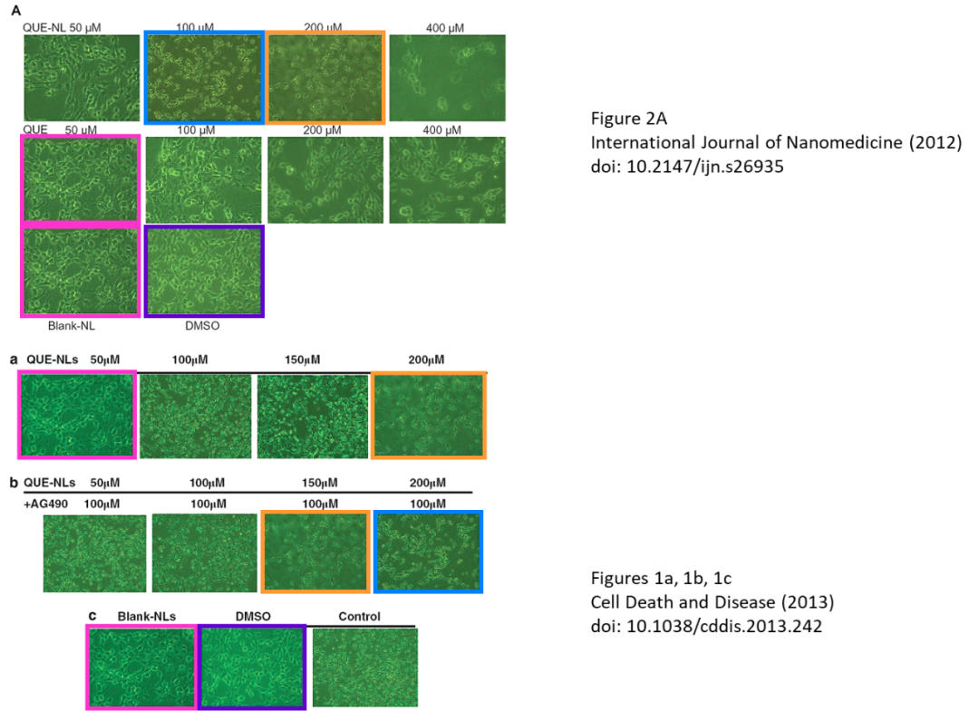

* **图4a,b和7e存在重叠面板。**

The images in Figure 1 also seem to appear in at least one other paper, where some of them appear to be described differently.

Journal of Biomedical Materials Research Part A (2013), doi: 10.1002/jbm.a.34607

Cell Death & Disease (2013), doi: 10.1038/cddis.2013.242

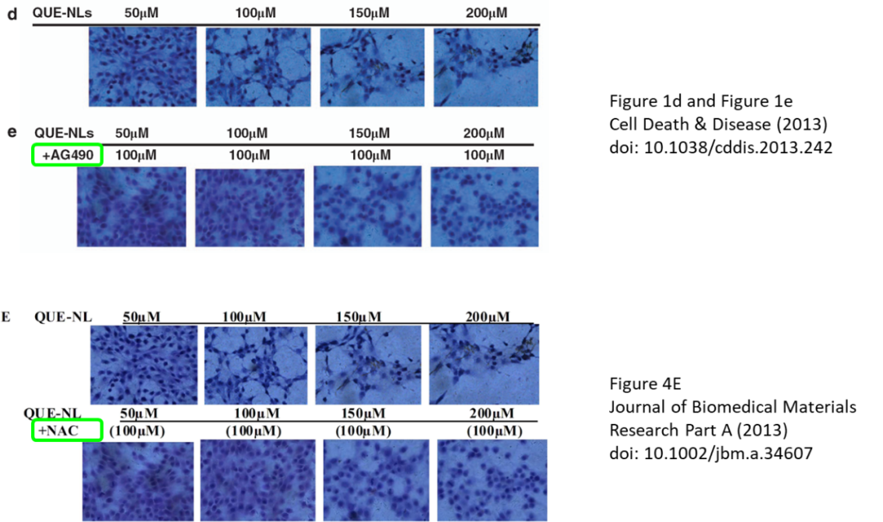



**撤稿原因**

**本文已于2025年4月15日被撤回：**主编已撤回该文章。 文章中存在多处图像问题，具体包括：图1A-C中各子图之间存在相似性；图1D内部存在图像重复；图4内部也存在图像重复。此外，部分图像还与此前由同一作者团队发表的另一篇论文[1]中的图像存在雷同。进一步调查发现，该团队数月前发表的另一篇论文[2]的图4E中，包含有与当前撤回论文图1D和图1E中的两个子图完全相同或高度相似的图像，但两篇论文所描述的实验条件或研究内容并不相同。鉴于上述问题，主编对该文章所基于的原始数据的真实性和可靠性失去信心。

出版方多次尝试联系 X. L. Chen, D. S. Li, Z. J. Pei, H. Lan以及L. B. Wu等论文作者，但均未能取得联系。通讯作者也未回应。

涉及文章：

[1] Wang G, Wang JJ, Yang GY, Du SM, Zeng N, Li DS, et al. Effects of quercetin nanoliposomes on C6 glioma cells through induction of type III programmed cell death. Int J Nanomed. 2012;7:271–80. https://doi.org/10.2147/IJN.S26935.

[2] Wang G, Wang J, Luo J, Wang L, Chen X, Zhang L, et al. PEG2000‐DPSE‐c oated quercetin nanoparticles remarkably enhanced anticancer effects through induced programed cell death on C6 glioma cells. J Biomed Mater Res Part A. 2013;101:3076–85.



**参考信息**

https://pubpeer.com/publications/6C338986D0FF7852CD67899DDAC215

https://pubmed.ncbi.nlm.nih.gov/23907460/

https://www.nature.com/articles/cddis2013242