[四川大学华西TCR图片被质疑](https://mp.weixin.qq.com/s?__biz=MzUxODcwODMzMw==&mid=2247484137&idx=1&sn=79f460bd048ecf924345570d02baf044)

原创一只鱼[严肃科研](javascript:void(0);)2025-04-30 17:32:01四川

**“**秉持严谨、深入、持续、开放与创新的态度，尊重他人成果，携手交流共进，推动科研发展。**”**

**Research Frontline**

**科研前线**

01

—

**问题论文**

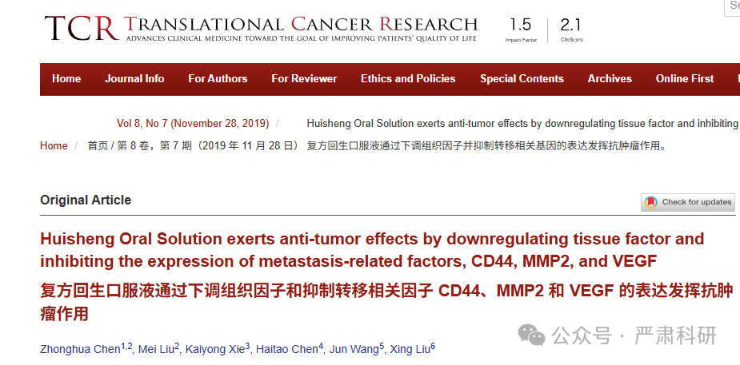

**标题：**Huisheng Oral Solution exerts anti-tumor effects by downregulating tissue factor and inhibiting the expression of metastasis-related factors, CD44, MMP2, and VEGF

**期刊：**Translational Cancer Research

**单位：**四川大学华西药学院

**发表时间：**2019年11月28日

**DOI:** 10.21037/tcr.2019.10.25

**研究摘要：**

In summary, HSOS could inhibit tumor cell metastasis by alleviating hypercoagulability and fibrinolytic disorders through the downregulation of TF, reduction of Fib and D-dimer levels, and the inhibition of platelet aggregation. Moreover, HSOS could directly inhibit tumor metastasis by inhibiting tumor cell adhesion, ECM degradation, neovascularization, and tumor cell migration through the regulation of protein and mRNA expression of metastasis-related factors CD44, MMP2, and VEGF. Additionally, HSOS also could inhibit inflammatory responses and enhance immune function. Together, the present results indicate that HSOS inhibits tumor growth and metastasis via multiple mechanisms.  
总之，HSOS 可以通过下调 TF、降低 Fib 和 D-二聚体水平以及抑制血小板聚集来减轻高凝状态和纤溶障碍，从而抑制肿瘤细胞转移。此外，HSOS 还可以通过调节与转移相关的因子 CD44、MMP2 和 VEGF 的蛋白质和 mRNA 表达，直接抑制肿瘤细胞的粘附、ECM 降解、血管生成和肿瘤细胞迁移，从而抑制肿瘤转移。此外，HSOS 还可以抑制炎症反应并增强免疫功能。总之，目前的研究结果表明，HSOS 通过多种机制抑制肿瘤生长和转移。

02

—

**具体说明**

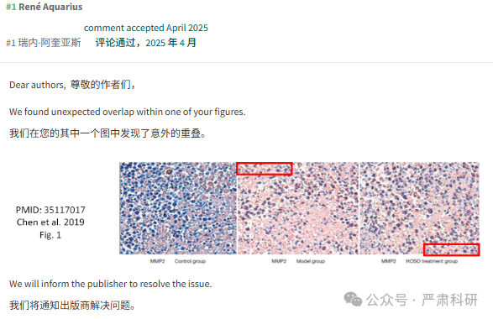

**参考信息  
https://tcr.amegroups.org/article/view/33280/23103**

**https://pubpeer.com/publications/97C154F8858FE3C3CAAAF2E643FEE9#0**

本平台对于科研问题的探讨，始终保持严谨、深入、持续、开放和创新的态度。所有推文信源，均来源于pubpeer、For Better Science等网站公开质疑。我们从来没有、也永远不会主动查重论文并去pubpeer上质疑。我们尊重他人的研究成果和贡献，通过交流和合作，共同推动科研领域的进步和发展。