[部分实验由未披露的第三方协助完成，作者无法验证数据，张家港市第一人民医院的论文被撤稿](https://mp.weixin.qq.com/s?__biz=MzkwMjY4ODQ5Mw==&mid=2247497336&idx=2&sn=399aaa10e9841d96e0e5367090e5e9c6)

R2[Reviewer 2](javascript:void(0);)2025-05-05 11:14:08浙江



点击蓝字关注我们



**论文信息**

2022年1月11日，张家港市第一人民医院的Ping Zhang（第一作者&通讯作者 音译 张萍） & Fang Zhao（第一作者）在Bioengineered（中科院四区 IF=4.2）期刊上在线发表题为"The LOXL1 antisense RNA 1 (LOXL1-AS1)/microRNA-423-5p (miR-423-5p)/ectodermal-neural cortex 1 (ENC1) axis promotes cervical cancer through the mitogen-activated protein kinase (MEK)/extracellular signal-regulated kinase (ERK) pathway"(LOXL1 反义 RNA 1 (LOXL1-AS1)/microRNA-423-5p (miR-423-5p)/ectodermal-neural cortex 1 (ENC1) 轴通过丝裂原活化蛋白激酶 (MEK)/ 细胞外信号调节激酶 (ERK) 通路促进宫颈癌的发生)论文。

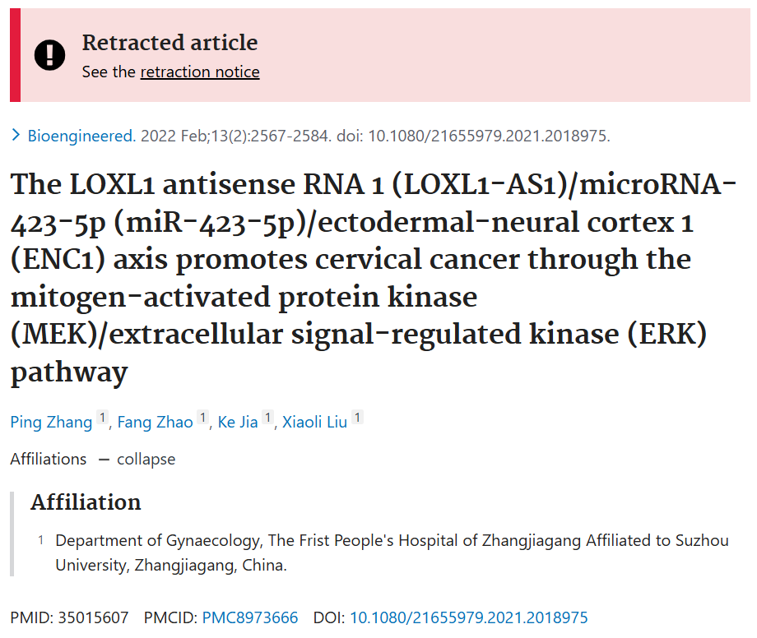

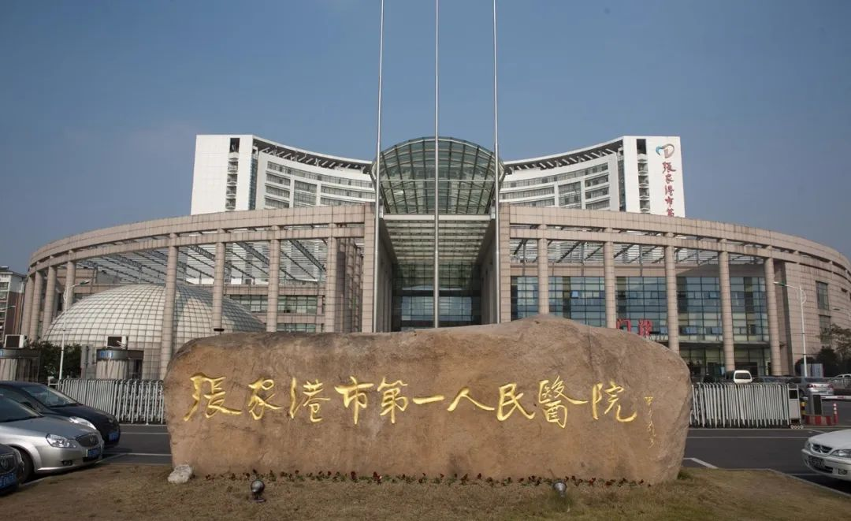



**质疑信息**

* **图3D与多篇无关论文多处面板重叠。**

Clockwise from upper left:

Fig 3a from "Ultrasound-Stimulated Microbubbles Inhibit Aggressive Phenotypes and Promotes Radiosensitivity of esophageal squamous cell carcinoma" (Shi et al 2021).

Fig 3D from "MiR-543 Inhibits the Migration and Epithelial-To-Mesenchymal Transition of TGF-β-Treated Endometrial Stromal Cells via the MAPK and Wnt/β-Catenin Signaling Pathways" (Wang et al 2021) [retracted].

Fig 1a from "miR-223-3p alleviates TGF-β-induced epithelial-mesenchymal transition and extracellular matrix deposition by targeting SP3 in endometrial epithelial cells" (Chen et al 2022).

Fig 3D.

Fig 5F from "lncRNA LOXL1?AS1 promotes liver cancer cell proliferation and migration by regulating the miR?377?3p/NFIB axis" (Yu & Dai ).

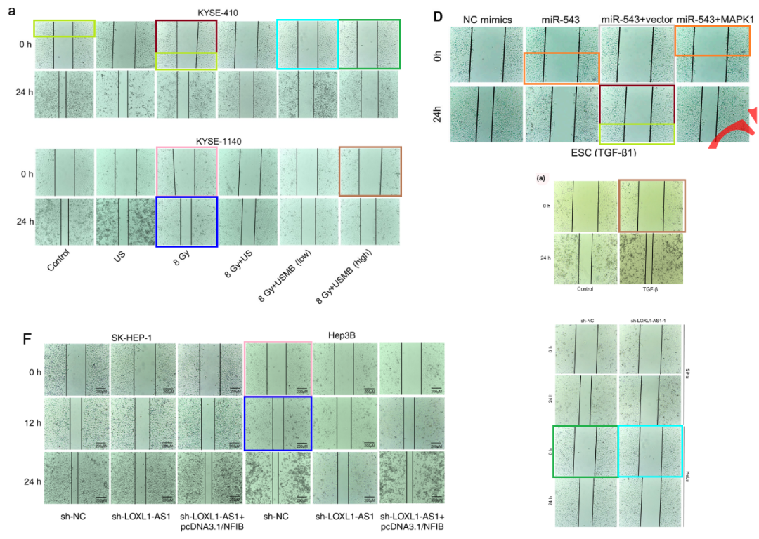

* **图3b与无关论文多处图像重叠。**

Clockwise from top:

Fig 1b from "Ginsenoside 20(S)-Rg3 suppresses cell viability in esophageal squamous cell carcinoma via modulating miR-324-5p-targeted PSME3" (Jiang et al 2021) [retracted].

Fig 3b.

Fig 4D from "Long non-coding RNA GATA6-AS1 upregulates GATA6 to regulate the biological behaviors of lung adenocarcinoma cells" (Kang et al 2021).

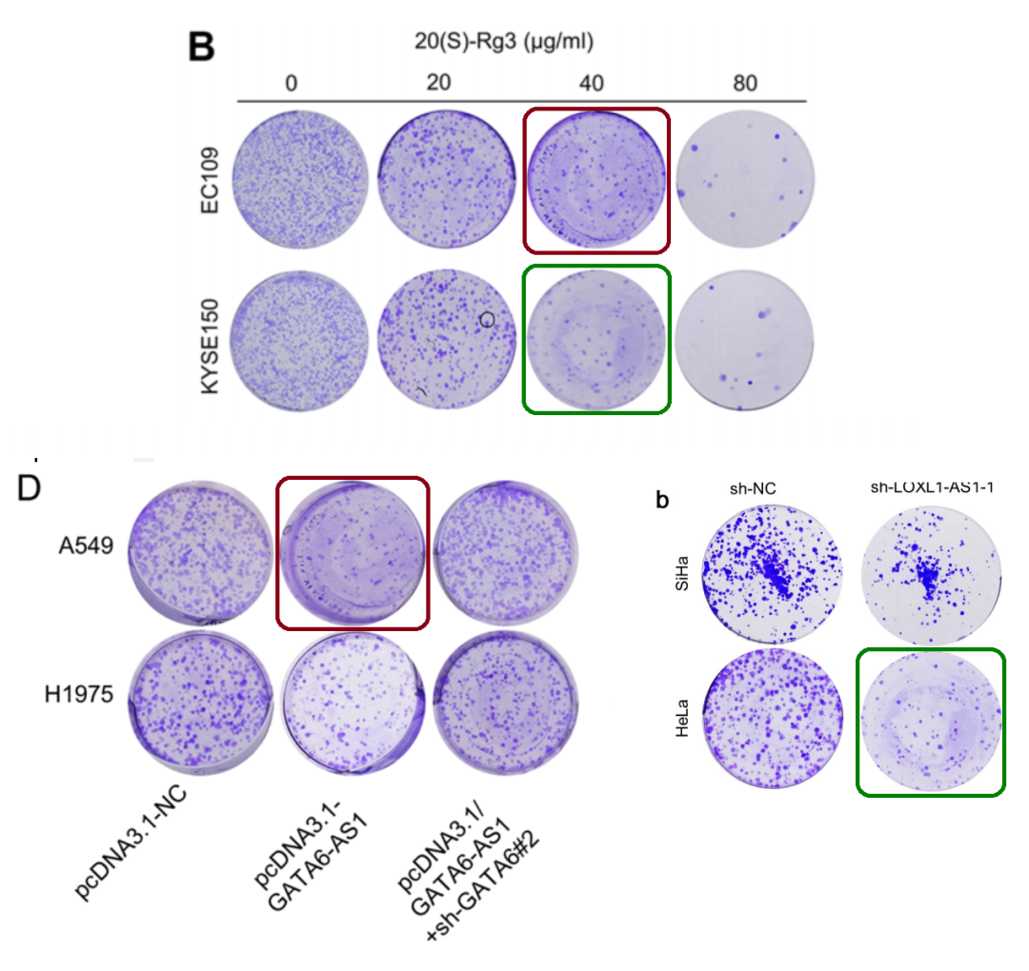

* **图3D与无关论文存在多处重叠。**

Clockwise from top:

Fig 2E from "Long noncoding RNA ROR1-AS1 enhances STC2-mediated cell growth and autophagy in cervical cancer through miR-670-3p" (Zhang et al 2021).

Fig 3D.

Fig 3a from "Ultrasound-Stimulated Microbubbles Inhibit Aggressive Phenotypes and Promotes Radiosensitivity of esophageal squamous cell carcinoma" (Shi et al 2021).

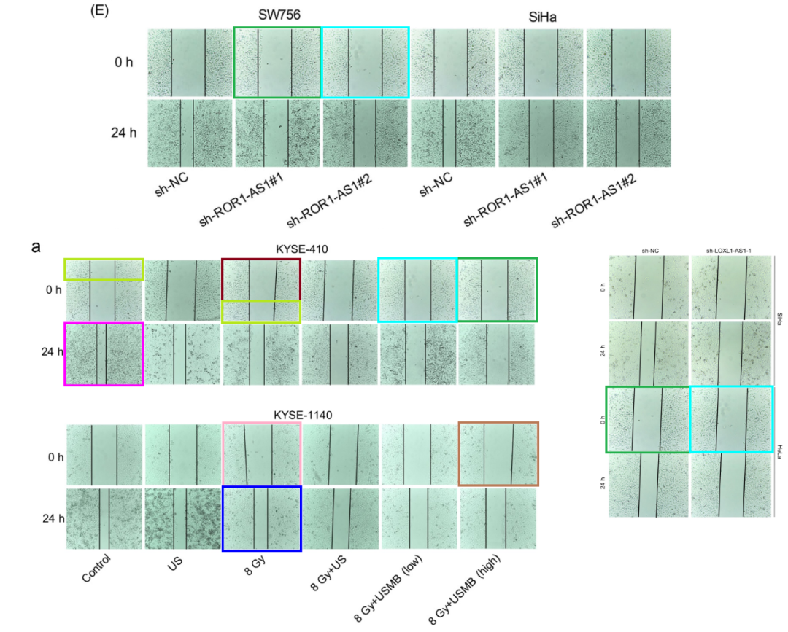



**撤稿原因**

**本文已于2025年4月23日被撤回：**文章发表后，作者于2024年联系期刊编辑部，告知他们无法核实文章中的数据。他们表示，文章中的部分实验是由第三方协助完成的，因此所报告的结果已不再可靠。而文章中并未披露实验是由第三方进行的这一情况。

由于我们无法核实已发表工作的有效性，也无法确认其是否符合我们的编辑政策，因此我们决定撤稿。我们已通知了本文列出的通讯作者。



**参考信息**

https://pubpeer.com/publications/C3790E715303DC643F70ACE9B02404

https://pubmed.ncbi.nlm.nih.gov/35015607/

https://www.tandfonline.com/doi/full/10.1080/21655979.2025.2496006