[图片与他人重复，第四军医大学西京医院主任论文被质疑](https://mp.weixin.qq.com/s?__biz=Mzk1Nzk5NzI3Mw==&mid=2247484840&idx=1&sn=d608389489aa7bd4248396c068d3885c)

原创观观[图片观察](javascript:void(0);)2025-04-29 19:52:22广东

这篇2017年发表的Oncotarget 期刊，主要由Jihong Shi , Shan Shi , Bin Wu , Jian Zhang , Yan Li , Xue Wu , Julei Zhang , Kejia Wang , Bin Zhao , Weixia Cai , Xiaozhi Bai , Dahai Hu , Hao Guan 共同完成，作者主要来自#第四军医大学西京医院，近期论文与他人重复引起质疑

**论文信息**

标题：Autophagy protein LC3 regulates the fibrosis of hypertrophic      scar by controlling Bcl-xL in dermal fibroblasts

作者：Jihong Shi, Shan Shi, Bin Wu, Jian Zhang, Yan Li, Xue Wu, Julei      Zhang, Kejia Wang, Bin Zhao, Weixia Cai, Xiaozhi Bai, Dahai Hu, Hao Guan

期刊：Oncotarget

发表日期：2017 年 9 月 8 日（eCollection 2017 年 11 月 7 日）

DOI：10.18632/oncotarget.20771

PMID：29212187

PMCID：PMC5706833

**质疑内容**

Figure 1B of this paper shows autophagy levels in NSFs or HSFs (no starvation and no IL10 treatment). Four micrographs also appear in Figure 1c of Shi et al. 2016 Cell Death Dis, a paper by the same group where the micrographs are supposed to show starvation-induced autophagy and +IL10 treatment in HSFs.  
Could the authors please comment?

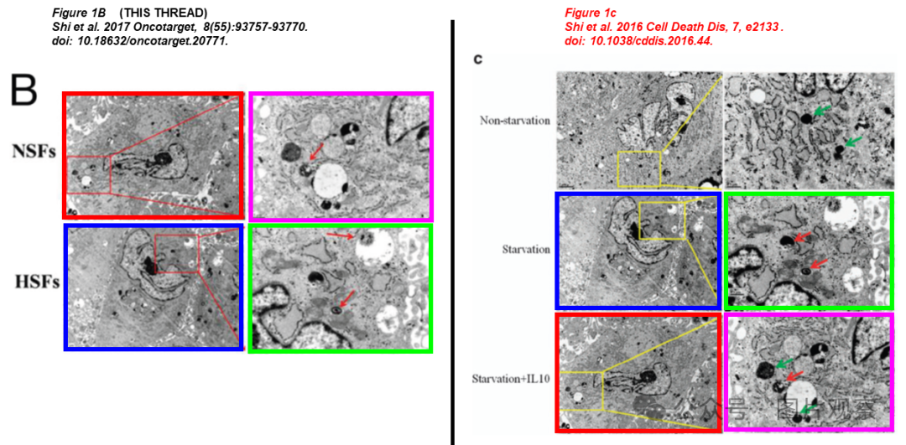



**END**



**#**

**扫码关注我们**



Don't be ashamed



专注于国内论文质疑报道

**欢迎投稿联系**