[第三军医大学JECR图片被质疑](https://mp.weixin.qq.com/s?__biz=MzUxODcwODMzMw==&mid=2247484143&idx=1&sn=3f6a31dfbec8be76b4d378e3db2d7fa7)

原创一只鱼[严肃科研](javascript:void(0);)2025-05-01 13:05:12四川

**“**秉持严谨、深入、持续、开放与创新的态度，尊重他人成果，携手交流共进，推动科研发展。**”**

**Research Frontline**

**科研前线**

01

—

**问题论文**

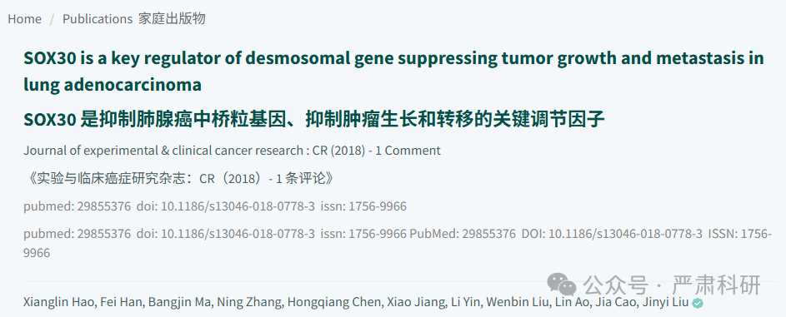

**标题：**SOX30 is a key regulator of desmosomal gene suppressing tumor growth and metastasis in lung adenocarcinoma

**期刊：**Journal of Experimental & Clinical Cancer Research

**单位：**第三军医大学预防医学学院

**发表时间：**2018年5月31日

**DOI:**10.1186/s13046-018-0778-3

**研究摘要：**

Background  背景

The expression of desmosomal genes in lung adenocarcinoma and lung squamous carcinoma is different. However, the regulatory mechanism of desmosomal gene expression in lung adenocarcinoma and lung squamous carcinoma remains unknown.  
肺腺癌和肺鳞状细胞癌中桥粒基因的表达不同。然而，肺腺癌和肺鳞状细胞癌中桥粒基因表达的调控机制尚不清楚。

Methods  方法

The correlation between expression of desmosomal gene expression and SOX30 expression were analyzed by bioinformatics. The expression of SOX30, DSP, JUP and DSC3 were detected in lung cancer cell lines, lung tissues of mice and patients’ tissues by qPCR, WB, Immunofluorescence and Immunohistochemistry. A chromatin Immunoprecipitation assay was used to investigate the mechanisms of the SOX30 regulation on desmosomal gene expression. In vitro proliferation, migration and invasion assays, and an in vivo nude mice model were utilized to assess the important role of desmosomal genes on SOX30-induced tumor suppression. A WB assay and TOP/FOP flash reporter assay was used to investigate the downstream pathway regulated by the SOX30-desmosomal gene axis. A chemical carcinogenic model of SOX30-knockout mice was generated to confirm the role of the SOX30-desmosomal gene axis in tumorigenesis.  
基因表达与 SOX30 表达的相关性通过生物信息学方法进行分析。通过 qPCR、WB、免疫荧光和免疫组化检测了肺癌细胞系、小鼠肺组织和患者组织中的 SOX30、DSP、JUP 和 DSC3 的表达。使用染色质免疫沉淀实验研究 SOX30 对桥粒基因表达的调控机制。通过体外增殖、迁移和侵袭实验以及裸鼠体内模型评估桥粒基因在 SOX30 诱导的肿瘤抑制中的重要作用。使用 WB 实验和 TOP/FOP 荧光报告基因实验研究由 SOX30-桥粒基因轴调控的下游通路。构建了 SOX30 敲除小鼠的化学致癌模型以确认 SOX30-桥粒基因轴在肿瘤发生中的作用。

Results  结果

The expression of desmosomal genes were upregulated by SOX30 in lung adenocarcinoma but not in lung squamous carcinoma. Further mechanism studies showed that SOX30 acts as a key transcriptional regulator of desmosomal genes by directly binding to the ACAAT motif of desmosomal genes promoter region and activating their transcription in lung adenocarcinoma. Knockdown of the expression of related desmosomal genes by miRNA significantly attenuated the inhibitory effect of SOX30 on cell proliferation, migration and invasion in vitro and on tumor growth and metastasis in vivo. In addition, knockout of SOX30 promotes lung tumor development and loss the inhibition of desmosomal genes on downstream Wnt and ERK signal in urethane-induced lung carcinogenesis in SOX30-knockout mice.  
细胞连接基因的表达在肺腺癌中由 SOX30 上调，但在肺鳞状细胞癌中则没有。进一步的机制研究表明，SOX30 通过直接结合到细胞连接基因启动子区域的 ACAAT 基序，作为细胞连接基因的关键转录调控因子，在肺腺癌中激活其转录。通过 miRNA 敲低相关细胞连接基因的表达，显著减弱了 SOX30 对细胞增殖、迁移和侵袭的抑制作用，以及在体外对肿瘤生长和转移的抑制作用，以及在体内对肿瘤生长和转移的抑制作用。此外，SOX30 敲除促进肺肿瘤发展，并使细胞连接基因对下游 Wnt 和 ERK 信号的抑制作用在 SOX30 敲除小鼠的尿烷诱导肺癌发生中丧失。

Conclusions  结论

Overall, these findings demonstrate for the first time that SOX30 acts as a master switch of desmosomal genes, inhibits lung adenocarcinoma cell proliferation, migration and invasion by activating the transcription of desmosomal genes. This study provides novel insights on the regulatory mechanism of desmosomal genes in lung adenocarcinoma.  
总体而言，这些发现首次表明 SOX30 作为连接蛋白基因的主开关，通过激活连接蛋白基因的转录，抑制肺腺癌细胞的增殖、迁移和侵袭。本研究为肺腺癌中连接蛋白基因的调控机制提供了新的见解。

02

—

**具体说明**

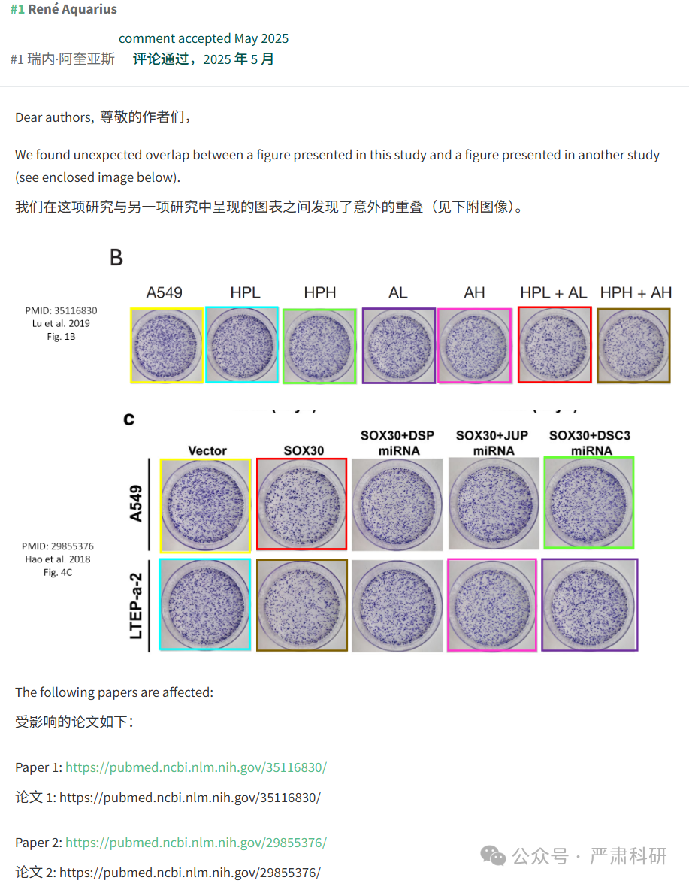

**参考信息  
https://jeccr.biomedcentral.com/articles/10.1186/s13046-018-0778-3**

**https://pubpeer.com/publications/B0429905FB664C8D9C996F5BA83854#0**

本平台对于科研问题的探讨，始终保持严谨、深入、持续、开放和创新的态度。所有推文信源，均来源于pubpeer、For Better Science等网站公开质疑。我们从来没有、也永远不会主动查重论文并去pubpeer上质疑。我们尊重他人的研究成果和贡献，通过交流和合作，共同推动科研领域的进步和发展。