[调查发现存在图像重复使用与篡改问题，山东医专附属医院&临沂市中心医院的论文被撤稿](https://mp.weixin.qq.com/s?__biz=MzkwMjY4ODQ5Mw==&mid=2247497194&idx=1&sn=9f688caa6476a7683778faa9e5371a65)

R2[Reviewer 2](javascript:void(0);)2025-05-02 00:02:06浙江



点击蓝字关注我们



**论文信息**

2017年6月6日，山东医专附属医院的Ping Chen（第一作者） & 临沂市中心医院的Jinlong Qu（通讯作者 音译 瞿金龙）在Journal of Cellular Biochemistry（中科院三区 IF=3）期刊上在线发表题为"Lycopene Protects Keratinocytes Against UVB Radiation-Induced Carcinogenesis via Negative Regulation of FOXO3a Through the mTORC2/AKT Signaling Pathway"(番茄红素通过mTORC2/AKT信号通路负调控FOXO3a，保护角质形成细胞免受紫外线B辐射诱导的致癌作用)论文。

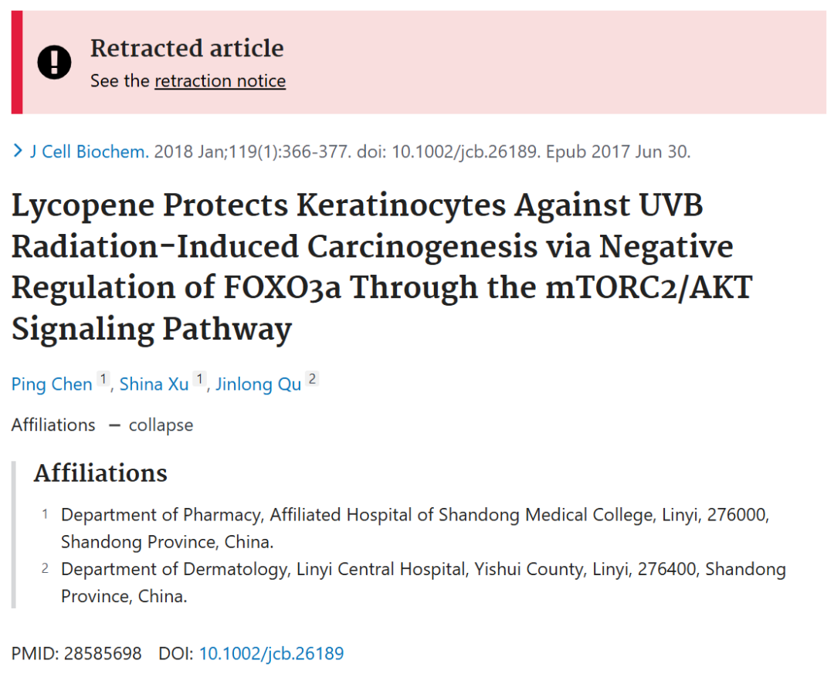

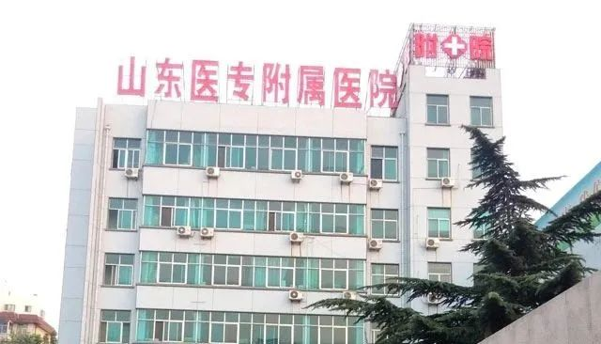

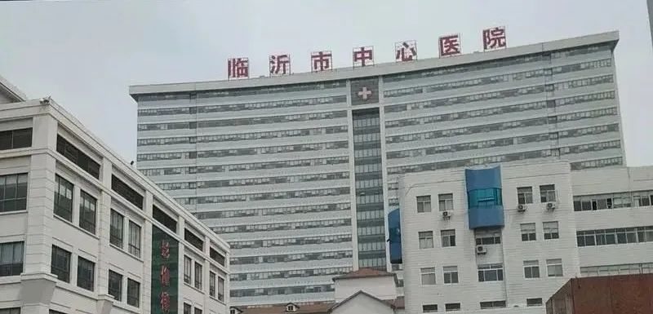



**质疑信息**

* **图4与无关论文存在多处重复面板。**

Fig. 4

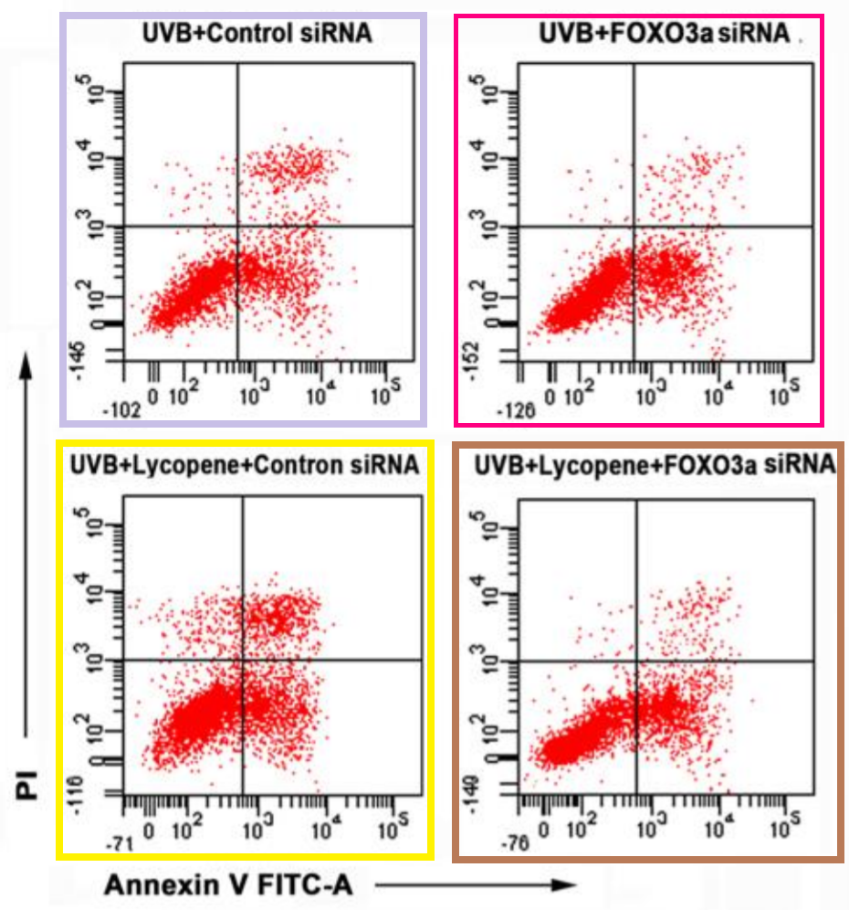

The color-coded these moose portraits to highlight the similarities to Fig 2E of Zhang et al (2017).

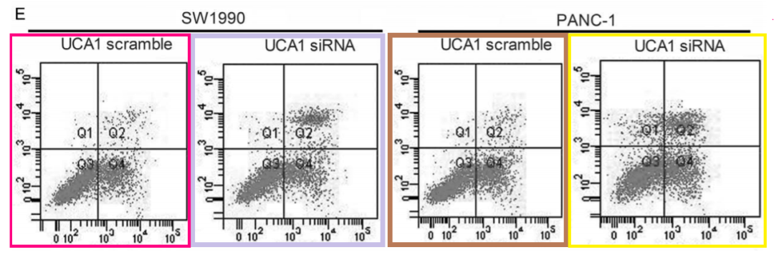

Light brown and light purple boxes also facilitate comparison with Fig 2G of Gao et al (2017), "Cell apoptosis was measured by flow cytometry".

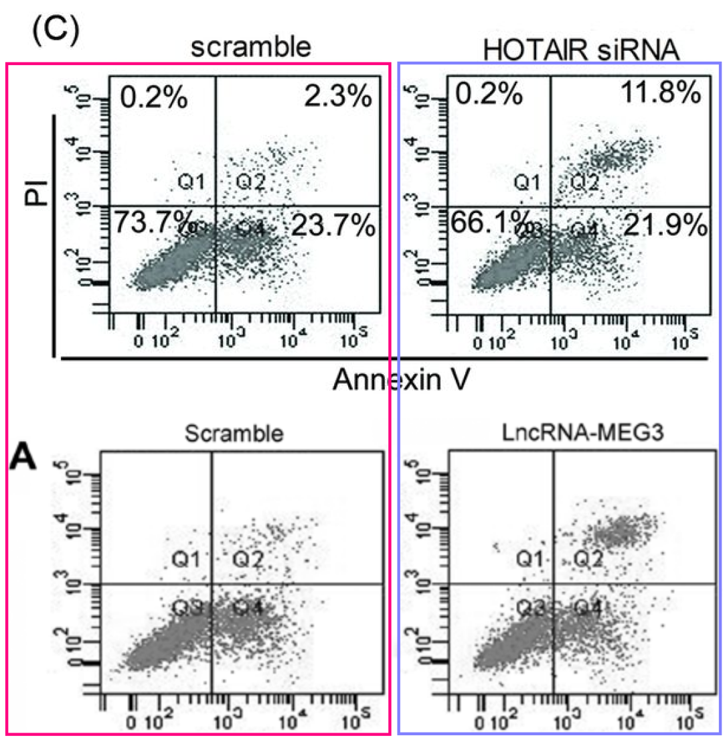

* **图2与多篇无关论文图像面板重复。**

Fig. 2

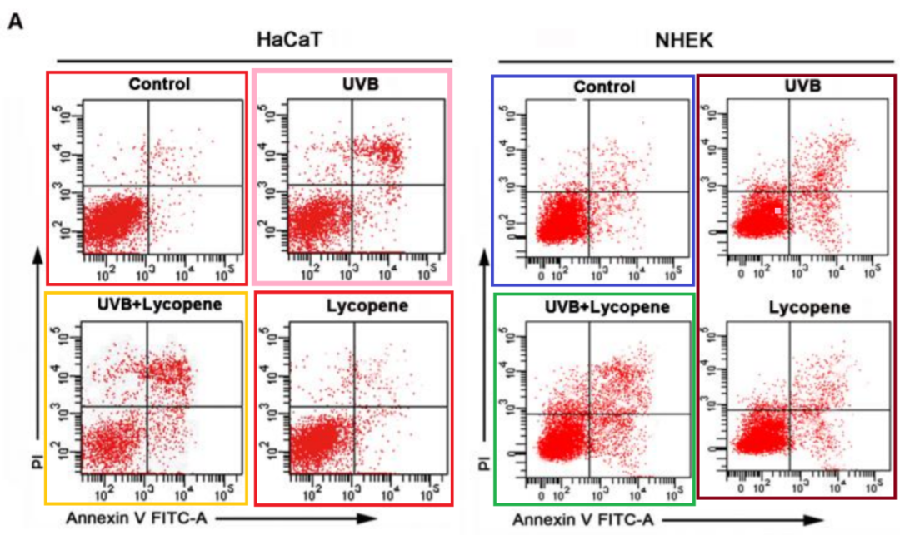

The color-coded these strawberries to indicate their manifestations in previous and subsequent papers by otherwise-unrelated authors. See Fig 5D of Zhang et al (2017) for the red, blue, green, light orange panels, although the two red-boxed panels here have seen some selective disappearance of points.

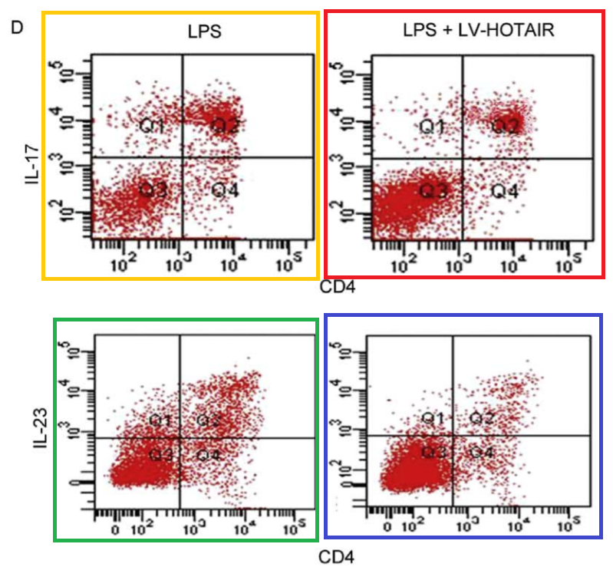

Pink-boxed panel (and also red again) appear in Fig 2C of Li et al (2016), and in a number of other papers linked in that thread.

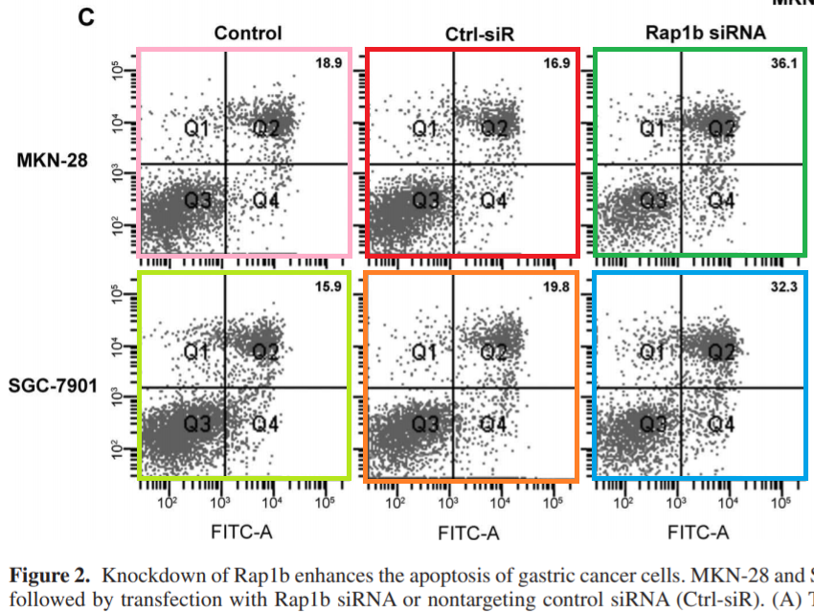

The two panels in the brown box at right are both versions of a panel in Fig 2G of Li et al (2018), and Fig 3A from Long et al (2017).

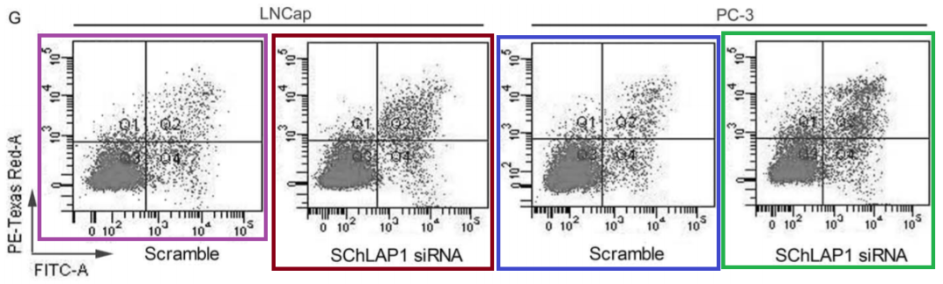

* **图3C存在多处重复面板。**

Fig 3C

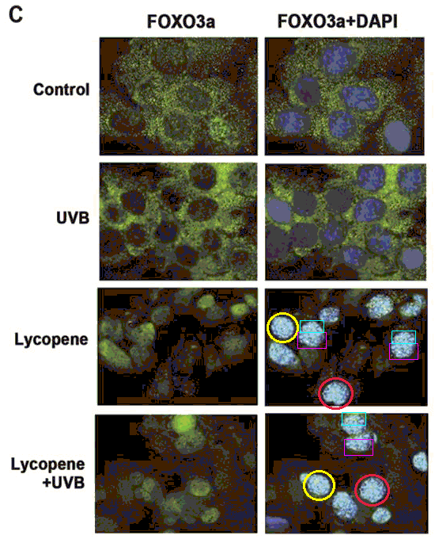



**撤稿原因**

**本文已于2025年4月3日被撤回：**上述文章于2017年6月6日在Wiley在线图书馆（wileyonlinelibrary.com）在线发表，现已由期刊主编Christian Behl与Wiley Periodicals LLC达成协议撤回。此次撤回是由于第三方提出的担忧。经调查发现，图2A和图4A中的多个图像元素此前和/或此后已由不同作者在不同科学背景下发表。此外，图3C中还发现了不恰当的图像编辑/篡改证据。作者被邀请就这些担忧发表评论，但未作出回应。因此，该文章被撤回，因为编辑对文章中呈现的全部数据的完整性和可靠性已失去信心，并认为其结论无效。作者已被告知文章被撤回。



**参考信息**

https://pubpeer.com/publications/C4975FB7D0CC972E55B6994D04E660

https://pubmed.ncbi.nlm.nih.gov/28585698/

https://onlinelibrary.wiley.com/doi/10.1002/jcb.70016