[与四篇同年发表的论文存在明显重复，四川省人民医院王瑜/林涛论文图像问题遭曝光](https://mp.weixin.qq.com/s?__biz=Mzk3NTEwMTE3OA==&mid=2247486537&idx=1&sn=c60228d2c154309497f6a3e0f8a6714e)

[学术荟萃](javascript:void(0);)2025-05-01 02:56:00山东

**Part.1**



**论文简介**

**标题：Remifentanil attenuates cardiac dysfunction, lipid peroxidation and immune disorder in rats with isoproterenol-induced myocardial injury via JNK/NF-KB p65 inhibition**

**日期：**2020年4月30日

**单位与作者**：四川省人民医院 Qin Zhou、Junmei Song、Yu Wang(通讯作者 音译 王瑜) 、Tao Lin(通讯作者 音译 林涛)

**期刊：*Annals of Translational Medicine***

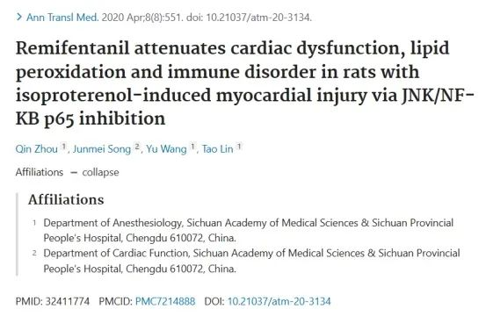

**Part.2**



**图像重复问题**

**#1 图5A与Ke et al 2020的3B、Mo et al 2020的5A出现重复。**

Left to right:

* Fig 5A.
* Fig 3B from "Remifentanil repairs cartilage damage and reduces the degradation of cartilage matrix in post-traumatic osteoarthritis, and inhibits IL-1β-induced apoptosis of articular chondrocytes via inhibition of PI3K/AKT/NF-κB phosphorylation" (Ke et al 2020).
* Fig 5A from "Diosmetin exerts cardioprotective effect on myocardial ischaemia injury in neonatal rats by decreasing oxidative stress and myocardial apoptosis" (Mo et al 2020).

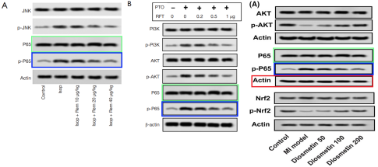

**#2  图2D与Luo et al 2020的6A、Fan et al 2020的2F出现重复。**

Left to right:

* Fig 6A from "Ligustilide modulates oxidative stress, apoptosis, and immunity to avoid pathological damages in bleomycin induced pulmonary fibrosis rats via inactivating TLR4/MyD88/NF-KB P65" (Luo et al 2020).
* Fig 2D.
* Fig 2F from "Artesunate alleviates myocardial ischemia/reperfusion-induced myocardial necrosis in rats and hypoxia/reoxygenation-induced apoptosis in H9C2 cells via regulating the FAK/PI3K/Akt pathway" (Fan et al 2020).

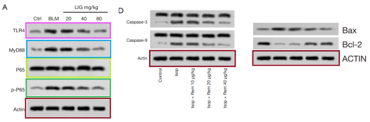

**参考信息：**

https://pubmed.ncbi.nlm.nih.gov/32411774/

https://pubpeer.com/publications/C1198C944809687274F858FBE131AB#2