[多图与他人重复，济宁医学院附属医院主任论文被撤回](https://mp.weixin.qq.com/s?__biz=Mzk1Nzk5NzI3Mw==&mid=2247484840&idx=2&sn=53afb36b82fffbbd2705741b25caabbd)

原创观观[图片观察](javascript:void(0);)2025-04-29 19:52:22广东

这篇2018年发表的Oncology Letters期刊，主要由Wenzhong Wei  , Xin Wei , Xiao Liang共同完成，上个月图片与他人重复引起质疑，近期该论文被撤稿

**论文信息**

标题：Correlation of nm 23 expression with pharyngeal cancer and      patient prognoses

作者：Wenzhong Wei, Xin Wei, Xiao Liang

期刊：Oncology Letters

发表日期：2018年11月

DOI：10.3892/ol.2018.9375

PMID：30344722

PMCID：PMC6176257

单位

* E.N.T. Department, The Affiliated Hospital of Jining Medical College, Jining, Shandong 272000, P.R. China.
* Emergency Department, The Affiliated Hospital of Jining Medical College, Jining, Shandong 272000, P.R. China.
* E.N.T. Department, Qufu City Hospital of Traditional Chinese Medicine, Qufu, Shandong 273100, P.R. China.

**质疑内容**

**#1** Actinopolyspora biskrensis comment accepted March 2025

Data in this paper also seems to appear in a different paper in the same journal. That other paper has signs of third-party involvement. Could this paper be part of the same gang? It has some of the hallmarks: Hospital affiliations and a manynumbers@163.com email address.

* Figure 3, Oncology Letters (2018), doi: 10.3892/ol.2018.9375, discussed here: https://pubpeer.com/publications/C16103535656D9FD921659B9DD5DE1
* Figure 4, Oncology Letters (2018), doi: 10.3892/ol.2018.8486, discussed here: https://pubpeer.com/publications/438100E7087A891E84E5C05D643608

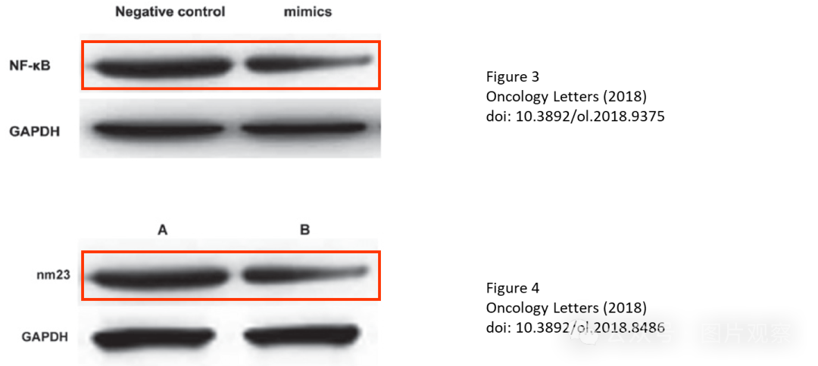

**#2** Actinopolyspora biskrensis comment accepted March 2025

Two images in this paper also seem to appear in an unrelated paper.

While the earlier paper could be the source for the later paper, I do note that the label describing the magnification seems to be located just within the field of view of the image outlined in red in the later paper. If this is correct, that suggests that a common third-party may have been the original source.

* Figure 1A and Figure 1B, Oncology Letters (2018), doi: 10.3892/ol.2018.9375, described here: https://pubpeer.com/publications/C16103535656D9FD921659B9DD5DE1
* Figure 1, World Journal of Surgical Oncology (2017), doi: 10.1186/s12957-017-1279-0, described here: https://pubpeer.com/publications/5967217F14C680652969BF24E79ACD

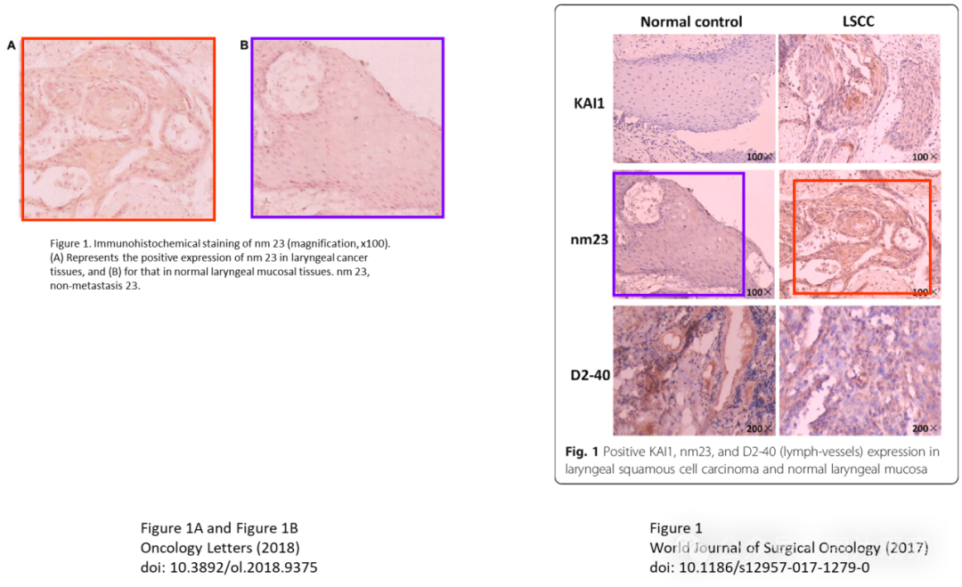

**撤回**

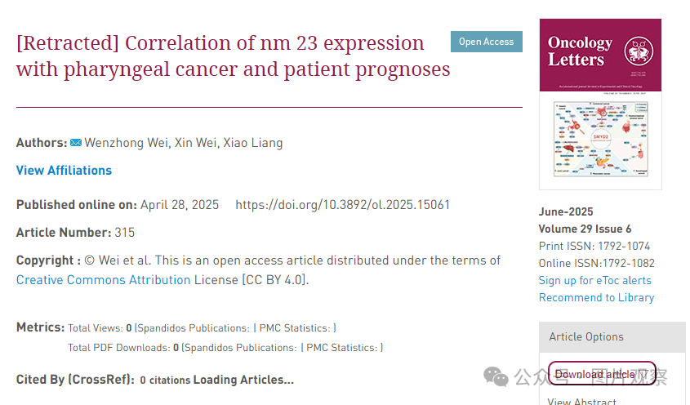

在这篇论文发表后，一位关心的读者提请编辑注意，第 5669 页图 1 中显示的组织学数据和第 5670 页图 3 中的 nm23 蛋白质印迹数据与已经被接受发表在不同研究机构的不同作者撰写的其他文章中的数据惊人地相似。由于上述文章中的争议数据在提交给 Oncology Letters 之前已经发表，编辑决定将这篇论文从该杂志上撤回。在与作者取得联系后，他们接受了撤回论文的决定。对于由此造成的任何不便，编辑向读者道歉。



**END**



**#**

**扫码关注我们**



Don't be ashamed



专注于国内论文质疑报道

**欢迎投稿联系**