[哈工大JCI图片被质疑](https://mp.weixin.qq.com/s?__biz=MzUxODcwODMzMw==&mid=2247484108&idx=1&sn=20cc29b7b77d9d193fc7991d953e06f6)

原创一只鱼[严肃科研](javascript:void(0);)2025-04-27 23:10:22四川

**“**秉持严谨、深入、持续、开放与创新的态度，尊重他人成果，携手交流共进，推动科研发展。**”**

**Research Frontline**

**科研前线**

01

—

**问题论文**

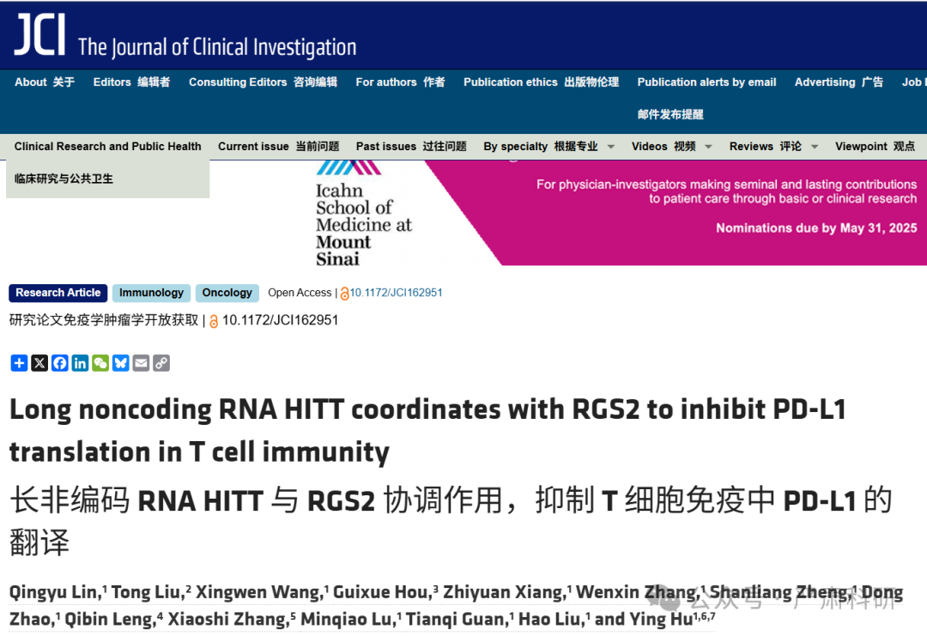

**标题：**Long noncoding RNA HITT coordinates with RGS2 to inhibit PD-L1 translation in T cell immunity

**期刊：**The Journal of clinical investigation

**单位：**哈尔滨工业大学生命科学与技术学院

**发表时间：**2023年4月4日

**DOI:**10.1172/jci162951

**研究摘要：**

Programmed cell death ligand 1 (PD-L1) is an immune checkpoint protein frequently expressed in human cancers that contributes to immune evasion through its binding to PD-1 on activated T cells. Unveiling the mechanisms underlying PD-L1 expression is essential for understanding the impact of the immunosuppressive microenvironment and is also crucial for the purpose of reboosting antitumor immunity. However, how PD-L1 is regulated, particularly at translational levels, remains largely unknown. Here, we discovered that a long noncoding RNA (lncRNA), HIF-1α inhibitor at translation level (HITT), was transactivated by E2F transcription factor 1 (E2F1) under IFN-γ stimulation. It coordinated with regulator of G protein signaling 2 (RGS2) in binding to the 5′ UTR of *PD-L1*, resulting in reduced PD-L1 translation. HITT expression enhanced T cell–mediated cytotoxicity both in vitro and in vivo in a PD-L1–dependent manner. The clinical correlation between HITT/PD-L1 and RGS2/PD-L1 expression was also detected in breast cancer tissues. Together, these findings demonstrate the role of HITT in antitumor T cell immunity, highlighting activation of HITT as a potential therapeutic strategy for enhancing cancer immunotherapy.  
程序性细胞死亡配体 1（PD-L1）是一种在人类癌症中频繁表达的免疫检查点蛋白，通过与其在活化 T 细胞上的 PD-1 结合，有助于免疫逃逸。揭示 PD-L1 表达背后的机制对于理解免疫抑制性微环境的影响至关重要，也是重新增强抗肿瘤免疫的目的所在。然而，PD-L1 是如何调控的，尤其是在翻译水平上，这仍然在很大程度上是个未知数。在这里，我们发现，在 IFN-γ刺激下，长非编码 RNA（lncRNA）HIF-1α抑制剂在翻译水平上（HITT）被 E2F 转录因子 1（E2F1）激活。它与 G 蛋白信号转导调节因子 2（RGS2）协调结合 PD-L1 的 5′UTR，导致 PD-L1 翻译减少。HITT 表达增强了 T 细胞介导的细胞毒性，无论是在体外还是在体内，都是 PD-L1 依赖性的。在乳腺癌组织中，也检测到了 HITT/PD-L1 和 RGS2/PD-L1 表达的临床相关性。 这些发现共同证明了 HITT 在抗肿瘤 T 细胞免疫中的作用，突出了 HITT 激活作为增强癌症免疫疗法的潜在治疗策略。

02

—

**具体说明**

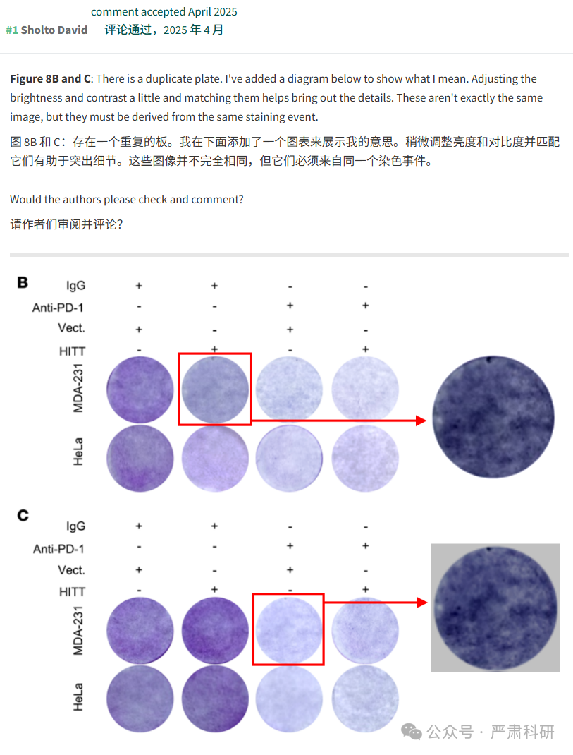

**参考信息  
https://www.jci.org/articles/view/162951**

**https://pubpeer.com/publications/0B3F78A4EF318F171EAE0E1A3D1F29#0**

本平台对于科研问题的探讨，始终保持严谨、深入、持续、开放和创新的态度。所有推文信源，均来源于pubpeer、For Better Science等网站公开质疑。我们从来没有、也永远不会主动查重论文并去pubpeer上质疑。我们尊重他人的研究成果和贡献，通过交流和合作，共同推动科研领域的进步和发展。