[中国科学院大学华美医院Translational Cancer Research被质疑](https://mp.weixin.qq.com/s?__biz=MzUxODcwODMzMw==&mid=2247484087&idx=1&sn=22937ac19244bc73a4edceafa353c7b8)

原创一只鱼[严肃科研](javascript:void(0);)2025-04-21 21:41:26四川

**“**秉持严谨、深入、持续、开放与创新的态度，尊重他人成果，携手交流共进，推动科研发展。**”**

**Research Frontline**

**科研前线**

01

—

**问题论文**

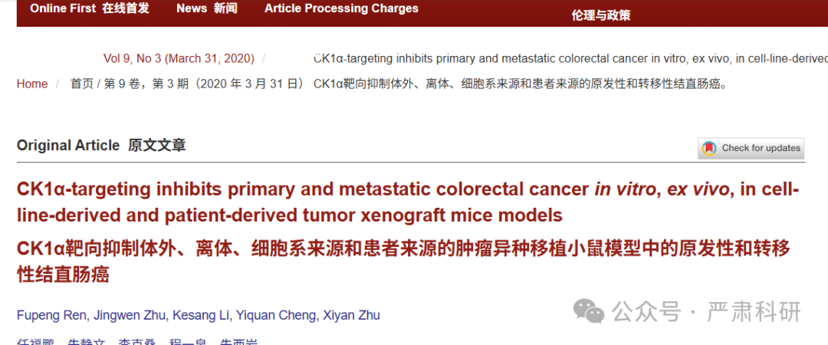

**标题：**CK1α-targeting inhibits primary and metastatic colorectal cancer in vitro, ex vivo, in cell-line-derived and patient-derived tumor xenograft mice models

**期刊：**Translational Cancer Research

**单位：**中国科学院大学宁波生命健康产业研究院

**发表时间：**2020年3月31日

**DOI:** 10.21037/tcr.2020.02.13

**研究摘要：**

**Background:**Colorectal cancer (CRC) remains a leading cause of cancer-related deaths globally. Despite improved understanding of its initiation and progression, and advances in diagnostic or therapeutic strategies, the treatment of metastatic CRC remains a clinical challenge, necessitating identification of novel efficacious therapeutics with little/no toxicity to non-tumor colorectal cells. The present study investigated the effect of *Epiblastin A,* an adenosine triphosphate (ATP)-mediated competitive inhibitor of casein kinase 1α (CK1α) on the viability, proliferation, and oncogenicity of CRC cells.  
背景：结直肠癌（CRC）是全球癌症相关死亡的主要原因。尽管对其发生和发展的理解有所提高，以及诊断或治疗策略的进步，但转移性结直肠癌的治疗仍然是一个临床挑战，需要识别具有新疗效且对非肿瘤结直肠细胞毒性小/无的药物。本研究调查了 Epiblastin A 对结直肠癌细胞存活、增殖和致癌性的影响，Epiblastin A 是一种腺苷三磷酸（ATP）介导的酪蛋白激酶 1α（CK1α）竞争性抑制剂。

**Methods:**Comparative evaluation of the effect of *Epiblastin A* on *CK1α i*n fetal human normal colonic mucosa (FHC) and CRC (HCT116, HT29, DLD1) cell lines, using western blot, immunohistochemical staining, real-time polymerase chain reaction (RT-PCR), and sulforhodamine B (SRB) cytotoxicity assays. Primary culture cells, patient-derived xenograft (PDX), and tumor xenograft mice CRC models were also employed. Kaplan-Meier plots were used for survival analysis of our CRC cohort.  
方法：采用 Western blot、免疫组化染色、实时聚合酶链反应（RT-PCR）和磺基罗丹明 B（SRB）细胞毒性试验，比较评估 Epiblastin A 对胎儿人正常结肠黏膜（FHC）和 CRC（HCT116、HT29、DLD1）细胞系中 CK1α的影响。同时，还使用了原代培养细胞、患者来源的异种移植（PDX）和肿瘤异种移植小鼠 CRC 模型。Kaplan-Meier 图用于分析我们的 CRC 队列的生存率。

**Results:**CRC cells aberrantly express CK1α at mRNA and protein levels. This overexpression of CK1α is strongly associated with worse 5-year overall survival (OS) in patients with CRC. *Epiblastin A* inhibits CK1α and compared to its apparent non-effect on FHC cells regardless of concentration, it elicits significant dose-dependent inhibition of the viability of HT29, HCT116, and DLD1 cells with a 48 h IC50 of 6.8, 5.0, and 3.2 μM, respectively. The expression of CK1α in CRC primary cultures and PDX samples, significantly correlated with Ki-67 expression, and both were attenuated by *Epiblastin A*. We also observed that the effect of 5 mg/kg *Epiblastin A* on tumor volume, and body weight in the CRC PDX mice models, was similar to that of 5 mg/kg Cetuximab over the time-course of our *in vivo* study. In DLD1-derived tumor xenograft mice, *Epiblastin A* with very mild effect on mice body weight, suppressed tumor volume and tumor weight in a CK1α-dependent manner (P=0.024).  
结果：CRC 细胞在 mRNA 和蛋白质水平上异常表达 CK1α。CK1α的过表达与 CRC 患者 5 年总生存率（OS）较差密切相关。Epiblastin A 抑制 CK1α，与它在 FHC 细胞中无论浓度如何均无显著效果相比，它对 HT29、HCT116 和 DLD1 细胞的存活率产生了显著的剂量依赖性抑制，48 小时 IC50 分别为 6.8、5.0 和 3.2 μM。CRC 原代培养和 PDX 样本中 CK1α的表达与 Ki-67 表达显著相关，并且两者均被 Epiblastin A 所减弱。我们还观察到，5 mg/kg Epiblastin A 对 CRC PDX 小鼠模型肿瘤体积和体重的影响，在我们的体内研究过程中与 5 mg/kg 西妥昔单抗相似。在 DLD1 来源的肿瘤异种移植小鼠中，Epiblastin A 对小鼠体重的影响非常轻微，以 CK1α依赖的方式抑制肿瘤体积和肿瘤重量（P=0.024）。

**Conclusions:**Our results demonstrate the efficacy of *Epiblastin A* in CRC and its potential as a putative small-molecule inhibitor of *CK1α* and Ki-67 signaling, which are relevant in the CRC initiation, progression and prognosis.  
结论：我们的结果表明 Epiblastin A 在结直肠癌（CRC）中的疗效及其作为 CK1α和 Ki-67 信号通路潜在的小分子抑制剂的潜力，这些通路与 CRC 的发生、发展和预后相关。

02

—

**具体说明**

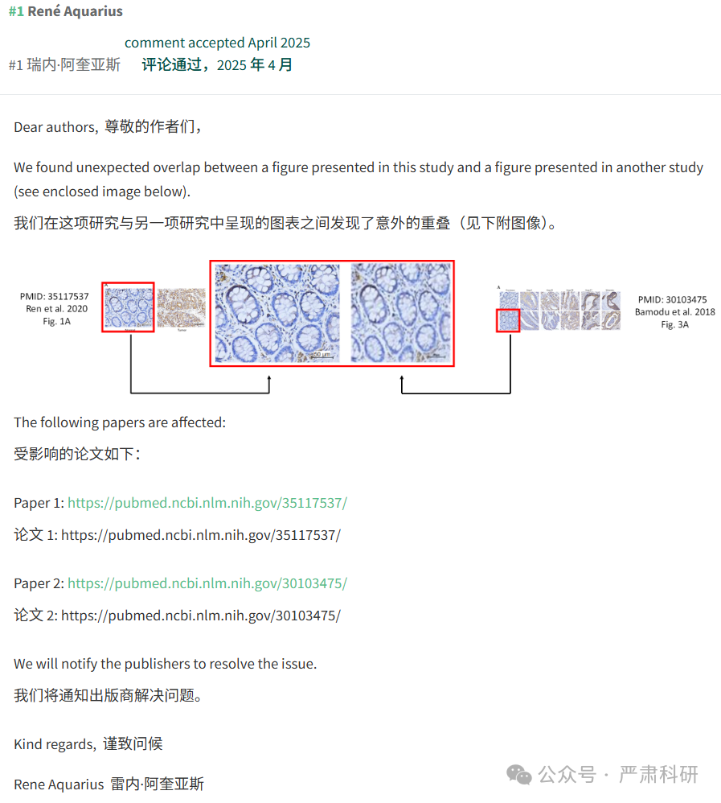

**参考信息  
https://tcr.amegroups.org/article/view/37546/html**

**https://pubpeer.com/publications/DF40EE52780D7AE7C3D55C92D7CA1A#0**

**本平台对于科研问题的探讨，始终保持严谨、深入、持续、开放和创新的态度。**

**所有推文信源，均来源于pubpeer、For Better Science等网站公开质疑。**

**我们从来没有、也永远不会主动查重论文并去pubpeer上质疑。**

**我们尊重他人的研究成果和贡献，通过交流和合作，共同推动科研领域的进步和**

**发展。**