[川北医学院附属医院骨科吴俊学团队论文 翻车，多图被指与多篇文献重合](https://mp.weixin.qq.com/s?__biz=Mzk3NTEwMTE3OA==&mid=2247486536&idx=1&sn=489bb828c8b420869a8faa6c53c23b55)

[学术荟萃](javascript:void(0);)2025-05-01 00:00:05山东

**Part.1**



**论文简介**

**标题：MiR-511 mimic transfection inhibits the proliferation, invasion of osteosarcoma cells and reduces metastatic osteosarcoma tumor burden in nude mice via targeting MAPK1**

**日期：**2020年4月16日

**单位与作者**：川北医学院附属医院骨科 Lu Chen、Junxue Wu(通讯作者 音译 吴俊学)

**期刊：*Cancer biomarkers***

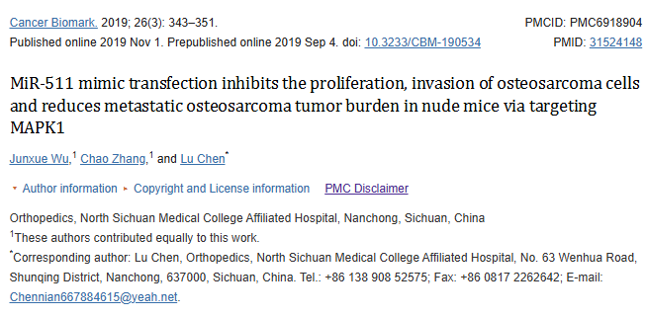

**Part.2**



**图像重复问题**

**#1 图4A与另外四篇论文出现重复。**

Clockwise from upper left:

* Fig 4A from "Long non-coding RNA LSINCT5 inactivates Wnt/β-catenin pathway to regulate MCF-7 cell proliferation and motility through targeting the miR-30a" (Zhang & Song 2020).
* Fig 2F from "Long noncoding RNA LINC00460 conduces to tumor growth and metastasis of hepatocellular carcinoma through miR-342-3p-dependent AGR2 up-regulation" (Hong et al 2020).
* Fig 4A.
* Fig 3A from "Ligustrazine inhibits the viability and motility of colon cancer cells" (Chen et al 2020).

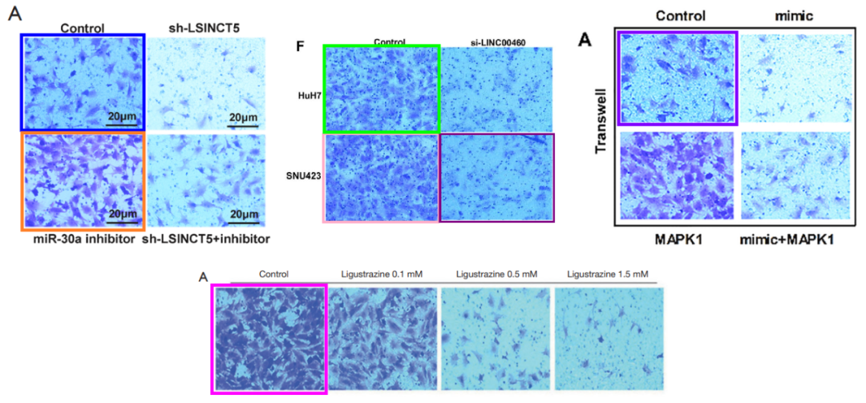

For comparison with Fig 6A-D from "GANT61 plays antitumor effects by inducing oxidative stress through the miRNA‐1286/RAB31 axis in osteosarcoma" (Zhang & Chu 2020).

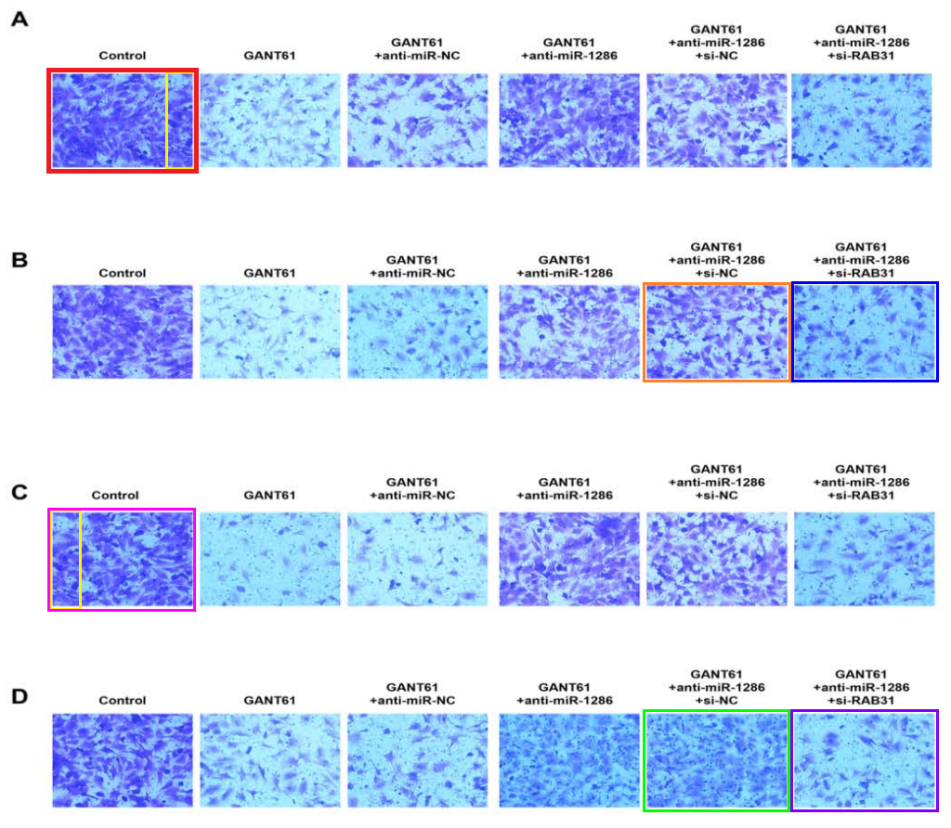

**#2  图5B与Zhang et al 2020的4D出现重复。**

[left] Fig 5B.

[right] Fig 4D from "MIER3 suppresses the progression of non-small cell lung cancer by inhibiting Wnt/β-Catenin pathway and histone acetyltransferase activity" (Zhang et al 2020).

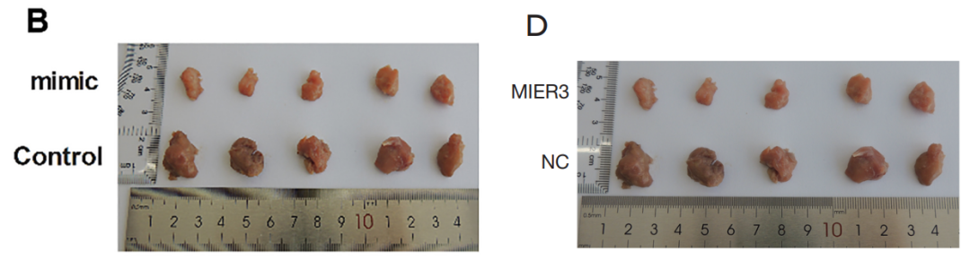

**#3  图4D与Li et al 2020的4B、Zhang et al 2020的2B出现重复。**

Left to right:

* Fig 4D.
* Fig 4B from "MiR-181c-5p Mitigates Tumorigenesis in Cervical Squamous Cell Carcinoma via Targeting Glycogen Synthase Kinase 3β Interaction Protein (GSKIP)" (Li et al 2020).
* Fig 2B from "miR-326 inhibits the cell proliferation and cancer stem cell-like property of cervical cancer in vitro and oncogenesis in vivo via targeting TCF4" (Zhang et al 2020).

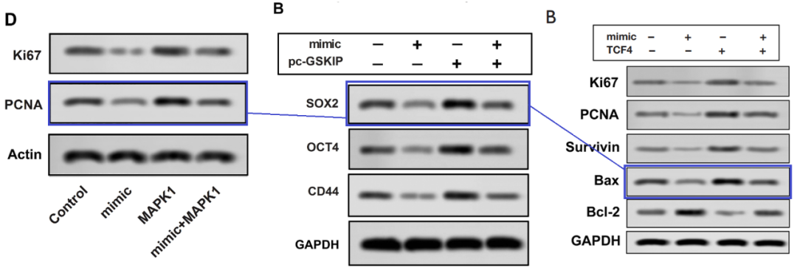

**参考信息：**

https://pubpeer.com/publications/3C4F09F1E98EFD20E8B9F08516C249#3

https://pubmed.ncbi.nlm.nih.gov/31524148/