[多幅图像重复自先前论文，吉林大学中日联谊医院韩涛的论文被撤稿](https://mp.weixin.qq.com/s?__biz=MzkwMjY4ODQ5Mw==&mid=2247496883&idx=4&sn=b34d853fd4e4f7d913cfcb81a33dd007)

R2[Reviewer 2](javascript:void(0);)2025-03-28 14:17:53浙江



点击蓝字关注我们



**论文信息**

2017年10月4日，吉林大学中日联谊医院的Youmao Tao（第一作者） & Tao Han（通讯作者 音译 韩涛）在Oncotarget期刊上在线发表题为"MicroRNA-216a inhibits the metastasis of gastric cancer cells by targeting JAK2/STAT3-mediated EMT process"(MicroRNA-216a 通过靶向 JAK2/STAT3 介导的 EMT 过程抑制胃癌细胞的转移)论文。

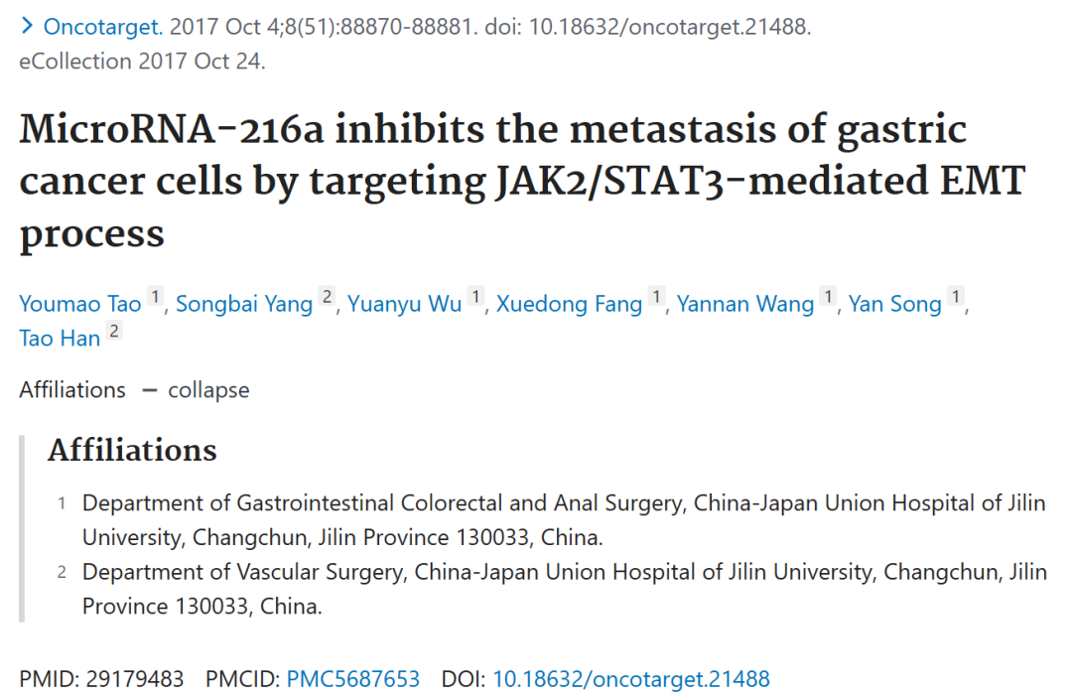





**质疑信息**

* **图2B,E与其他论文多处图像面板重复。**

Unexpected similarities among scratch-assay migration images from three papers:[above] Fig 5a from "EZH2-mediated epigenetic suppression of long noncoding RNA SPRY4-IT1 promote s NSCLC cell proliferation and metastasis by affecting the epithelial–mesenchymal transition" (Sun et al 2014a).[middle] Fig 4A/B from "Downregulation of BRAF activated non-coding RNA is associated with poor prognosis for non-small cell lung cancer and promotes metastasis by affecting epithelial-mesenchymal transition" (Sun et al 2014b).[lower] Fig 2B,E.

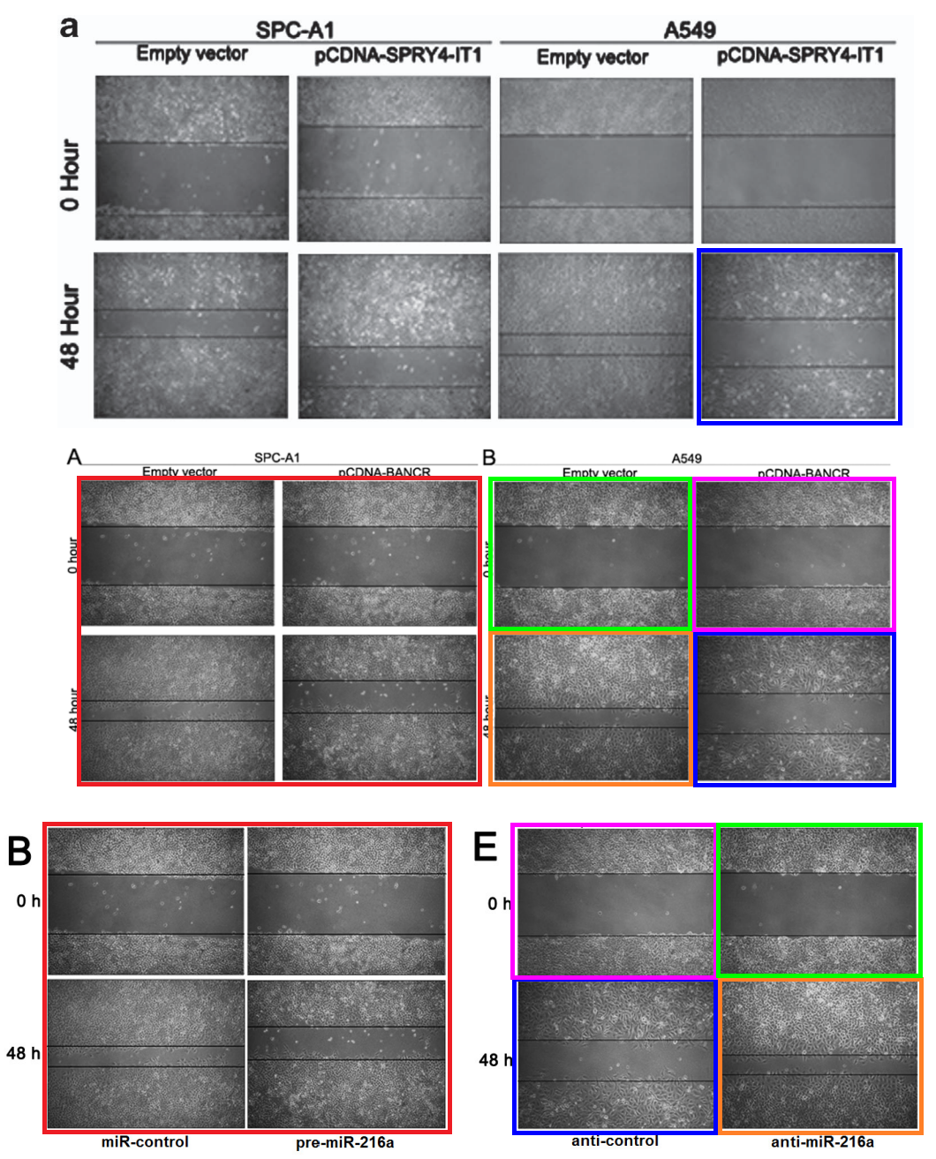

* **图2C,F与其他论文图像重复。**

[above] Fig 2C/F.

[below] Figs 2C, 3C from "miR-944 inhibits metastasis of gastric cancer by preventing the epithelial-mesenchymal transition via MACC1/Met/AKT signaling" (Pan et al 2017).

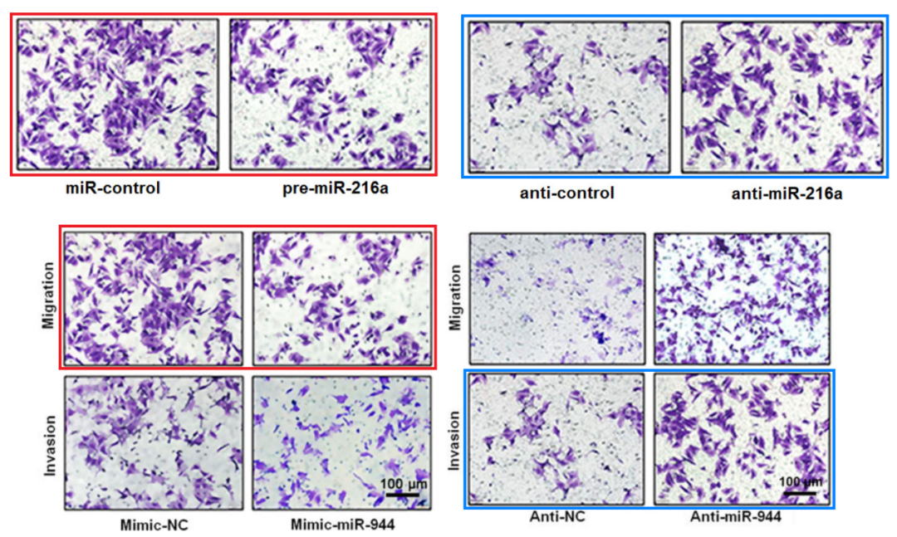

* **图7C与其他论文图像面板重复。**

[left] Fig 7C.

[right] Fig 3D from Pan et al (2017).

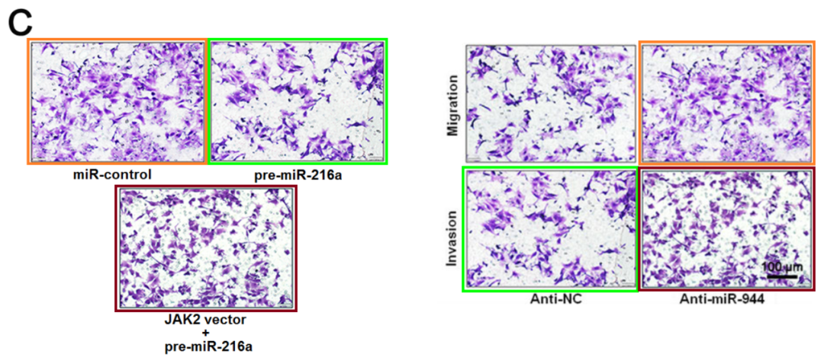

* **图7B与其他论文图像面板重复。**

[left] Fig 7B.

[right] Fig 4E from "SUMOylation of Grb2 enhances the ERK activity by increasing its binding with Sos1" (Qu et al 2014).

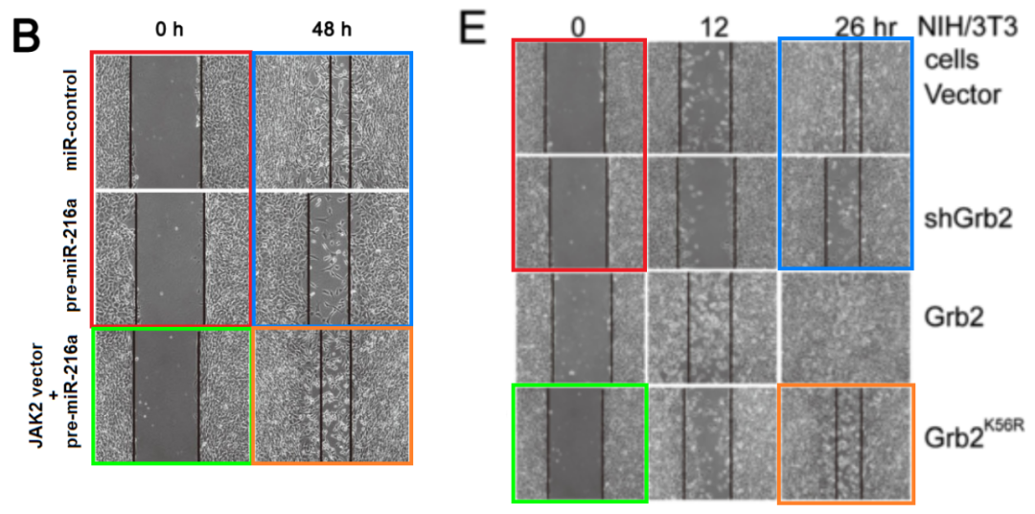

* **图6与其他论文的WB印迹重复。**

[left] Fig 6.[right] Fig 8 from "microRNA-526b servers as a prognostic factor and exhibits tumor suppressive property by targeting Sirtuin 7 in hepatocellular carcinoma" (Liu et al 2017).

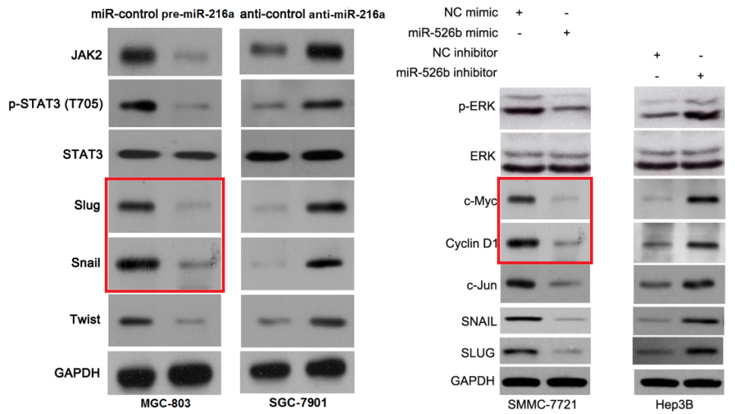

[left] Figs 9A,C from "LncRNA CHRF-induced miR-489 loss promotes metastasis of colorectal cancer via TWIST1/EMT signaling pathway" (Tao et al 2017).

[right] Fig 6 again.

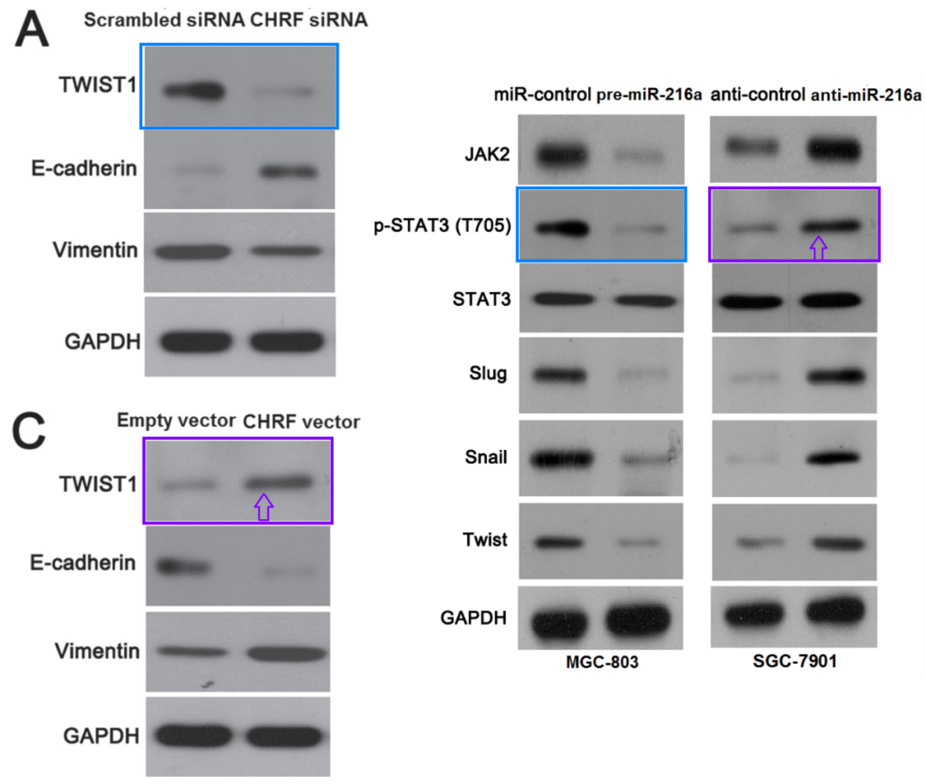

* **图5C与其他论文WB印迹重复。**

[left] Fig 6a from "MicroRNA-27b exerts an oncogenic function by targeting Fbxw7 in human hepatocellular carcinoma" (Sun et al 2016).

[right] Fig 5C.

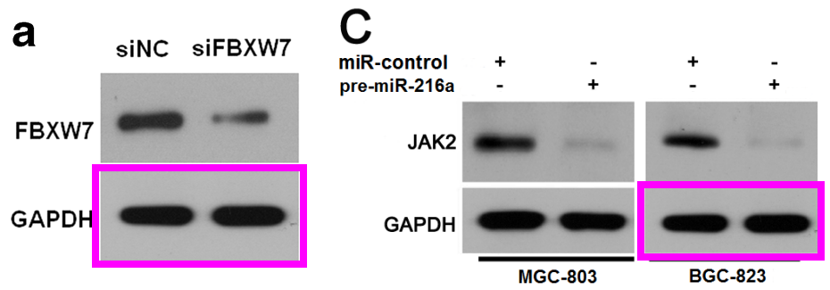

* **图7A与其他论文的WB印迹重复。**

[left] Fig 6B/D from "Acylglycerol kinase promotes cell proliferation and tumorigenicity in breast cancer via suppression of the FOXO1 transcription factor" (Wang et al 2014).

[right] Fig 7A.

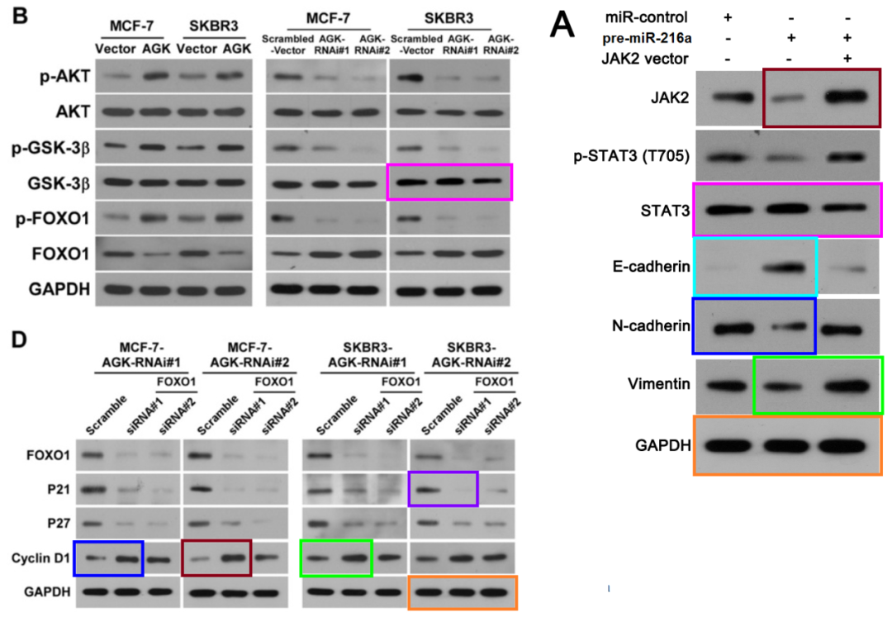

* **图7B，8B与其他论文图像面板重复。**

[left] Figs 2B/E, 6B from "MicroRNA-448 suppresses metastasis of pancreatic ductal adenocarcinoma through targeting JAK1/STAT3 pathway" (Yu et al 2017)[middle] Figs 7B, 8B.

[right] Fig 4E/F from "SUMOylation of Grb2 enhances the ERK activity by increasing its binding with Sos1" (Qu et al 2014).

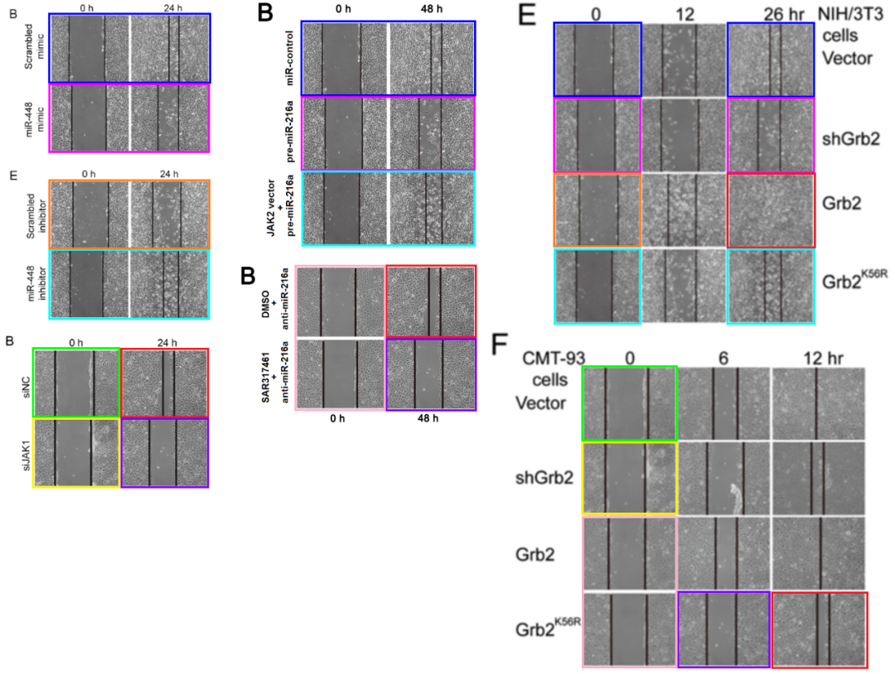



**撤稿原因**

**本文已于2025年3月10日被撤回：**Oncotarget已完成对该论文的调查，并证实该论文中的多幅图像是从先前发表的论文中重复使用的。特别是，图2（B和E面板）以及图7B和图8B中的伤口愈合试验图像是四个不同早期论文[1-4]中伤口愈合试验图像的重复。图2的C和F面板以及图7C和图8C中的Transwell迁移试验图像被发现是另一篇已被撤回的早期文章[5]中Transwell迁移试验图像的重复。图4A、5C、6和7A重复使用了多篇不相关论文[6-8]中的大量蛋白质印迹图像，其中一篇论文也已被撤回[8]。图6还重复使用了图5C中的蛋白质印迹图像以及同一实验室早期论文中的图像[9]。我们尝试联系作者以获取有关这些重复图像的更多信息，但作者未予回应。因此，编辑部决定撤回该论文。

涉及文章：

1. Sun M, Liu XH, Lu KH, Nie FQ, Xia R, Kong R, Yang JS, Xu TP, Liu YW, Zou YF, Lu BB, Yin R, Zhang EB, et al. EZH2-mediated epigenetic suppression of long noncoding RNA SPRY4-IT1 promotes NSCLC cell proliferation and metastasis by affecting the epithelial-mesenchymal transition. Cell Death Dis. 2014; 5:e1298. https://doi.org/10.1038/cddis.2014.256.

2. Sun M, Liu XH, Wang KM, Nie FQ, Kong R, Yang JS, Xia R, Xu TP, Jin FY, Liu ZJ, Chen JF, Zhang EB, De W, Wang ZX. Downregulation of BRAF activated non-coding RNA is associated with poor prognosis for non-small cell lung cancer and promotes metastasis by affecting epithelial-mesenchymal transition. Mol Cancer. 2014; 13:68. https://doi.org/10.1186/1476-4598-13-68.

3. Qu Y, Chen Q, Lai X, Zhu C, Chen C, Zhao X, Deng R, Xu M, Yuan H, Wang Y, Yu J, Huang J. SUMOylation of Grb2 enhances the ERK activity by increasing its binding with Sos1. Mol Cancer. 2014; 13:95. https://doi.org/10.1186/1476-4598-13-95.

4. Yu DL, Zhang T, Wu K, Li Y, Wang J, Chen J, Li XQ, Peng XG, Wang JN, Tan LG. MicroRNA-448 suppresses metastasis of pancreatic ductal adenocarcinoma through targeting JAK1/STAT3 pathway. Oncol Rep. 2017; 38:1075–82. https://doi.org/10.3892/or.2017.5781. [PubMed]. Retraction in: Oncol Rep. 2022; 48:209. https://doi.org/10.3892/or.2022.8424.

5. Pan T, Chen W, Yuan X, Shen J, Qin C, Wang L. miR-944 inhibits metastasis of gastric cancer by preventing the epithelial-mesenchymal transition via MACC1/Met/AKT signaling. FEBS Open Bio. 2017; 7:905–14. https://doi.org/10.1002/2211-5463.12215. [PubMed]. Retraction in: FEBS Open Bio. 2022; 12:2260. https://doi.org/10.1002/2211-5463.13512.

6. Sun XF, Sun JP, Hou HT, Li K, Liu X, Ge QX. MicroRNA-27b exerts an oncogenic function by targeting Fbxw7 in human hepatocellular carcinoma. Tumour Biol. 2016; 37:15325–32. https://doi.org/10.1007/s13277-016-5444-9.

7. Liu X, Yang L, Tu J, Cai W, Zhang M, Shou Z, Yao Y, Xu Q. microRNA-526b serves as a prognostic factor and exhibits tumor suppressive property by targeting Sirtuin 7 in hepatocellular carcinoma. Oncotarget. 2017; 8:87737–49. https://doi.org/10.18632/oncotarget.21209.

8. Wang X, Lin C, Zhao X, Liu A, Zhu J, Li X, Song L. Acylglycerol kinase promotes cell proliferation and tumorigenicity in breast cancer via suppression of the FOXO1 transcription factor. Mol Cancer. 2014; 13:106. https://doi.org/10.1186/1476-4598-13-106.

9. Tao Y, Han T, Zhang T, Ma C, Sun C. LncRNA CHRF-induced miR-489 loss promotes metastasis of colorectal cancer via TWIST1/EMT signaling pathway. Oncotarget. 2017; 8:36410–22. https://doi.org/10.18632/oncotarget.16850.



**参考信息**

https://pubpeer.com/publications/32B611AC1BD530A362C0E798B303B7

https://pubmed.ncbi.nlm.nih.gov/29179483/

https://www.oncotarget.com/article/28702/