[图片重复多人，吉林大学白求恩第一、第三医院学者论文被撤回](https://mp.weixin.qq.com/s?__biz=Mzk1Nzk5NzI3Mw==&mid=2247484809&idx=3&sn=e7e261bb406bc1d8463245b598124780)

原创观观[图片观察](javascript:void(0);)2025-04-23 20:56:18广东

这篇2020年发表的Human Cell期刊，主要由Qingmin Chen , Peiqiang Jiang , Baoxing Jia , Yahui Liu  , Ze Zhang共同完成，2021年-2023年被多次质疑，包括图片重复，旋转重复，与多人图片重复等问题，昨天这篇论文被撤回

**论文信息**

标题：RCC2 contributes to tumor invasion and chemoresistance to cisplatin in hepatocellular carcinoma

作者：Qingmin Chen, Peiqiang Jiang, Baoxing Jia, Yahui Liu, Ze Zhang

期刊：Hum Cell

发表日期：2020年7月

DOI：10.1007/s13577-020-00353-7

PubMed ID：32239438

单位：吉林大学第一医院普外科、 吉林大学中日联谊医院(白求恩第三医院)

**质疑内容**

**#1** Elisabeth M Bik comment accepted January 2021

Figure 3C.

Red boxes: Two panels appear to show an overlap, with a rotation.

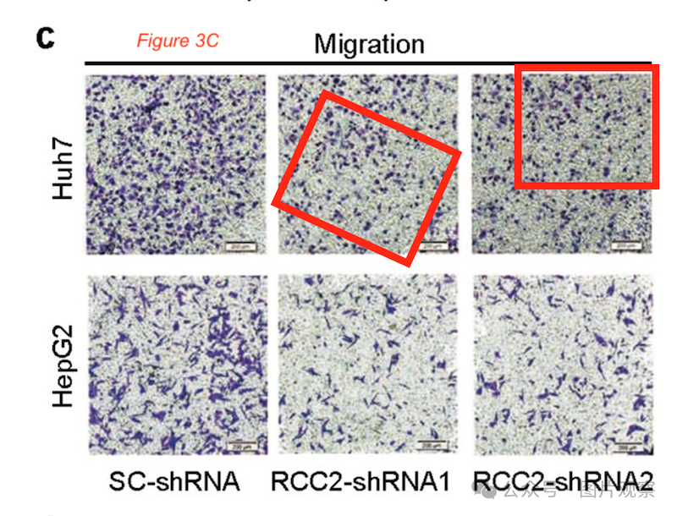

**#2** Elisabeth M Bik comment accepted January 2021

Figure 1B: the Western blots here look very similar to those in Figure 1B of another paper by the same group. They might be representing the same patient samples, but the top panel is representing a different protein.

Left: Qingmin Chen et al., BioMed Research International (2020), DOI: 10.1155/2020/3098327

Right: Qingmin Chen et al., Human Cell (2020), DOI: 10.1007/s13577-020-00353-7

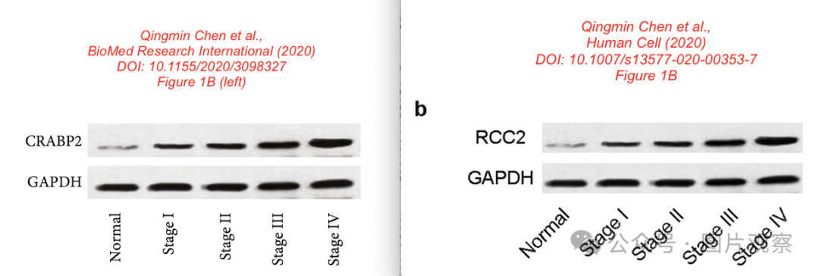

**#3** Yahui Liu comment accepted January 2021

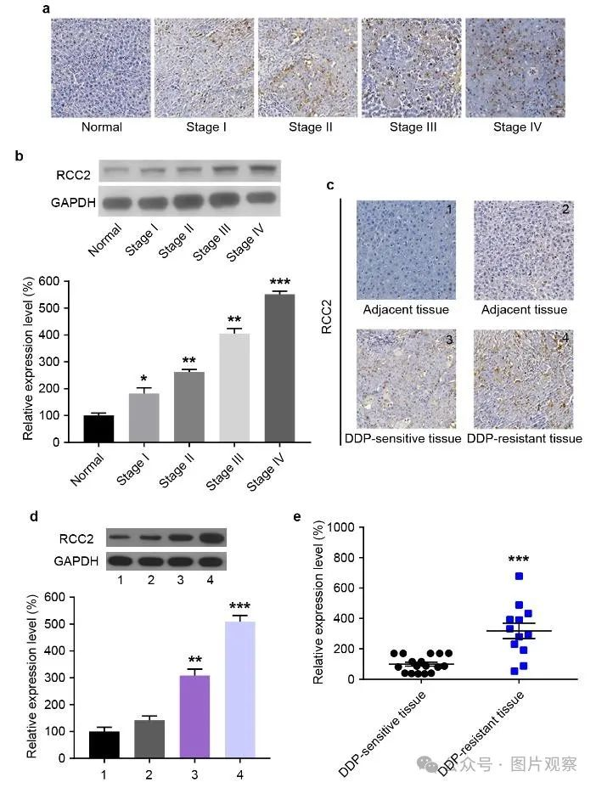

Corrected 4 years ago

**#4** Elisabeth M Bik comment accepted June 2022

Correction, February 2021: https://link.springer.com/article/10.1007/s13577-020-00480-1

"In the original publication of the article, Fig. 1 and Fig. 3 were published with errors. The correct Fig. 1 and 3 are given in this correction."

**#5** Hoya camphorifolia comment accepted December 2023

Left to right:

Fig 4F from "In Vitro and In Vivo Prostate Cancer Metastasis and Chemoresistance Can Be Modulated by Expression of either CD44 or CD147" (Hao et al 2012); and Fig 1D from "Yi-qi-yang-yin-tian-sui-fang enhances cisplatin-induced tumor eradication and inhibits interleukin-7 reduction in non-small cell lung cancer" (Ke et al 2019).

Fig 7C from "Coronin 3 Promotes the Development of Oncogenic Properties in Glioma Through the Wnt/β-Catenin Signaling Pathway" (Wang et al 2020).

Fig 5C.

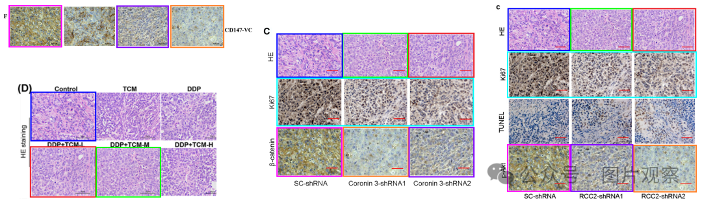

**#6** Hoya camphorifolia comment accepted December 2023

Figs 1A,C.

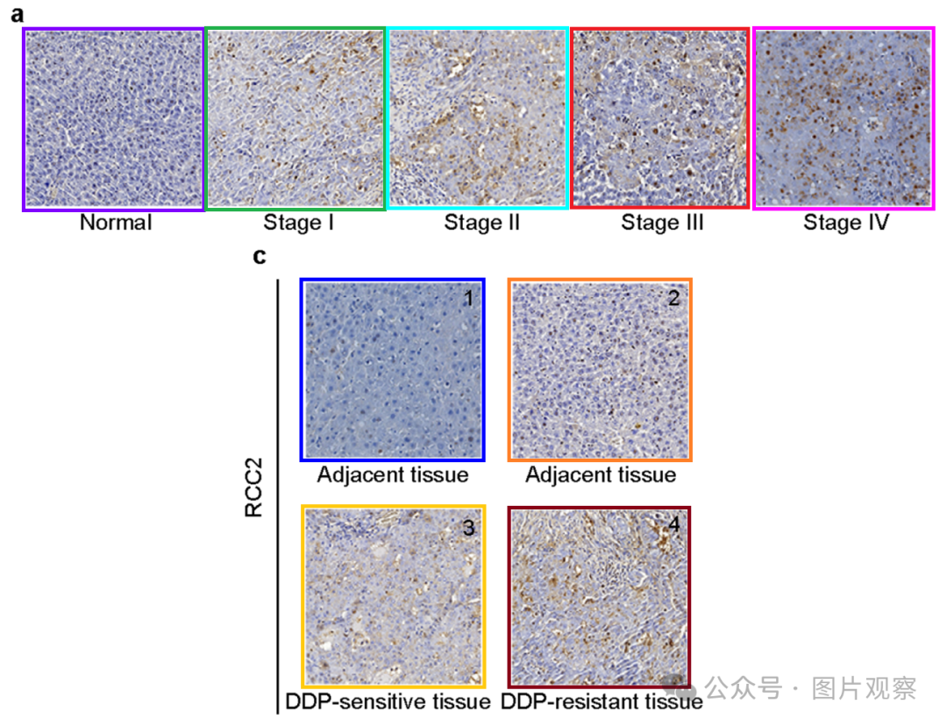

The panels all appeared previously in Fig 3a from "miR-203 inhibits augmented proliferation and metastasis of hepatocellular carcinoma residual in the promoted regenerating liver" (Zheng et al 2017).

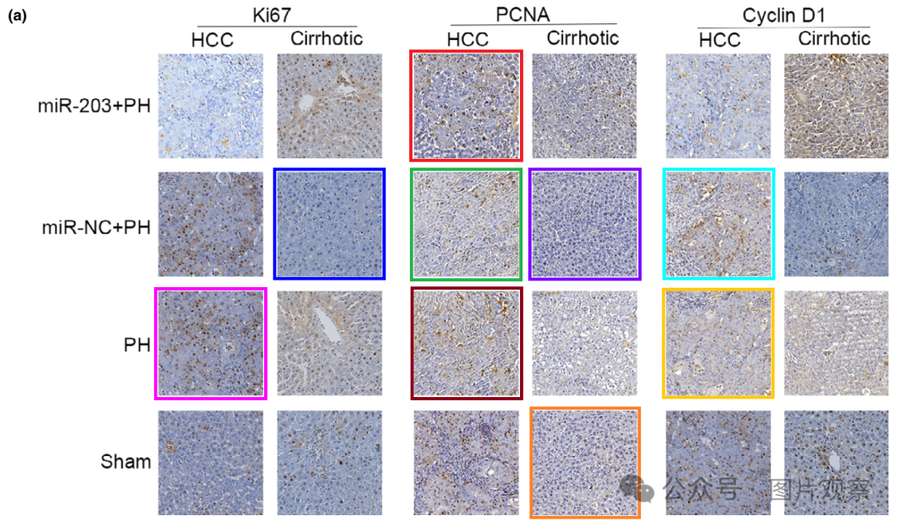

**#7** Hoya camphorifolia comment accepted December 2023

[left] Fig 5b. The source appears to be [right] Fig 6B from "Different Triple-Negative Breast Cancer Tumor Cell Lysates (TCLs) Induce Discrepant Anti-Tumor Immunity by PD1/PDL-1 Interaction" (Dong et al 2019).

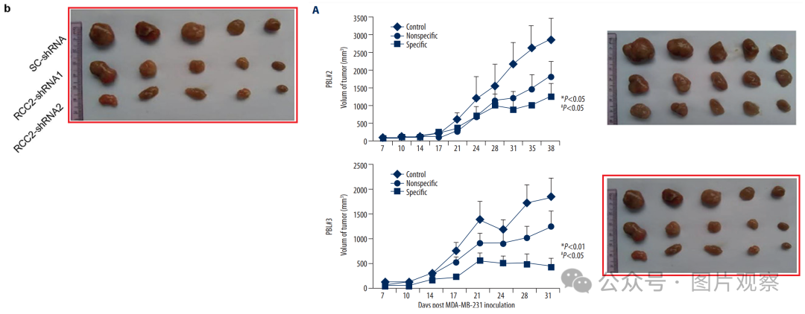

**#8** Hoya camphorifolia comment accepted December 2023

#3 "As for the “Figure 3C”, it is due to our negligent picture selection."

Indeed.

[left] Fig 3.

[right] Fig 2a, Figs 2c and 5c, Fig 3b,c,e, and 5d from "CDP138 silencing inhibits TGF-β/Smad signaling to impair radioresistance and metastasis via GDF15 in lung cancer" (Lu et al 2017).

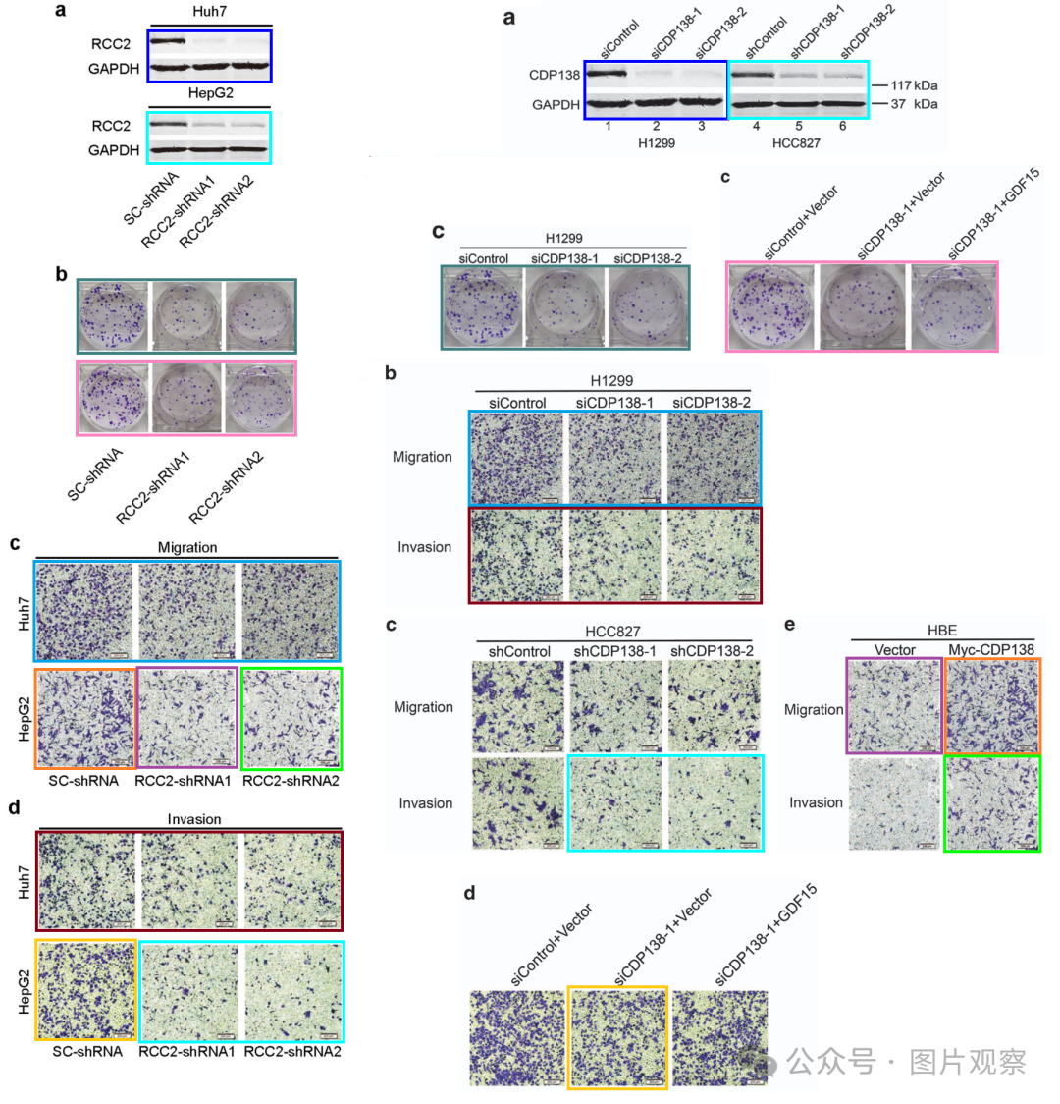

**#9** Hoya camphorifolia comment accepted December 2023

#5 Do-over!

Left to right:

Fig 1D from "Yi-qi-yang-yin-tian-sui-fang enhances cisplatin-induced tumor eradication and inhibits interleukin-7 reduction in non-small cell lung cancer" (Ke et al 2019); Fig 8d from "miR-145 sensitizes esophageal squamous cell carcinoma to cisplatin through directly inhibiting PI3K/AKT signaling pathway" (Zheng et al 2019); and Fig 4F from "In Vitro and In Vivo Prostate Cancer Metastasis and Chemoresistance Can Be Modulated by Expression of either CD44 or CD147" (Hao et al 2012).

Fig 7C from "Coronin 3 Promotes the Development of Oncogenic Properties in Glioma Through the Wnt/β-Catenin Signaling Pathway" (Wang et al 2020).

Fig 5C.

**撤回**

Retraction Note: Human Cell (2020) 33:709–720 https://doi.org/10.1007/s13577-020-00353-7

主编已撤回本文。发布后提出了一些担忧。发现图 3 与另一出版物的图 2 和图 3 重叠 [1]。发现图 5C 与 [2] 中的图 1D 和图 4F 以及 8D 重叠来自 [3]，两者都是之前发表的，以及同时考虑的一篇文章的图 7C [4]。图 4B 和 C 与早期文章的图 6E 和 F 重叠 [5]。

作者尚未回复出版商关于此次撤回的信件。



**END**



**#**

**扫码关注我们**



Don't be ashamed



专注于国内论文质疑报道

**欢迎投稿联系**