[辽宁省人民医院Oncology Letters被质疑](https://mp.weixin.qq.com/s?__biz=MzUxODcwODMzMw==&mid=2247484096&idx=1&sn=dc4797e633352b28acae241f4344e453)

原创一只鱼[严肃科研](javascript:void(0);)2025-04-22 21:09:29四川

**“**秉持严谨、深入、持续、开放与创新的态度，尊重他人成果，携手交流共进，推动科研发展。**”**

**Research Frontline**

**科研前线**

01

—

**问题论文**

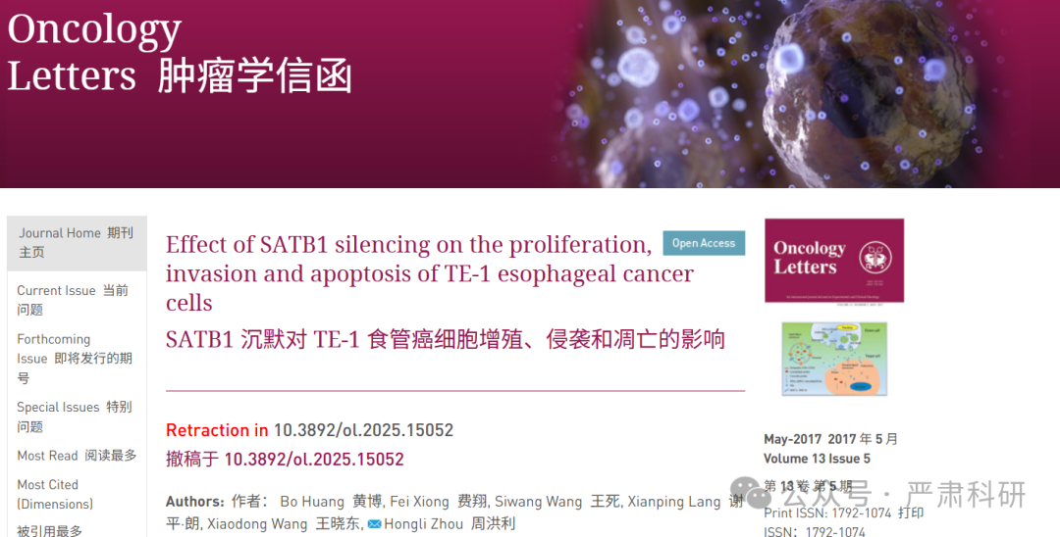

**标题：**Effect of SATB1 silencing on the proliferation, invasion and apoptosis of TE-1 esophageal cancer cells

**期刊：**Oncology Letters

**单位：**辽宁省人民医院

**发表时间：**2017年3月13日

**DOI:**10.3892/ol.2025.15052

**研究摘要：**

The aim of the present study was to investigate the effect of special AT-rich sequence-binding protein-1 (SATB1)-targeted small interfering RNA (siRNA) on the proliferation, invasion and apoptosis of TE?1 human esophageal cancer cells. SATB1 has been correlated with the metastasis and poor prognosis of colon and breast cancer, but the role of SATB1 in esophageal cancer remains unknown. Therefore, the present study constructed and transfected SATB1?siRNA into TE?1 cells in order to knockdown the expression of the SATB1 gene. Western blot analysis, a cell counting kit, transwell chamber assays and flow cytometry were used to assess the effect of SATB1?siRNA on the proliferation, invasion and apoptosis of cells. The results demonstrated that the expression of the SATB1 gene was efficiently knocked down by SATB1?siRNA, and that SATB1-siRNA inhibited the proliferation, invasion and apoptosis of TE?1 cells. Therefore, it was concluded that the SATB1 gene is important in the pathogenesis of human esophageal cancer, and may present a novel therapeutic target for esophageal cancer.  
本研究旨在探讨特殊 AT 富集序列结合蛋白 1（SATB1）靶向小干扰 RNA（siRNA）对 TE-1 人食管癌细胞增殖、侵袭和凋亡的影响。SATB1 与结直肠癌和乳腺癌的转移和不良预后相关，但 SATB1 在食管癌中的作用尚不清楚。因此，本研究构建并转染 SATB1-siRNA 到 TE-1 细胞中，以敲低 SATB1 基因的表达。通过 Western blot 分析、细胞计数试剂盒、Transwell 小室实验和流式细胞术评估 SATB1-siRNA 对细胞增殖、侵袭和凋亡的影响。结果表明，SATB1-siRNA 有效地敲低了 SATB1 基因的表达，并抑制了 TE-1 细胞的增殖、侵袭和凋亡。因此，得出结论，SATB1 基因在人类食管癌的发生发展中起着重要作用，可能成为食管癌治疗的新靶点。

02

—

**具体说明**

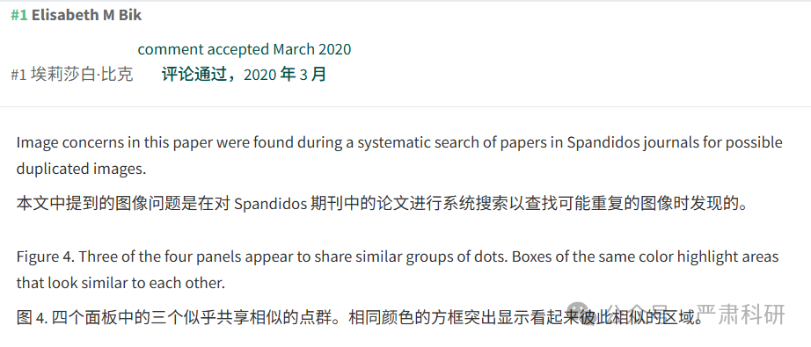

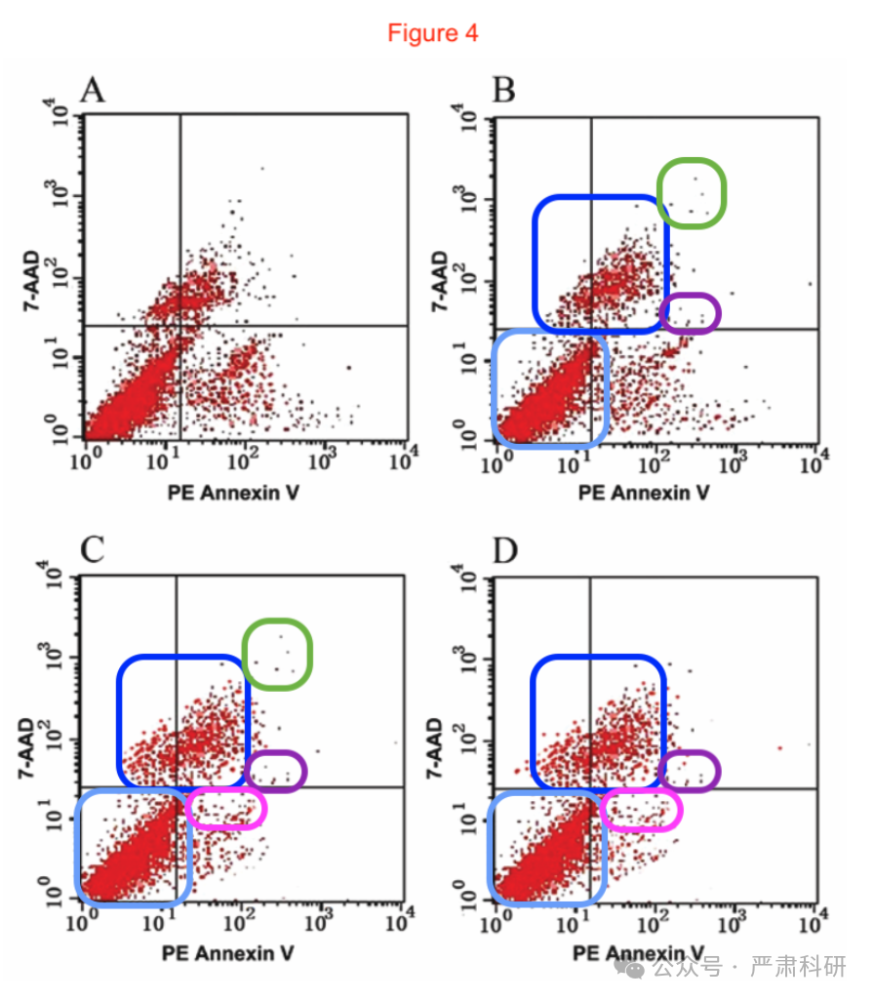

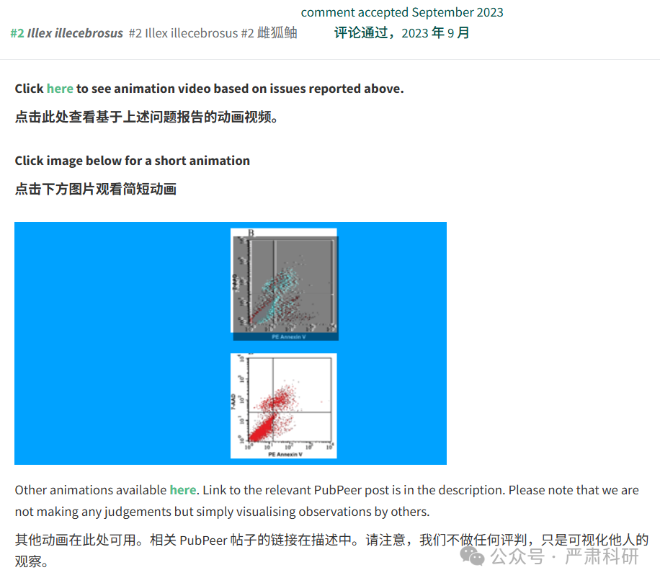

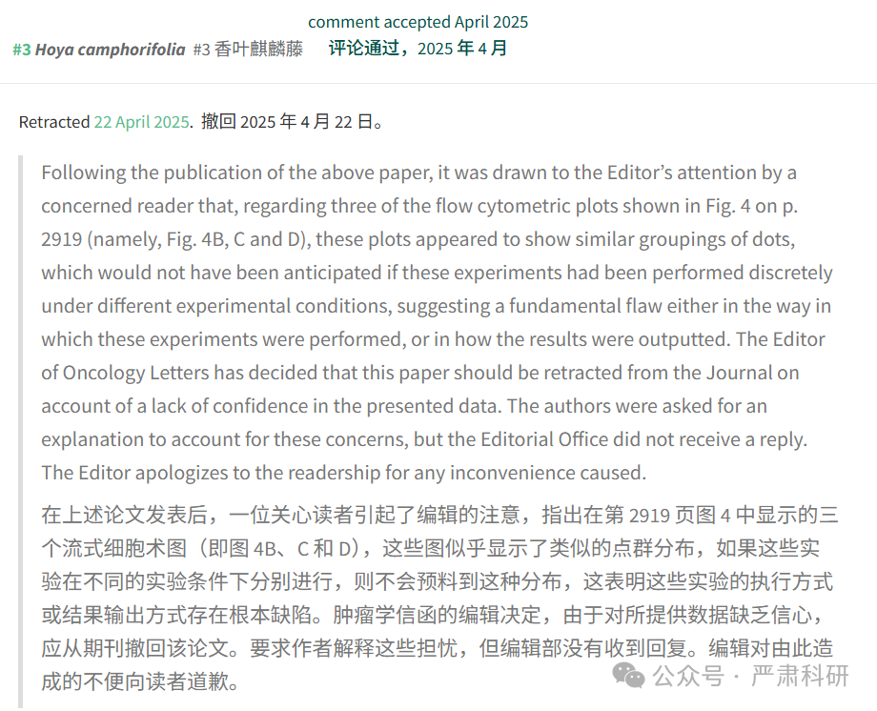

**参考信息  
https://www.spandidos-publications.com/10.3892/ol.2017.5854**

**https://pubpeer.com/publications/172748053CC002158E4AB6DE3CFB00#0**

本平台对于科研问题的探讨，始终保持严谨、深入、持续、开放和创新的态度。所有推文信源，均来源于pubpeer、For Better Science等网站公开质疑。我们从来没有、也永远不会主动查重论文并去pubpeer上质疑。我们尊重他人的研究成果和贡献，通过交流和合作，共同推动科研领域的进步和发展。