[中山大学附属一院Circulation Research被质疑](https://mp.weixin.qq.com/s?__biz=MzUxODcwODMzMw==&mid=2247484081&idx=1&sn=e24d2f0a3ddc53d54de2791efb6df36c)

原创一只鱼[严肃科研](javascript:void(0);)2025-04-20 18:19:01四川

**“**秉持严谨、深入、持续、开放与创新的态度，尊重他人成果，携手交流共进，推动科研发展。**”**

**Research Frontline**

**科研前线**

01

—

**问题论文**

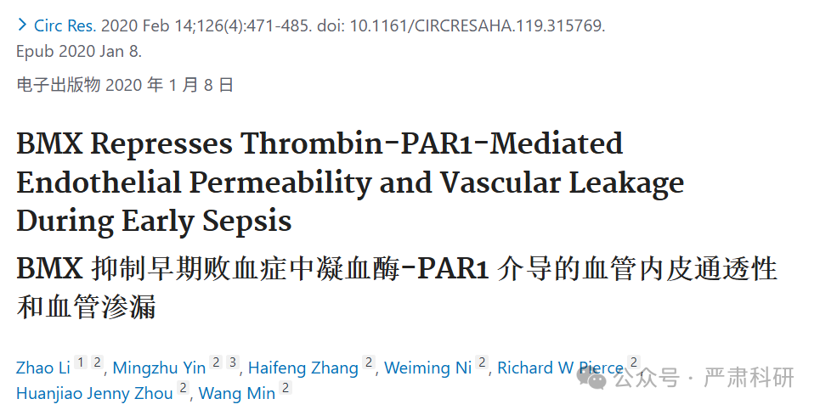

**标题：**BMX Represses Thrombin-PAR1-Mediated Endothelial Permeability and Vascular Leakage During Early Sepsis

**期刊：**Circulation Research

**单位：**中山大学附属第一医院

**发表时间：**2020年1月8日

**DOI:**10.1161/circresaha.119.315769

**研究摘要：**

**Rationale:**BMX (bone marrow kinase on the X chromosome) is highly expressed in the arterial endothelium from the embryonic stage to the adult stage in mice. It is also expressed in microvessels and the lymphatics in response to pathological stimuli. However, its role in endothelial permeability and sepsis remains unknown.  
原因：BMX（X 染色体上的骨髓激酶）在从胚胎期到成年期的小鼠动脉内皮细胞中高度表达。它还可在微血管和淋巴管中响应病理刺激而表达。然而，其在内皮细胞通透性和败血症中的作用尚不清楚。

**Objective:**We aimed to delineate the function of BMX in thrombin-mediated endothelial permeability and the vascular leakage that occurs with sepsis in cecal ligation and puncture models.  
目标：本研究旨在阐明 BMX 在凝血酶介导的内皮通透性和结扎穿孔模型中伴随败血症发生的血管渗漏中的作用。

**Methods and results:**The cecal ligation and puncture model was applied to WT (wild type) and BMX-KO (BMX global knockout) mice to induce sepsis. Meanwhile, the electric cell-substrate impedance sensing assay was used to detect transendothelial electrical resistance in vitro and, the modified Miles assay was used to evaluate vascular leakage in vivo. We showed that BMX loss caused lung injury and inflammation in early cecal ligation and puncture-induced sepsis. Disruption of BMX increased thrombin-mediated permeability in mice and cultured endothelial cells by 2- to 3-fold. The expression of BMX in macrophages, neutrophils, platelets, and lung epithelial cells was undetectable compared with that in endothelial cells, indicating that endothelium dysfunction, rather than leukocyte and platelet dysfunction, was involved in vascular permeability and sepsis. Mechanistically, biochemical and cellular analyses demonstrated that BMX specifically repressed thrombin-PAR1 (protease-activated receptor-1) signaling in endothelial cells by directly phosphorylating PAR1 and promoting its internalization and deactivation. Importantly, pretreatment with the selective PAR1 antagonist SCH79797 rescued BMX loss-mediated endothelial permeability and pulmonary leakage in early cecal ligation and puncture-induced sepsis.  
方法和结果：将回肠结扎穿孔模型应用于野生型（WT）和 BMX-KO（BMX 全球敲除）小鼠以诱导败血症。同时，使用电细胞-基底阻抗传感法在体外检测跨内皮电阻力，并使用改良的 Miles 法在体内评估血管渗漏。我们发现，BMX 缺失导致早期回肠结扎穿孔诱导的败血症中肺损伤和炎症。BMX 破坏增加了小鼠和培养的血管内皮细胞的凝血酶介导的通透性，增加 2-3 倍。与内皮细胞相比，巨噬细胞、中性粒细胞、血小板和肺上皮细胞中的 BMX 表达不可检测，表明内皮功能障碍，而不是白细胞和血小板功能障碍，参与了血管通透性和败血症。机制上，生化分析和细胞分析表明，BMX 通过直接磷酸化 PAR1（蛋白酶激活受体-1）并促进其内化和失活，特异性地抑制内皮细胞中的凝血酶-PAR1 信号通路。 重要的是，预先使用选择性 PAR1 拮抗剂 SCH79797 挽救了 BMX 缺失介导的早期回肠结扎和穿刺诱导的败血症中内皮通透性和肺漏出。

**Conclusions:**Acting as a negative regulator of PAR1, BMX promotes PAR1 internalization and signal inactivation through PAR1 phosphorylation. Moreover, BMX-mediated PAR1 internalization attenuates endothelial permeability to protect vascular leakage during early sepsis.  
结论：作为 PAR1 的负调节因子，BMX 通过 PAR1 磷酸化促进 PAR1 的内化和信号失活。此外，BMX 介导的 PAR1 内化减轻内皮通透性，以保护早期脓毒症期间的血管渗漏。

02

—

**具体说明**

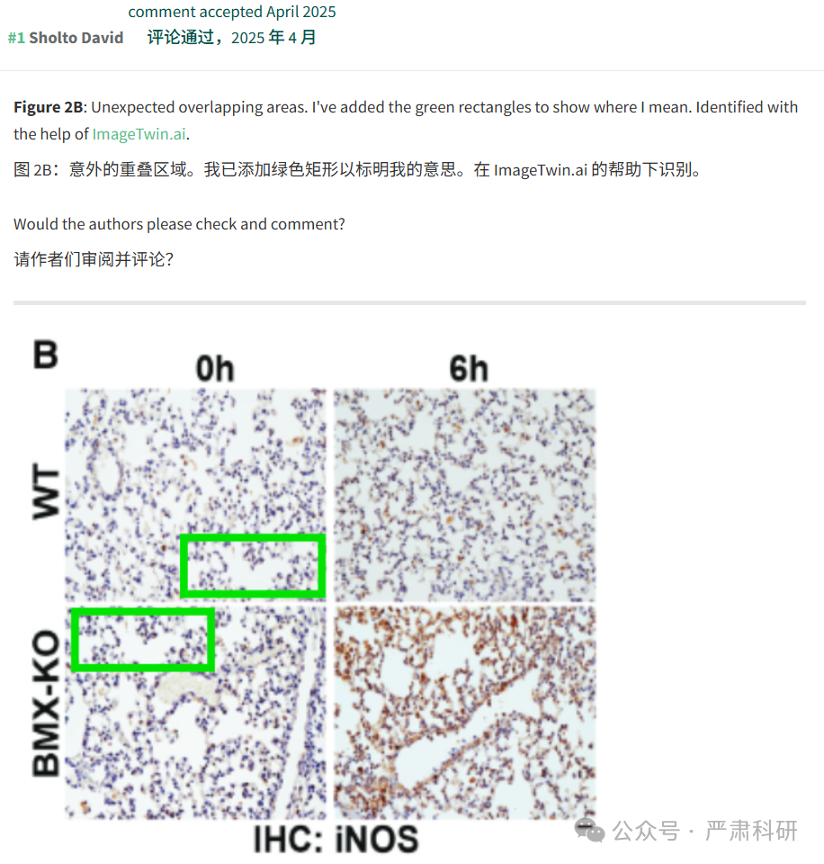

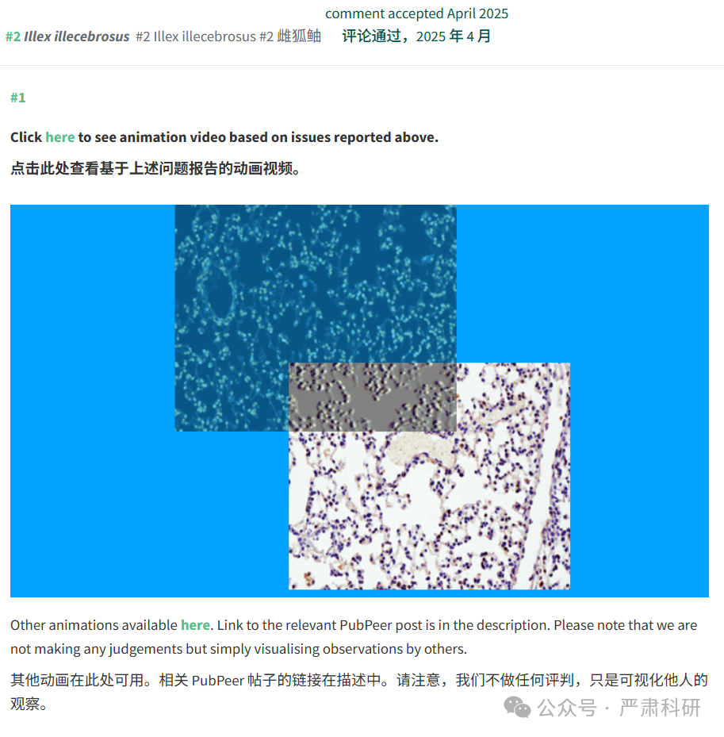

**参考信息  
https://pubmed.ncbi.nlm.nih.gov/31910739/**

**https://pubpeer.com/publications/EEB72952E71D129EF3485A632244BA#0**

本平台对于科研问题的探讨，始终保持严谨、深入、持续、开放和创新的态度。所有推文信源，均来源于pubpeer、For Better Science等网站公开质疑。我们从来没有、也永远不会主动查重论文并去pubpeer上质疑。我们尊重他人的研究成果和贡献，通过交流和合作，共同推动科研领域的进步和发展