[作者与学术侦探展开激烈“交锋”！中国药科大学&杭州市第七人民医院虽然被质疑存在TGR5表达以及图像重复问题，但尚未确认！](https://mp.weixin.qq.com/s?__biz=MzkzNjYxMTEzMA==&mid=2247532355&idx=3&sn=ed273bc1f457d1362c2d8e59492afb88)

DataTwin[DataTwin](javascript:void(0);)2025-04-19 12:21:57浙江

**点击上方蓝字**关注我们







**论文信息**

2024年6月5日，中国药科大学&杭州市第七人民医院在Neuron（中科院一区 IF=14.7）期刊上在线发表题为**"TGR5-mediated lateral hypothalamus-dCA3-dorsolateral septum circuit regulates depressive-like behavior in male mice"**(TGR5 介导的下丘脑外侧-DCA3-背外侧隔回路调节雄性小鼠的抑郁样行为)的论文。

第一作者：中国药科大学 Xu-Yi Li

通讯作者：中国药科大学 Hao Hong(音译 洪浩)， 杭州市第七人民医院 Hao Wang（音译 王浩）， 中国药科大学 Su-Su Tang（音译 唐苏苏）

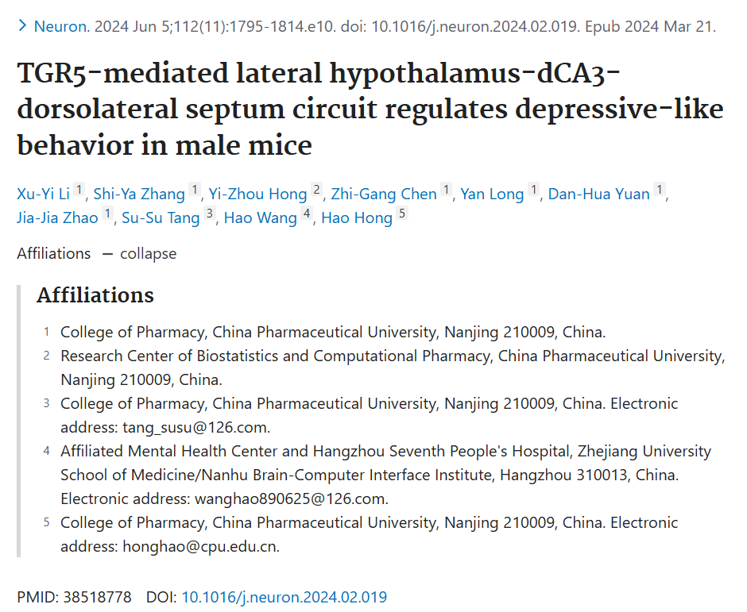

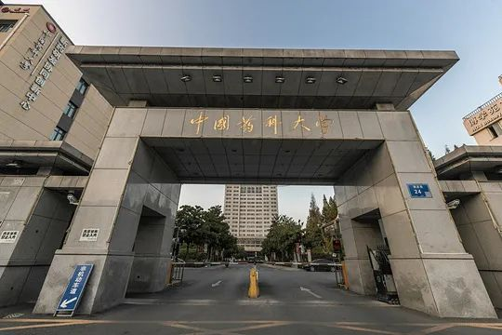





**质疑信息**

**#1**TGR5 is up-regulated in AD models and AD patients, such as in this paper: TGR5 deficiency in excitatory neurons ameliorates Alzheimer's pathology by regulating APP processing（2024）. However, in your research, we find that TGR5 is down-regulated in your models and other papers in this previous studies. **（本文TGR5表达与其他研究中的结果存在矛盾之处）**

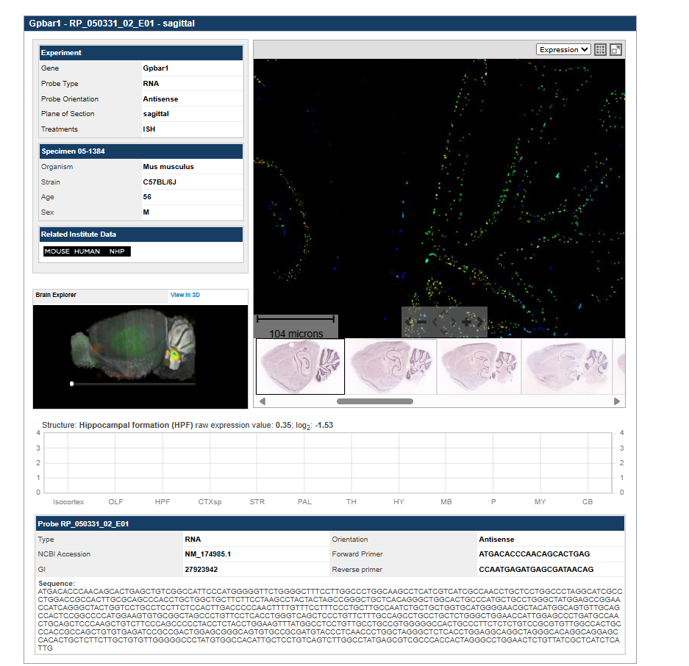

 DataTwin图片查重

Likewise, the GTEXportal shows no expression in the human brain（GTEx门户网站显示人脑中并无该基因表达）:

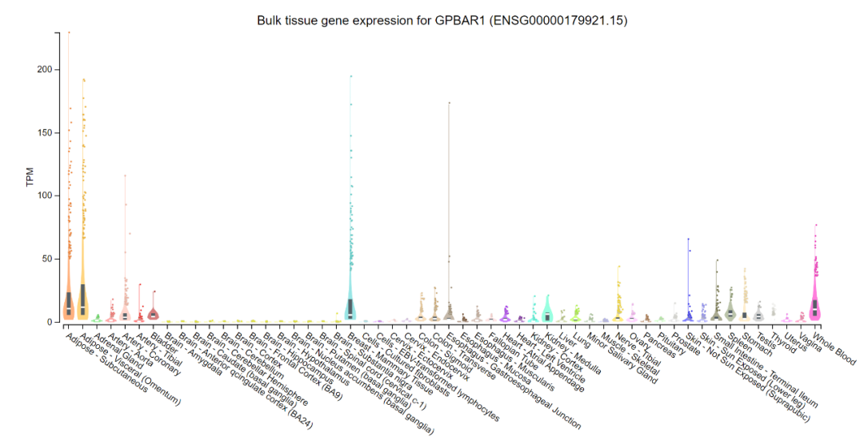

 DataTwin图片查重

**通讯作者洪浩回应：**

某种功能分子在细胞内的表达变化因疾病、疾病发展阶段、脑区、细胞类型等因素而异。由于所使用的模型不同，TGR5表达变化的不同是合理的。已有充分文献支持TGR5在小鼠大脑中的表达，其表达水平受多种因素影响，包括动物状态、实验试剂、抗体质量、样本制备、实验程序及实验者技能。

且人类蛋白质图谱（The Human Protein Atlas）、艾伦脑图谱（Allen Brain Atlas）和GeneCards数据库均显示，TGR5在人类脑组织中存在表达。

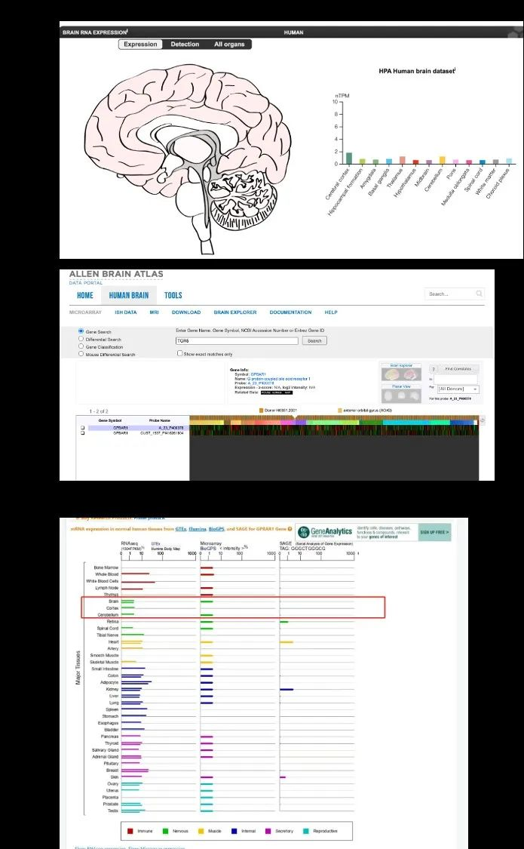

**#2** The author is showing only partial data. The full page is below and seems to indicate extremely levels, presumably "non-specific transcription" as indicated in the last graph. Mice have pretty much zero expression. **(作者仅提供部分数据，完整数据显示TGR5表达水平极低，小鼠中的表达几乎为零。)**



 DataTwin图片查重

**通讯作者洪浩回应：**

首先，感谢您对TGR5的关注。在我们之前的回复中，我们基于您关于TGR5是否在人脑中表达的关切，提供了一个来自人脑数据库的表达结果图。然而，需要指出的是，确定TGR5在人脑中的表达情况需要直接使用人脑样本进行检测。我们的研究并未检测TGR5是否在人脑中表达。

其次，关于您提到TGR5在小鼠大脑中表达稀少的说法，我想澄清的是，这一结论仅基于某些基因组数据库。在脑区检测特定基因的能力取决于多种因素，包括样本质量、检测灵敏度等。公共基因组数据库只能作为参考。至于TGR5是否在小鼠大脑中表达，我之前已经对类似问题给出了详细答复。

此外，近年来，关于TGR5在小鼠大脑中的表达和功能的研究越来越多。在此，我列出了一些其他实验室与中枢TGR5研究相关的文章。

涉及：

1. Castellanos-Jankiewicz, A., Guzmán-Quevedo, O., Fénelon, V.S., et al. Hypothalamic bile acid-TGR5 signaling protects from obesity. Cell Metab 2021, 33 (7), 1483-1492 e1410.

2. Perino, A., Velázquez-Villegas, L.A., Bresciani, N., et al. Central anorexigenic actions of bile acids are mediated by TGR5. Nat Metab 2021, 3 (5), 595-603.

3. Li, C., Wang, L., Xie, W., et al. TGR5 deficiency in excitatory neurons ameliorates Alzheimer's pathology by regulating APP processing. Sci Adv 2024, 10 (26), eado1855.

4. Reddy, I.A., Smith, N.K., Erreger, K., et al. Bile diversion, a bariatric surgery, and bile acid signaling reduce central cocaine reward. PLoS Biol 2018, 16 (7), e2006682.

5. Keitel V, G?rg B, Bidmon HJ, Zemtsova I, Spomer L, Zilles K, H?ussinger D The bile acid receptor TGR5 (Gpbar-1) acts as a neurosteroid receptor in brain. Glia. 2010 Nov 15;58(15):1794-805.

6. Vassileva, G., Golovko, A., Markowitz, L., et al. Targeted deletion of Gpbar1 protects mice from cholesterol gallstone formation. Biochem J 2006, 398 (3), 423-430.

7. Maruyama, T., Tanaka, K., Suzuki, J., et al. Targeted disruption of G protein-coupled bile acid receptor 1 (Gpbar1/M-Bar) in mice. J Endocrinol 2006, 191 (1), 197-205.

8. Doignon, I., Julien, B., Serrière-Lanneau, V., et al. Immediate neuroendocrine signaling after partial hepatectomy through acute portal hyperpressure and cholestasis. J Hepatol 2011, 54 (3), 481-488.

9. McMillin, M., Frampton, G., Tobin, R., et al. TGR5 signaling reduces neuroinflammation during hepatic encephalopathy. J Neurochem 2015, 135 (3), 565-576.

10. Yanguas-Casás, N., Barreda-Manso, M.A., Nieto-Sampedro, M. & Romero-Ramírez, L. TUDCA: An Agonist of the Bile Acid Receptor GPBAR1/TGR5 With Anti-Inflammatory Effects in Microglial Cells. J Cell Physiol 2017, 232 (8), 2231-2245.

11. Huang, R., Gao, Y., Chen, J., et al. TGR5 Agonist INT-777 Alleviates Inflammatory Neurodegeneration in Parkinson's Disease Mouse Model by Modulating Mitochondrial Dynamics in Microglia. Neuroscience 2022, 490, 100-119.

12. Romero-Ramírez L, Mey J.Emerging Roles of Bile Acids and TGR5 in the Central Nervous System: Molecular Functions and Therapeutic Implications. Int J Mol Sci. 2024；27;25(17):9279

13. Zhang, Z., Zhang, Y., Peng, H., et al. Decoding TGR5: A comprehensive review of its impact on cerebral diseases. Pharmacol Res 2025, 213, 107671. 14 Darmanto, A.G., Yen, T.L., Jan, J.S., et al. Beyond metabolic messengers: Bile acids and TGR5 as pharmacotherapeutic intervention for psychiatric disorders. Pharmacol Res 2025, 211, 107564.

14. Romero-Ramírez, L. & Mey, J. Emerging Roles of Bile Acids and TGR5 in the Central Nervous System: Molecular Functions and Therapeutic Implications. Int J Mol Sci 2024,25(17):9279.

15. Li, Y., Gao, Y.N., Zhu, Y.B., et al. Taurocholic acid ameliorates hypertension through the activation of TGR5 in the hypothalamic paraventricular nucleus. Food Funct 2024, 15 (9), 5088-5102.

16. Chen, S., Shao, Q., Chen, J., et al. Bile acid signalling and its role in anxiety disorders. Front Endocrinol (Lausanne) 2023, 14, 1268865.

17. Xu N, He Y, Zhang C, Zhang Y, Cheng S, Deng L, Zhong Y, Liao B, Wei Y, Feng J. TGR5 signalling in heart and brain injuries: focus on metabolic and ischaemic mechanisms. Neurobiol Dis. 2024 ;192:106428.

18. Zhang F, Deng Y, Wang H, Fu J, Wu G, Duan Z, Zhang X, Cai Y, Zhou H, Yin J, He Y. Gut microbiota-mediated ursodeoxycholic acids regulate the inflammation of microglia through TGR5 signaling after MCAO. Brain Behav Immun. 2024 Jan;115:667-679.

19. Zizzari, P., Castellanos-Jankiewicz, A., Yagoub, S., et al. TGR5 receptors in SF1-expressing neurons of the ventromedial hypothalamus regulate glucose homeostasis. Mol Metab 2025, 91, 102071.

无论如何，所有这些研究都与现有的基因组数据库检测结果相矛盾。难道读者在暗示这些文章关于小鼠大脑中TGR5表达的结论是错误的？如果这些研究结果正确，能否解释一下为什么公共基因组数据库无法检测到小鼠大脑中的TGR5？

**#4**Genomic databases also show inconsistencies with respect to brain expression of TGR5.

The reader encourage readers to approach the literature with healthy skepticism for the following reasons:

Reference 2 (Reddy et al.) does not demonstrate endogenous TGR5 expression in the brain; it instead shows virally induced TGR5 in a knockout model.

Reference 6 (Vassileva) provides evidence showing the absence of TGR5 mRNA in the brain.

Antibodies against GPCRs are often nonspecific (as highlighted in PMID: 19172248). Furthermore, antibodies targeting TGR5 have not been adequately validated, so data obtained using these anti-TGR5 antibodies should be interpreted with caution.

Studies employing RT-PCR with 40 cycles, such as reference 8 (Doignon et al.), carry a risk of false positives.**（鼓励读者以怀疑态度看待相关文献。原因包括：参考文献2未证明内源性TGR5表达，而是病毒诱导产生；参考文献6表明大脑中无TGR5 mRNA；针对GPCR的抗体常缺乏特异性，TGR5抗体未充分验证，需谨慎解读相关数据；采用40个循环RT-PCR的研究存在假阳性风险；基因组数据库在TGR5大脑表达方面存在不一致性。）**

**#5**(1) Fig. 3E and Fig. 6H contain identical images, which are used in completely different experiments, and it is hard to explain this as a simple case of image misuse.

(2) Additionally, parts of Fig. 1A and Fig. 1H are highly similar, which is also from completely different experiments.（图3E和图6H包含完全相同的图像，但被用于不同的实验；图1A和图1H的部分内容也高度相似，同样来自不同的实验，这难以用图像误用来解释。）

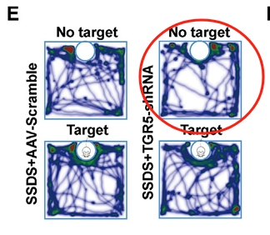

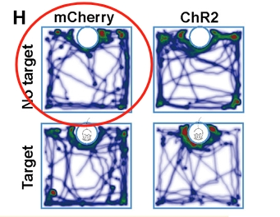

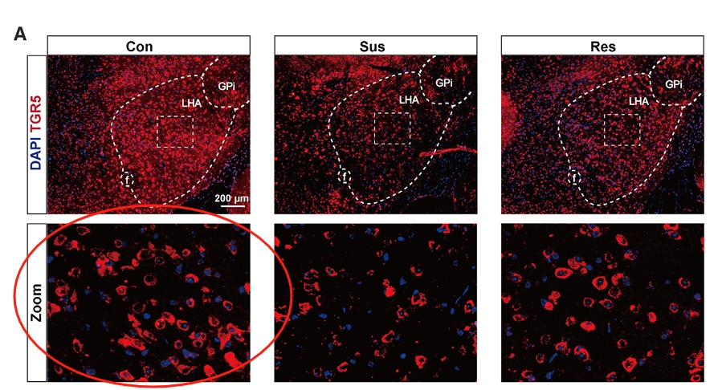

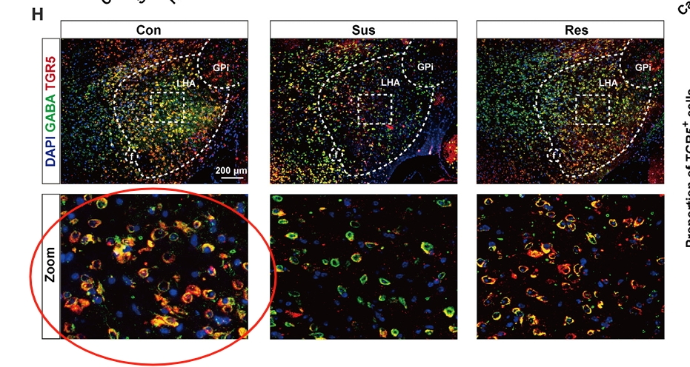

 DataTwin图片查重

**通讯作者洪浩回应：**

由于数据量庞大，我们未能充分核实图像，导致不慎重用了同一张图像。我们对此疏忽深表歉意，并已与编辑联系，将发表更正说明以纠正通路图的错误放置。

此外，关于第二张图中的脑切片观察，我们分析了TGR5在GABA能神经元中的共表达情况。图1A展示了TGR5与DAPI的共染色结果，而图1H则进一步展示了TGR5、GABA和DAPI的三通道共染色情况，其中GABA抗体是在TGR5染色后进行孵育的。这些数据来自CSDS模型的正常对照组，旨在验证TGR5与GABA能神经元之间的关系。因此，需要澄清的是，图1A和图1H并非重复图片。

**参考信息**

https://pubpeer.com/publications/35AA3DF451EE02BB2EC30D28F2D19D#8

https://pubmed.ncbi.nlm.nih.gov/38518778/

**声明：**

任何单位或个人认为本内容可能涉嫌侵犯其合法权益，及时向我们提出书面权利通知及详细侵权情况，我们将会依法尽快移除相关涉嫌侵权的内容。

联系微信号：DataTwin



**往期报道精选**

[全网最低价！文件图片查重+比对Pubmed和Pubpeer数据库查重，DataTwin高效权威图片识别！众多知名打假人士推荐使用](http://mp.weixin.qq.com/s?__biz=MzkzNjYxMTEzMA==&mid=2247486008&idx=5&sn=43a2d45f61ed36770808541d737ca3cd&chksm=c29d566df5eadf7bcf1cee3ab814981f26fd4b8aef7a56bb740c999691685526232641ed1bc9&scene=21" \l "wechat_redirect" \t "_blank)

[一区Top9.2分，西安交通大学第二附属医院(西北医院)单涛等人论文撤稿。](http://mp.weixin.qq.com/s?__biz=MzkzNjYxMTEzMA==&mid=2247496577&idx=1&sn=5f6c203ab8c8a90910fb169fb557f09e&chksm=c29eafd4f5e926c23429d2cdbfa4b858d50d365ccedb076342024a06cdef3503285527c04f71&scene=21#wechat_redirect)

[图片重复未作解释，成武县人民医院岳彩云&山东第一医科大学第一附属医院（千佛山医院）杨敏等人论文被撤稿。](http://mp.weixin.qq.com/s?__biz=MzkzNjYxMTEzMA==&mid=2247496577&idx=2&sn=f7e9d4976a062f45ab4c82678d64d647&chksm=c29eafd4f5e926c22879afc68758ce79092ccd6e09bdcf84ed33af28cb858720cdd98d8d1f8b&scene=21#wechat_redirect)

[希腊期刊撤稿，涉与多篇重复的老问题，常州市第一人民医院整形烧伤科李玲巧论文撤回。](http://mp.weixin.qq.com/s?__biz=MzkzNjYxMTEzMA==&mid=2247496577&idx=3&sn=adf0cc7a805cb0b3022cee01276ed136&chksm=c29eafd4f5e926c25f570665cbfe7cf5453ccca0d903d47b581b521c3496e83427771694da50&scene=21#wechat_redirect)

[网友玩微信发现问题论文，浙江大学贺永教授、浙江大学医学院附属口腔医院石钰等人发表到Small的论文存在图片重复使用问题！](http://mp.weixin.qq.com/s?__biz=MzkzNjYxMTEzMA==&mid=2247496547&idx=1&sn=e28eef8cce3be96e2c9b87e9b47742f3&chksm=c29eaf36f5e926205da762928b9510337e641e83d400e166df0687fdaa0597e99598739585a7&scene=21#wechat_redirect)

[一篇声称新冠疫苗具有广泛危害的论文将被撤回，作者回应：出版社不允许对抗性陈述的论文存在](http://mp.weixin.qq.com/s?__biz=MzkzNjYxMTEzMA==&mid=2247496526&idx=1&sn=a7684678c2d1f7537332323923be6239&chksm=c29eaf1bf5e9260dff6cc8d0fa5823592736a87e03adaf78ed3aa67722776822efdf084c09eb&scene=21#wechat_redirect)

# [今日学术问题发现 | 兄弟借一步说话，看你是不是火眼金睛](http://mp.weixin.qq.com/s?__biz=MzkzNjYxMTEzMA==&mid=2247484202&idx=4&sn=6c887f60b170b0352211a4056136471d&chksm=c29d5f7ff5ead669026d14f9ce4fc72a33dc49b4872d0649ae332312a1497f95ee48b6e39aac&scene=21#wechat_redirect)

# [今日学术问题发现 | 你把Error Bar当作奖励给幼儿园小朋友的小红花？](http://mp.weixin.qq.com/s?__biz=MzkzNjYxMTEzMA==&mid=2247484202&idx=5&sn=6726065dc778f5d6f734f6d8e4bb4519&chksm=c29d5f7ff5ead669fa3cf39a0504fbcdd0a8856dc8e893c0c7d5a64114b6d7c0fd1bdd1274b6&scene=21#wechat_redirect)

[今日学术问题发现 | Table中的异常数据（PMID：26111626）](http://mp.weixin.qq.com/s?__biz=MzkzNjYxMTEzMA==&mid=2247484202&idx=6&sn=fa04280bf1e13fb388f5fcd7364dca92&chksm=c29d5f7ff5ead66915da906253ca3fcbdc95955d9bedfa1484acbbd6ec65069baea3c7617f17&scene=21#wechat_redirect)

[今日学术问题发现 | 不要侥幸，白天到黑夜，你还是你（荧光图片造假重复）](http://mp.weixin.qq.com/s?__biz=MzkzNjYxMTEzMA==&mid=2247484091&idx=3&sn=b4812492b782f5b1098df327c7118b29&chksm=c29d5eeef5ead7f8a36ba0a2fe28ebca0c0abf09d97a9c311ffe16fe8c6204436dafa6ed02af&scene=21#wechat_redirect)

[今日学术问题发现 | 山西医科大学贺婵婷等人论文数据图片出现多处重复](http://mp.weixin.qq.com/s?__biz=MzkzNjYxMTEzMA==&mid=2247484091&idx=4&sn=465b44b280962a59b5f3a38e18c7ccd1&chksm=c29d5eeef5ead7f8daf6a43c748db2b408fc71ae5377942fbc3ff48c3fe5b68be6a8808bb641&scene=21#wechat_redirect)

[Hepatology论文被质疑，南京医科大学第一附属医院孙倍成/南京大学医学院姜润秋教授发表的论文因图片重复](http://mp.weixin.qq.com/s?__biz=MzkzNjYxMTEzMA==&mid=2247495175&idx=2&sn=ff4146bc29b7ed9cefbbd2d02ba2454c&chksm=c29eb252f5e93b4416dd8000e979b09f21e70a7b0e188a9e8853a5957148362a894a5393c1e1&scene=21#wechat_redirect)

[DataTwin图片查重| 浙大医二院神经外科陈高教授发表的论文因图片重复被质疑](http://mp.weixin.qq.com/s?__biz=MzkzNjYxMTEzMA==&mid=2247495175&idx=3&sn=8cf91fc18af7e9230a0b51de678e4b77&chksm=c29eb252f5e93b44e6a3c09af3c60cbb0b41bf002b9e43946628019dc0250c78ec7f6301f816&scene=21#wechat_redirect)

[国家优青、海军军医大学（第二军医大学）药学院孙鹏教授发表的论文因图片重复被质疑](http://mp.weixin.qq.com/s?__biz=MzkzNjYxMTEzMA==&mid=2247495175&idx=4&sn=ceb343c415ac6e1eafde0114fff757b0&chksm=c29eb252f5e93b4452873038b8a8fa8593679122f3b552f04bfeff67d46e25d425d8a9ea08a1&scene=21#wechat_redirect)

[上海九院普外科刘斌发表的论文因图片重复被质疑](http://mp.weixin.qq.com/s?__biz=MzkzNjYxMTEzMA==&mid=2247495175&idx=5&sn=052dad49954ae38cdfcc83c7bf4bb92a&chksm=c29eb252f5e93b4449543cd4b808a98122448a7b588d2c3b0f41a03dace7e9f952d7fd128926&scene=21#wechat_redirect)

*END*



    客服微信：DataTwin



文件内部+Pubmed&Pubpeer数据库全网查重 请联系客服。