[郑州大学第一附院AJCR图片被质疑，作者已回复](https://mp.weixin.qq.com/s?__biz=MzUxODcwODMzMw==&mid=2247484066&idx=1&sn=4acab6de871bf4140a6232a254fffc2e)

原创一只鱼[严肃科研](javascript:void(0);)2025-04-13 23:04:45四川

**“**秉持严谨、深入、持续、开放与创新的态度，尊重他人成果，携手交流共进，推动科研发展。**”**

**Research Frontline**

**科研前线**

01

—

**问题论文**



**标题：**MiR-210-3p inhibits the tumor growth and metastasis of bladder cancer via targeting fibroblast growth factor receptor-like 1

**期刊：**American Journal of Cancer Research

**单位：**郑州大学第一附属医院

**发表时间：**2017年8月1日

**Pubmed:**28861329

**研究摘要：**

Current evidence indicates that microRNAs are widely down-regulated in various tumors including colorectal carcinoma, liver cancer and lung cancer, and function as tumor suppressors through inhibiting cancer cell growth, invasion and migration. Here, we demonstrated that miR-210-3p level was significantly reduced in the bladder cancer compared to paratumor tissues, and attempt to reveal the regulatory role of miR-210-3p in bladder cancer progression. Exogenous overexpression of miR-210-3p inhibited the proliferation, migration and invasion of bladder cancer cells in vitro. In addition, the nude mouse xenograft model showed that miR-210-3p over-expressing inhibited bladder cancer growth and liver metastasis whereas silencing miR-210-3p caused an opposite outcome, which is mainly regulated by targeting fibroblast growth factor receptor-like 1 (FGFRL1). We also demonstrated that the expression of FGFRL1 in bladder cancer specimens were negatively correlated with miR-210-3p level, and FGFRL1 overexpression rescued the cell proliferation and invasion inhibited by ectopic expression of miR-210-3p. Moreover, knockdown of FGFRL1 was able to mimic the cell growth and metastasis effects induced by miR-210-3p over-expressing in bladder cancer cells. Together, these results indicate that miR-210-3p plays an important role in the regulation of bladder cancer growth and metastasis in vitro and in vivo through targeting FGFRL1.

当前证据表明，microRNAs 在包括结直肠癌、肝癌和肺癌在内的多种肿瘤中广泛下调，通过抑制癌细胞生长、侵袭和迁移发挥肿瘤抑制因子作用。本研究中，我们证明了与肿瘤旁组织相比，膀胱癌中 miR-210-3p 水平显著降低，并试图揭示 miR-210-3p 在膀胱癌进展中的调控作用。体外实验中，外源性过表达 miR-210-3p 抑制了膀胱癌细胞的增殖、迁移和侵袭。此外，裸鼠异种移植模型显示，过表达 miR-210-3p 抑制了膀胱癌的生长和肝转移，而沉默 miR-210-3p 则产生相反的结果，这主要是由靶向成纤维细胞生长因子受体样 1（FGFRL1）调节的。我们还证明了膀胱癌标本中 FGFRL1 的表达与 miR-210-3p 水平呈负相关，FGFRL1 过表达可挽救由 miR-210-3p 异位表达抑制的细胞增殖和侵袭。 此外，敲低 FGFRL1 能够模拟 miR-210-3p 在膀胱癌细胞中过表达所诱导的细胞生长和转移效应。这些结果共同表明，miR-210-3p 通过靶向 FGFRL1 在体外和体内调节膀胱癌的生长和转移中发挥着重要作用。

02

—

**具体说明**



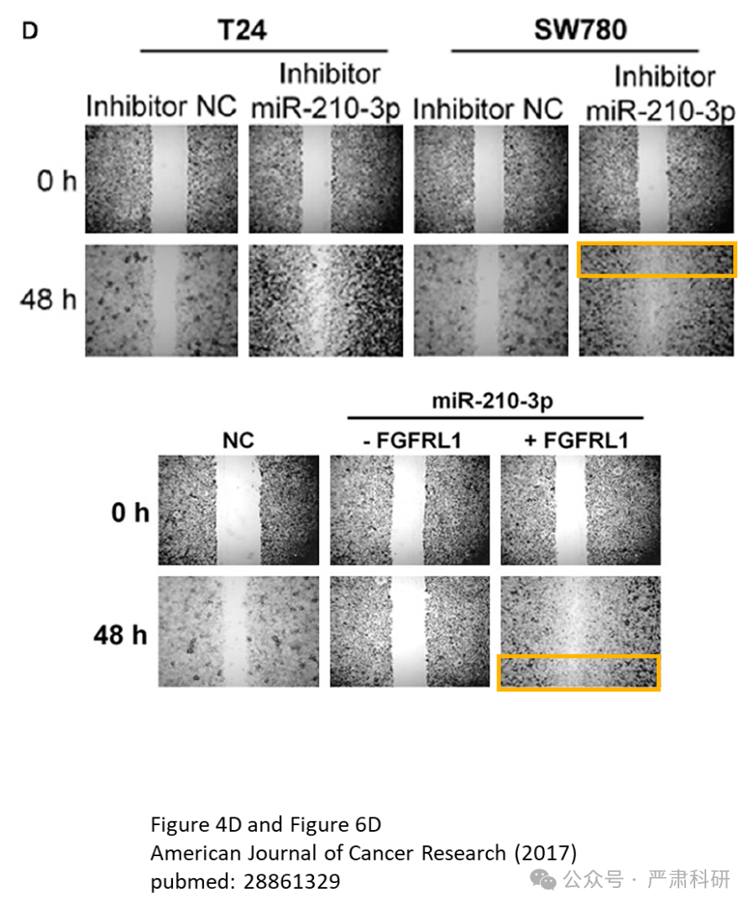

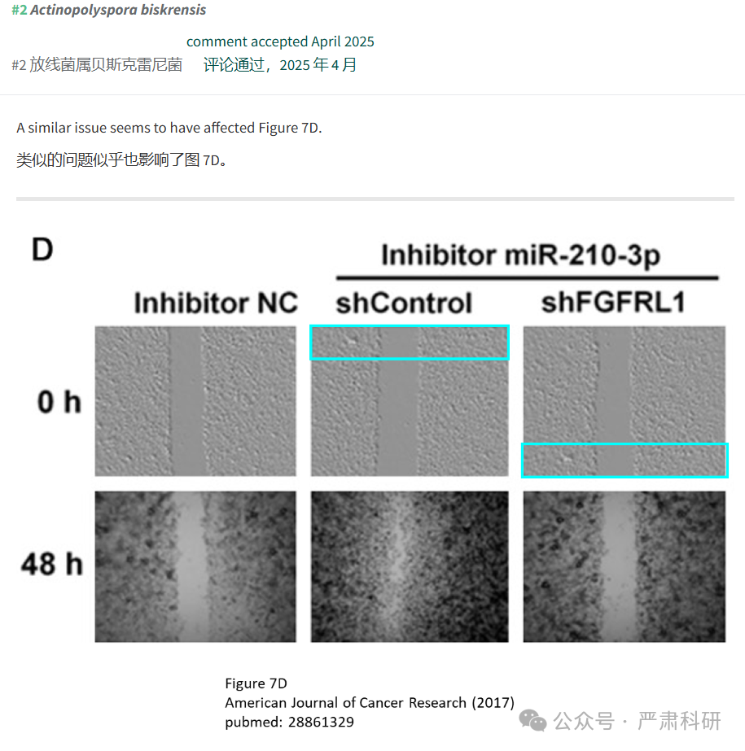



**参考信息  
https://pubmed.ncbi.nlm.nih.gov/28861329/**

**https://pubpeer.com/publications/7C1F6E52442DD0565B0916316243DA#0**

本平台对于科研问题的探讨，始终保持严谨、深入、持续、开放和创新的态度。所有推文信源，均来源于pubpeer、For Better Science等网站公开质疑。我们从来没有、也永远不会主动查重论文并去pubpeer上质疑。我们尊重他人的研究成果和贡献，通过交流和合作，共同推动科研领域的进步和发展。