[Graphpad作图模板，欢迎下载](https://mp.weixin.qq.com/s?__biz=MzkxMzc0MTQ2Nw==&mid=2247487965&idx=1&sn=2900f48dc42a16d4a4f50e40e526a128)

原创学术资讯家[学术资讯家](javascript:void(0);)2025-04-26 12:18:30北京

为了大家准备了Graphpad作图模板，供大家免费领取！

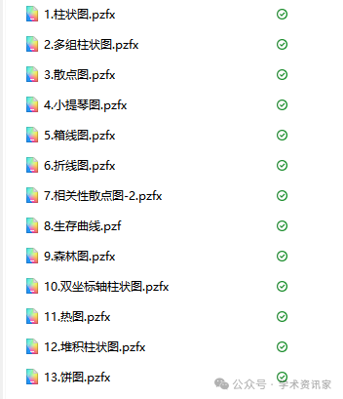

**获取方法：在公众号学术资讯家**回复**【Graphpad作图模板】。**

[#周末分享](https://mp.weixin.qq.com/mp/appmsgalbum?__biz=MzkxMzc0MTQ2Nw==&action=getalbum&album_id=3613791851066458113#wechat_redirect)[#精选](https://mp.weixin.qq.com/mp/appmsgalbum?__biz=MzkxMzc0MTQ2Nw==&action=getalbum&album_id=3791861987865559042#wechat_redirect)