[上海普陀中心医院CMN图片被质疑](https://mp.weixin.qq.com/s?__biz=MzUxODcwODMzMw==&mid=2247484029&idx=1&sn=5c02def1713d6a80f5eedb882ad5d885)

原创一只鱼[严肃科研](javascript:void(0);)2025-04-07 20:59:26四川

**“**秉持严谨、深入、持续、开放与创新的态度，尊重他人成果，携手交流共进，推动科研发展。**”**

**Research Frontline**

**科研前线**

01

—

**问题论文**

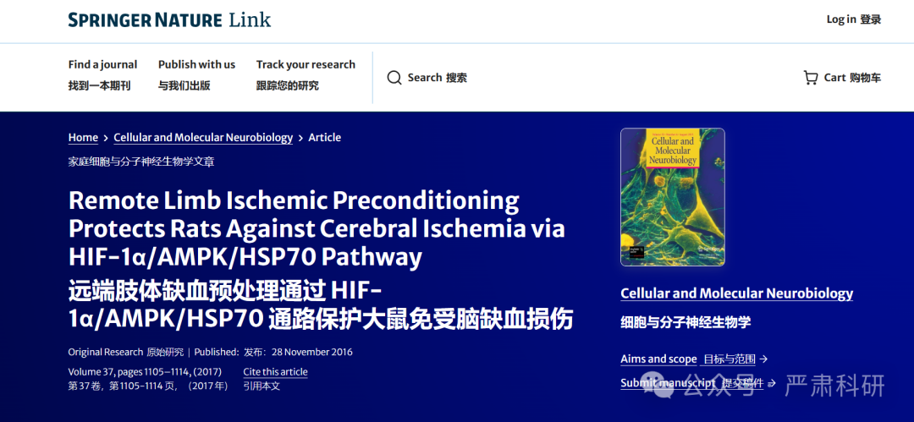

**标题：**Remote Limb Ischemic Preconditioning Protects Rats Against Cerebral Ischemia via HIF-1α/AMPK/HSP70 Pathway

**期刊：**Cellular and Molecular Neurobiology

**单位：**上海普陀区中心医院

**发表时间：**2016年11月28日

**DOI:**10.1007/s10571-016-0444-2

**研究摘要：**

Remote limb ischemic preconditioning (RIPC) is a clinically feasible strategy to protect against ischemia/reperfusion injury, but the knowledge concerning the mechanism underlying RIPC is scarce. This study was performed to examine the effect of RIPC on brain tissue suffering from ischemia challenge and explore its underlying mechanism in a rat model. The animals were divided into four groups: Sham, middle cerebral artery occlusion (MCAO), RIPC, and MCAO+RIPC. We found that previous exposure to RIPC significantly attenuated neurological dysfunction and lessened brain edema in MCAO+RIPC group. Moreover, other important events were observed in MCAO+RIPC group, including substantial decrements in the concentrations of oxidative response indicators [malondialdehyde (MDA), 8-hydroxy-2-deoxyguanosine (8-OHdG), and protein carbonyl], significant reductions in levels of inflammation mediators [myeloperoxidase (MPO), tumor necrosis factor-a (TNF-a), interleukin-1β (IL-1β), and IL-6], and significant decline in neuronal apoptosis revealed by a smaller number of TUNEL-positive cells. Interestingly, both MCAO and RIPC groups exhibited meaningful elevations in the levels of HIF-1a, HSP70, and AMP-activated protein kinase (AMPK) compared to Sham group, and previous exposure to RIPC further elevated the levels of HIF-1a, HSP70, and AMPK in MCAO+RIPC group. Furthermore, the administration of YC-1 (HIF-1 inhibitor), 8-bAMP (AMPK inhibitor), and Quercetin (HSP70 inhibitor) to MCAO+RIPC rats demonstrated that HIF-1α/AMPK/HSP70 was involved in RIPC-mediated protection against cerebral ischemia.  
远程肢体缺血预处理（RIPC）是一种临床可行的保护缺血/再灌注损伤的策略，但关于 RIPC 潜在机制的认知却很少。本研究旨在检查 RIPC 对缺血挑战下脑组织的影响，并探讨其在大鼠模型中的潜在机制。动物被分为四组：假手术组、大脑中动脉闭塞（MCAO）组、RIPC 组和 MCAO+RIPC 组。我们发现，先前接受 RIPC 暴露显著减轻了 MCAO+RIPC 组的神经功能障碍和脑水肿。此外，在 MCAO+RIPC 组还观察到其他重要事件，包括氧化应激指标（丙二醛（MDA）、8-羟基-2-脱氧鸟苷（8-OHdG）和蛋白羰基）浓度显著降低，炎症介质（髓过氧化物酶（MPO）、肿瘤坏死因子-α（TNF-α）、白细胞介素-1β（IL-1β）和 IL-6）水平显著下降，以及神经元凋亡显著减少，表现为 TUNEL 阳性细胞数量减少。 有趣的是，与假手术组相比，MCAO 组和 RIPC 组 HIF-1α、HSP70 和 AMP 激活蛋白激酶（AMPK）的水平均有显著升高，且先前对 RIPC 的暴露进一步提高了 MCAO+RIPC 组中 HIF-1α、HSP70 和 AMPK 的水平。此外，对 MCAO+RIPC 大鼠给予 YC-1（HIF-1 抑制剂）、8-bAMP（AMPK 抑制剂）和槲皮素（HSP70 抑制剂）的处理表明，HIF-1α/AMPK/HSP70 参与了 RIPC 介导的脑缺血保护作用。

02

—

**具体说明**

#1 **René Aquarius**comment accepted April 2025  
评论通过，2025 年 4 月

Dear authors,  尊敬的作者们，

We found unexpected overlap within one of your figures and between a figure presented in this study and a figure presented in another study (see enclosed image below).  
我们在您的其中一个图中以及本研究中展示的图与另一研究中展示的图之间发现了意外的重叠（见下附图像）。

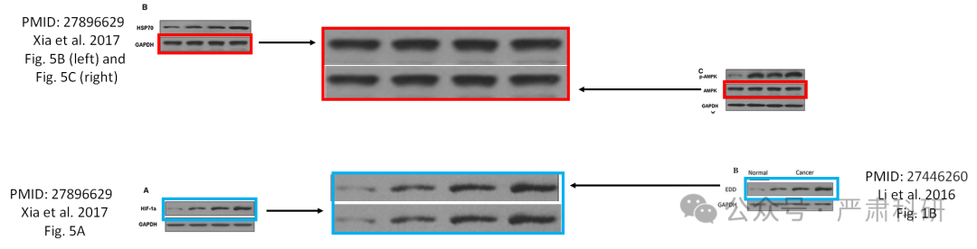

The following papers are affected:  
受影响的论文如下：

Paper 1: https://pubmed.ncbi.nlm.nih.gov/27896629/  
论文 1: https://pubmed.ncbi.nlm.nih.gov/27896629/

Paper 2: https://pubmed.ncbi.nlm.nih.gov/27446260/  
论文 2: https://pubmed.ncbi.nlm.nih.gov/27446260/

We will notify the publisher to resolve these issues.  
我们将通知出版商解决这些问题。

**参考信息  
https://link.springer.com/article/10.1007/s10571-016-04442**

**https://pubpeer.com/publications/EEA5A4650EAD8786E2FB07FEA9D7F6#0**

本平台对于科研问题的探讨，始终保持严谨、深入、持续、开放和创新的态度。所有推文信源，均来源于pubpeer、For Better Science等网站公开质疑。我们从来没有、也永远不会主动查重论文并去pubpeer上质疑。我们尊重他人的研究成果和贡献，通过交流和合作，共同推动科研领域的进步和发展。