[涉嫌大面积图像重复，西安交通大学第一附属医院肝胆外科郑鑫团队研究真实性遭严重质疑](https://mp.weixin.qq.com/s?__biz=Mzk3NTEwMTE3OA==&mid=2247486302&idx=1&sn=4052eeef83743145791e5ed10be74fe7)

[学术荟萃](javascript:void(0);)2025-04-25 17:57:00山东

**Part.1**



**论文简介**

**标题：Histone acetyltransferase PCAF accelerates apoptosis by repressing a GLI1/BCL2/BAX axis in hepatocellular carcinoma**

**日期：**2015年4月9日

**单位与作者**：西安交通大学第一附属医院肝胆外科 X Gai 、X Zheng(通讯作者 音译 郑鑫)

**期刊：*Cell Death and Disease***

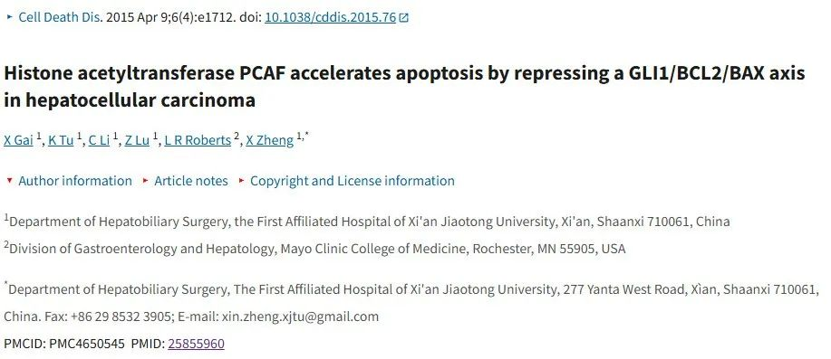

**Part.2**



**图像重复问题**

**#1 图7c与另外一篇论文存在多处重复。**

[left] Fig 7c.

[right] Fig 8 from "CtBP2 is an independent prognostic marker that promotes GLI1 induced epithelial-mesenchymal transition in hepatocellular carcinoma" (Liu et al 2015).

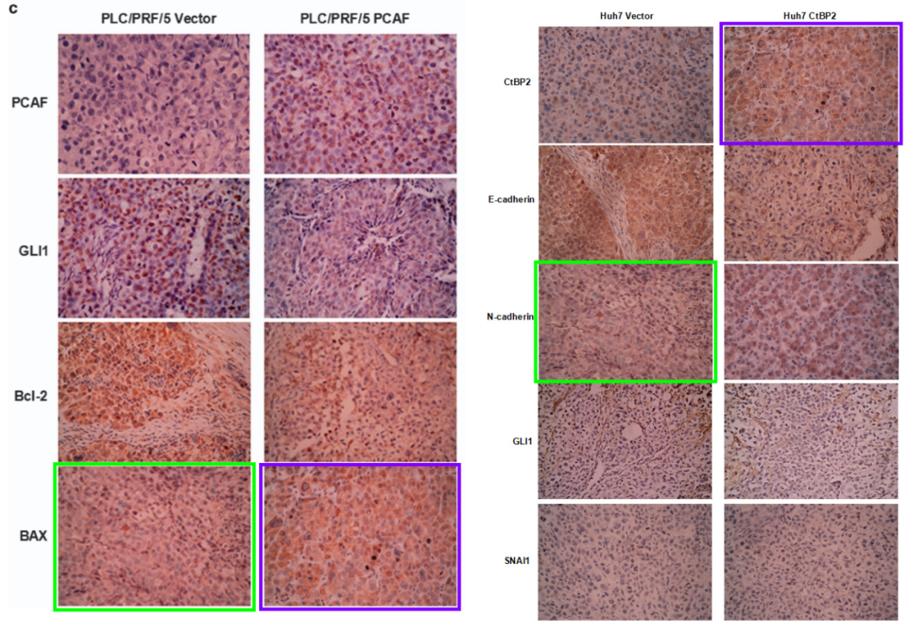

**#2 WB 波段似乎在两篇文章之间重复（180度翻转），具有不同的标签。这里有一些对比度调整：**

[left] Fig 1c.

[right] Fig 6B from "CtBP2 is an independent prognostic marker that promotes GLI1 induced epithelial-mesenchymal transition in hepatocellular carcinoma" (Liu et al 2015).

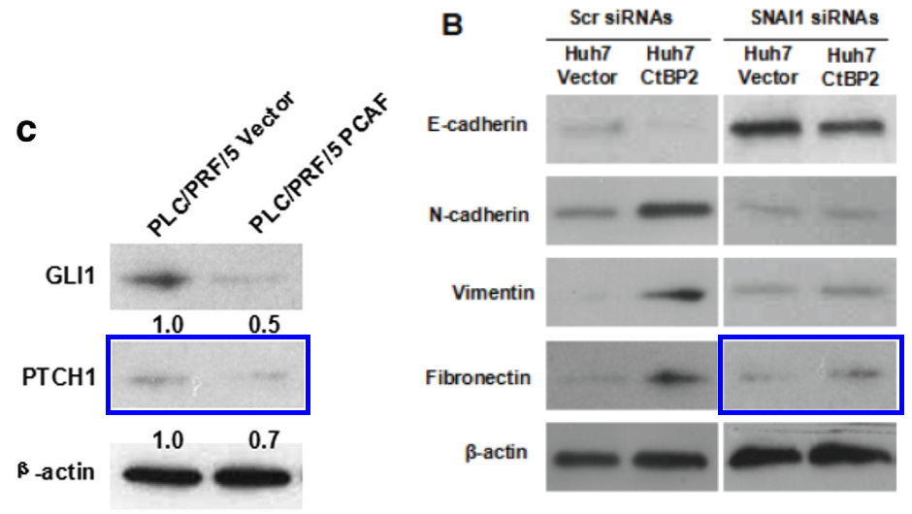

A WB band seems to be repeated between the two papers (modulo a 180-deg flip), with different labels. Here with some contrast adjustment:

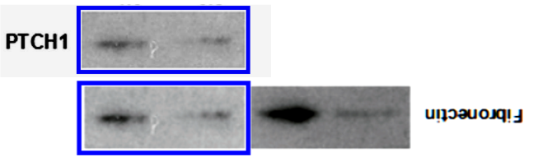

**#3 图3b被发现与其他文章存在重复。**

Left to right:

Fig 3b.

Fig 3D from Liu et al (2015).

Fig 4D from Liu et al (2015).

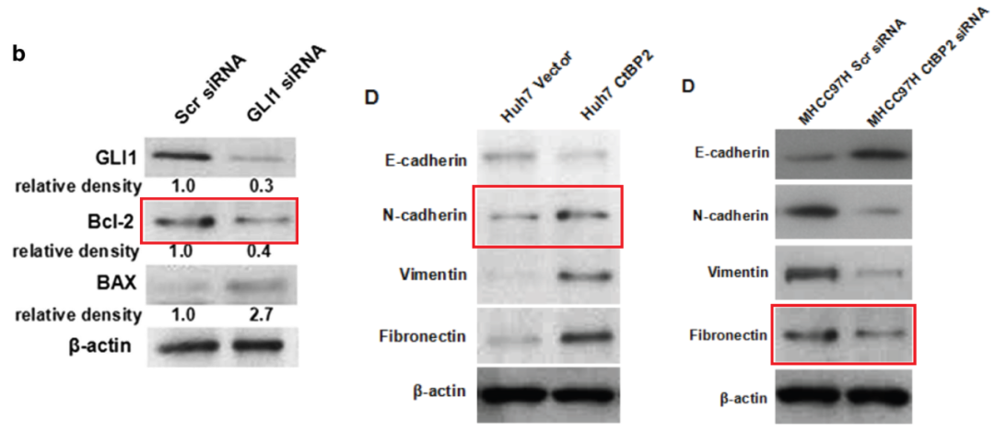

**#4 两篇文章中不同的细胞系，不同的处理，但相同的流式细胞术细胞凋亡图。**

[left] Fig 5b, "PCAF sensitizes HCC cells to 5-FU via modulating GLI1/Bcl-2/BAX axis".

[right] Figs 3c, 4c from "RIP1 upregulation promoted tumor progression by activating AKT/Bcl-2/BAX signaling and predicted poor postsurgical prognosis in HCC" (Wang et al 2016).

Different cell-lines, different treatments, but the same flow-cytometry apoptosis plots.

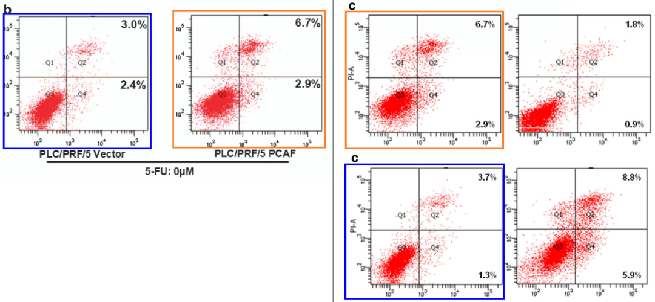

**#5 本文的图3b和图1c分别与其他文章存在重复。**

[left] Fig 3b again.

[right] Fig 5B (Hep3B panel) from "MicroRNA-92a contributes to tumor growth of human hepatocellular carcinoma by targeting FBXW7" (Yang et al 2015).

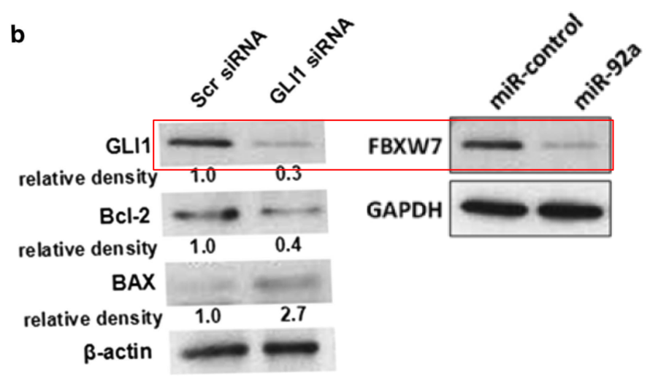

Here, with contrast enhanced to accentuate the similarities.

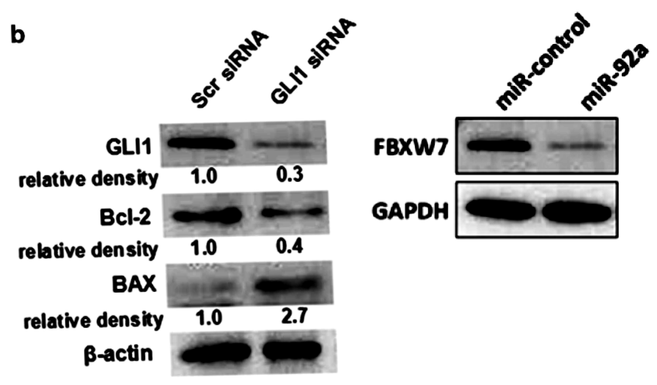

[left] Fig 1c.

[middle] Fig 5B (Hep3B panel) from Yang et al (2015).

[right] Fig 3C from "Fibulin-5 inhibits hepatocellular carcinoma cell migration and invasion by down-regulating matrix metalloproteinase-7 expression" (Tu et al 2014).

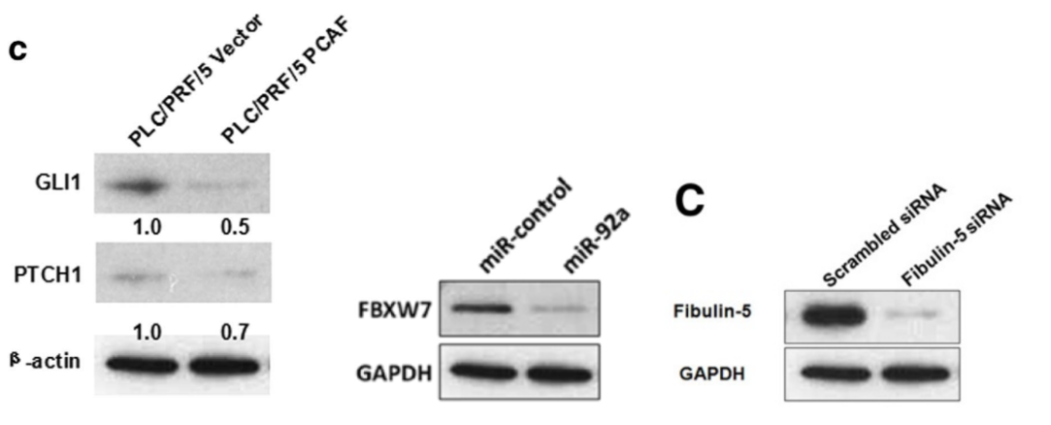

**#6 图4a和同年发表的一篇文章的图2E出现重复。**

Much more similar than expected. Similarities detected by ImageTwin.

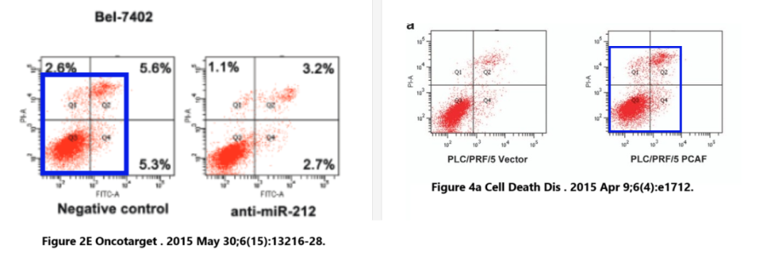

**#7 本文中的情节似乎出现在其他论文中。这三篇论文都有其他问题，包括出现在不同论文中的其他数据。可能有共同的作者。**

* A plot in this paper seem to appear in other papers. All three of these papers have other concerns, including other data that appears across different papers. There may be common authors.
* Figure 3C, Oncology Reports (2014), doi: 10.3892/or.2014.3386, discussed here: https://pubpeer.com/publications/71853E6EAA2DCB385CE3B9E957A793
* Figure 4a, Cell Death & Disease (2015), doi: 10.1038/cddis.2015.76, discussed here: https://pubpeer.com/publications/5A347BA141FCD107554CAEDA54EDE2
* Figure 4B, International Journal of Molecular Sciences (2014), doi: 10.3390/ijms15057124, discussed here: https://pubpeer.com/publications/820A96FD414F1107E52D7101477680

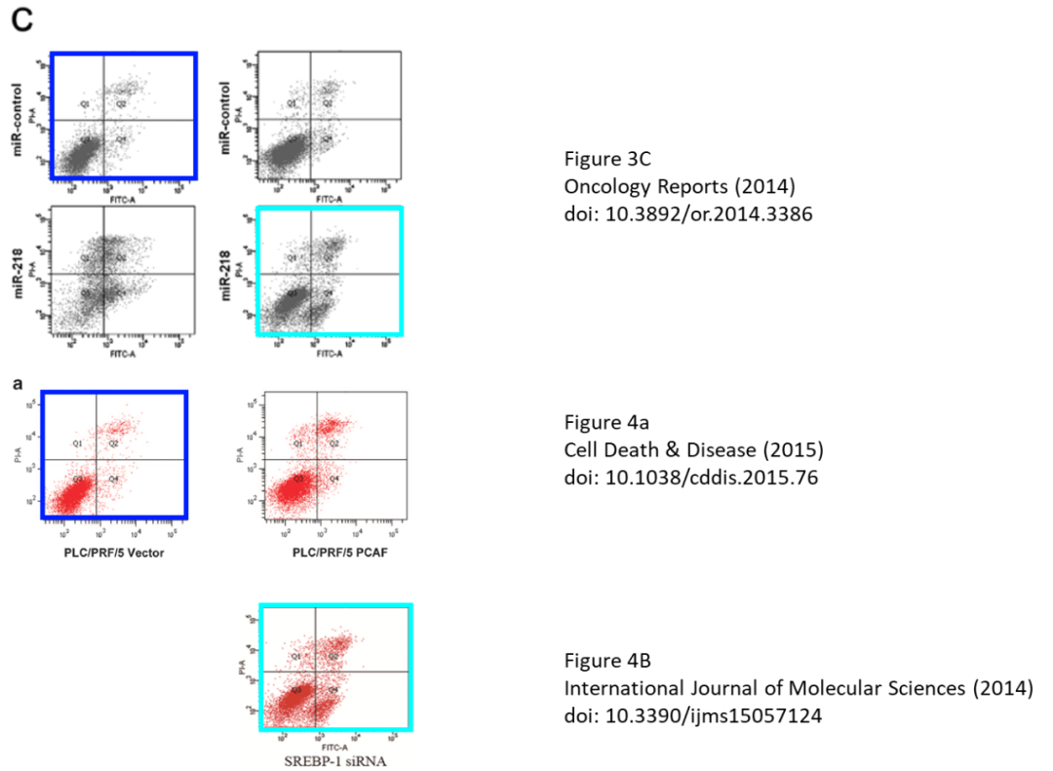

**基金支持：**

* 国家自然科学基金（81301743，Xin Zheng）
* 教育部高等学校博士学科点科学研究基金（20120201120090，Xin Zheng）
* 陕西省重点科技计划（2014K11-01-01-21，Xin Zheng）
* 西安交通大学资助的中央高校基本科研业务费项目基础研究基金（2014K11-01-01-21，Xin Zheng）

**参考信息：**

https://pubpeer.com/publications/5A347BA141FCD107554CAEDA54EDE2#0

https://pmc.ncbi.nlm.nih.gov/articles/PMC4650545/