[内部图像重复以及与他文论文图像的相似，湖北医药学院太和医院的论文被撤稿.PMID: 23907460](https://mp.weixin.qq.com/s?__biz=MzkzNjYxMTEzMA==&mid=2247532543&idx=1&sn=146ea591534256aa9a2532b1d0040888)

图片查重[DataTwin](javascript:void(0);)2025-04-24 16:10:37浙江

**点击上方蓝字**关注我们







**论文信息**

2013年8月1日，湖北医药学院太和医院在Cell Death & Disease（中科院一区 IF=8.1）期刊上在线发表题为**"The JAK2/STAT3 and mitochondrial pathways are essential for quercetin nanoliposome-induced C6 glioma cell death"**(JAK2/STAT3和线粒体途径对槲皮素纳米脂质体诱导的C6胶质瘤细胞死亡至关重要)论文。

第一作者：湖北医药学院太和医院 G Wang

通讯作者：湖北医药学院太和医院 J J Wang

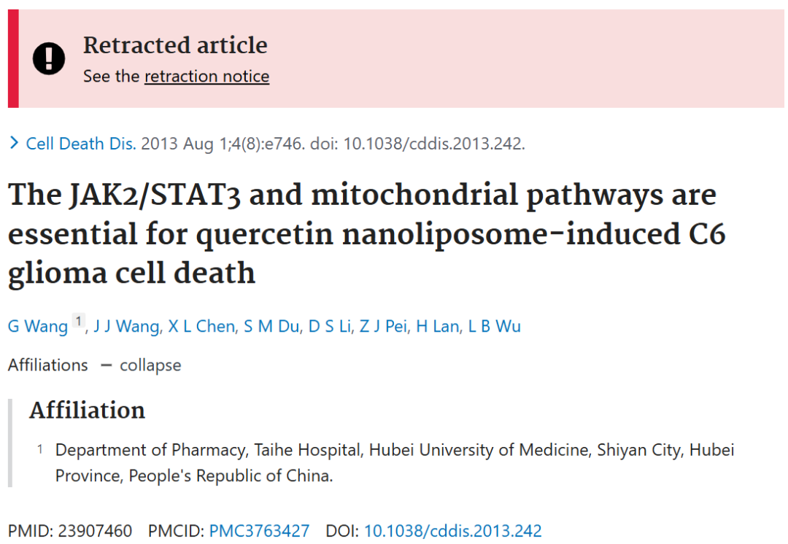





**质疑信息**

**#1**Figs 1A, B, C. Reused panels.

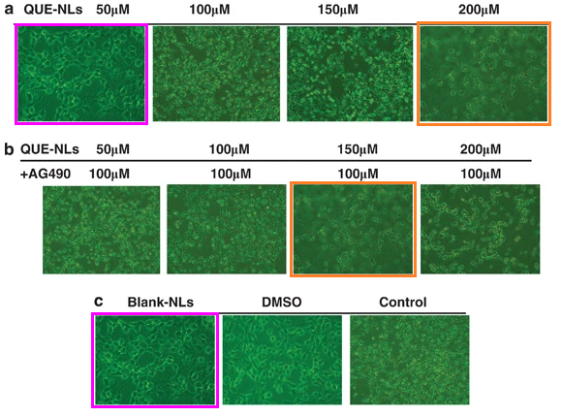

Fig 1D. Overlap marked.

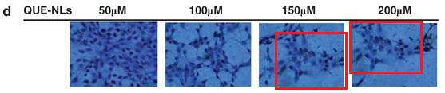

DataTwin图片查重

**#2**Figs 4a,b and 7e. Panels appear repeatedly, with different labels each time.

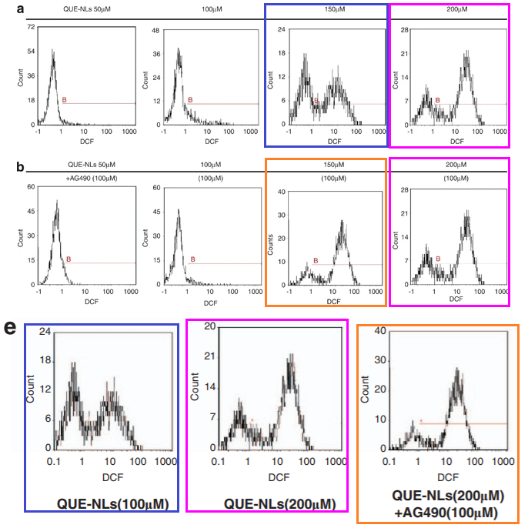

DataTwin图片查重

**#3**Some images in this paper also appear in a different paper with some common authors. In several cases the images are described differently, although in two cases they are described the same (but with no obvious notice of the republication in the latter paper).

Figure 2A, International Journal of Nanomedicine (2012), doi: 10.2147/ijn.s26935

Figures 1a, 1b, 1c, Cell Death and Disease (2013), doi: 10.1038/cddis.2013.242

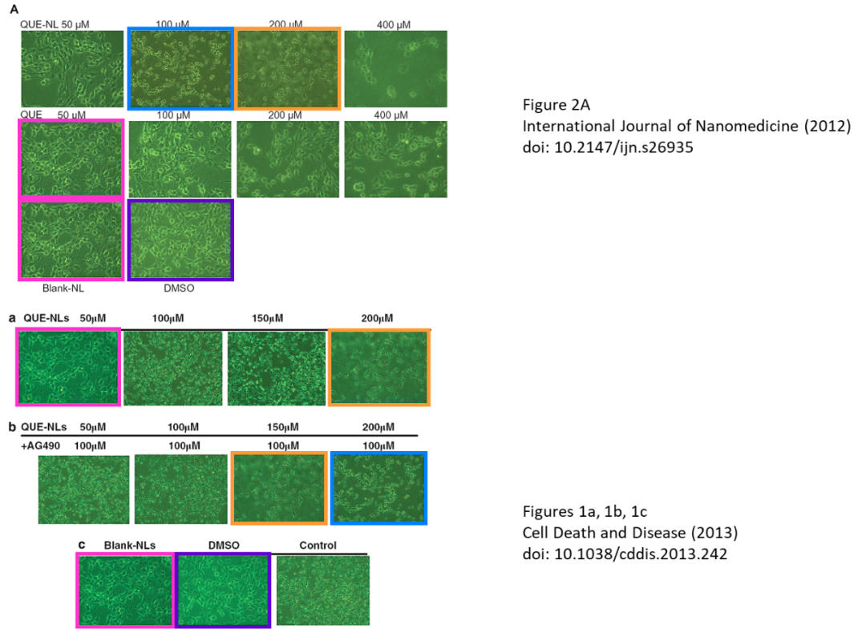

DataTwin图片查重

**#4**The images in Figure 1 also seem to appear in at least one other paper, where some of them appear to be described differently.

Journal of Biomedical Materials Research Part A (2013), doi: 10.1002/jbm.a.34607

Cell Death & Disease (2013), doi: 10.1038/cddis.2013.242

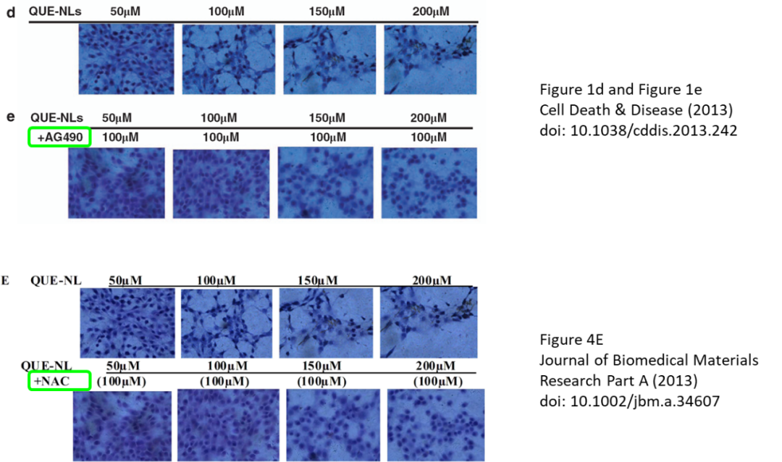

DataTwin图片查重



**撤稿原因**

**本文已于2025年4月15日被撤回：**

主编们已撤回该文章。文中存在多处图像问题，包括图1A-C之间、图1D内部以及图4内部的相似性，还与同一作者先前发表的一篇论文[1]中的图像存在相似。此外，还发现图1D和图1E中的两个面板被用在了同一作者几个月前发表的另一篇论文[2]的图4E中，且代表不同的实验条件。因此，主编们对该文章所依据的数据失去了信心。

出版方无法联系到作者X. L. Chen、D. S. Li、Z. J. Pei、H. Lan和L. B. Wu。第一作者针对所提出的问题给出了不令人满意的答复，且未就本撤稿通知进行回复。通讯作者也未就出版方关于此次撤稿的任何通信作出回应。

涉及文章：

[1] Wang G, Wang JJ, Yang GY, Du SM, Zeng N, Li DS, et al. Effects of quercetin nanoliposomes on C6 glioma cells through induction of type III programmed cell death. Int J Nanomed. 2012;7:271–80. https://doi.org/10.2147/IJN.S26935.

[2] Wang G, Wang J, Luo J, Wang L, Chen X, Zhang L, et al. PEG2000‐DPSE‐c oated quercetin nanoparticles remarkably enhanced anticancer effects through induced programed cell death on C6 glioma cells. J Biomed Mater Res Part A. 2013;101:3076–85.

**参考信息**https://pubpeer.com/publications/6C338986D0FF7852CD67899DDAC215https://pubmed.ncbi.nlm.nih.gov/23907460/https://www.nature.com/articles/cddis2013242

**声明：**

任何单位或个人认为本内容可能涉嫌侵犯其合法权益，及时向我们提出书面权利通知及详细侵权情况，我们将会依法尽快移除相关涉嫌侵权的内容。

联系微信号：DataTwin



**往期报道精选**

[全网最低价！文件图片查重+比对Pubmed和Pubpeer数据库查重，DataTwin高效权威图片识别！众多知名打假人士推荐使用](http://mp.weixin.qq.com/s?__biz=MzkzNjYxMTEzMA==&mid=2247486008&idx=5&sn=43a2d45f61ed36770808541d737ca3cd&chksm=c29d566df5eadf7bcf1cee3ab814981f26fd4b8aef7a56bb740c999691685526232641ed1bc9&scene=21" \l "wechat_redirect" \t "_blank)

[一区Top9.2分，西安交通大学第二附属医院(西北医院)单涛等人论文撤稿。](http://mp.weixin.qq.com/s?__biz=MzkzNjYxMTEzMA==&mid=2247496577&idx=1&sn=5f6c203ab8c8a90910fb169fb557f09e&chksm=c29eafd4f5e926c23429d2cdbfa4b858d50d365ccedb076342024a06cdef3503285527c04f71&scene=21#wechat_redirect)

[图片重复未作解释，成武县人民医院岳彩云&山东第一医科大学第一附属医院（千佛山医院）杨敏等人论文被撤稿。](http://mp.weixin.qq.com/s?__biz=MzkzNjYxMTEzMA==&mid=2247496577&idx=2&sn=f7e9d4976a062f45ab4c82678d64d647&chksm=c29eafd4f5e926c22879afc68758ce79092ccd6e09bdcf84ed33af28cb858720cdd98d8d1f8b&scene=21#wechat_redirect)

[希腊期刊撤稿，涉与多篇重复的老问题，常州市第一人民医院整形烧伤科李玲巧论文撤回。](http://mp.weixin.qq.com/s?__biz=MzkzNjYxMTEzMA==&mid=2247496577&idx=3&sn=adf0cc7a805cb0b3022cee01276ed136&chksm=c29eafd4f5e926c25f570665cbfe7cf5453ccca0d903d47b581b521c3496e83427771694da50&scene=21#wechat_redirect)

[网友玩微信发现问题论文，浙江大学贺永教授、浙江大学医学院附属口腔医院石钰等人发表到Small的论文存在图片重复使用问题！](http://mp.weixin.qq.com/s?__biz=MzkzNjYxMTEzMA==&mid=2247496547&idx=1&sn=e28eef8cce3be96e2c9b87e9b47742f3&chksm=c29eaf36f5e926205da762928b9510337e641e83d400e166df0687fdaa0597e99598739585a7&scene=21#wechat_redirect)

[一篇声称新冠疫苗具有广泛危害的论文将被撤回，作者回应：出版社不允许对抗性陈述的论文存在](http://mp.weixin.qq.com/s?__biz=MzkzNjYxMTEzMA==&mid=2247496526&idx=1&sn=a7684678c2d1f7537332323923be6239&chksm=c29eaf1bf5e9260dff6cc8d0fa5823592736a87e03adaf78ed3aa67722776822efdf084c09eb&scene=21#wechat_redirect)

# [今日学术问题发现 | 兄弟借一步说话，看你是不是火眼金睛](http://mp.weixin.qq.com/s?__biz=MzkzNjYxMTEzMA==&mid=2247484202&idx=4&sn=6c887f60b170b0352211a4056136471d&chksm=c29d5f7ff5ead669026d14f9ce4fc72a33dc49b4872d0649ae332312a1497f95ee48b6e39aac&scene=21#wechat_redirect)

# [今日学术问题发现 | 你把Error Bar当作奖励给幼儿园小朋友的小红花？](http://mp.weixin.qq.com/s?__biz=MzkzNjYxMTEzMA==&mid=2247484202&idx=5&sn=6726065dc778f5d6f734f6d8e4bb4519&chksm=c29d5f7ff5ead669fa3cf39a0504fbcdd0a8856dc8e893c0c7d5a64114b6d7c0fd1bdd1274b6&scene=21#wechat_redirect)

[今日学术问题发现 | Table中的异常数据（PMID：26111626）](http://mp.weixin.qq.com/s?__biz=MzkzNjYxMTEzMA==&mid=2247484202&idx=6&sn=fa04280bf1e13fb388f5fcd7364dca92&chksm=c29d5f7ff5ead66915da906253ca3fcbdc95955d9bedfa1484acbbd6ec65069baea3c7617f17&scene=21#wechat_redirect)

[今日学术问题发现 | 不要侥幸，白天到黑夜，你还是你（荧光图片造假重复）](http://mp.weixin.qq.com/s?__biz=MzkzNjYxMTEzMA==&mid=2247484091&idx=3&sn=b4812492b782f5b1098df327c7118b29&chksm=c29d5eeef5ead7f8a36ba0a2fe28ebca0c0abf09d97a9c311ffe16fe8c6204436dafa6ed02af&scene=21#wechat_redirect)

[今日学术问题发现 | 山西医科大学贺婵婷等人论文数据图片出现多处重复](http://mp.weixin.qq.com/s?__biz=MzkzNjYxMTEzMA==&mid=2247484091&idx=4&sn=465b44b280962a59b5f3a38e18c7ccd1&chksm=c29d5eeef5ead7f8daf6a43c748db2b408fc71ae5377942fbc3ff48c3fe5b68be6a8808bb641&scene=21#wechat_redirect)

[Hepatology论文被质疑，南京医科大学第一附属医院孙倍成/南京大学医学院姜润秋教授发表的论文因图片重复](http://mp.weixin.qq.com/s?__biz=MzkzNjYxMTEzMA==&mid=2247495175&idx=2&sn=ff4146bc29b7ed9cefbbd2d02ba2454c&chksm=c29eb252f5e93b4416dd8000e979b09f21e70a7b0e188a9e8853a5957148362a894a5393c1e1&scene=21#wechat_redirect)

[DataTwin图片查重| 浙大医二院神经外科陈高教授发表的论文因图片重复被质疑](http://mp.weixin.qq.com/s?__biz=MzkzNjYxMTEzMA==&mid=2247495175&idx=3&sn=8cf91fc18af7e9230a0b51de678e4b77&chksm=c29eb252f5e93b44e6a3c09af3c60cbb0b41bf002b9e43946628019dc0250c78ec7f6301f816&scene=21#wechat_redirect)

[国家优青、海军军医大学（第二军医大学）药学院孙鹏教授发表的论文因图片重复被质疑](http://mp.weixin.qq.com/s?__biz=MzkzNjYxMTEzMA==&mid=2247495175&idx=4&sn=ceb343c415ac6e1eafde0114fff757b0&chksm=c29eb252f5e93b4452873038b8a8fa8593679122f3b552f04bfeff67d46e25d425d8a9ea08a1&scene=21#wechat_redirect)

[上海九院普外科刘斌发表的论文因图片重复被质疑](http://mp.weixin.qq.com/s?__biz=MzkzNjYxMTEzMA==&mid=2247495175&idx=5&sn=052dad49954ae38cdfcc83c7bf4bb92a&chksm=c29eb252f5e93b4449543cd4b808a98122448a7b588d2c3b0f41a03dace7e9f952d7fd128926&scene=21#wechat_redirect)

*END*



    客服微信：DataTwin



文件内部+Pubmed&Pubpeer数据库全网查重 请联系客服。