[多图重复，中国农业大学动物医学院教授论文被质疑](https://mp.weixin.qq.com/s?__biz=Mzk1Nzk5NzI3Mw==&mid=2247484781&idx=1&sn=065214f91497a9ebed91f010a1c24c86)

原创观观[图片观察](javascript:void(0);)2025-04-22 20:17:04广东

这篇2023年发表的Journal of Nanobiotechnology期刊，主要由Ruihua Ye , Qingyun Guo , Jiaqiang Huang , Zixu Wang , Yaoxing Chen , Yulan Dong共同完成，近期图片重复引起质疑

**论文信息**

标题：Eucommia ulmoides polysaccharide modified nano-selenium      effectively alleviated DSS-induced colitis through enhancing intestinal      mucosal barrier function and antioxidant capacity

作者：Ruihua Ye, Qingyun Guo, Jiaqiang Huang, Zixu Wang, Yaoxing      Chen, Yulan Dong

期刊：J Nanobiotechnology

发表日期：2023年7月12日

DOI：10.1186/s12951-023-01965-5

PMID：37438752

PMCID：PMC10337189

单位：中国农业大学动物医学院、北京米鲁生态研究中心米鲁保护研究组、中国农业大学营养与健康系

**质疑内容**

 我注意到本文中处理方式不同的多张图片都存在图片重复的问题。具体说来：

* Figure 7H (H&E staining): Identical tissue sections appear mislabeled as distinct treatment groups: Spleen: 7-day control vs. 30-day control，7-day oral EUP-SeNP vs. 30-day oral EUP-SeNP group Kidney: 7-day control vs. 30-day oral EUP-SeNP group Colon: 7-day oral EUP-SeNP vs. 30-day oral EUP-SeNP group The duplicated regions (highlighted in attached annotations) demonstrate identical cellular architecture and staining artifacts.
* Figure 8C (IEC6 cell imaging): Merged fluorescence images labeled as "1-hour EUP-SeNP treatment" and "4-hour EUP-SeNP treatment" show spatial overlap of cellular structures , suggesting potential reuse of the same field of view.

鉴于明显的重复，我敦促作者提供解释和原始数据来澄清这个问题。

Figure 7H

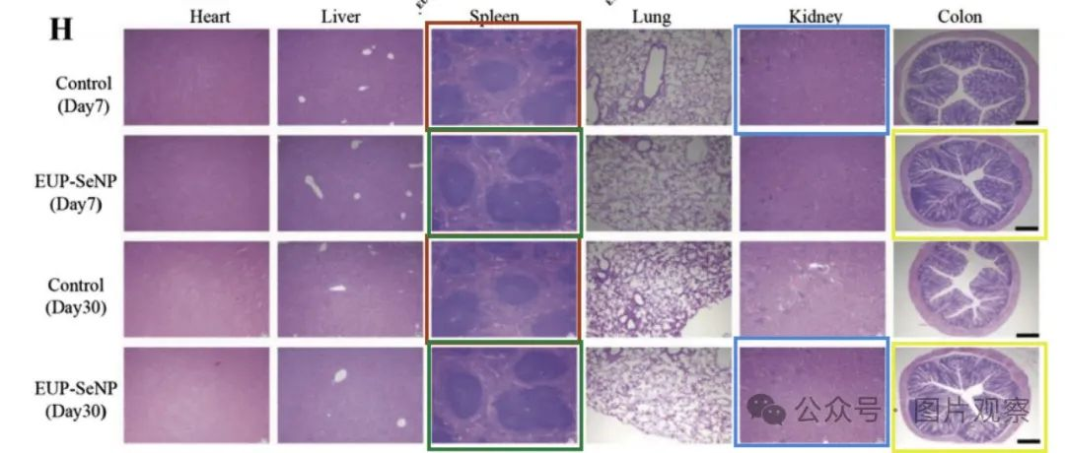

Figure 8C

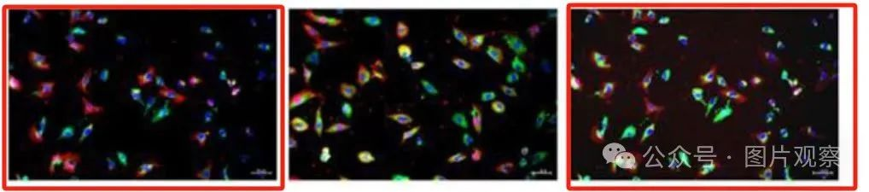



**END**



**#**

**扫码关注我们**



Don't be ashamed



专注于国内论文质疑报道

**欢迎投稿联系**

[#中国农业大学动物医学院](https://mp.weixin.qq.com/mp/appmsgalbum?__biz=Mzk1Nzk5NzI3Mw==&action=getalbum&album_id=3954925121193558034#wechat_redirect)