[查重技术立功！Imagetwin助力揭露罗切斯特大学医学中心&华中科技大学同济医学院附属同济医院论文重复问题](https://mp.weixin.qq.com/s?__biz=Mzk0NjYzMDcyNQ==&mid=2247513915&idx=1&sn=50aeebcabea3908183fe249f93b4ca59)

[图片查重指南针](javascript:void(0);)2025-04-21 10:24:42美国

[](http://mp.weixin.qq.com/s?__biz=Mzk0NjYzMDcyNQ==&mid=2247494760&idx=1&sn=9f28762dc91428c028f15e4f752f2e88&chksm=c3019542f4761c5449a4b653c431eba3a2d17317fed2115923f1044eabc511f4a936059ae166&scene=21#wechat_redirect)

***01***

**论文信息**

2015年11月5日，罗切斯特大学医学中心&华中科技大学同济医学院附属同济医院Oncotarget发表题为“Recruited mast cells in the tumor microenvironment enhance bladder cancer metastasis via modulation of ERβ/CCL2/CCR2 EMT/MMP9 signals”的论文。

通讯作者：华中科技大学同济医学院附属同济医院Qun Rao, Yuan Chen

第一作者：罗切斯特大学医学中心Shuyuan Ye

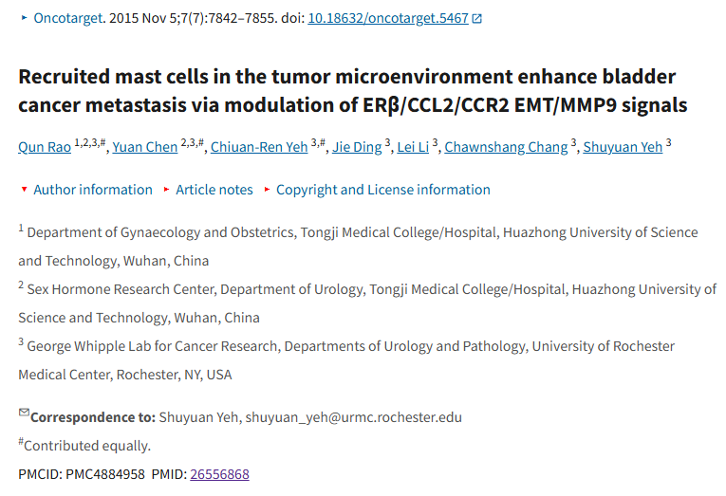

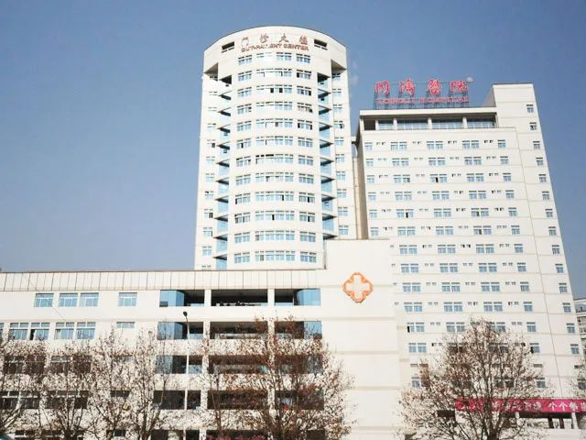

***02***

**质疑信息**

**质疑一：Figure 4G有标记为不同事物的面板重复区域。**

Figure 4G has duplicated areas of panels that are labeled as being different things

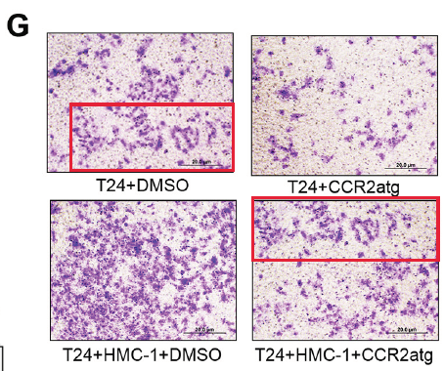

Imagetwin全网查(如需要查重服务，请联系文末客服微信)

**质疑二：图1D：“T24”和“647V”面板似乎显示重叠。**

Figure 1D.Blue boxes: The "T24" and "647V" panels appear to show an overlap.

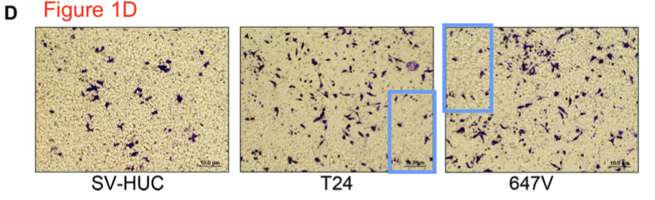

Imagetwin全网查(如需要查重服务，请联系文末客服微信)

**质疑三：图 3D 所示的 647V scr Ctrl 培养物不应与图 6D 所示的 647V 培养物相同。**

I dont think the 647V scr Ctrl culture shown in Figure 3D is supposed to be identical to the 647V culture shown in Figure 6D.

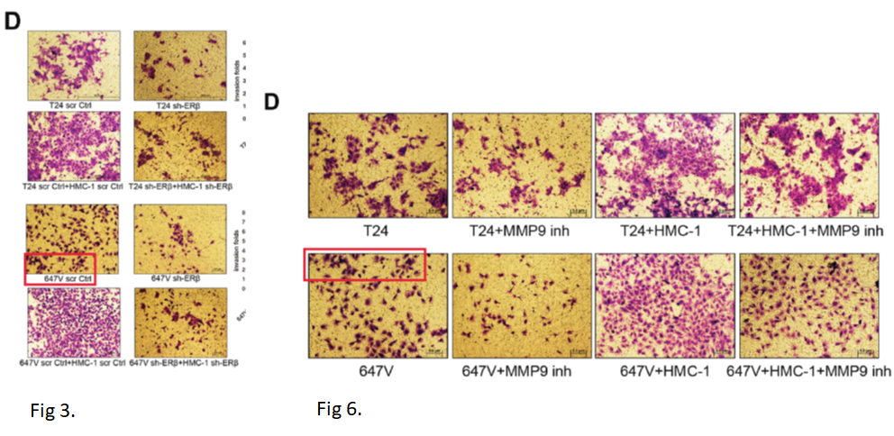

Imagetwin全网查(如需要查重服务，请联系文末客服微信)

**质疑四：图 7A 中用红色方框勾勒出的大鼠图像背景有一些相似之处。此外，作者似乎试图对图片进行裁剪，使其看起来大鼠是成对成像的，然而，中心面板显示，通风口的长度不同，因此中心图片明显是拼接的，这让人相信其他图片也是拼接在一起的，但图片被裁剪，使两个通风口看起来是一个通风口。作者能否详细描述检查和成像过程，让读者相信其中一些图像不是同一只老鼠的图像，而是经过重新定位后看起来像另一只老鼠的图像？**

There are some similarities in the background of the rat images in Figure 7A outlined in red squares. In addition, it appears that the authors tried to crop the pictures so that it appears that the rats were imaged in pairs, however, the central panel shows that the vents are different lengths so the center image is clearly spliced which leads one to believe that the other images were also spliced together but the images were cropped so that 2 vents appear to be a single vent. Can the authors describe, in detail, the examination and imaging process so that the reader is convinced that some of the images are not of the same rat that has been repositioned to look like a different rat?

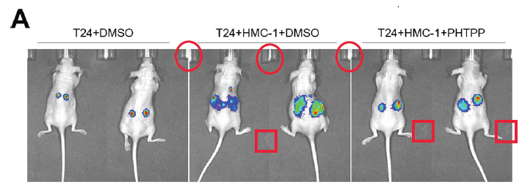

Imagetwin全网查(如需要查重服务，请联系文末客服微信)

**质疑五：ImageTwin 发现了另一个重叠，如图 2B 和 3E 所示：**

ImageTwin found another overlap, between Figures 2B and 3E:

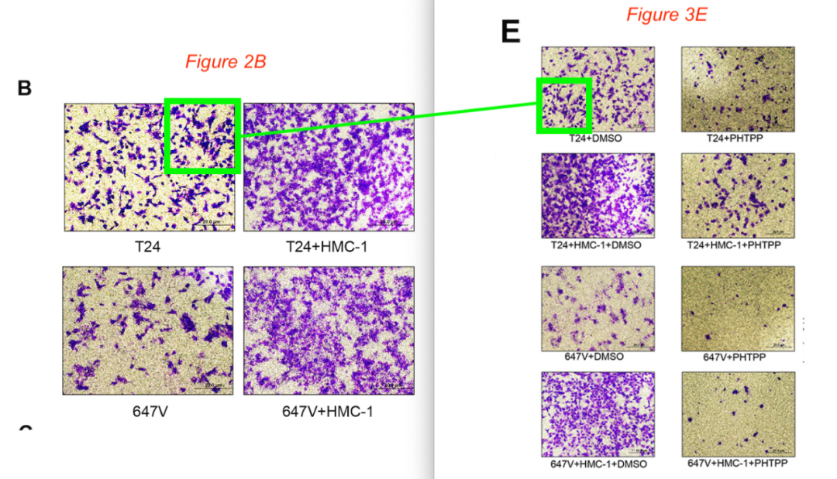

Imagetwin全网查(如需要查重服务，请联系文末客服微信)

**质疑六：ImageTwin发现了图 3C 和 5D 之间的另一个重叠：**

ImageTwin found another overlap, between Figures 3C and 5D:

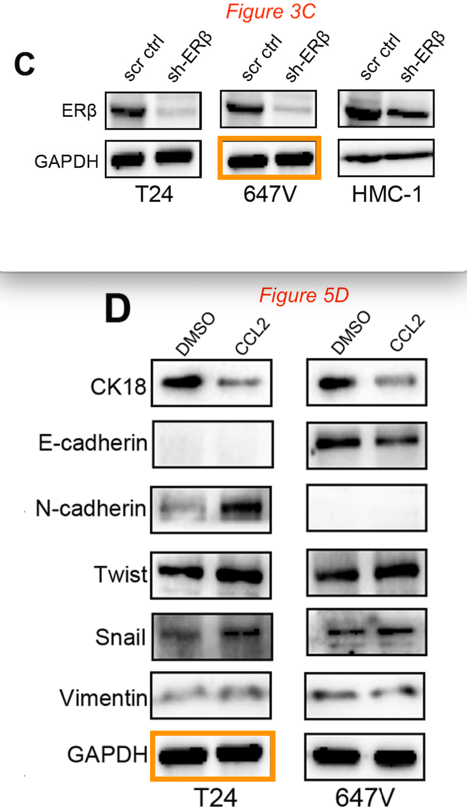

Imagetwin全网查(如需要查重服务，请联系文末客服微信)

**参考信息：**

https://pubpeer.com/publications/4F83E7FD406A0F4CDEB020DA94E72B#0

https://pmc.ncbi.nlm.nih.gov/articles/PMC4884958/

**论文图片Imagetwin查重服务**

**请添加查重部客服微信：figfig04**



*#*

***往期精选***

城门失火，殃及池鱼| 涨知识，非洲大草原上的蚂蚁如何打败狮子：物种入侵的危害

**近日Onco Targets and Therapy接连撤稿数篇，本周涉四川省人民医院李刚教授文章，与两篇论文图片重复**

猎杀狼保护牲畜？可能会适得其反

DOVE期下期刊近期撤稿和质疑高发，重点警惕，南京医科大学附属第一医院顾艳宏等人文章因多处图片重复被质疑

[**Science最新封面研究！人类使用的植物都分布在哪里？**](http://mp.weixin.qq.com/s?__biz=Mzk0NjYzMDcyNQ==&mid=2247484011&idx=1&sn=c66c081849cf2df587aa956f14f783dc&chksm=c3027b41f475f2579f223d5f58c14d6000fc335b1147f43d6c7f76d056e1f6c4819a8373d34f&scene=21#wechat_redirect)

**校园霸凌导致逃避心理VS被打败的老鼠会绕道走！最新Nature重磅成果——专门的下丘脑催产素回路控制厌恶性社交学习**

[世界领先！柳叶刀-复旦大学舒易来教授团队成果，恢复先天性耳聋儿童听力的临床试验取得成功](http://mp.weixin.qq.com/s?__biz=Mzk0NjYzMDcyNQ==&mid=2247484011&idx=1&sn=c66c081849cf2df587aa956f14f783dc&chksm=c3027b41f475f2579f223d5f58c14d6000fc335b1147f43d6c7f76d056e1f6c4819a8373d34f&scene=21#wechat_redirect)

**和早期发表论文图片重复，北京大学人民医院郭卫教授的文章因图片重复被质疑**

[**普通的水也能引发核反应？Science Report新发现！**](http://mp.weixin.qq.com/s?__biz=Mzk0NjYzMDcyNQ==&mid=2247483830&idx=2&sn=537cebf16ad583dbd66f7b3189a53c16&chksm=c302789cf475f18a890d93724d2ac5f2d46b927242fdac92456d4d405e42fa839840ee8375e7&scene=21#wechat_redirect)

[**科研心法| 字字触动科研人的灵魂**](http://mp.weixin.qq.com/s?__biz=Mzk0NjYzMDcyNQ==&mid=2247483653&idx=1&sn=f7be4bed0253bd20d69b549bc1371b98&chksm=c302782ff475f139ced644ce446311f6444100157db60ffcbb33a81d844cd3bbd068315d108b&scene=21#wechat_redirect)

[**疑似数据在不同论文重复使用！国家卫健委直属北京医院国家老年病学中心内分泌科郭立新教授等发表的文章被质疑**](http://mp.weixin.qq.com/s?__biz=Mzk0NjYzMDcyNQ==&mid=2247483830&idx=3&sn=19dfc430973d4390f940258997ec5da2&chksm=c302789cf475f18a0ccf7c722741814d9b477fdfa256bfdc97a50cb3538c2a58fe48583ef55a&scene=21#wechat_redirect)

[**一图两用，双双撤稿，深圳大学第一附属医院放射科两篇论文近日被撤稿**](http://mp.weixin.qq.com/s?__biz=Mzk0NjYzMDcyNQ==&mid=2247483765&idx=1&sn=02944f4bc5de4cf631b484fe00fa5440&chksm=c302785ff475f1496244384c1ec34dd2fb9907d59cde4156637810f48dde2b40c908b01dfb88&scene=21#wechat_redirect)

[**通讯作者邮箱有误，论文工厂参与操作图片！聊城市人民医院肿瘤科马丹论文被撤稿**](http://mp.weixin.qq.com/s?__biz=Mzk0NjYzMDcyNQ==&mid=2247483765&idx=2&sn=eff726b58cf0ff803a53cf1b8591f8b6&chksm=c302785ff475f14901bcbb18a9f8134d1bb1fe2cc40ab8c3e418f3f56e4494b8334209ef741c&scene=21#wechat_redirect)

[**第三方参与操纵发表迹象，青岛大学附属医院/四川大学华西口腔医院/复旦大学附属妇产科医院三家单位的论文本周被撤稿**](http://mp.weixin.qq.com/s?__biz=Mzk0NjYzMDcyNQ==&mid=2247483690&idx=1&sn=bc06edadea5ca7926a7155565664a660&chksm=c3027800f475f1161978def48dc683f7964c6f493b03398c7f22a6c6cb9aadd51d0cca34f636&scene=21#wechat_redirect)

[**盗用他人多年前发表图片，上海中医药大学附属第七人民医院被撤稿**](http://mp.weixin.qq.com/s?__biz=Mzk0NjYzMDcyNQ==&mid=2247483690&idx=2&sn=a13ff72bf531150f978d559e5964edd5&chksm=c3027800f475f116462ad6cc0fcea63b0ee700741bedf113c3dbf81250d7a65ae5767ccfa0ce&scene=21#wechat_redirect)