[中山大学附属一院Bioscience Reports图片重复](https://mp.weixin.qq.com/s?__biz=MzUxODcwODMzMw==&mid=2247484022&idx=1&sn=bc09527e4421a1f62208a460cb060bcb)

原创一只鱼[严肃科研](javascript:void(0);)2025-04-05 14:40:49四川

**“**秉持严谨、深入、持续、开放与创新的态度，尊重他人成果，携手交流共进，推动科研发展。**”**

**Research Frontline**

**科研前线**

01

—

**问题论文**

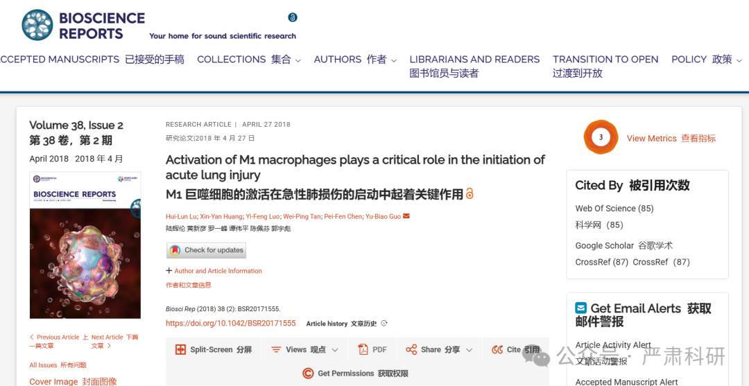

**标题：**Activation of M1 macrophages plays a critical role in the initiation of acute lung injury

**期刊：**Bioscience Reports

**单位：**中山大学附属第一医院

**发表时间：**2018年4月27日

**DOI:**10.1042/bsr20171555

**研究摘要：**

The goal of the present study was to investigate the role of M1 macrophages in acute lung injury (ALI). To address this, we used lipopolysaccharide (LPS)-treated wild-type and CD11b-DTR mice, and examined their M1 macrophage levels, and the extent of their inflammation and pulmonary injuries. In addition, we evaluated pulmonary function by measuring the expressions of SP-A and SP-B in infiltrated M1 macrophages. Finally, we co-cultured the mouse type II-like alveolar epithelial cells (AT-II) and mouse pulmonary microvascular endothelial cells (PMECs) with M1 macrophages in the presence of TNF-α or H2O2 and assessed them for viability and apoptosis. After LPS treatment, we observed that the number of pulmonary M1/M2 macrophages and the serum levels of interleukin-1β (IL-1β), tumor necrosis factor α (TNF-α), and reactive oxygen species (ROS) significantly increased. Furthermore, the increase in cytokines was accompanied with the initiation of lung injury indicated by the decreased levels of SP-A and SP-B. In macrophage-depleted CD11b-DTR mice, ALI was attenuated, serum levels of IL-1β, TNF-α and ROS were reduced, and lung levels of monocyte chemoattractant protein-1 (MCP-1) and macrophage inflammatory protein-2 (MIP-2) were decreased. After administering TNF-α and H2O2, the proapoptotic effect of M1 macrophages on AT-II or PMECs significantly increased, the cell viabilities significantly decreased, and apoptosis significantly increased. Our results suggest that M1 macrophages are recruited to the lungs where they significantly contribute to an increase in TNF-α and ROS production, thus initiating ALI.  
本研究旨在探讨 M1 巨噬细胞在急性肺损伤（ALI）中的作用。为此，我们使用了脂多糖（LPS）处理的野生型和 CD11b-DTR 小鼠，检测了它们的 M1 巨噬细胞水平以及炎症和肺损伤的程度。此外，我们还通过测量浸润 M1 巨噬细胞中 SP-A 和 SP-B 的表达来评估肺功能。最后，我们在 TNF-α或 H 2 O 2 的存在下，将小鼠 II 型肺泡上皮细胞（AT-II）和小鼠肺微血管内皮细胞（PMECs）与 M1 巨噬细胞共培养，并评估了它们的存活率和细胞凋亡。LPS 处理后，我们观察到肺部的 M1/M2 巨噬细胞数量和血清中白细胞介素-1β（IL-1β）、肿瘤坏死因子α（TNF-α）和活性氧（ROS）的水平显著增加。此外，细胞因子水平的增加伴随着肺损伤的启动，表现为 SP-A 和 SP-B 水平的降低。 在 CD11b-DTR 小鼠的巨噬细胞耗竭模型中，急性肺损伤（ALI）减轻，血清中 IL-1β、TNF-α和 ROS 水平降低，肺中单核细胞趋化蛋白-1（MCP-1）和巨噬细胞炎症蛋白-2（MIP-2）水平下降。给予 TNF-α和 H 2 O 2 后，M1 巨噬细胞对 AT-II 或 PMECs 的促凋亡作用显著增强，细胞活力显著降低，凋亡显著增加。我们的结果表明，M1 巨噬细胞被招募到肺部，它们显著增加了 TNF-α和 ROS 的产生，从而启动了 ALI。

02

—

**具体说明**

#1 **René Aquarius** comment accepted April 2025  
评论通过，2025 年 4 月

Dear authors,  尊敬的作者们，

We found unexpected overlap between a figure presented in this study and figures presented in other studies (see enclosed image below).  
我们发现在本研究中展示的图表与其他研究中展示的图表之间存在意外的重叠（见下附图像）。

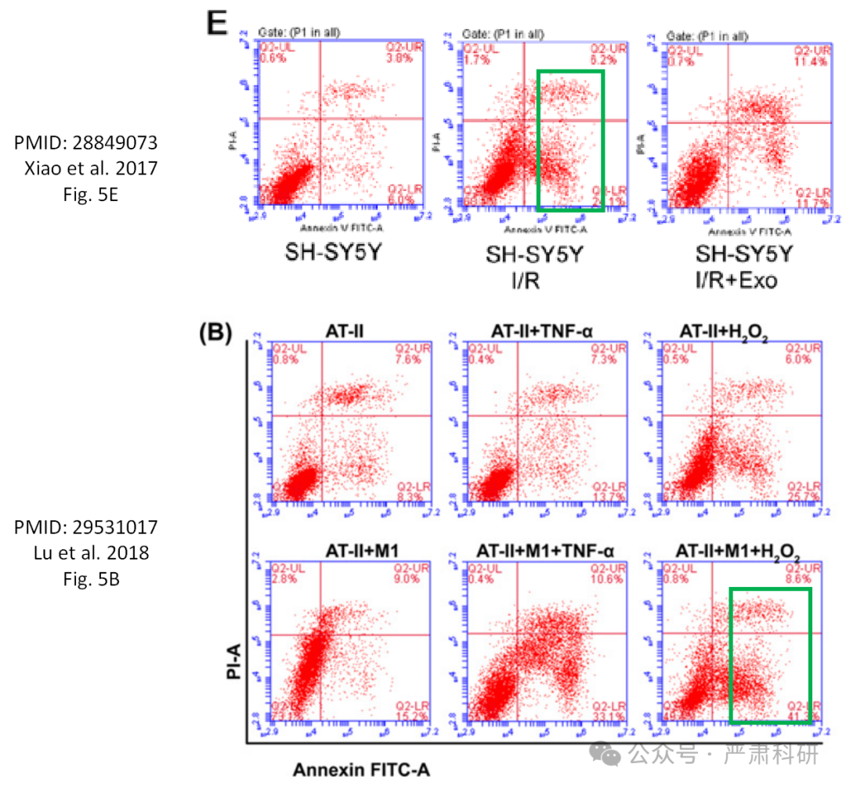

The following paper are affected:  
以下论文受到影响：

Paper 1: https://pubmed.ncbi.nlm.nih.gov/28849073/  
论文 1: https://pubmed.ncbi.nlm.nih.gov/28849073/

Paper 2: https://pubmed.ncbi.nlm.nih.gov/29531017/  
论文 2: https://pubmed.ncbi.nlm.nih.gov/29531017/

We will notify the publishers to resolve these issues.  
我们将通知出版商解决这些问题。

**参考信息  
https://portlandpress.com/bioscirep/article/38/2/BSR20171555/57138/Activation-of-M1-macrophages-plays-a-critical-role**

**https://pubpeer.com/publications/24F833F83FB334920EA5C2C520906E#0**

本平台对于科研问题的探讨，始终保持严谨、深入、持续、开放和创新的态度。所有推文信源，均来源于pubpeer、For Better Science等网站公开质疑。我们从来没有、也永远不会主动查重论文并去pubpeer上质疑。我们尊重他人的研究成果和贡献，通过交流和合作，共同推动科研领域的进步和发展。