[广西医科大学第一附院Bioengineered被质疑](https://mp.weixin.qq.com/s?__biz=MzUxODcwODMzMw==&mid=2247484056&idx=1&sn=ef630bdcdf3e8ccc4c98b1d0892d5906)

原创一只鱼[严肃科研](javascript:void(0);)2025-04-12 23:43:23四川

**“**秉持严谨、深入、持续、开放与创新的态度，尊重他人成果，携手交流共进，推动科研发展。**”**

**Research Frontline**

**科研前线**

01

—

**问题论文**

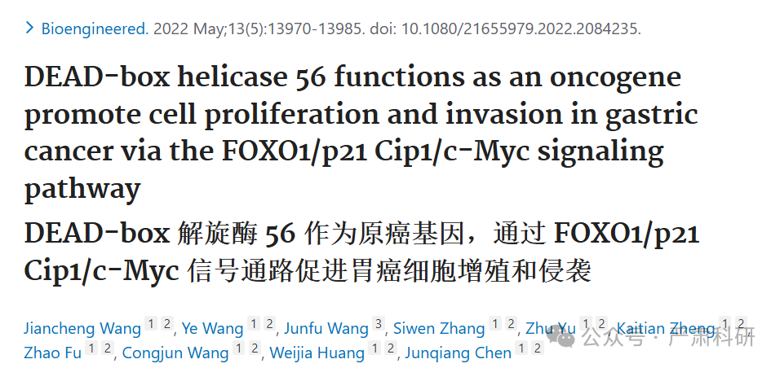

**标题：**DEAD-box helicase 56 functions as an oncogene promote cell proliferation and invasion in gastric cancer via the FOXO1/p21 Cip1/c-Myc signaling  pathway

**期刊：**Bioengineered

**单位：**广西医科大学第一附属医院

**发表时间：**2022年5月13日

**DOI:**10.1080/21655979.2022.2084235

**研究摘要：**

DEAD-box helicase (DDX) family exerts a critical effect on cancer initiation and progression through alternative splicing, transcription and ribosome biogenesis. Increasing evidence has demonstrated that DEAD-box helicase 56 (DDX56) is over-expressed in several cancers, which plays an oncogenic role. Till the present, the impact of DDX56 on gastric cancer (GC) remains unclear. We conducted high-throughput sequencing (RNA-seq) to demonstrate aberrant DDX56 levels within 10 GC and matched non-carcinoma tissue samples. DDX56 levels were detected through qRT-PCR, western blotting (WB) and immunochemical staining in GC patients. We conducted gain- and loss-of-function studies to examine DDX56's biological role in GC development. In vitro, we carried out 5?Ethynyl?2?deoxyuridine (EdU), scratch, Transwell, and flow cytometry (FCM) assays for detecting GC cell growth, invasion, migration and apoptosis. Additionally, gene set enrichment analysis (GSEA), WB assay, and Encyclopedia of RNA Interactomes (ENCORI) were carried out for analyzing DDX56-regulated downstream genes and signaling pathways. In vivo, tumor xenograft experiment was performed for investigating how DDX56 affected GC development within BALB/c nude mice. Functionally, DDX56 knockdown arrested cell cycle at G1 phase, invasion and migration of AGS and MKN28 cells, and enhanced their apoptosis. Ectopic DDX56 expression enhanced the cell growth, migration and invasion, and inhibited apoptosis. Knockdown of DDX56 suppressed GC growth in the tumor models of BALB/c nude mice. Mechanistically, DDX56 post-transcriptionally suppressed FOXO1/p21 Cip1 protein expression, which could activate its downstream cyclin E1/CDK2/c-Myc signaling pathways. This sheds lights on the GC pathogenic mechanism and offers a potential anti-cancer therapeutic target.  
DEAD-box 解旋酶（DDX）家族通过选择性剪接、转录和核糖体生物发生，对癌症的发生和发展起着关键作用。越来越多的证据表明，DEAD-box 解旋酶 56（DDX56）在多种癌症中过度表达，并发挥致癌作用。截至目前，DDX56 对胃癌（GC）的影响尚不清楚。我们进行了高通量测序（RNA-seq），以证明 10 例 GC 和匹配的非癌组织样本中 DDX56 水平的异常。在 GC 患者中，通过 qRT-PCR、Western 印迹（WB）和免疫化学染色检测 DDX56 水平。我们进行了功能获得和功能丧失研究，以检验 DDX56 在 GC 发展中的生物学作用。在体外，我们进行了 5-乙炔-2-脱氧尿苷（EdU）、划痕、Transwell 和流式细胞术（FCM）检测 GC 细胞生长、侵袭、迁移和凋亡。此外，还进行了基因集富集分析（GSEA）、WB 检测和 RNA 相互作用百科全书（ENCORI）分析，以分析 DDX56 调控的下游基因和信号通路。 体内，进行了肿瘤异种移植实验，以研究 DDX56 如何影响 BALB/c 裸鼠的 GC 发育。功能上，DDX56 敲低使细胞周期停滞在 G1 期，抑制了 AGS 和 MKN28 细胞的侵袭和迁移，并增强了它们的凋亡。异位表达 DDX56 增强了细胞生长、迁移和侵袭，并抑制了凋亡。DDX56 敲低抑制了 BALB/c 裸鼠肿瘤模型中的 GC 生长。机制上，DDX56 在转录后抑制了 FOXO1/p21 Cip1 蛋白的表达，这可以激活其下游的细胞周期 E1/CDK2/c-Myc 信号通路。这有助于阐明 GC 发病机制，并提供了潜在的抗癌治疗靶点。

02

—

**具体说明**

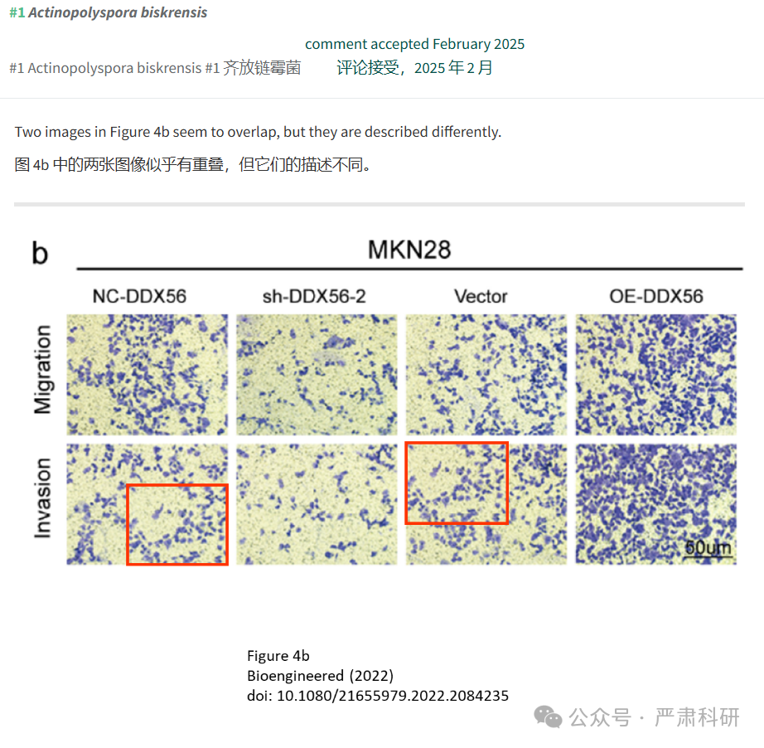

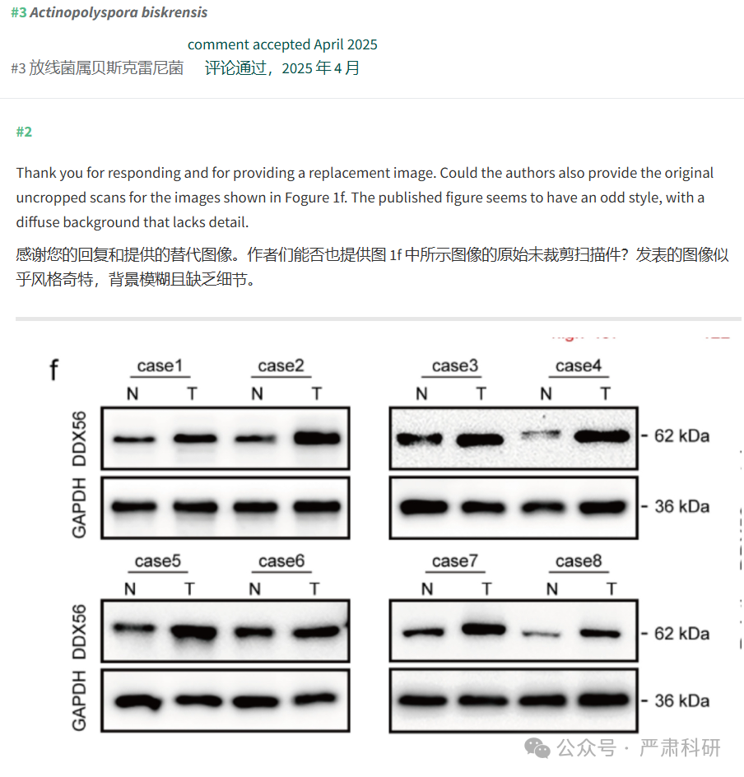

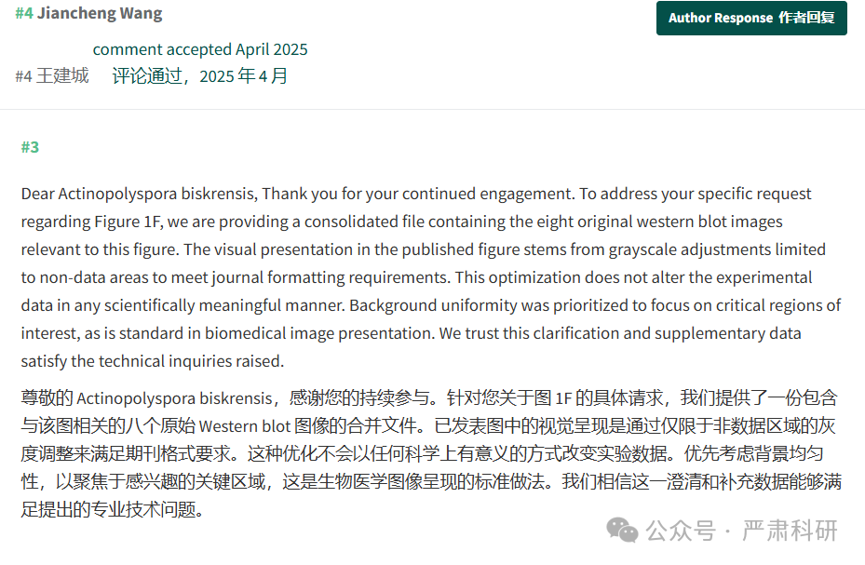

**参考信息  
https://pubmed.ncbi.nlm.nih.gov/35723050/**

**https://pubpeer.com/publications/46B3114976FEB73B61E99B889BA427#0**

本平台对于科研问题的探讨，始终保持严谨、深入、持续、开放和创新的态度。所有推文信源，均来源于pubpeer、For Better Science等网站公开质疑。我们从来没有、也永远不会主动查重论文并去pubpeer上质疑。我们尊重他人的研究成果和贡献，通过交流和合作，共同推动科研领域的进步和发展。