[存在多处图像重复使用且与不同机构无关论文图像重叠，北部战区总医院的论文被撤稿.PMID: 31170089](https://mp.weixin.qq.com/s?__biz=MzkzNjYxMTEzMA==&mid=2247532355&idx=2&sn=2ac01f955e2d9bffb3e8ad7d124be960)

DataTwin[DataTwin](javascript:void(0);)2025-04-19 12:21:57浙江

**点击上方蓝字**关注我们







**论文信息**

2019年6月5日，北部战区总医院整形与修复重建外科在Aging期刊上在线发表题为**"Apigenin inhibits growth and migration of fibroblasts by suppressing FAK signaling"**(芹菜素通过抑制FAK信号通路抑制成纤维细胞的生长和迁移)论文。

第一作者：北部战区总医院 Hongyi Wang，Bingyu Guo

通讯作者：北部战区总医院 Kai Tao（音译 陶凯）

本研究得到了辽宁省自然科学基金（20180550689）的支持。

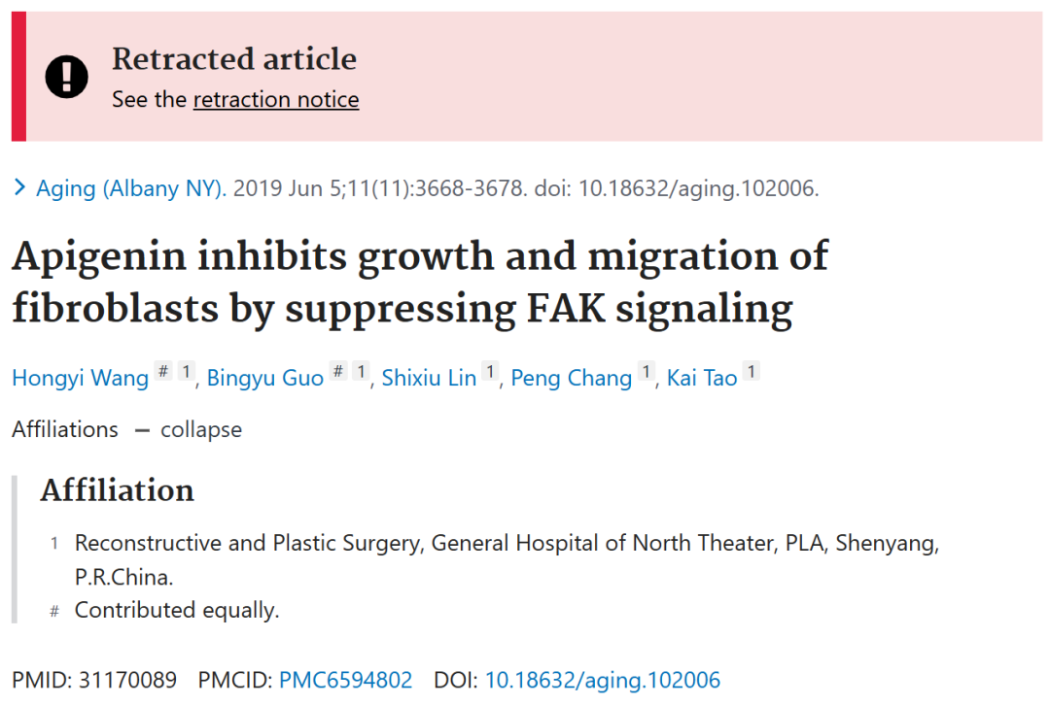





**质疑信息**

**#1**[above] Fig 2G/H from "miR-34a inhibits melanoma growth by targeting ZEB1" (Xu et al 2021).

[below] Fig 1H.

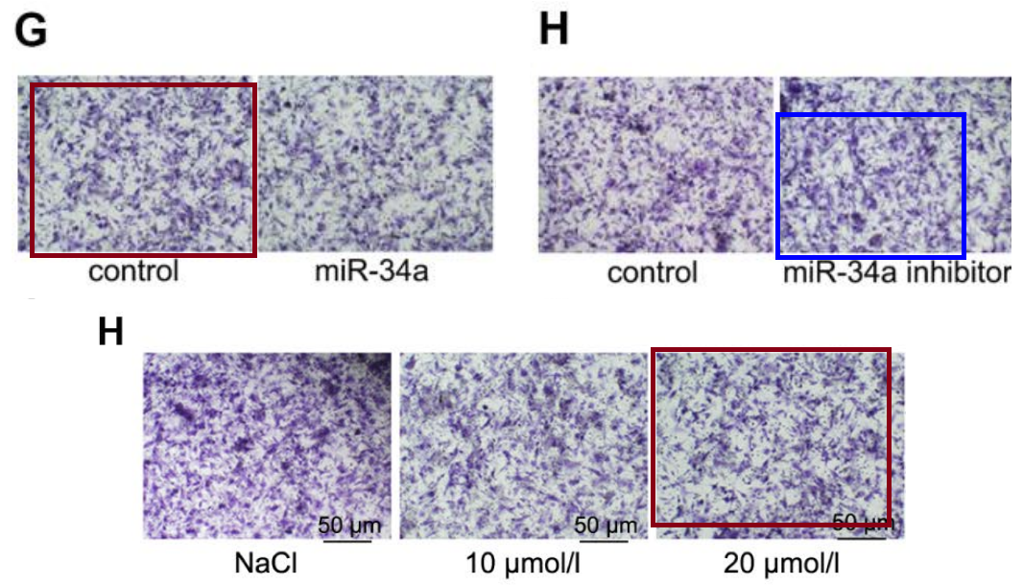

DataTwin图片查重

[left] Fig 1H,I.

[right] Figs 4A, 5B from "miR-627-3p inhibits osteosarcoma cell proliferation and metastasis by targeting PTN" (He et al 2019).

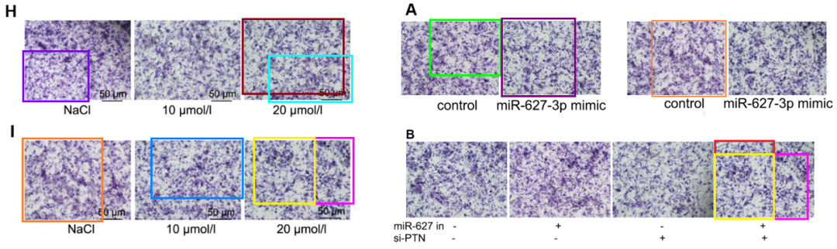

Fig 3E,F from "miR-548d-3p inhibits osteosarcoma by downregulating KRAS" (Chen et al 2019).

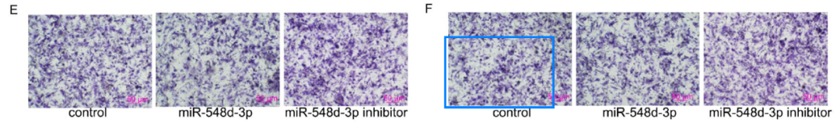

[above] Fig 5D from "Sulfated polysaccharide of Sepiella maindroni ink targets Akt and overcomes resistance to the FGFR inhibitor AZD4547 in bladder cancer" (Shan et al 2019).

[below] Fig 5B from "MicroRNA-506-3p inhibits osteosarcoma cell proliferation and metastasis by suppressing RAB3D expression" (Wang et al 2018).

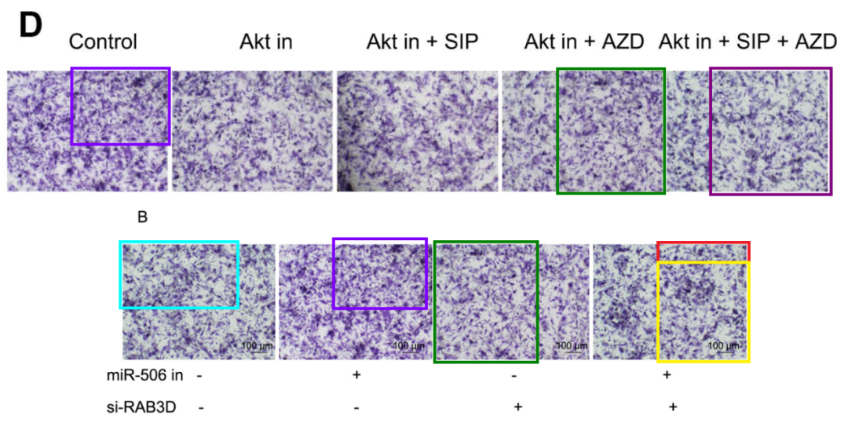

**#2**Fig 4A,B.

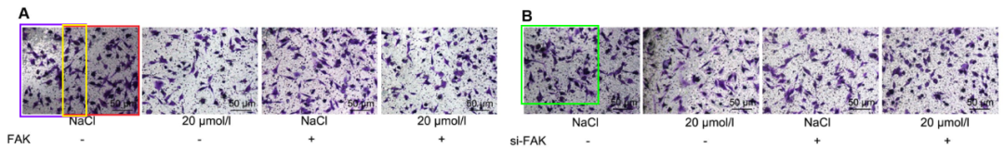

Left to right:

Fig 4D from "miR‐627‐3p inhibits osteosarcoma cell proliferation and metastasis by targeting PTN" (He et al 2019).

Fig 4C from "MicroRNA‐506‐3p inhibits osteosarcoma cell proliferation and metastasis by suppressing RAB3D expression" (Wang et al 2018).

Fig 3C,D from "miR-548d-3p inhibits osteosarcoma by downregulating KRAS" (Chen et al 2019).

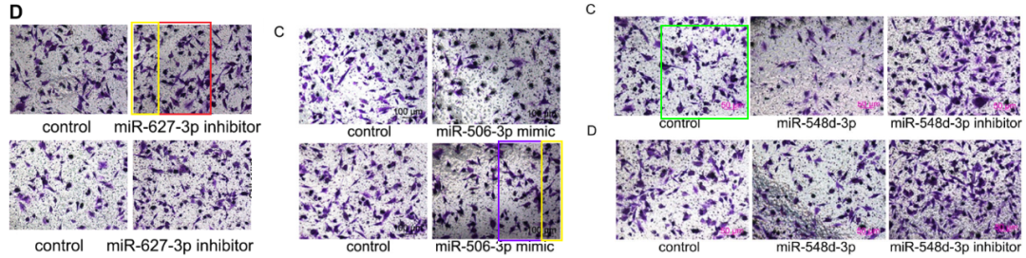

DataTwin图片查重

**#3**Figs 4A,b and 1G from "Apigenin inhibits growth and migration of fibroblasts by suppressing FAK signaling" (Wang et al 2019).

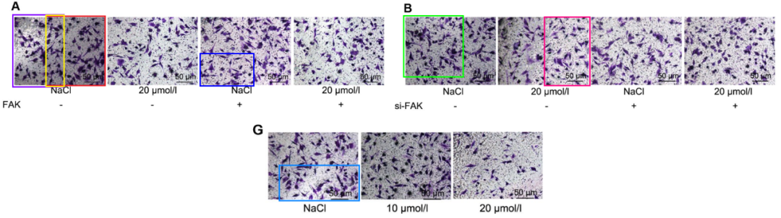

[above] Figs 4C from "Naringin targets Zeb1to suppress osteosarcoma cell proliferation and metastasis" (He et al 2018), and 4C from "Circular RNA circ\_001621 promotes osteosarcoma cells proliferation and migration by sponging miR-578 and regulating VEGF expression" (Ji et al 2020).

[below] Fig 4F,G from "Naringin suppresses the growth and motility of hypertrophic scar fibroblasts by inhibiting the kinase activity of Akt" (Song et al 2018).

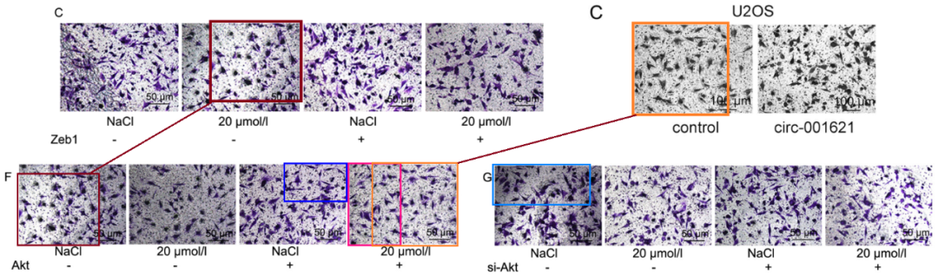

DataTwin图片查重



**撤稿原因**

**本文已于2025年3月26日被撤回：**

本文已被撤回：《衰老》杂志已完成对此论文的调查。我们发现存在多处图像重复使用的情况，且这些图像与来自不同机构的无关论文中的图像重叠。具体情况如下：

图1：

图1G中的跨孔分析图像重复使用了作者先前论文[1]中图4G的图像；

图1H中的对照跨孔分析图像在作者2021年的论文[2]（该论文已被撤回）的图2G中被重复使用；

图1H中的对照跨孔分析图像与已被撤回的论文[3]中图5D的一个无关图像重叠；

图1H、1I中的图像与先前发表的无关论文[4]中图5B的图像重叠；

此外，图1I中的图像与已被撤回的论文[5]中图4A和图5B的图像重叠；

另外，图1I中的图像在同时发表的论文[6]的图3F中被发现。

图4：

图4A、4B中的跨孔分析图像被发现与[1]中图4F、[4]中图4C、[5]中图4D以及[6]中图3C的图像重叠。

通讯作者告知我们，这些重叠是由于实验室数据存储不当造成的，并已申请撤回论文。鉴于这些发现，编辑部的决定是撤回该论文。所有作者均已同意此次撤回。

涉及文章

1. Song Y, Guo B, Ma S, Chang P, Tao K. Naringin suppresses the growth and motility of hypertrophic scar fibroblasts by inhibiting the kinase activity of Akt. Biomed Pharmacother. 2018; 105:1291–8. https://doi.org/10.1016/j.biopha.2018.06.103

2. Xu Y, Guo B, Liu X, Tao K. miR-34a inhibits melanoma growth by targeting ZEB1. Aging (Albany NY). 2021; 13:15538–47. https://doi.org/10.18632/aging.203114 [PubMed] Retraction in: Aging (Albany NY). 2024; 16:13432–3. https://doi.org/10.18632/aging.206155

3. Shan L, Liu W, Zhan Y. Sulfated polysaccharide of Sepiella maindroni ink targets Akt and overcomes resistance to the FGFR inhibitor AZD4547 in bladder cancer. Aging (Albany NY). 2019; 11:7780–95. https://doi.org/10.18632/aging.102286 [PubMed] Retraction in: Aging (Albany NY). 2024; 16:12652–3. https://doi.org/10.18632/aging.206104

4. Jiashi W, Chuang Q, Zhenjun Z, Guangbin W, Bin L, Ming H. MicroRNA-506-3p inhibits osteosarcoma cell proliferation and metastasis by suppressing RAB3D expression. Aging (Albany NY). 2018; 10:1294–305. https://doi.org/10.18632/aging.101468

5. He M, Shen P, Qiu C, Wang J. miR-627-3p inhibits osteosarcoma cell proliferation and metastasis by targeting PTN. Aging (Albany NY). 2019; 11:5744–56. https://doi.org/10.18632/aging.102157 [PubMed] Retraction in: Aging (Albany NY). 2024; 16:12953–4. https://doi.org/10.18632/aging.206128

6. Chen J, Yan C, Yu H, Zhen S, Yuan Q. miR-548d-3p inhibits osteosarcoma by downregulating KRAS. Aging (Albany NY). 2019; 11:5058–69. https://doi.org/10.18632/aging.102097

**参考信息**https://pubpeer.com/publications/49E8FA51C7EB37195240CC22E9B604https://pubmed.ncbi.nlm.nih.gov/31170089/https://www.aging-us.com/article/206230/text

**声明：**

任何单位或个人认为本内容可能涉嫌侵犯其合法权益，及时向我们提出书面权利通知及详细侵权情况，我们将会依法尽快移除相关涉嫌侵权的内容。

联系微信号：DataTwin



**往期报道精选**

[全网最低价！文件图片查重+比对Pubmed和Pubpeer数据库查重，DataTwin高效权威图片识别！众多知名打假人士推荐使用](http://mp.weixin.qq.com/s?__biz=MzkzNjYxMTEzMA==&mid=2247486008&idx=5&sn=43a2d45f61ed36770808541d737ca3cd&chksm=c29d566df5eadf7bcf1cee3ab814981f26fd4b8aef7a56bb740c999691685526232641ed1bc9&scene=21" \l "wechat_redirect" \t "_blank)

[一区Top9.2分，西安交通大学第二附属医院(西北医院)单涛等人论文撤稿。](http://mp.weixin.qq.com/s?__biz=MzkzNjYxMTEzMA==&mid=2247496577&idx=1&sn=5f6c203ab8c8a90910fb169fb557f09e&chksm=c29eafd4f5e926c23429d2cdbfa4b858d50d365ccedb076342024a06cdef3503285527c04f71&scene=21#wechat_redirect)

[图片重复未作解释，成武县人民医院岳彩云&山东第一医科大学第一附属医院（千佛山医院）杨敏等人论文被撤稿。](http://mp.weixin.qq.com/s?__biz=MzkzNjYxMTEzMA==&mid=2247496577&idx=2&sn=f7e9d4976a062f45ab4c82678d64d647&chksm=c29eafd4f5e926c22879afc68758ce79092ccd6e09bdcf84ed33af28cb858720cdd98d8d1f8b&scene=21#wechat_redirect)

[希腊期刊撤稿，涉与多篇重复的老问题，常州市第一人民医院整形烧伤科李玲巧论文撤回。](http://mp.weixin.qq.com/s?__biz=MzkzNjYxMTEzMA==&mid=2247496577&idx=3&sn=adf0cc7a805cb0b3022cee01276ed136&chksm=c29eafd4f5e926c25f570665cbfe7cf5453ccca0d903d47b581b521c3496e83427771694da50&scene=21#wechat_redirect)

[网友玩微信发现问题论文，浙江大学贺永教授、浙江大学医学院附属口腔医院石钰等人发表到Small的论文存在图片重复使用问题！](http://mp.weixin.qq.com/s?__biz=MzkzNjYxMTEzMA==&mid=2247496547&idx=1&sn=e28eef8cce3be96e2c9b87e9b47742f3&chksm=c29eaf36f5e926205da762928b9510337e641e83d400e166df0687fdaa0597e99598739585a7&scene=21#wechat_redirect)

[一篇声称新冠疫苗具有广泛危害的论文将被撤回，作者回应：出版社不允许对抗性陈述的论文存在](http://mp.weixin.qq.com/s?__biz=MzkzNjYxMTEzMA==&mid=2247496526&idx=1&sn=a7684678c2d1f7537332323923be6239&chksm=c29eaf1bf5e9260dff6cc8d0fa5823592736a87e03adaf78ed3aa67722776822efdf084c09eb&scene=21#wechat_redirect)

# [今日学术问题发现 | 兄弟借一步说话，看你是不是火眼金睛](http://mp.weixin.qq.com/s?__biz=MzkzNjYxMTEzMA==&mid=2247484202&idx=4&sn=6c887f60b170b0352211a4056136471d&chksm=c29d5f7ff5ead669026d14f9ce4fc72a33dc49b4872d0649ae332312a1497f95ee48b6e39aac&scene=21#wechat_redirect)

# [今日学术问题发现 | 你把Error Bar当作奖励给幼儿园小朋友的小红花？](http://mp.weixin.qq.com/s?__biz=MzkzNjYxMTEzMA==&mid=2247484202&idx=5&sn=6726065dc778f5d6f734f6d8e4bb4519&chksm=c29d5f7ff5ead669fa3cf39a0504fbcdd0a8856dc8e893c0c7d5a64114b6d7c0fd1bdd1274b6&scene=21#wechat_redirect)

[今日学术问题发现 | Table中的异常数据（PMID：26111626）](http://mp.weixin.qq.com/s?__biz=MzkzNjYxMTEzMA==&mid=2247484202&idx=6&sn=fa04280bf1e13fb388f5fcd7364dca92&chksm=c29d5f7ff5ead66915da906253ca3fcbdc95955d9bedfa1484acbbd6ec65069baea3c7617f17&scene=21#wechat_redirect)

[今日学术问题发现 | 不要侥幸，白天到黑夜，你还是你（荧光图片造假重复）](http://mp.weixin.qq.com/s?__biz=MzkzNjYxMTEzMA==&mid=2247484091&idx=3&sn=b4812492b782f5b1098df327c7118b29&chksm=c29d5eeef5ead7f8a36ba0a2fe28ebca0c0abf09d97a9c311ffe16fe8c6204436dafa6ed02af&scene=21#wechat_redirect)

[今日学术问题发现 | 山西医科大学贺婵婷等人论文数据图片出现多处重复](http://mp.weixin.qq.com/s?__biz=MzkzNjYxMTEzMA==&mid=2247484091&idx=4&sn=465b44b280962a59b5f3a38e18c7ccd1&chksm=c29d5eeef5ead7f8daf6a43c748db2b408fc71ae5377942fbc3ff48c3fe5b68be6a8808bb641&scene=21#wechat_redirect)

[Hepatology论文被质疑，南京医科大学第一附属医院孙倍成/南京大学医学院姜润秋教授发表的论文因图片重复](http://mp.weixin.qq.com/s?__biz=MzkzNjYxMTEzMA==&mid=2247495175&idx=2&sn=ff4146bc29b7ed9cefbbd2d02ba2454c&chksm=c29eb252f5e93b4416dd8000e979b09f21e70a7b0e188a9e8853a5957148362a894a5393c1e1&scene=21#wechat_redirect)

[DataTwin图片查重| 浙大医二院神经外科陈高教授发表的论文因图片重复被质疑](http://mp.weixin.qq.com/s?__biz=MzkzNjYxMTEzMA==&mid=2247495175&idx=3&sn=8cf91fc18af7e9230a0b51de678e4b77&chksm=c29eb252f5e93b44e6a3c09af3c60cbb0b41bf002b9e43946628019dc0250c78ec7f6301f816&scene=21#wechat_redirect)

[国家优青、海军军医大学（第二军医大学）药学院孙鹏教授发表的论文因图片重复被质疑](http://mp.weixin.qq.com/s?__biz=MzkzNjYxMTEzMA==&mid=2247495175&idx=4&sn=ceb343c415ac6e1eafde0114fff757b0&chksm=c29eb252f5e93b4452873038b8a8fa8593679122f3b552f04bfeff67d46e25d425d8a9ea08a1&scene=21#wechat_redirect)

[上海九院普外科刘斌发表的论文因图片重复被质疑](http://mp.weixin.qq.com/s?__biz=MzkzNjYxMTEzMA==&mid=2247495175&idx=5&sn=052dad49954ae38cdfcc83c7bf4bb92a&chksm=c29eb252f5e93b4449543cd4b808a98122448a7b588d2c3b0f41a03dace7e9f952d7fd128926&scene=21#wechat_redirect)

*END*



    客服微信：DataTwin



文件内部+Pubmed&Pubpeer数据库全网查重 请联系客服。