[南通大学神经再生重点实验室学者论文图片重复引起质疑](https://mp.weixin.qq.com/s?__biz=Mzk1Nzk5NzI3Mw==&mid=2247484640&idx=2&sn=49a48c7330c93c7b059d2c043a1be7f3)

原创观观[图片观察](javascript:void(0);)2025-04-11 20:05:42广东

这篇2020年发表的Biomaterials期刊，主要由Yahong Zhao , Yunyun Liang , Supeng Ding , Kunyu Zhang , Hai-quan Mao  , Yumin Yang共同完成，近期图片重复引起质疑

**论文信息**

标题：Application of conductive PPy/SF composite scaffold and      electrical stimulation for neural tissue engineering

作者：Yahong Zhao, Yunyun Liang, Supeng Ding, Kunyu Zhang, Hai-Quan      Mao, Yumin Yang

期刊：Biomaterials

发表日期：2020年10月

DOI：10.1016/j.biomaterials.2020.120164

单位：南通大学神经再生重点实验室、约翰霍普金斯大学材料科学与工程系

**质疑内容**

**#1** Archasia belfragei comment accepted April 2025

Figure 5A contains two panels that seem more similar than expected:

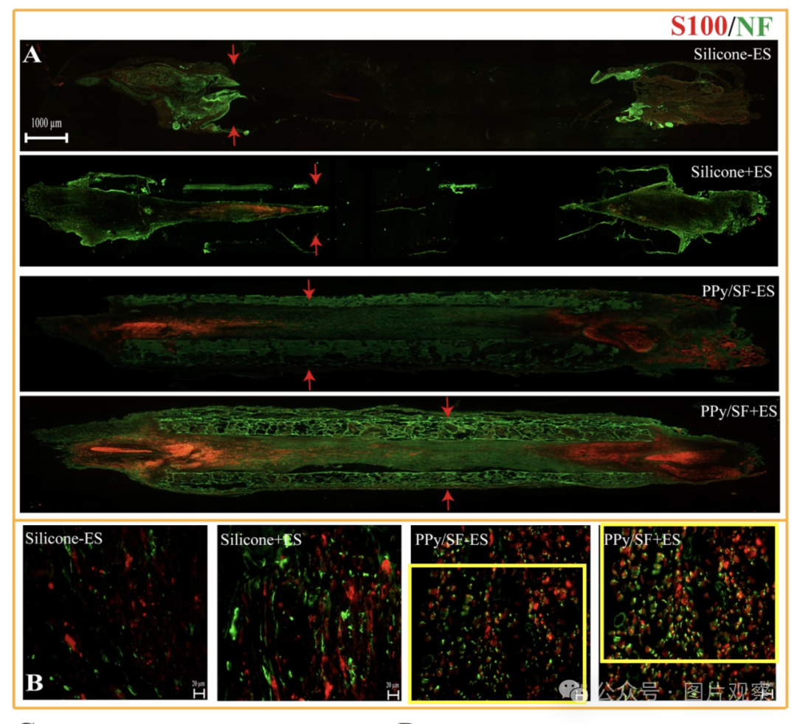

Could the authors clarify?

Archasia Belfragei

**#2**Archasia belfragei comment accepted April 2025

Figure 6, similarly, contains two panels with likely overlap:

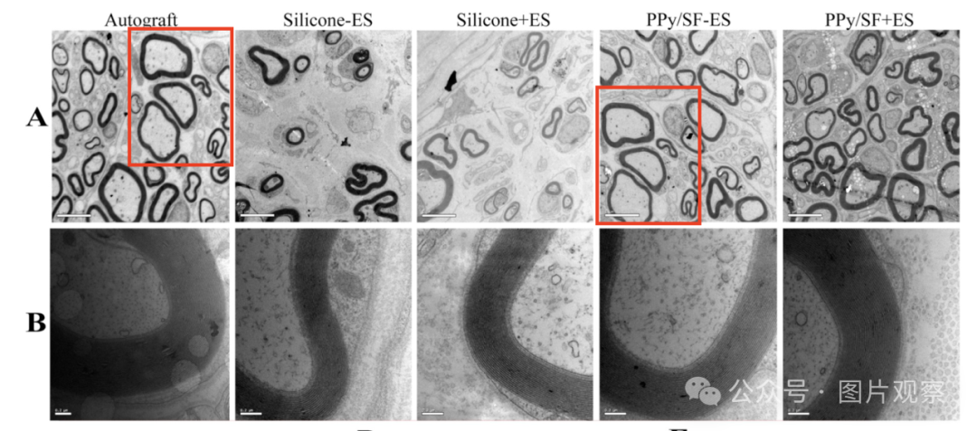

**#3**Illex illecebrosus comment accepted April 2025

#1

Click here to see animation video based on issues reported above.

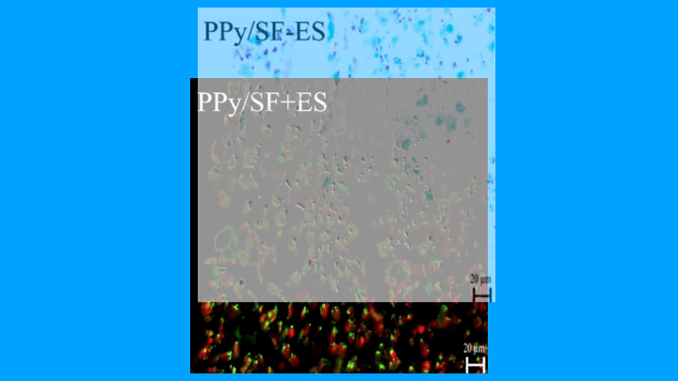

Other animations available here. Link to the relevant PubPeer post is in the description. Please note that we are not making any judgements but simply visualising observations by others.



**END**



**#**

**扫码关注我们**



Don't be ashamed



专注于国内论文质疑报道

**欢迎投稿联系**

[#南通大学](https://mp.weixin.qq.com/mp/appmsgalbum?__biz=Mzk1Nzk5NzI3Mw==&action=getalbum&album_id=3938931944225685517#wechat_redirect)