[江苏省人民医院某研究团队所发文章被质疑文章内发生图片重叠](https://mp.weixin.qq.com/s?__biz=MzIwNzc3MzU3NQ==&mid=2247484443&idx=2&sn=f338c5e0c63559b449bc3eaa2d4aab2f)

[诚信探索](javascript:void(0);)2025-04-16 17:24:33上海

2017 年 4 月 21 日，江苏省人民医院Li Qing 研究团队，在***Journal of experimental & clinical cancer research***上发表的题为**“Overexpression of miR-584-5p inhibits proliferation and induces apoptosis by targeting WW domain-containing E3 ubiquitin protein ligase 1 in gastric cancer”**的研究论文，**被质疑文章内发生图片重叠。**

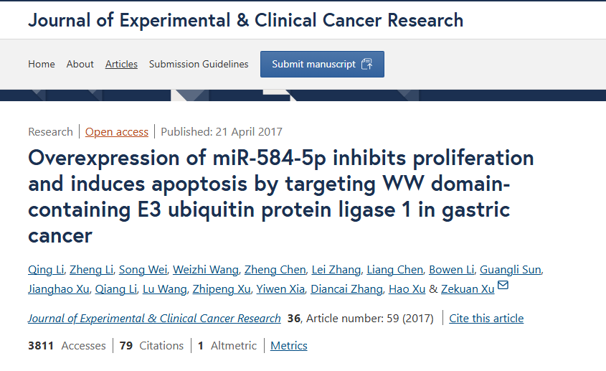

该文章于2021年11月在Pubpeer上被读者质疑：**文章内发生图片重叠。**

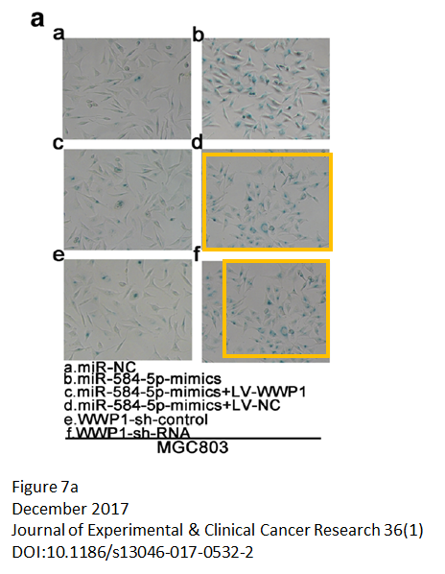

**国家自然科学基金委员会对江苏某高校Xu Zekuan等人发表的一篇论文涉嫌学术不端行为展开调查，涉及论文内容如下：**

Paper 1: Zekuan Xu*, et al. miR-664a-3p functions as an oncogene by targeting Hippo pathway in the development of gastric cancer. Cell Proliferation, 2019, 52(3): e12567. (Grant No. 81572362, 81361120398)

Paper 2: Zekuan Xu*, et al. Circular RNA circNRIP1 acts as a microRNA-149-5p sponge to promote gastric cancer progression via the AKT1/mTOR pathway. Molecular Cancer, 2019, 18(1): 20. (Grant No. 81572362, 81361120398)

Paper 3: Zekuan Xu*, et al. Circular RNA UBE2Q2 promotes malignant progression of gastric cancer by regulating signal transducer and activator of transcription 3-mediated autophagy and glycolysis. Cell Death and Disease, 2021, 12(10): 910. (Fund number 81871946, 82072708)

Paper 4: Zekuan Xu*, et al. Novel role of miR-133a-3p in repressing gastric cancer growth and metastasis via blocking autophagy-mediated glutaminolysis. Journal of Experimental & Clinical Cancer, 2018, 37(1): 320. (Fund No. 81572362, 81361120398)

Paper 5: Zekuan Xu*, et al. ZNF143 enhances metastasis of gastric cancer by promoting the process of EMT through PI3K/AKT signaling pathway. Tumor Biology, 2016, 37(9): 12813-12821. (Grant No. 81272712, 81572362, 812111519)

Paper 6: Zekuan Xu*, et al. miR-3174 Contributes to Apoptosis and Autophagic Cell Death Defects in Gastric Cancer Cells by Targeting ARHGAP10. Molecular Therapy: Nucleic Acids, 2017, 9: 294-311. (Grant No. 81361120398, 81572362)

Paper 7: Zekuan Xu*, et al. Overexpression of miR-584-5p inhibits proliferation and induces apoptosis by targeting WW domain-containing E3 ubiquitin protein ligase 1 in gastric cancer. Journal of Experimental & Clinical Cancer Research, 2017, 36(1): 59. (Fund number 81361120398, 81572362)

Paper 8: Zekuan Xu*, et al. Netrin-1 promotes gastric cancer cell proliferation and invasion via the receptor neogenin through PI3K/AKT signaling pathway. Oncotarget, 2017, 8(31): 51177-51189. (Fund No. 81572362, 81602080, 812111519)

Paper 9: Zekuan Xu*, et al. MiR-422a regulates cellular metabolism and malignancy by targeting pyruvate dehydrogenase kinase 2 in gastric cancer. Cell Death & Disease, 2018, 9(5): 505. (Fund No. 81572362, 81361120398)

Paper 10: Zekuan Xu*, et al. miR-874 functions as a tumor suppressor by inhibiting angiogenesis through STAT3/VEGF-A pathway in gastric cancer. Oncotarget, 2015, 6(3): 1605-17. (Grant No. 81361120398, 81272712, 30901421)

**相关消息**

https://pubpeer.com/publications/5F7A48EACC973E3B394C622547FEA3#0