[北京协和STTT图片被质疑，作者已回复](https://mp.weixin.qq.com/s?__biz=MzUxODcwODMzMw==&mid=2247484074&idx=1&sn=b3e821b8c2d0e8d0ddd670baee3e3a7a)

原创一只鱼[严肃科研](javascript:void(0);)2025-04-17 20:36:11四川

**“**秉持严谨、深入、持续、开放与创新的态度，尊重他人成果，携手交流共进，推动科研发展。**”**

**Research Frontline**

**科研前线**

01

—

**问题论文**

**标题：**Dysregulated ceramides metabolism by fatty acid 2-hydroxylase exposes a metabolic vulnerability to target cancer metastasis

**期刊：**Signal Transduction and Targeted Therapy

**单位：**中国医学科学院北京协和医学院

**发表时间：**2022年10月24日

**DOI:**10.1038/s41392-022-01199-1

**研究摘要：**

Whereas it is appreciated that cancer cells rewire lipid metabolism to survive and propagate, the roles of lipid metabolism in metastasis remain largely unknown. In this study, using esophageal squamous cell carcinoma (ESCC) as a pulmonary metastasis model, we find that the enzyme fatty acid 2-hydroxylase (FA2H), which catalyzes the hydroxylation of free fatty acids (FAs), is enriched in a subpopulation of ESCC cells with high metastatic potential, and that FA2H knockdown markedly mitigates metastatic lesions. Moreover, increased FA2H expression is positively associated with poor survival in patients with ESCC. Lipidomics analysis identifies that two dihydroceramides-Cer(d18:0/24:0) and Cer(d18:0/24:1)-are increased in FA2H-depleted metastasizing ESCC cells. Upon administration, Cer(d18:0/24:0) and Cer(d18:0/24:1) impair the formation of overt metastases in a mouse experimental metastasis model. Then, forkhead box protein C2 (FOXC2) and FA2H are found to be co-upregulated in metastatic ESCC cell populations and ESCC specimens, and FA2H expression is further experimentally verified to be transcriptionally induced by FOXC2, which is boosted per se by tumour necrosis factor α (TNFα), a critical pro-metastasis cytokine in the tumour microenvironment, in metastasizing cells. Together, these results demonstrate that TNFα-FOXC2-FA2H is a novel signaling axis to promote metastasis, and its downstream dihydroceramide products could be promising drugs to intervene in metastasis.  
癌症细胞重新配置脂质代谢以生存和传播，这一点得到了认可，但脂质代谢在转移中的作用仍 largely 未知。在本研究中，以食管鳞状细胞癌（ESCC）作为肺转移模型，我们发现催化游离脂肪酸（FAs）羟基化的酶脂肪酸 2-羟基化酶（FA2H）在具有高转移潜能的 ESCC 细胞亚群中富集，并且 FA2H 敲低显著减轻了转移性病变。此外，FA2H 表达增加与 ESCC 患者的不良预后呈正相关。脂质组学分析发现，两种二氢鞘脂-Cer(d18:0/24:0)和 Cer(d18:0/24:1)在 FA2H 耗竭的转移性 ESCC 细胞中增加。给予后，Cer(d18:0/24:0)和 Cer(d18:0/24:1)在实验性小鼠转移模型中损害了明显转移的形成。 然后，发现 forkhead box 蛋白 C2（FOXC2）和 FA2H 在转移性 ESCC 细胞群体和 ESCC 标本中共同上调，并且 FA2H 的表达通过实验进一步证实是由 FOXC2 转录诱导的，而 FOXC2 本身则由肿瘤坏死因子α（TNFα）增强，TNFα是肿瘤微环境中关键的促转移细胞因子，在转移细胞中增强。总之，这些结果表明 TNFα-FOXC2-FA2H 是促进转移的新型信号轴，其下游的二氢神经酰胺产物可能是干预转移的有希望的药物。

02

—

**具体说明**

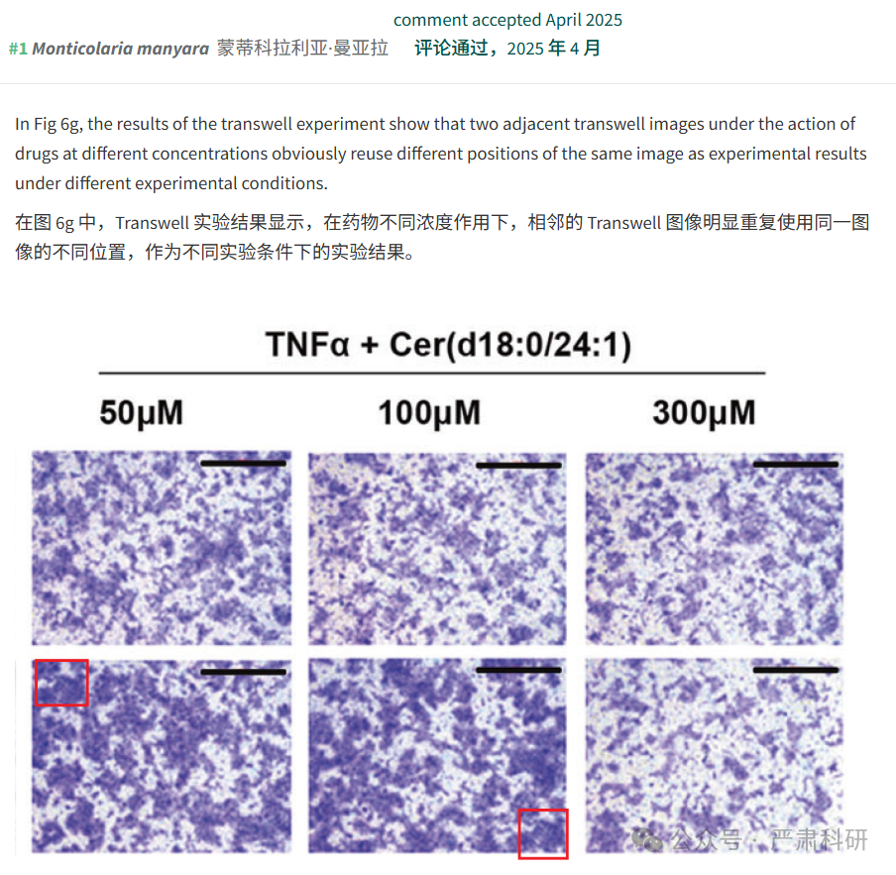

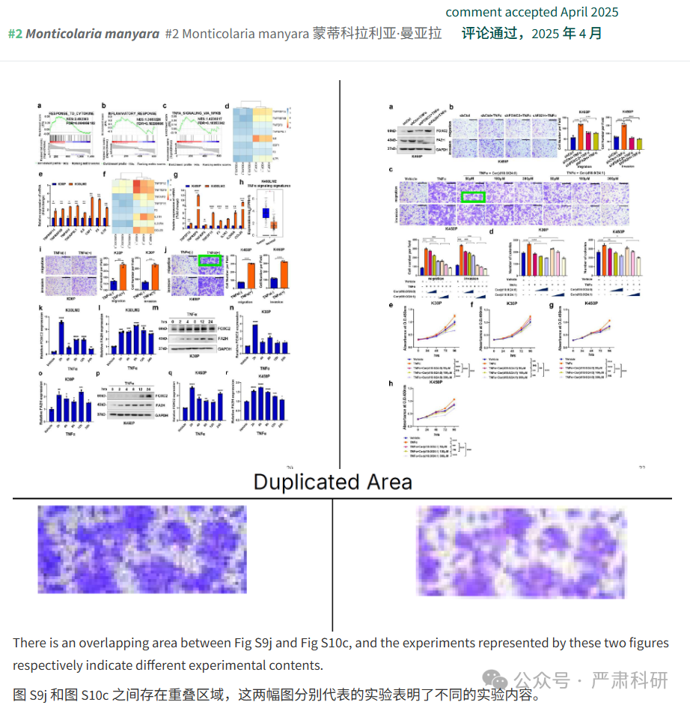

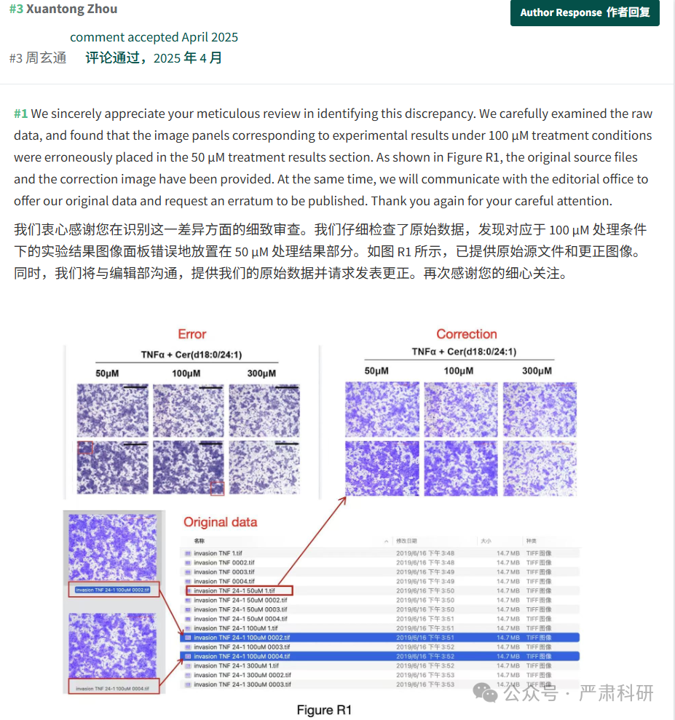

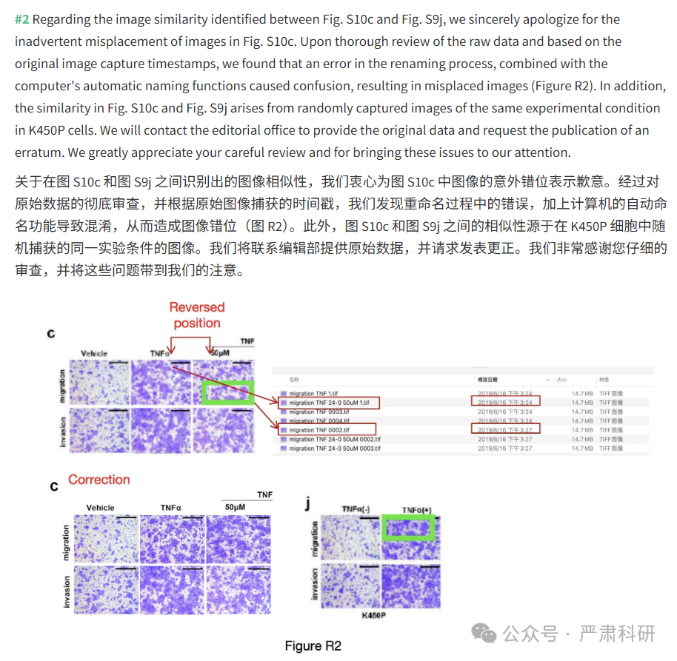

**参考信息  
https://pubmed.ncbi.nlm.nih.gov/36274060/**

**https://pubpeer.com/publications/84C82AD45DAC7F72CE7CC9E8DAE0D9#**

**本平台对于科研问题的探讨，始终保持严谨、深入、持续、开放和创新的态度。**

**所有推文信源，均来源于pubpeer、For Better Science等网站公开质疑。**

**我们从来没有、也永远不会主动查重论文并去pubpeer上质疑。**

**我们尊重他人的研究成果和贡献，通过交流和合作，共同推动科研领域的进步和**

**发展。**