[安徽建筑大学&广东工业大学合作论文被质疑图像造假！国自然基金资助，或可通报！](https://mp.weixin.qq.com/s?__biz=MzkxMDYyNzI5NQ==&mid=2247500843&idx=1&sn=d3b386f5a81af44964ae1e255446097b)

五棵松[学者探讨](javascript:void(0);)2025-04-17 13:35:00北京

2022年，主要分别来自安徽建筑大学环境与能源工程学院，广东工业大学土木与交通工程学院的 Wei Wei （第一作者，音译韦伟） , Haoyang Gong , Lin Sheng , Shuguang Zhu , Li Feng （通讯作者）在Journal of Alloys and Compounds 期刊发表了一篇论文，题目为: Loading Rh single atoms onto hollow cubic Cu2MoS4 nanoparticles for decreased electron/hole recombination and increased photocatalytic performance。

作者感谢以下机构提供的资金支持：安徽省教育厅自然科学基金重点项目（中国）（编号：KJ2019A0756）、安徽建筑大学研究项目基金（中国合肥）（编号：2018QD08）、安徽省自然科学基金（中国）（编号：1908085QE249）、安徽省重点研发计划：一般重点项目（编号：201904A07020070）以及中国国家自然科学基金（编号：52000036）。

**2022年1月，国际著名职业学术打假人Hoya camphorifolia 在 Pubpeer 论坛发表评论：**

图 1.

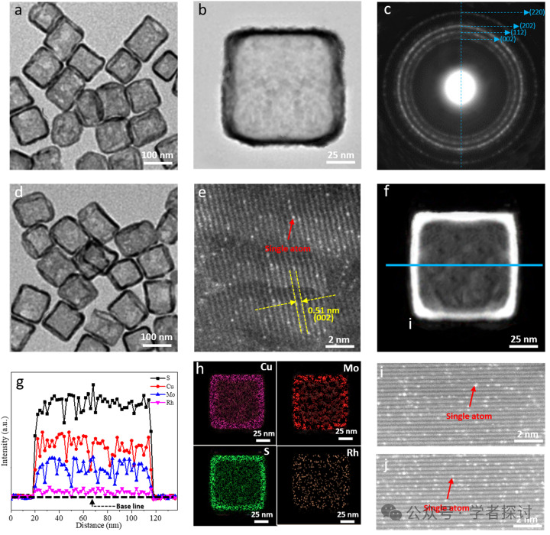

令人感兴趣的特征包括图（b）中出乎意料的镜像对称……

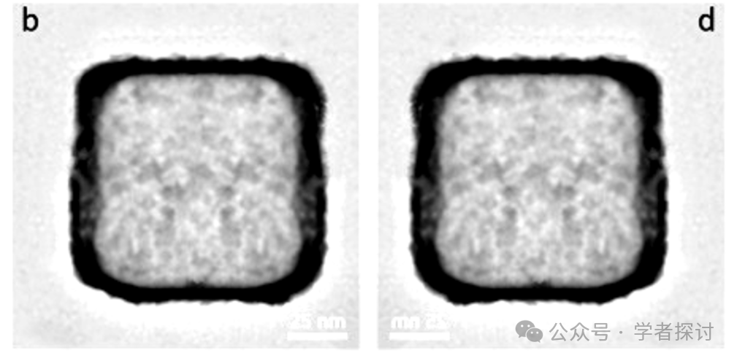

如图所示，当图（b）进行镜像翻转、黑白反转并与自身叠加时，其抵消程度。

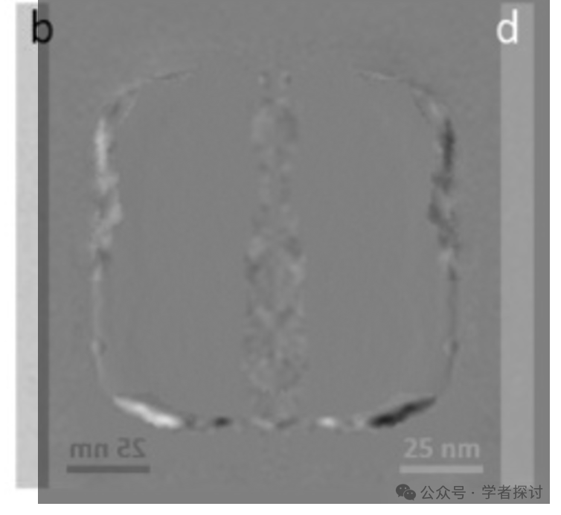

如何解释图（e）中的重复现象？

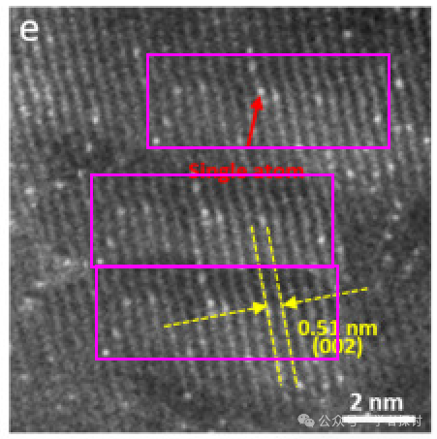

图（a）和[垂直翻转的]图（d）之间出现意外重叠。据称是不同的材料。

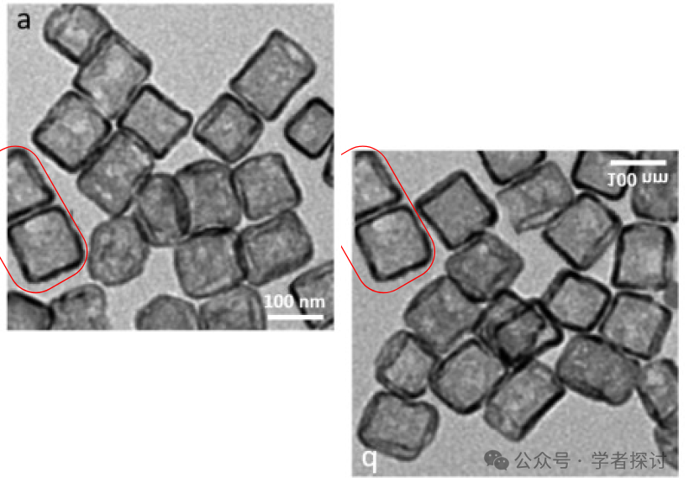

**2025年4月，Hoya camphorifolia 继续发表新质疑：**

**引文被赋予了一些有问题的接受者：**

Robust structure regulation of geopolymer as novel efficient amine support to prepare high-efficiency CO2 capture solid sorbent Hao Chen, Sheying Dong, Yaojun Zhang, Panyang He 2022, Chemical Engineering Journal

Peracetic acid enhanced electrochemical advanced oxidation for organic pollutant elimination Deling Yuan, Kai Yang, Shiyu Pan, Yao Xiang, Shoufeng Tang, Liting Huang, Mengting Sun, Xiaoyu Zhang, Tifeng Jiao, Qingrui Zhang, Bing Li 2021, Separation and Purification Technology

High-temperature stability of dielectric and energy-storage properties of weakly-coupled relaxor (1-x)BaTiO3-xBi(Y1/3Ti1/2)O3 ceramics Cuiying Ma, Huiling Du, Jia Liu, Le Kang, Xian Du, Xueyan Xi, Hongpei Ran 2021, Ceramics International

Effects of A/B-Site Co-Doping on Microstructure and Dielectric Thermal Stability of AgNbO3 Ceramics Hongpei Ran, Huiling Du, Cuiying Ma, Yingying Zhao, Danni Feng, Hang Xu 2021, Science of Advanced Materials

Accelerated photocatalytic degradation of tetracycline hydrochloride over CuAl2O4/g-C3N4 p-n heterojunctions under visible light irradiation Wei Chen, Jian Huang, Zhi-Cai He, Xiong Ji, Yun-Fei Zhang, Hua-Li Sun, Kai Wang, Zheng-Wei Su 2021, Separation and Purification Technology

MoS2 co-catalysis promoted CaO2 Fenton-like process: Performance and mechanism Mengzhen Zhao, Yao Xiang, Xuping Jiao, Bo Cao, Shoufeng Tang, Ziye Zheng, Xiaoyu Zhang, Tifeng Jiao, Deling Yuan 2021, Separation and Purification Technology

Fabrication of Cu2MoS4 decorated WO3 nano heterojunction embedded on chitosan: Robust photocatalytic efficiency, antibacterial performance, and bacteria detection by peroxidase activity Haitao Lin, Tao Li, Baadal Jushi Janani, Ali Fakhri 2021, Journal of Photochemistry and Photobiology B Biology

Ferric ion-ascorbic acid complex catalyzed calcium peroxide for organic wastewater treatment: Optimized by response surface method Deling Yuan, Chen Zhang, Shoufeng Tang, Zetao Wang, Qina Sun, Xiaoyu Zhang, Tifeng Jiao, Qingrui Zhang 2021, Chinese Chemical Letters -

Simultaneous Unknown Input and State Estimation for the Linear System with a Rank‐Deficient Distribution Matrix Yu Hua, Na Wang, Keyou Zhao 2021, Mathematical Problems in Engineering

Constructing Straight Pores and Improving Mechanical Properties of Gangue-Based Porous Ceramics Hang Xu, Huiling Du, Le Kang, Qiudi Cheng, Danni Feng, Siyu Xia 2021, Journal of Renewable Materials

Application of a simazine degrading bacterium, Arthrobacter ureafaciens XMJ‐Z01 for bioremediation of simazine pollution Jiangwei Zhu, Yan Zhao, Li Fu, Zongmin Liu, Xiaolou Li, Zili Meng 2020, Water and Environment Journal

**消息来源：**

https://pubpeer.com/publications/FFAA109BED5529A197AB8678B7BF83#0

**郑重声明：**

我们的全网查重系统收录了 Pubmed 和 Pubpeer 中的 7000 万 +已发表图库，让您的待查图片可以和已发表论文的图片进行对比，防止图片误用，为您的论文发表保驾护航！基于AI人工智能大数据算法，提供论文图片的核查服务，方便学术期刊、高校、研院所等科研管理部门及时发现并纠正结果图片不当使用。

**如果您有任何建议或需要图片查重帮助，请随时通过客服QQ号3639926437与我们联系。**

[#安徽建筑大学](https://mp.weixin.qq.com/mp/appmsgalbum?__biz=MzkxMDYyNzI5NQ==&action=getalbum&album_id=3947267467067441156#wechat_redirect)[#广东工业大学](https://mp.weixin.qq.com/mp/appmsgalbum?__biz=MzkxMDYyNzI5NQ==&action=getalbum&album_id=3947267465221947399#wechat_redirect)