[武汉大学&中科院Journal of Pharmaceutical Analysis被质疑](https://mp.weixin.qq.com/s?__biz=MzUxODcwODMzMw==&mid=2247483999&idx=1&sn=1a3d566c32587894ed4001ed32ca8800)

原创一只鱼[严肃科研](javascript:void(0);)2025-03-31 22:06:54四川

**“**秉持严谨、深入、持续、开放与创新的态度，尊重他人成果，携手交流共进，推动科研发展。**”**

**Research Frontline**

**科研前线**

01

—

**问题论文**

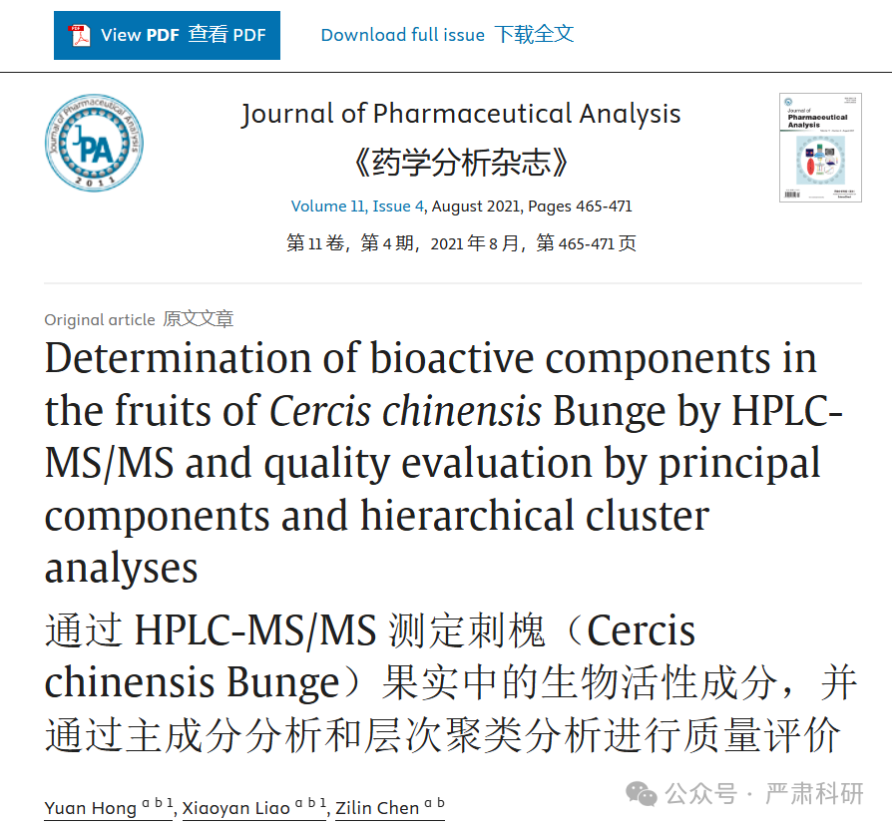

**标题：Determination of bioactive components in the fruits of Cercis chinensis Bunge by HPLC-MS/MS and quality evaluation by principal components and hierarchical cluster analyses**

**期刊：**Journal of Pharmaceutical Analysis

**单位：**武汉大学国家教育部重点开放实验室&中国科学院国家传感器技术重点实验室

**发表时间：**2021年8月30日

**DOI:**10.1016/j.jpha.2020.07.010

**研究摘要：**

The fruits of leguminous plants *Cercis Chinensis* Bunge are still overlooked although they have been reported to be antioxidative because of the limited information on the phytochemicals of *C. chinensis* fruits. A simple, rapid and sensitive HPLC-MS/MS method was developed for the identification and quantitation of the major bioactive components in *C. chinensis* fruits. Eighteen polyphenols were identified, which are first reported in *C. chinensis* fruits. Moreover, ten components were simultaneously quantified. The validated quantitative method was proved to be sensitive, reproducible and accurate. Then, it was applied to analyze batches of *C. chinensis* fruits from different phytomorph and areas. The principal components analysis (PCA) realized visualization and reduction of data set dimension while the hierarchical cluster analysis (HCA) indicated that the content of phenolic acids or all ten components might be used to differentiate *C. chinensis* fruits of different phytomorph.  
豆科植物刺槐（Cercis Chinensis Bunge）的果实尽管因有关刺槐果实植物化学成分的信息有限而被报道具有抗氧化性，但仍被忽视。开发了一种简单、快速、灵敏的 HPLC-MS/MS 方法，用于鉴定和定量刺槐果实中的主要生物活性成分。鉴定出 18 种多酚，这是首次在刺槐果实中报道。此外，同时定量了 10 种成分。经过验证的定量方法被证明是灵敏、可重复和准确的。然后，将其应用于分析来自不同植物形态和地区的刺槐果实批次。主成分分析（PCA）实现了数据集维度的可视化和降维，而层次聚类分析（HCA）表明，酚酸或所有 10 种成分的含量可能被用来区分不同植物形态的刺槐果实。

02

—

**具体说明**

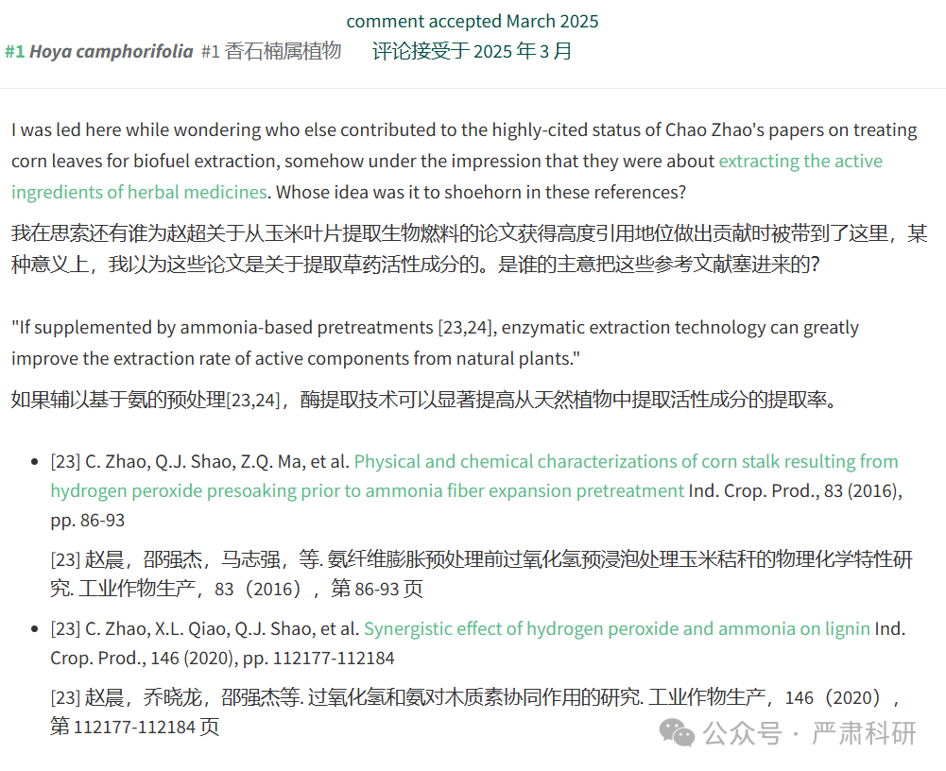

**参考信息  
https://www.sciencedirect.com/science/article/pii/S209517792031039X?via%3Dihub**

**https://pubpeer.com/publications/FA73A3B1A6FE0026A844E3D6AF1E5C#0**

**本平台对于科研问题的探讨，始终保持严谨、深入、持续、开放和创新的态度。**

**所有推文信源，均来源于pubpeer、For Better Science等网站公开质疑。**

**我们从来没有、也永远不会主动查重论文并去pubpeer上质疑。**

**我们尊重他人的研究成果和贡献，通过交流和合作，共同推动科研领域的进步和**

**发展。**