[吉林大学第一医院Med. Sci. Monit因图片重复被质疑](https://mp.weixin.qq.com/s?__biz=MzUxODcwODMzMw==&mid=2247483993&idx=1&sn=3ed06489bbaaebbf3d5212a9bb21f33d)

原创一只鱼[严肃科研](javascript:void(0);)2025-03-29 21:40:10四川

**“**秉持严谨、深入、持续、开放与创新的态度，尊重他人成果，携手交流共进，推动科研发展。**”**

**Research Frontline**

**科研前线**

01

—

**问题论文**

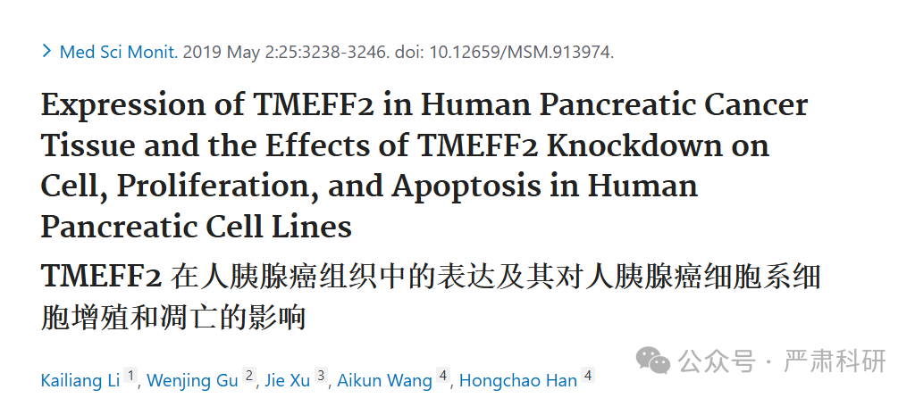

**标题：**Expression of TMEFF2 in Human Pancreatic Cancer Tissue and the Effects of TMEFF2 Knockdown on Cell, Proliferation, and Apoptosis in Human Pancreatic Cell Lines

**期刊：**Medical science monitor : international medical journal of experimental and clinical research

**单位：**吉林大学第一医院

**发表时间：**2019年5月2日

**DOI:**10.12659/msm.913974

**研究摘要：（中英双语）**

**BACKGROUND** The TMEFF2 gene encodes the transmembrane protein with EGF like and two follistatin-like domains 2 and has been reported to be a tumor suppressor gene, but its role remains unknown in pancreatic cancer. This study aimed to investigate the expression of TMEFF2 in human pancreatic cancer tissue and the effects of knockdown of TMEFF2 on cell, proliferation, and apoptosis in human pancreatic cell lines.

**MATERIAL AND METHODS** Thirty-five samples of human pancreatic tissue and adjacent normal pancreatic tissue, and five human pancreatic cancer cell lines, CAPAN1, ASPC1, BXPC3, SW1990, and CFPAC were studied. RNA expression, protein expression, cell proliferation, and apoptosis were studied using real-time polymerase chain reaction (RT-PCR), Western blot, the cell counting kit-8 (CCK-8) assay, and ?ow cytometry, respectively. A co-immunoprecipitation assay evaluated protein interactions. RESULTS TMEFF2 expression was down-regulated in pancreatic cancer tissue compared with normal pancreas. In human pancreatic cancer cell lines, overexpression of TMEFF2 suppressed cell proliferation and enhanced apoptosis, suppressed the expression of p-STAT3, MCL1, VEGF and increased the expression of the tyrosine-specific protein phosphatase, SHP-1. The co-immunoprecipitation assay showed that TMEFF2 interacted with SHP-1. Knockdown of expression of TMEFF2 resulted in the increased expression of p-STAT3, MCL1, and VEGF, increased cell proliferation and decreased cell apoptosis, which were reversed by overexpression of SHP-1.

**CONCLUSIONS** In pancreatic cancer, TMEFF2 exerted as a tumor suppressor effect by regulating p-STAT3, MCL1, and VEGF via SHP-1.  
背景：TMEFF2 基因编码具有 EGF 样结构和两个 follistatin 样结构域 2 的跨膜蛋白，已被报道为一种肿瘤抑制基因，但其作用在胰腺癌中尚不清楚。本研究旨在调查 TMEFF2 在人类胰腺癌组织中的表达以及敲低 TMEFF2 对人类胰腺癌细胞系细胞增殖和凋亡的影响。

材料与方法：研究了 35 例人类胰腺组织和邻近的正常胰腺组织样本，以及 5 个人类胰腺癌细胞系 CAPAN1、ASPC1、BXPC3、SW1990 和 CFPAC。分别使用实时聚合酶链反应（RT-PCR）、Western 印迹、细胞计数试剂盒-8（CCK-8）试验和流式细胞术研究 RNA 表达、蛋白表达、细胞增殖和凋亡。共免疫沉淀试验评估蛋白相互作用。结果：与正常胰腺相比，胰腺癌组织中 TMEFF2 表达下调。 在人胰腺癌细胞系中，TMEFF2 过表达抑制细胞增殖并增强细胞凋亡，抑制 p-STAT3、MCL1、VEGF 的表达，并增加酪氨酸特异性蛋白磷酸酶 SHP-1 的表达。共免疫沉淀实验显示 TMEFF2 与 SHP-1 相互作用。TMEFF2 表达敲低导致 p-STAT3、MCL1 和 VEGF 表达增加，细胞增殖增加和细胞凋亡减少，这些效应可通过 SHP-1 过表达逆转。

结论：在胰腺癌中，TMEFF2 通过调节 p-STAT3、MCL1 和 VEGF 通过 SHP-1 发挥肿瘤抑制效应。

02

—

**具体说明**

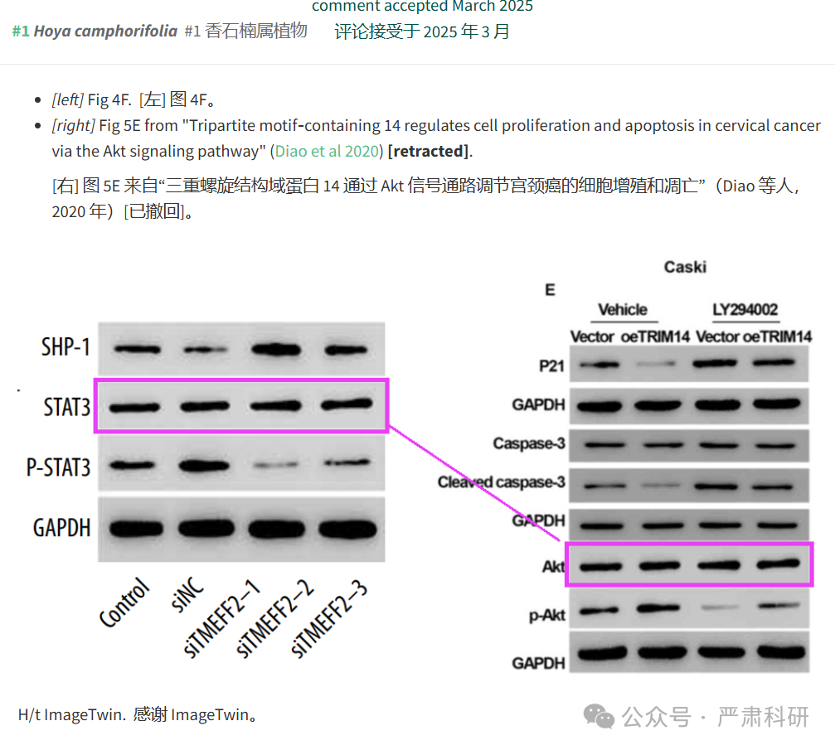

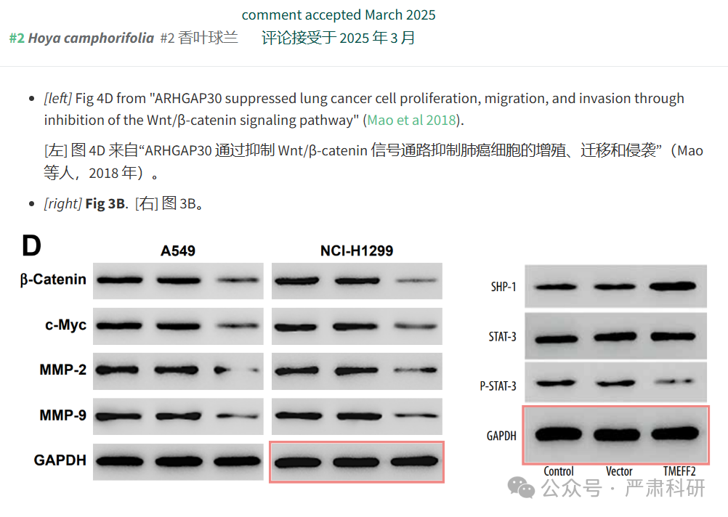

**参考信息  
https://pubmed.ncbi.nlm.nih.gov/31044775/**

**https://pubpeer.com/publications/E0AE4098593398989C91212176697B#0**

**本平台对于科研问题的探讨，始终保持严谨、深入、持续、开放和创新的态度。**

**所有推文信源，均来源于pubpeer、For Better Science等网站公开质疑。**

**我们从来没有、也永远不会主动查重论文并去pubpeer上质疑。**

**我们尊重他人的研究成果和贡献，通过交流和合作，共同推动科研领域的进步和**

**发展。**