[上海交通大学附属六院Cancer Management and Research图片重复被质疑](https://mp.weixin.qq.com/s?__biz=MzUxODcwODMzMw==&mid=2247483986&idx=1&sn=539ebddfed43d950c2dd233c27624f16)

原创一只鱼[严肃科研](javascript:void(0);)2025-03-28 22:52:04四川

**“**秉持严谨、深入、持续、开放与创新的态度，尊重他人成果，携手交流共进，推动科研发展。**”**

**Research Frontline**

**科研前线**

01

—

**问题论文**

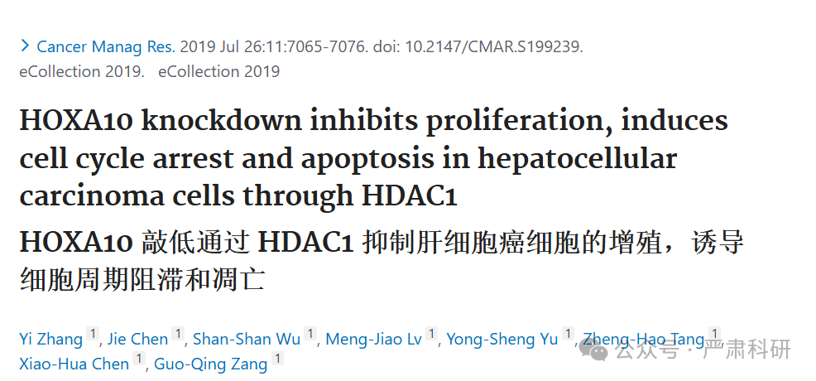

**标题：**HOXA10 knockdown inhibits proliferation, induces cell cycle arrest and apoptosis in hepatocellular carcinoma cells through HDAC1

**期刊：**Cancer Management and Research

**单位：**上海交通大学附属第六人民医院

**发表时间：**2019年7月26日

**DOI:**10.2147/cmar.s199239

**研究摘要：**

**Background:**Homeobox A10 (HOXA10) has been implicated in the development and progression of various human cancers. However, the precise biological functions of HOXA10 in hepatocellular carcinoma (HCC) have not been defined.  
背景：Homeobox A10（HOXA10）与多种人类癌症的发生和发展有关。然而，HOXA10 在肝细胞癌（HCC）中的确切生物学功能尚未明确。

**Methods:**In this study, we examined mRNA expression by quantitative real-time PCR (qRT-PCR) of HOXA10 as well as histone deacetylase (HDAC) and protein levels by Western blot of HOXA10, HDAC1, Cyclin D1, proliferating cell nuclear antigen (PCNA), Survivin and p53 acetylation in HCC tissues and cell lines. We also assessed cell proliferation using Cell Counting Kit-8 (CCK-8) and analyzed cell cycle by flow cytometry. Furthermore, tumor growth of HCC cells in vivo was monitored using the nude mouse xenograft model. Finally, HDAC1 promoter activity and binding in HCC cell lines were detected by luciferase reporter assay and chromatin immunoprecipitation (ChIP), respectively.  
方法：本研究通过定量实时 PCR（qRT-PCR）检测 HOXA10 mRNA 表达，以及通过 Western blot 检测 HCC 组织和细胞系中 HOXA10、HDAC1、Cyclin D1、增殖细胞核抗原（PCNA）、Survivin 和 p53 乙酰化水平。我们还使用细胞计数试剂盒-8（CCK-8）评估细胞增殖，并通过流式细胞术分析细胞周期。此外，使用裸鼠异种移植模型监测 HCC 细胞在体内的肿瘤生长。最后，通过荧光素酶报告基因检测和染色质免疫沉淀（ChIP）分别检测 HCC 细胞系中 HDAC1 启动子活性和结合。

**Results:**We uncovered the elevated expression of HOXA10 in HCC tissues compared to adjacent normal liver tissues. RNA interference-mediated knockdown of HOXA10 inhibited HCC cell proliferation both in vitro and in vivo. HOXA10 knockdown also induced cell cycle arrest at G0/G1 phase and apoptosis, which were accompanied with the reduced expression of Cyclin D1, PCNA and Survivin. Notably, HOXA10 knockdown enhanced p53 acetylation (Lys382), which is crucial to the activation of p53. Likewise, HOXA10 knockdown suppressed the transcription of HDAC1, a potential deacetylase for p53. In line with these observations, HDAC1 downregulation abrogated the effects of HOXA10 overexpression on proliferation, cell cycle progression, apoptosis and p53 acetylation, indicating the role of HDAC1 in mediating HOXA10 functions.  
结果：与邻近的正常肝组织相比，我们发现 HCC 组织中 HOXA10 表达上调。RNA 干扰介导的 HOXA10 敲低在体外和体内均抑制了 HCC 细胞的增殖。HOXA10 敲低还诱导细胞周期在 G0/G1 期停滞和凋亡，伴随着 Cyclin D1、PCNA 和 Survivin 表达的降低。值得注意的是，HOXA10 敲低增强了 p53 乙酰化（Lys382），这对于 p53 的激活至关重要。同样，HOXA10 敲低抑制了 HDAC1 的转录，HDAC1 是 p53 的潜在去乙酰化酶。与这些观察结果一致，HDAC1 的下调消除了 HOXA10 过表达对增殖、细胞周期进程、凋亡和 p53 乙酰化的影响，表明 HDAC1 在介导 HOXA10 功能中的作用。

**Conclusion:**Our results demonstrate that HOXA10 knockdown inhibits proliferation, induces cell cycle arrest and apoptosis in HCC cells by regulating HDAC1 transcription.  
结论：我们的结果表明，通过调节 HDAC1 转录，HOXA10 敲低抑制了 HCC 细胞的增殖，诱导细胞周期阻滞和凋亡。

02

—

**具体说明**

#1 ***Hoya camphorifolia***  comment accepted January 2023  
评论接受于 2023 年 1 月

* *[left]*

 Fig 2A.  [左] 图 2A。

* *[right]*

 Fig 6b from "Discovery of LAMP-2A as potential biomarkers for glioblastoma development by modulating apoptosis through N-CoR degradation" (Wang et al 2021).  
[右] 图 6b 来自“通过 N-CoR 降解调节细胞凋亡，发现 LAMP-2A 作为胶质母细胞瘤发展的潜在生物标志物”（王等，2021 年）。

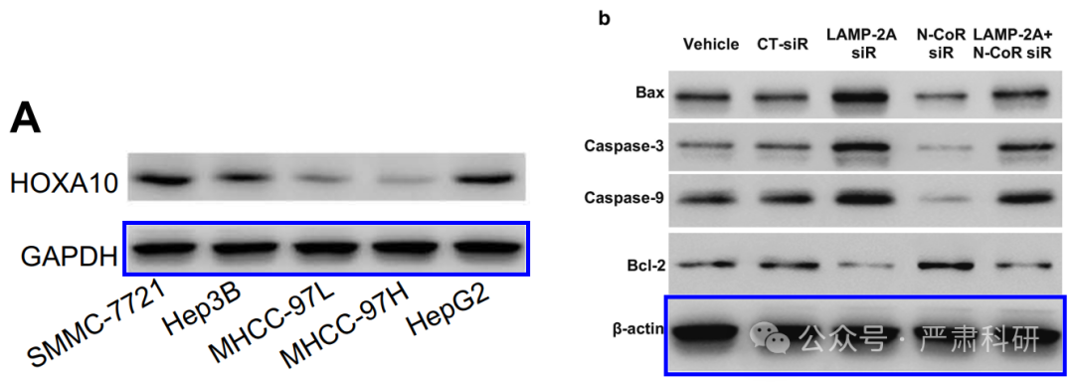

Loading bands are surprisingly similar. Here with one flipped horizontally and rescaled:  
加载带惊人地相似。这里有一个水平翻转并重新缩放的：

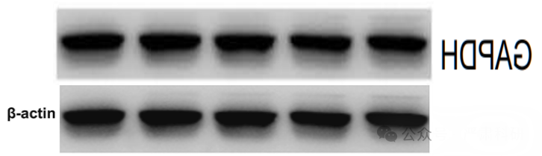

#2 ***Hoya camphorifolia***   comment accepted January 2023  
评论接受于 2023 年 1 月

Fig 2B. Flipped horizontally...  
图 2B. 水平翻转...

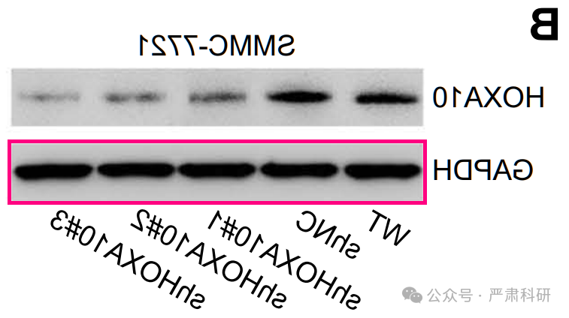

...For comparison with  与...进行比较

* *[left]*

 Fig 2C from "NCTD elicits proapoptotic and antiglycolytic effects on colorectal cancer cells via modulation of Fam46c expression and inhibition of ERK1/2 signaling" (Zhang et al 2020).  
[左] 图 2C 来自“NCTD 通过调节 Fam46c 表达和抑制 ERK1/2 信号通路诱导结直肠癌细胞的促凋亡和抗糖酵解效应”（张等，2020 年）。

* *[right]*

 Fig 2A from "Salidroside ameliorated hypoxia‐induced tumorigenesis of BxPC‐3 cells via downregulating hypoxia‐inducible factor (HIF)‐1α and LOXL2" (Chen et al 2020).  
[右] 图 2A 来自“淫羊藿苷通过下调缺氧诱导因子（HIF）-1α和 LOXL2 改善 BxPC-3 细胞的缺氧诱导肿瘤发生” (陈等，2020)。

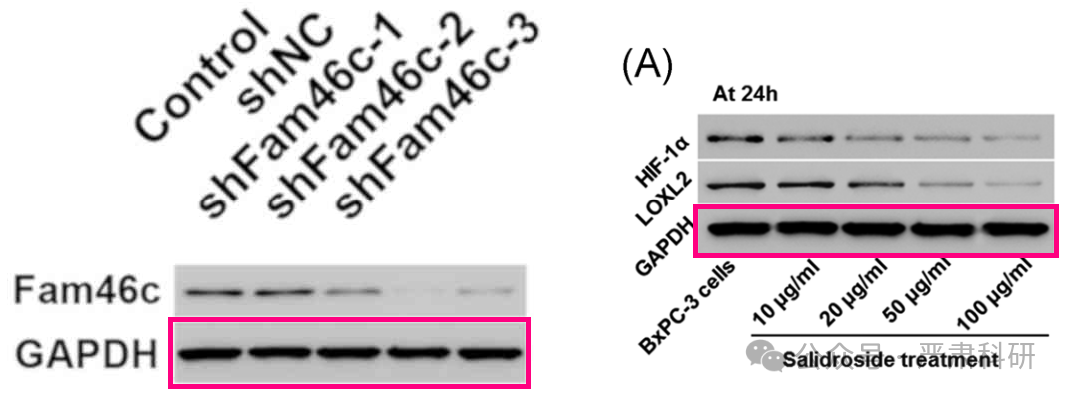

#3 ***Hoya camphorifolia***  comment accepted March 2025  
评论接受于 2025 年 3 月

* *[left]*

 Fig 4A.  [左] 图 4A。

* *[right]*

 Fig 4A from "TRIM24 siRNA induced cell apoptosis and reduced cell viability in human nasopharyngeal carcinoma cells" (Wang et al 2018).  
[右] 图 4A 来自“TRIM24 siRNA 诱导人鼻咽癌细胞的细胞凋亡并降低细胞活力”（王等，2018）。

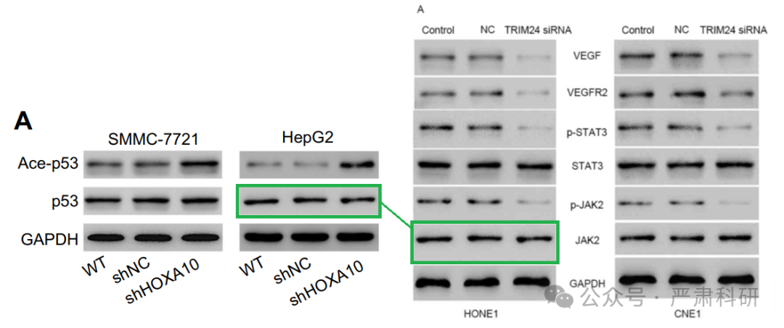

#4 ***Hoya camphorifolia***   comment accepted March 2025  
评论接受于 2025 年 3 月

#2 Another sighting! Left to right:  
#2 另一次目击！从左到右：

* Fig 3D from "TNF-α induces apoptosis of human nucleus pulposus cells via activating the TRIM14/NF-κB signalling pathway" (Zhu et al 2019).  
  图 3D 来自“TNF-α通过激活 TRIM14/NF-κB 信号通路诱导人椎间盘细胞凋亡”（朱等，2019）。
* Fig 2A from "Salidroside ameliorated hypoxia-induced tumorigenesis of BxPC-3 cells via downregulating hypoxia-inducible factor (HIF)-1α and LOXL2" (Chen et al 2020) (flipped horizontally).  
  图 2A 来自“淫羊藿苷通过下调缺氧诱导因子（HIF）-1α和 LOXL2 改善 BxPC-3 细胞的缺氧诱导肿瘤发生”（陈等，2020 年）（水平翻转）。
* **Fig 2B**

.  图 2B。

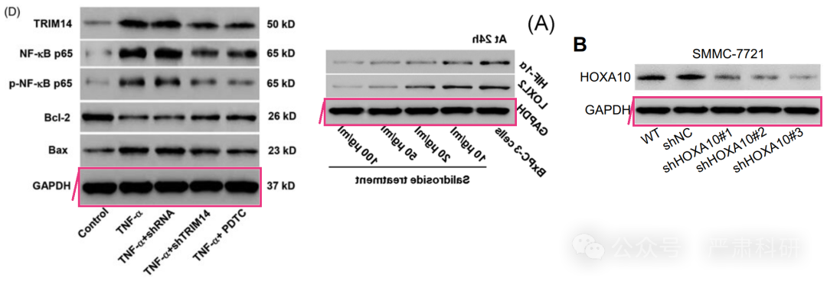**参考信息  
https://pubmed.ncbi.nlm.nih.gov/31440094/**

**https://pubpeer.com/publications/7CE9A79416301547156BCA38940AB1**

**本平台对于科研问题的探讨，始终保持严谨、深入、持续、开放和创新的态度。**

**所有推文信源，均来源于pubpeer、For Better Science等网站公开质疑。**

**我们从来没有、也永远不会主动查重论文并去pubpeer上质疑。**

**我们尊重他人的研究成果和贡献，通过交流和合作，共同推动科研领域的进步和**

**发展。**