[学术诚信崩塌？河南大学淮河医院张媛、广州医科大学附属第三医院张平、新乡市中心医院赵新利论文共用同一条带图](https://mp.weixin.qq.com/s?__biz=Mzk3NTEwMTE3OA==&mid=2247485541&idx=1&sn=b265c7a7ddfd3f397f7b9bc0839f64ac)

[学术荟萃](javascript:void(0);)2025-04-09 19:59:00山东

**Part.1**



**论文一简介**

**标题：AEG-1 deletion promotes cartilage repair and modulates bone remodeling-related cytokines via TLR4/MyD88/NF-κB inhibition in ovariectomized rats with osteoporosis**

**日期：**2020年10月30日

**单位与作者：**河南大学淮河医院 Qing Zhao、Yuan Zhang(通讯作者 音译 张媛)

**期刊：*Annals of Translational Medicine***

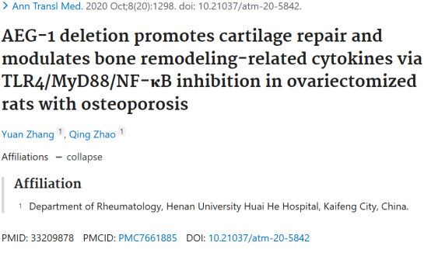

**Part.2**



**论文二简介**

**标题：High-mobility group box chromosomal protein-1 deletion alleviates osteoporosis in OVX rat model via suppressing the osteoclastogenesis and inflammation**

**日期：**2022年4月12日

**单位与作者：**广州医科大学附属第三医院 Haotao Yu、Ping Zhang(通讯作者 音译 张平)

**期刊：*Journal of Orthopaedic Surgery and Research***

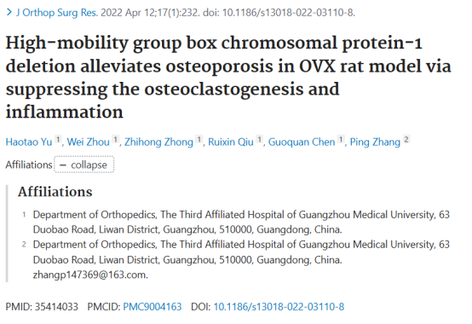

**Part.3**



**论文三简介**

**标题：miR-103a-3p alleviates oxidative stress, apoptosis, and immune disorder in oxygen-glucose deprivation-treated BV2 microglial cells and rats with cerebral ischemia-reperfusion injury by targeting high mobility group box 1**

**日期：**2022年10月30日

**单位与作者：**新乡市中心医院神经内科 Jianshe Li、Xinli Zhao(通讯作者 音译 赵新利)

**期刊：*Annals of Translational Medicine***

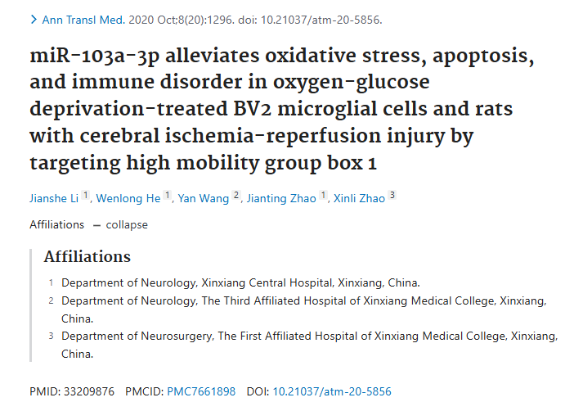

**Part.4**



**图像重复问题**

**#1 三篇论文出现同一张条带图。**

Clockwise from left:

* Fig 3D from "AEG-1 deletion promotes cartilage repair and modulates bone remodeling-related cytokines via TLR4/MyD88/NF-κB inhibition in ovariectomized rats with osteoporosis"(Zhang & Zhao et al 2020).
* Fig 2D from "High-mobility group box chromosomal protein-1 deletion alleviates osteoporosis in OVX rat model via suppressing the osteoclastogenesis and inflammation"(Yu et al 2022).(论文二)
* Fig 1K from "miR-103a-3p alleviates oxidative stress, apoptosis, and immune disorder in oxygen-glucose deprivation-treated BV2 microglial cells and rats with cerebral ischemia-reperfusion injury by targeting high mobility group box 1" (Li et al 2020).(论文三)

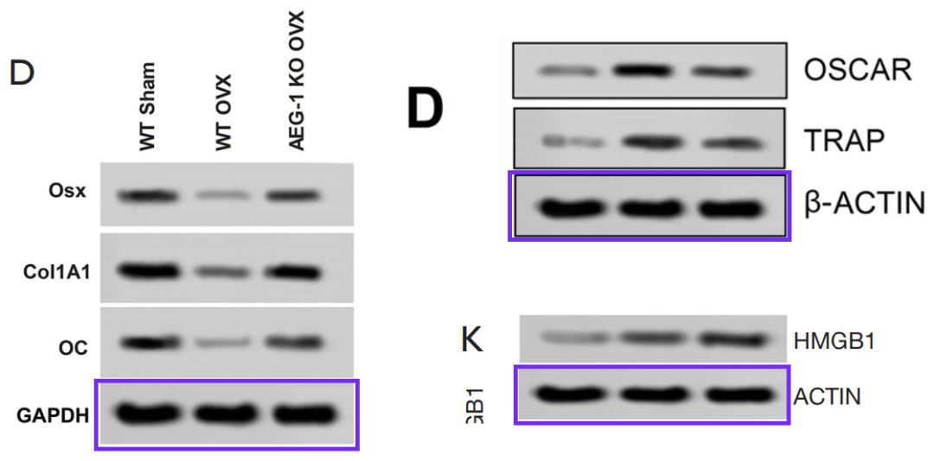

**参考信息：**

https://pubpeer.com/publications/AF1A02A879EAFC34BC42775CEDDC6E#1

https://pubmed.ncbi.nlm.nih.gov/33209878/

https://pubmed.ncbi.nlm.nih.gov/35414033/

https://pubmed.ncbi.nlm.nih.gov/33209876/