[十堰市太和医院与黄石市中心医院论文重复 “翻车”：图片复制疑云无解，文章终遭撤稿](https://mp.weixin.qq.com/s?__biz=Mzk3NTEwMTE3OA==&mid=2247485542&idx=1&sn=7c51261cc2bec0ef19db1f88e181583c)

[学术荟萃](javascript:void(0);)2025-04-09 23:00:00山东

**Part.1**



**论文简介**

**标题：MiR-181c-5p Mitigates Tumorigenesis in Cervical Squamous Cell Carcinoma via Targeting Glycogen Synthase Kinase 3β Interaction Protein (GSKIP)**

**日期：**2020年5月21日

**单位与作者：**

十堰市太和医院 Niuniu Li、Tieyan Wang

黄石市中心医院 Chun Cheng

**期刊：*OncoTargets and Therapy***

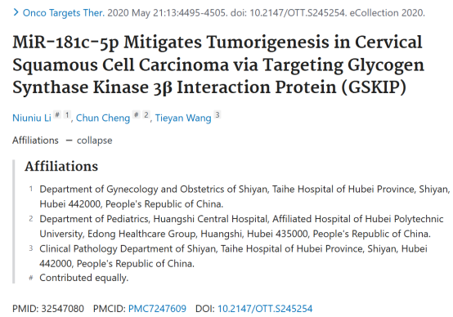

**Part.2**



**图像重复问题**

**#1 图6A与Bai & Jiao 2020的1B出现重复。**

[above] Fig 6A.

[below] Fig 1B from "Down-Regulation of ZEB1 by miR-199a-3p Overexpression Restrains Tumor Stem-Like Properties and Mitochondrial Function of Non-Small Cell Lung Cancer" (Bai & Jiao 2020).doi: 10.2147/ott.s244525

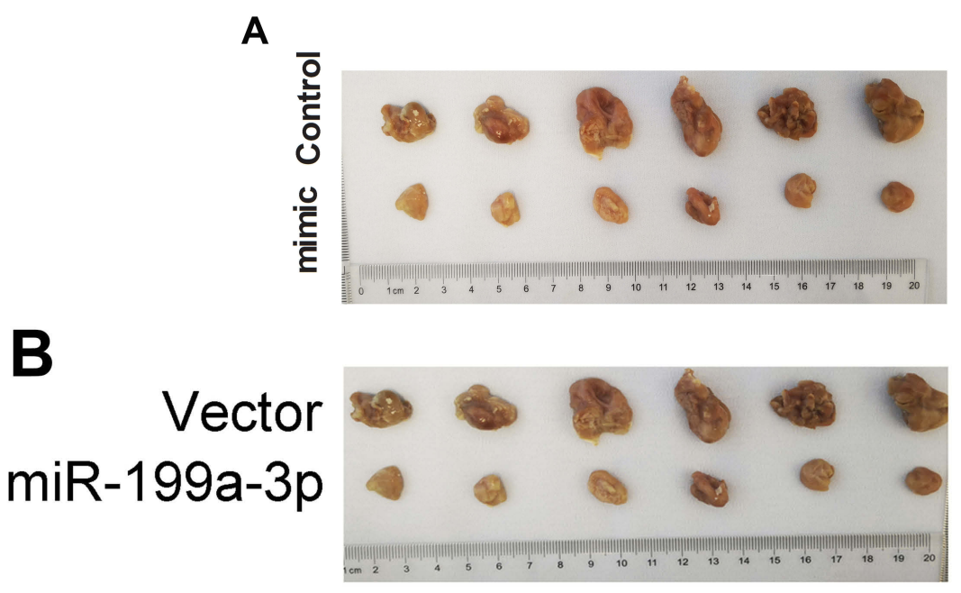

**#2 图6D与Shi et al 2018的4C、Lei et al 2020的5B、Jiang & Mao 2019的6C出现重复。**

[left] Fig 6D.

[right]

* Fig 4C from "MiR-320d suppresses the progression of breast cancer via lncRNA HNF1A-AS1 regulation and SOX4 inhibition" (Shi et al 2018) [retracted].
* Fig 5B from "Icariin Mitigates the Growth and Invasion Ability of Human Oral Squamous Cell Carcinoma via Inhibiting Toll-Like Receptor 4 and Phosphorylation of NF-κB P65" (Lei et al 2020).
* Fig 6C from "Astragaloside IV (AS-IV) alleviates the malignant biological behavior of hepatocellular carcinoma via Wnt/b-catenin signaling pathway" (Jiang & Mao 2019).

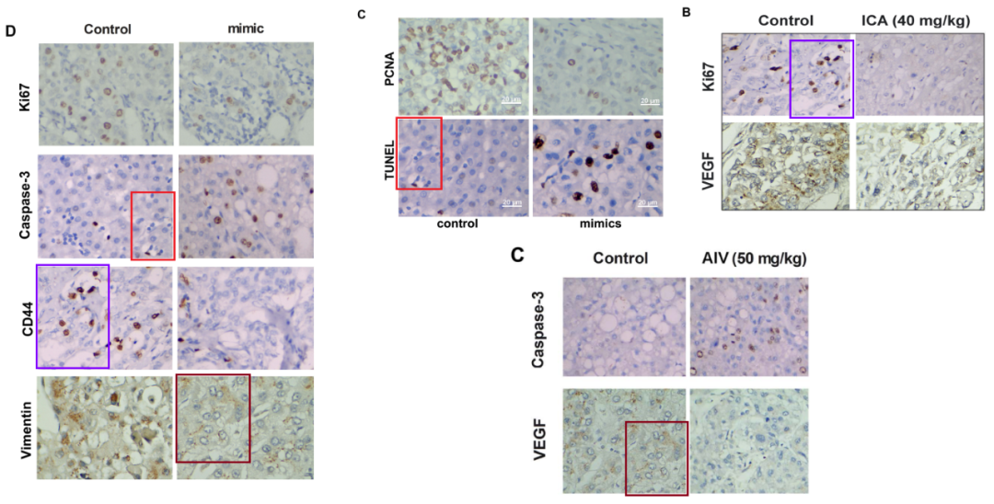

**#3 图4B与Zhang et al 2020的3F、Wang et al 2021的5A出现重复。**Left to right:

* Fig 4B.
* Fig 3F from "miR-326 inhibits the cell proliferation and cancer stem cell-like property of cervical cancer in vitro and oncogenesis in vivo via targeting TCF4" (Zhang et al 2020).
* Fig 5A from "Bupivacaine inhibits the malignant biological behavior of oral squamous cell carcinoma cells by inhibiting the activation of ERK1/2 and STAT3" (Wang et al 2021).

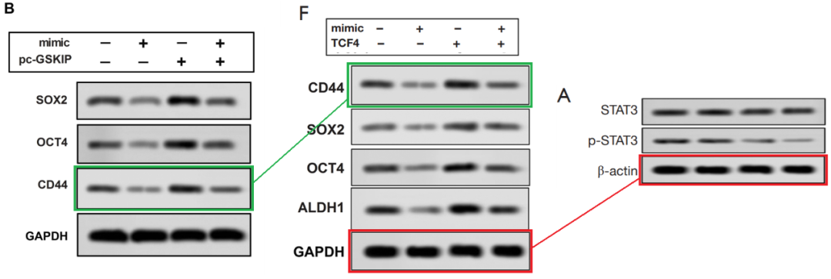

**#4 图4B与Wu et al 2021的4D出现重复。**

[left] Fig 4D from "MiR-511 mimic transfection inhibits the proliferation, invasion of osteosarcoma cells and reduces metastatic osteosarcoma tumor burden in nude mice via targeting MAPK1" (Wu et al 2021).

[right] Fig 4B again.

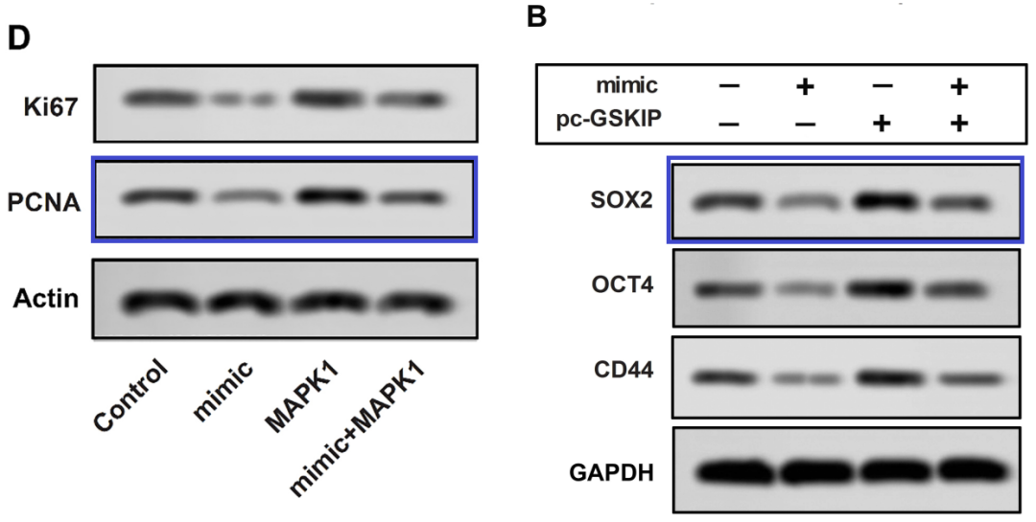

**#5 图4B与Wu et al 2021的4D出现重复。**

[left] Fig 4D from "MiR-511 mimic transfection inhibits the proliferation, invasion of osteosarcoma cells and reduces metastatic osteosarcoma tumor burden in nude mice via targeting MAPK1" (Wu et al 2021).

[right] Fig 4B again.



**#6 图4B与Wu et al 2018的4D、Zhang et al 2020的2B出现重复。**

Left to right:

* Fig 4D from "MiR-511 mimic transfection inhibits the proliferation, invasion of osteosarcoma cells and reduces metastatic osteosarcoma tumor burden in nude mice via targeting MAPK1" (Wu et al 2018).
* Fig 4B.
* Fig 2B from "miR-326 inhibits the cell proliferation and cancer stem cell-like property of cervical cancer in vitro and oncogenesis in vivo via targeting TCF4" (Zhang et al 2020).



**#7 图4B与Che et al 2022的4A出现重复。**

* Fig 4B found another friend.
* [left] Fig 4A from "Lupeol induces autophagy and apoptosis with reduced cancer stem-like properties in retinoblastoma via phosphoinositide 3-kinase/protein kinase B/mammalian target of rapamycin inhibition" (Che et al 2022).
* [right] Fig 4B.

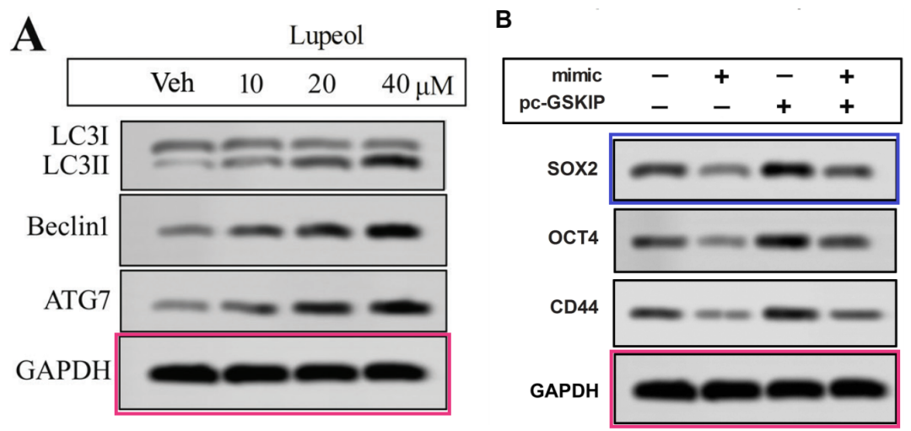

**Part.3**



**撤稿说明**

**本文已撤稿：**文章发表后，有人对图 4 和图 6 中的图片与无关文章中的图片重复提出了质疑。具体来说

miR-326 inhibits the cell proliferation and cancer stem cell-like property of cervical cancer in vitro and oncogenesis in vivo via targeting TCF4。Ann Transl Med. https://doi.org/10.21037/atm-20-6830 和图3D来自Wu J, Zhang C, Chen L. MiR-511 Mimic Transfection Inhibits the Proliferation, Invasion of Osteosarcoma Cells and Reduces Metastatic Osteosarcoma Tumor Burden in Nude Mice via Targeting MAPK1. Cancer Biomark. 2019:26(3):343-351.

图6A的图片与图1B的图片重复来自Bai J, Jiao WY. Down-Regulation of ZEB1 by miR-199a-3p Overexpression Restrains Tumor Stem-Like Properties and Mitochondrial Function of Non-Small Cell Lung Cancer. Onco Targets Ther. 2020;13:4607-4616. https://doi.org/10.2147/OTT.S244525.

图 6D 的图像与来自 Shi S, Hu X, Xu J, Liu H, Zou L 的图 4C 的图像重复。被撤回的文章： MiR-320d suppresses the progression of breast cancer via lncRNA HNF1A-AS1 regulation and SOX4 inhibition。RSC Adv. 2018;8:19196-19207；图 5B 来自 Lei K, Ma B, Shi P, et al. Icariin Mitigates the Growth and Invasion Ability of Human Oral Squamous Cell Carcinoma via Inhibiting Toll-Like Receptor 4 and Phosphorylation of NF-κB P65. Onco Targets Ther. https://doi.org/10.2147/OTT.S214514 和图 6C 摘自 Jiang Z, Mao Z. Retracted Article： Astragaloside IV (AS-IV) alleviates the malignant biological behavior of hepatocellular carcinoma via Wnt/β-catenin signaling pathway. RSC Adv. 2019;9: 35473-35482.

通讯作者没有回复我们的询问，也无法就图片是如何被复制的提供令人满意的解释，或为研究提供令人满意的原始数据。由于核实发表作品的有效性是学术记录完整性的核心，出版商和编辑要求撤回文章，并将此决定通知了通讯作者。

**参考信息：**

https://pubpeer.com/publications/9175EA35019E8D770219BBEF9E9B61#6

https://pubmed.ncbi.nlm.nih.gov/32547080/