[江南大学附属医院茆勇/游庆军、上海交通大学医学院附属第九人民医院王峰等人论文多处与他文雷同，关乎学术声誉！](https://mp.weixin.qq.com/s?__biz=Mzk3NTEwMTE3OA==&mid=2247485520&idx=1&sn=020a345c0a3e3410473bbdeb8cfd7d0f)

[学术荟萃](javascript:void(0);)2025-04-08 19:01:00山东

**Part.1**



**论文简介**

**标题：Piperlongumine induces apoptosis and autophagy in human lung cancer cells through inhibition of PI3K/Akt/mTOR pathway**

**日期：**2015年8月5日

**单位与作者：**

上海交通大学医学院附属第九人民医院胸外科Feng Wang(音译 王峰)

江南大学附属医院 Yong Mao(音译 茆勇)、Qingjun You(通讯作者 音译 游庆军)

**期刊：*International journal of immunopathology and pharmacology***

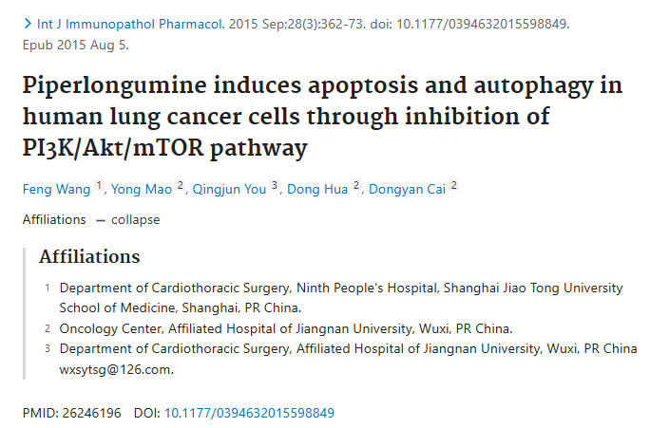

**Part.2**



**图像重复问题**

**#1 图1B与另外两篇论文出现重复。**

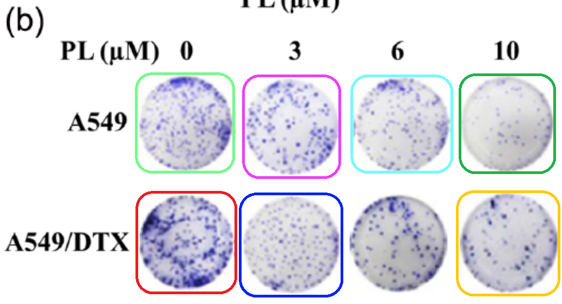

[above] Figs 2C, 3C from "miR-944 acts as a prognostic marker and promotes the tumor progression in endometrial cancer" (He et al 2017).

[below] Fig 4C from "HMGB1-mediated autophagy promotes docetaxel resistance in human lung adenocarcinoma" (Pan et al 2014).

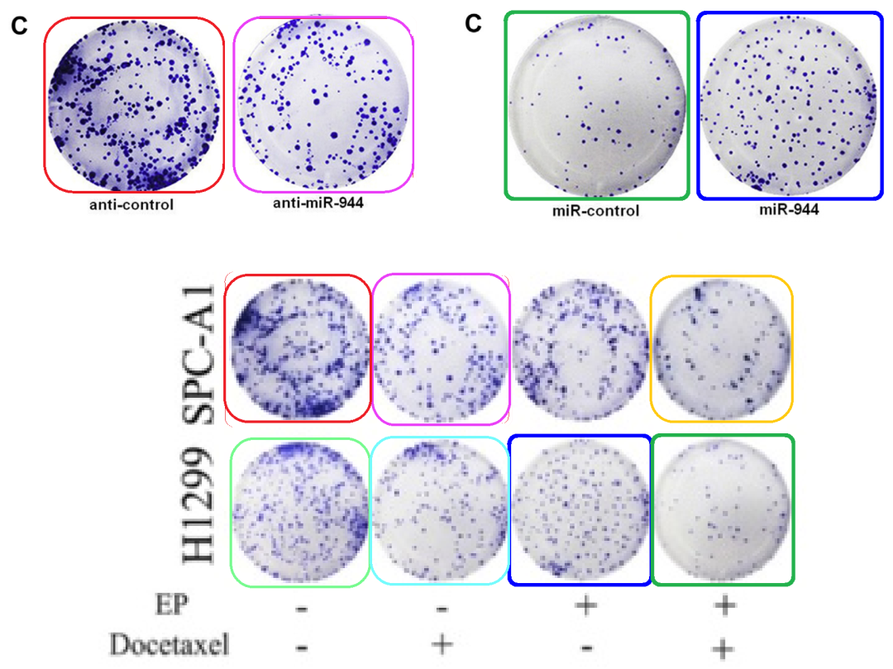

**#2 图2b/3a与Liu et al 2013的2A/B出现重复。**

Figs 2b, 3a.

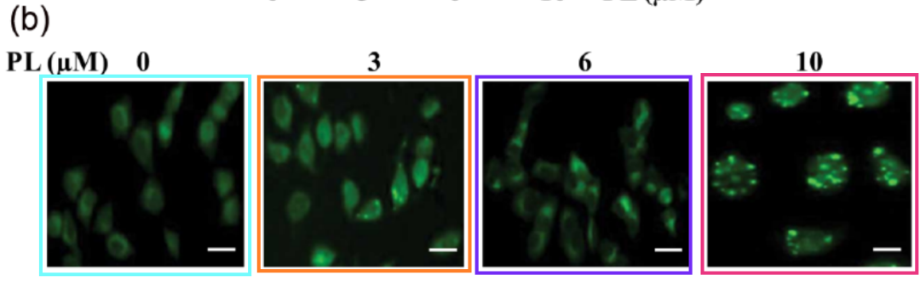

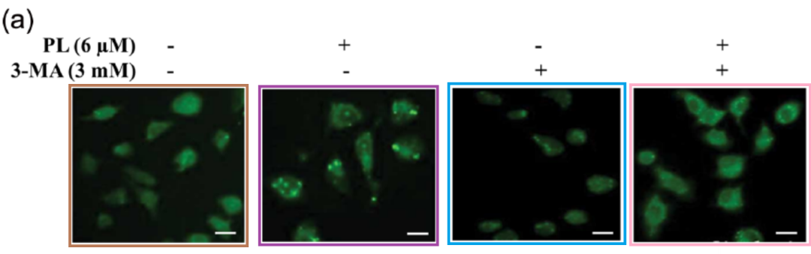

Panels are sourced from Fig 2A,B of "Effect of autophagy inhibition on chemotherapy?induced apoptosis in A549 lung cancer cells" (Liu et al 2013).

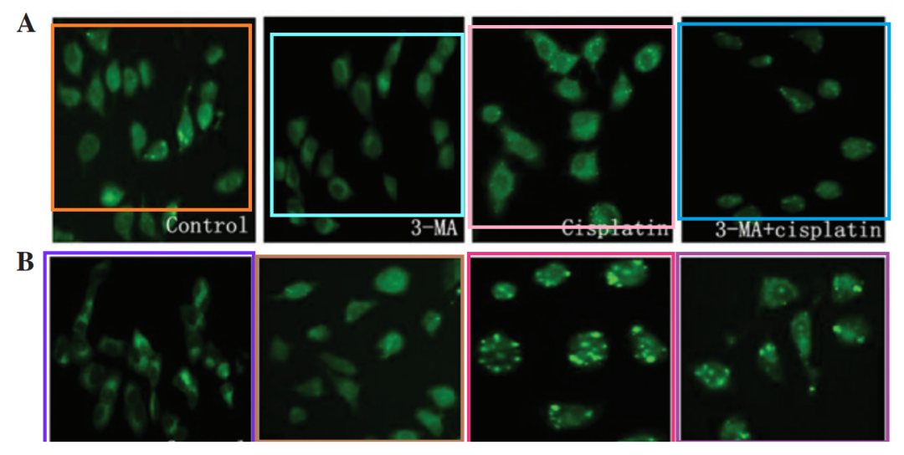

**#3 图5c与Jiang et al 2015的图6C/D出现重复，与Wang et al 2015的6D出现重复。**

Fig 5c:

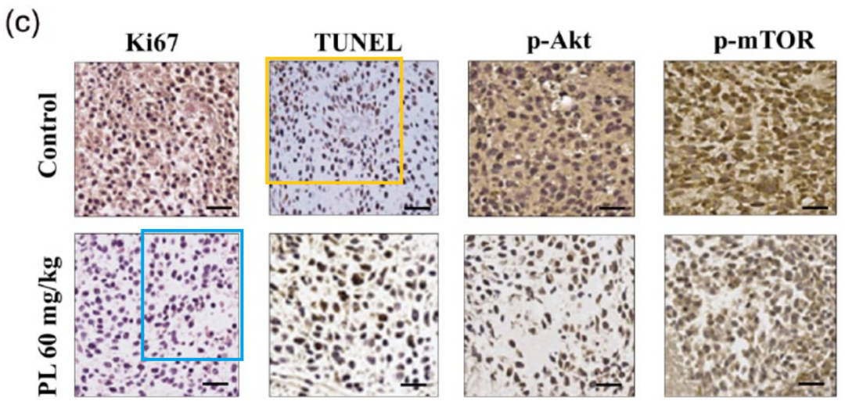

Panel marked with a light orange box overlaps with a panel from [above] Fig 6C/D from "Sorafenib and DE605, a novel c-Met inhibitor, synergistically suppress hepatocellular carcinoma" (Jiang et al 2015).

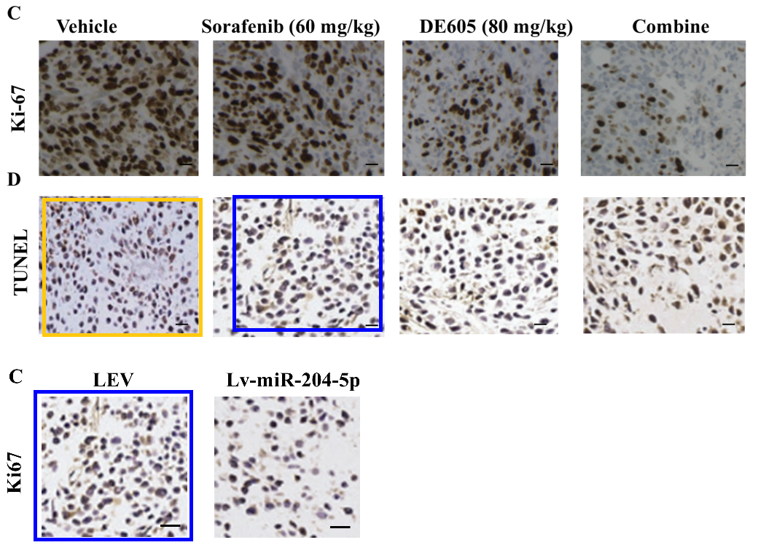

Panel marked with a light blue box overlaps with [left] Fig 6D from "MiR-25 promotes hepatocellular carcinoma cell growth, migration and invasion by inhibiting RhoGDI1" (Wang et al 2015).

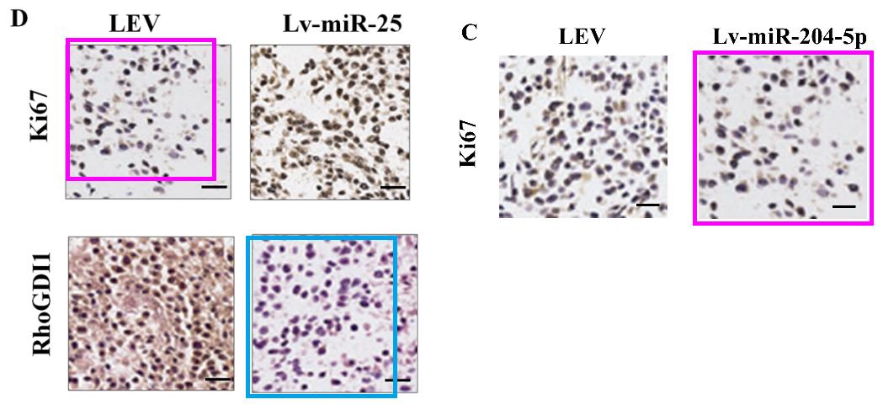

**#4 图4a与Ma et al 2015的4a/c出现重复。**

Fig 4a.

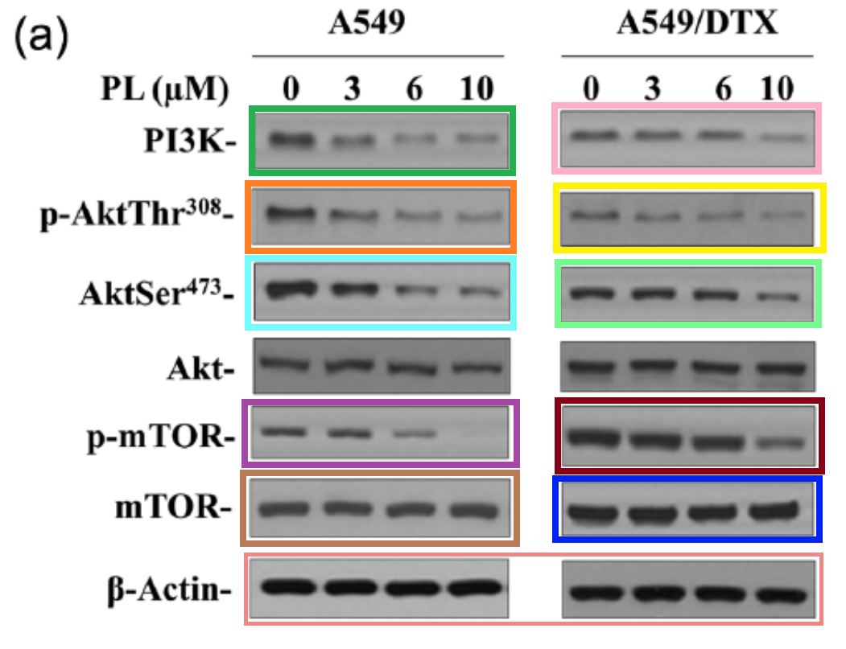

Bands also feature in Fig 4a,c from "Pachymic acid induces apoptosis via activating ROS-dependent JNK and ER stress pathways in lung cancer cells" (Ma et al 2015).

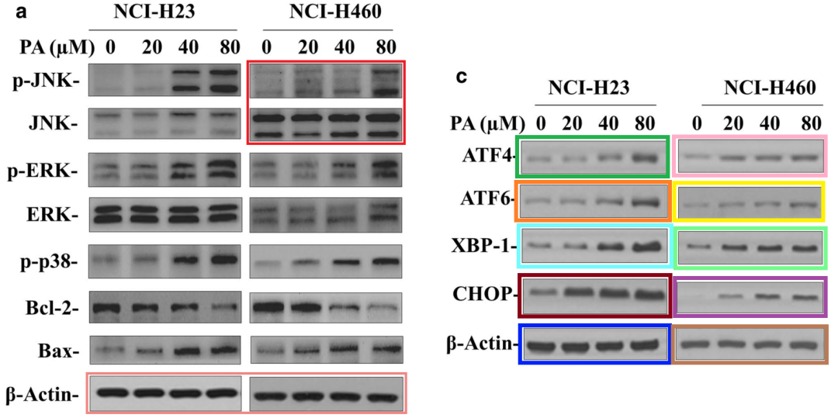

**#5 图4a再次与多篇论文出现重复。**

Fig 4a again

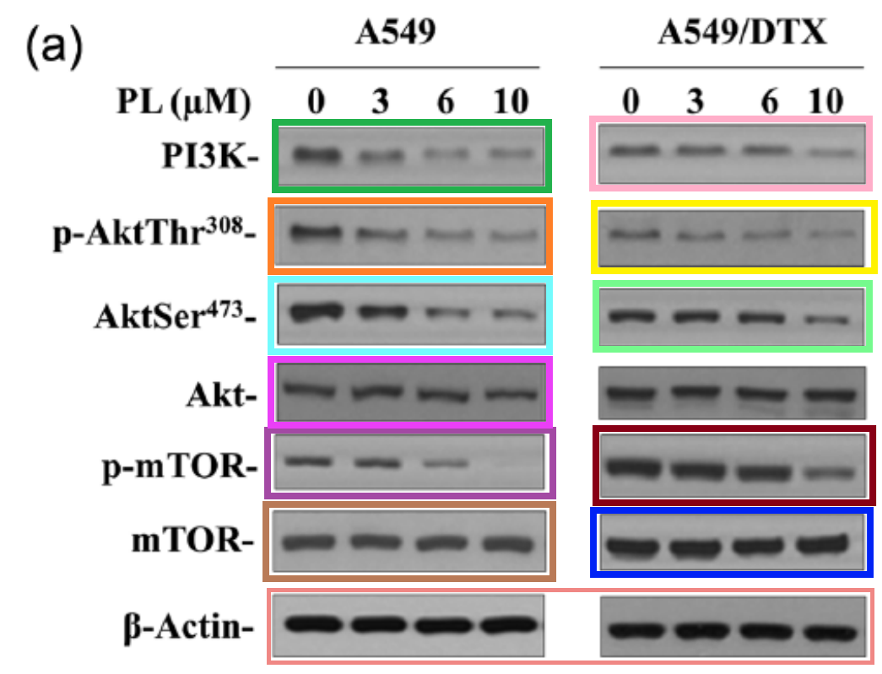

Bands also appear in

[left] Fig 5a from "Chelerythrine chloride induces apoptosis in renal cancer HEK-293 and SW-839 cell lines" (Chen et al 2016) [retracted].

[right] Fig 5a from "The role of angiopoietin-2 in nucleus pulposus cells during human intervertebral disc degeneration" (Wang et al 2017).

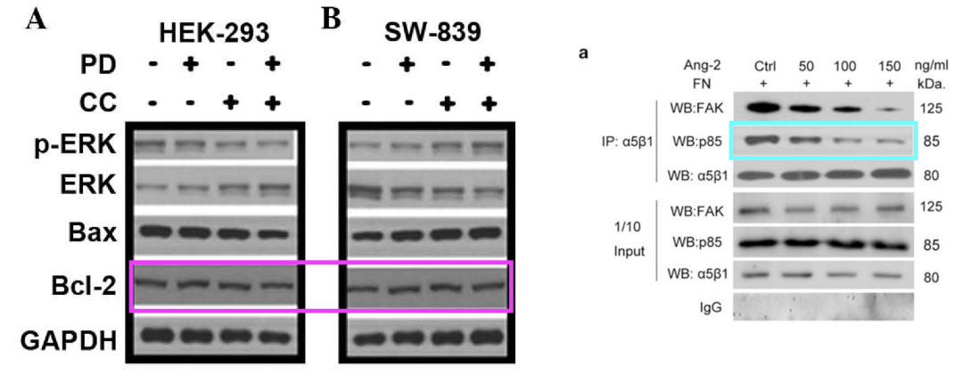

UPDATE: Many of the bands had their first appearance in Fig 2C from "Metformin kills and radio-sensitizes cancer cells and preferentially kills cancer stem cells" (Song et al 2012).

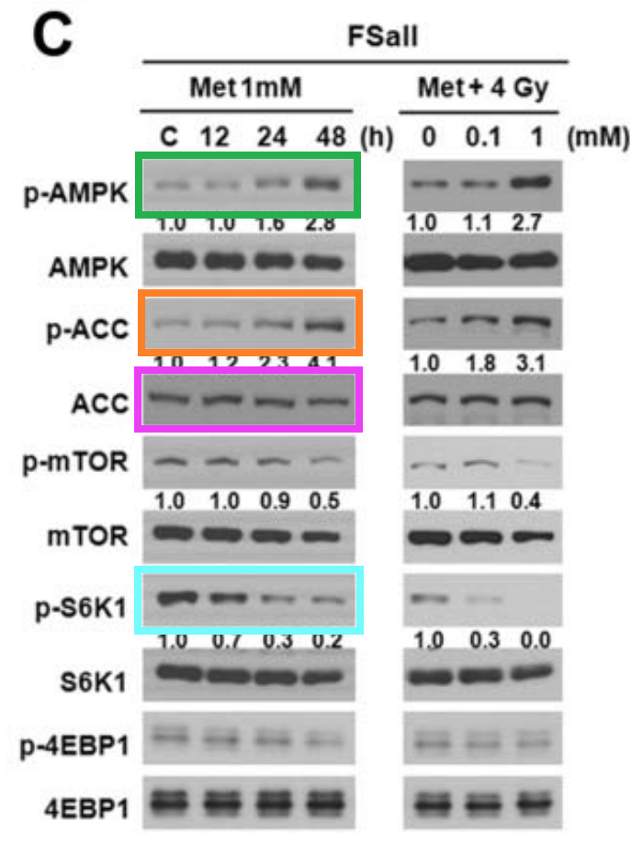

**参考信息：**

https://pubpeer.com/publications/1CAB4AE83C2771B820E4230AF4BA7B#

https://pubmed.ncbi.nlm.nih.gov/26246196/