[回击无门心惆怅，5GH团队暖心房！](https://mp.weixin.qq.com/s?__biz=Mzk1NzE0NTE5Mg==&mid=2247489431&idx=2&sn=37c0b62e233c113b4fc648b8fceeda4b)

崔健同志[净研行动](javascript:void(0);)2025-04-07 11:04:43浙江

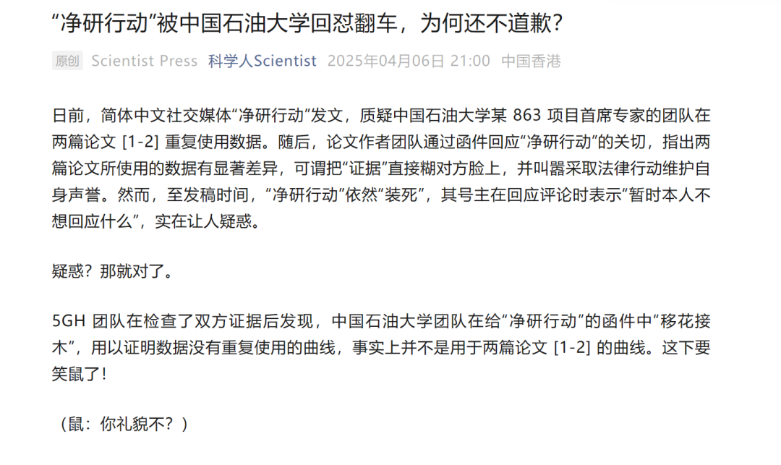

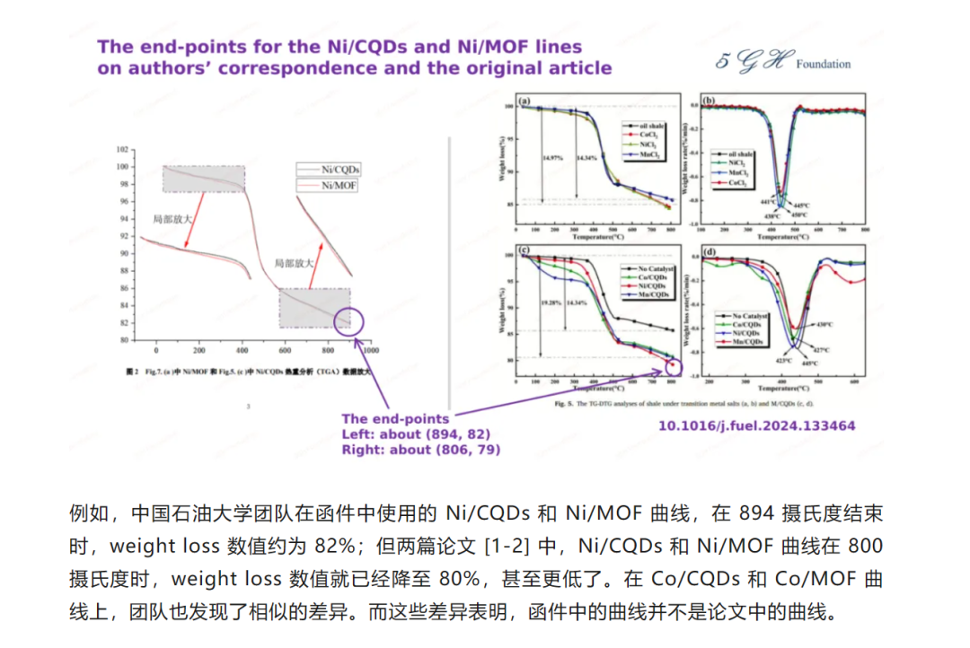

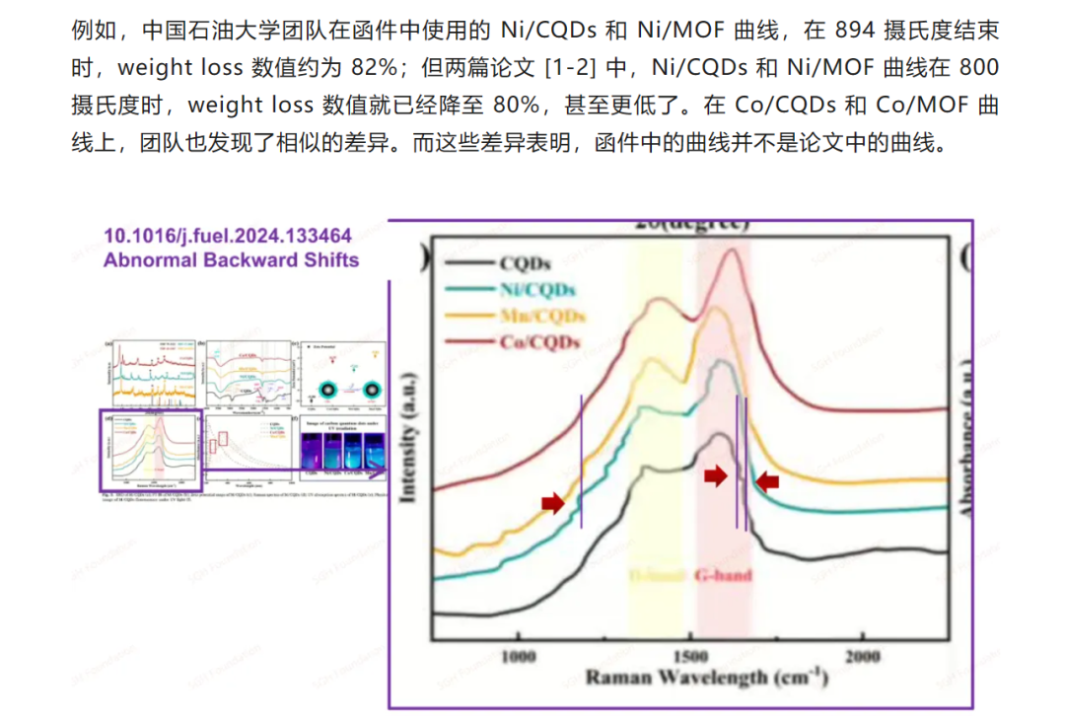

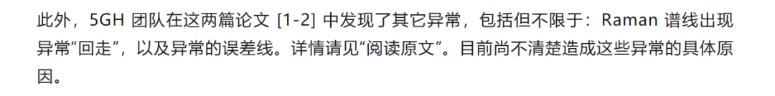

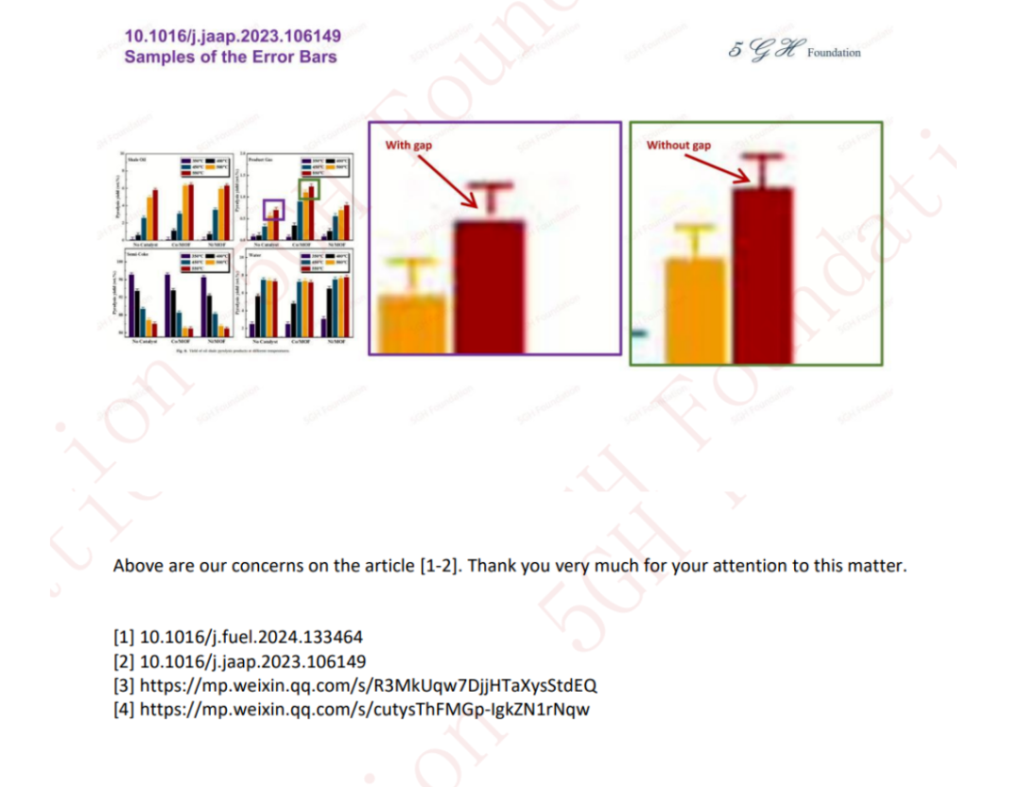

提供线索或对推文存在疑义，请联系邮箱：jxscuijian@163.com





**微信搜一搜**



 净研行动

[#崔健博士专栏](https://mp.weixin.qq.com/mp/appmsgalbum?__biz=Mzk1NzE0NTE5Mg==&action=getalbum&album_id=3778818414182055941#wechat_redirect)