[重庆医科大学第二附院Oncotarget被质疑](https://mp.weixin.qq.com/s?__biz=MzUxODcwODMzMw==&mid=2247484047&idx=1&sn=7c81a3831693cfed761b4fba0b9605e7)

原创一只鱼[严肃科研](javascript:void(0);)2025-04-09 22:04:17四川

**“**秉持严谨、深入、持续、开放与创新的态度，尊重他人成果，携手交流共进，推动科研发展。**”**

**Research Frontline**

**科研前线**

01

—

**问题论文**

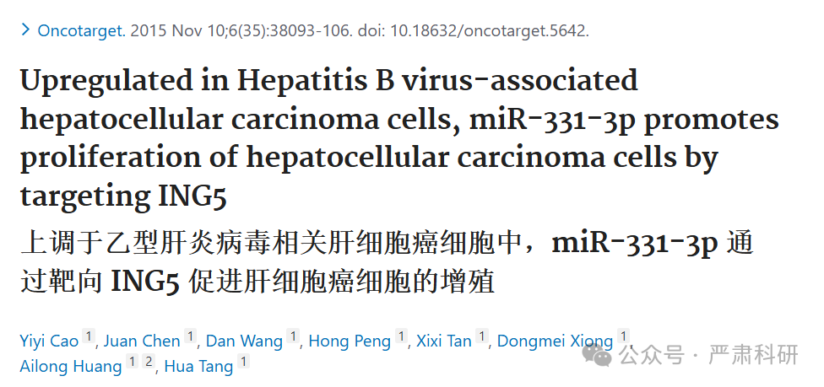

**标题：**Upregulated in Hepatitis B virus-associated hepatocellular carcinoma cells, miR-331-3p promotes proliferation of hepatocellular carcinoma cells by targeting ING5

**期刊：**Oncotarget

**单位：**重庆医科大学第二附属医院&浙江大学感染病诊断与治疗协同创新中心

**发表时间：**2015年11月10日

**DOI:**10.18632/oncotarget.5642

**研究摘要：**

Hepatitis B virus (HBV) is a major risk factor for development and progression of hepatocellular carcinoma (HCC). It has been reported that viral infection can interfere with cellular microRNA (miRNA) expression and participate in the pathogenesis of oncogenicity. Our miRNAs array data indicated that miR-331-3p expression in HCC cell lines increased, but the relationship between miR-331-3p expression and HBV activity is unclear. Here, we observed elevated expression of miR-331-3p in different HCC cell lines expressing HBV. HBV, especially HBx, promotes miR-331-3p expression by enhancing its promoter activity. Using a miRNA target prediction database miRBase, we identified ING5 to be a novel target gene of miR-331-3p. miR-331-3p could inhibit ING5 expression by directly targeting its 3'-untranslated region (3'-UTR). As predicted, HBV was confirmed to repress ING5 at both mRNA and protein levels by promoting miR-331-3p expression. Our result indicated that miR-331-3p expression promotes proliferation of SMMC7721 cells by inhibiting ING5. ING5 overexpression promoted cell apoptosis in HCC cell lines. We also found ING5 expression was decreased in tumor tissue of HCC patient with HBV infection compared to its expression in para-carcinoma tissues.  
乙型肝炎病毒（HBV）是肝细胞癌（HCC）发生和进展的主要危险因素。已有报道指出，病毒感染可干扰细胞 microRNA（miRNA）表达并参与肿瘤发生发展的病理机制。我们的 miRNAs 芯片数据表明，HCC 细胞系中 miR-331-3p 的表达增加，但 miR-331-3p 表达与 HBV 活性的关系尚不明确。在此，我们观察到在表达 HBV 的不同 HCC 细胞系中 miR-331-3p 表达升高。HBV，尤其是 HBx，通过增强其启动子活性来促进 miR-331-3p 的表达。利用 miRNA 靶基因预测数据库 miRBase，我们确定了 ING5 是 miR-331-3p 的一个新型靶基因。miR-331-3p 可以通过直接靶向其 3'-非编码区（3'-UTR）来抑制 ING5 的表达。正如预测的那样，HBV 通过促进 miR-331-3p 的表达，在 mRNA 和蛋白水平上证实了抑制 ING5。我们的结果表明，miR-331-3p 的表达通过抑制 ING5 来促进 SMMC7721 细胞的增殖。ING5 过表达可促进 HCC 细胞系的细胞凋亡。 我们还在 HBV 感染的患者肝细胞癌（HCC）肿瘤组织中发现了 ING5 表达降低，与癌旁组织中的表达相比。

**Conclusion:**These results showed that miR-331-3p is upregulated by HBV and promotes proliferation of HCC cells though repression of ING5 expression. These data provide new insights for understanding the mechanisms of HBV-related HCC pathogenesis.  
结论：这些结果表明，HBV 上调 miR-331-3p，通过抑制 ING5 表达促进 HCC 细胞的增殖。这些数据为理解 HBV 相关 HCC 发病机制提供了新的见解。

02

—

**具体说明**

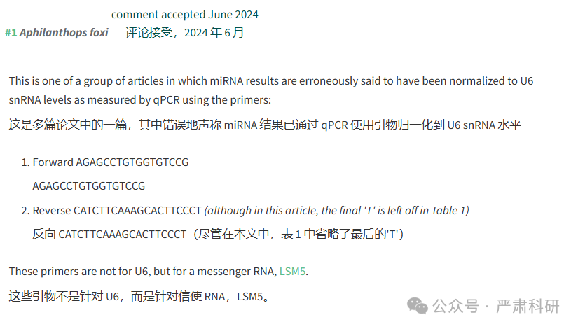

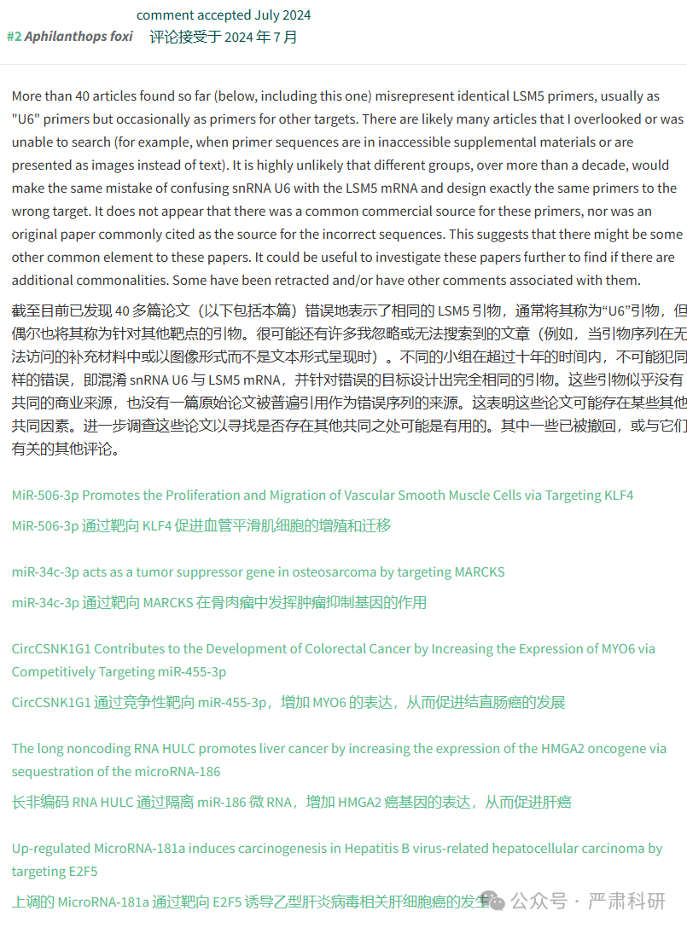

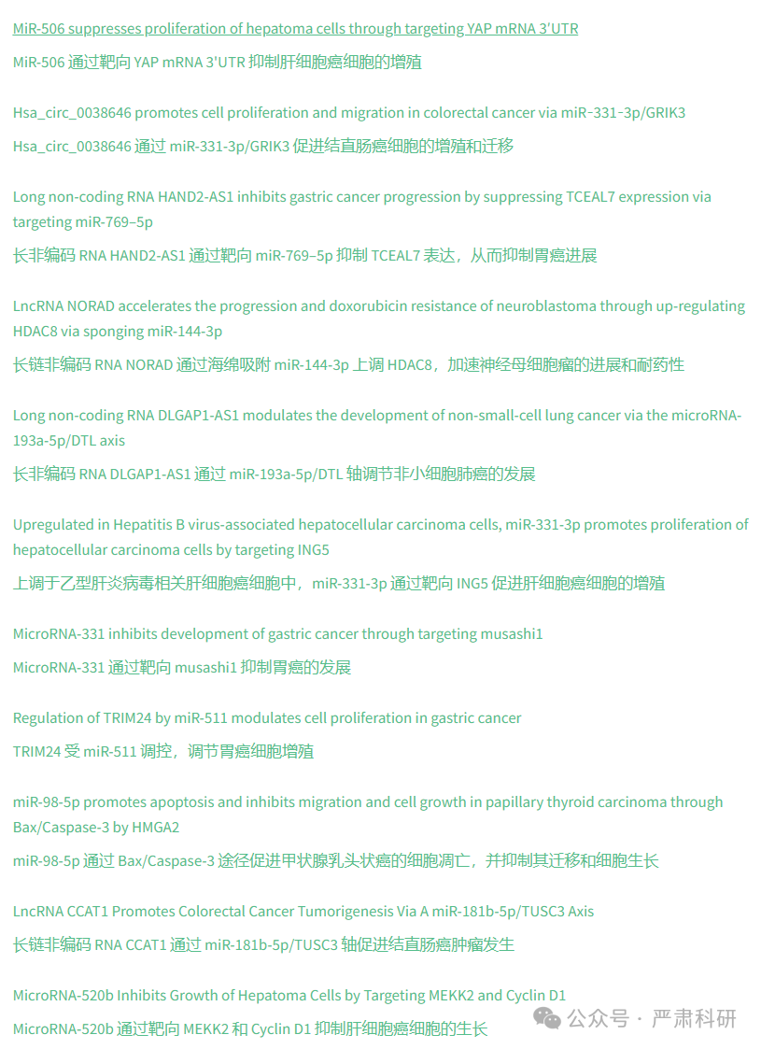

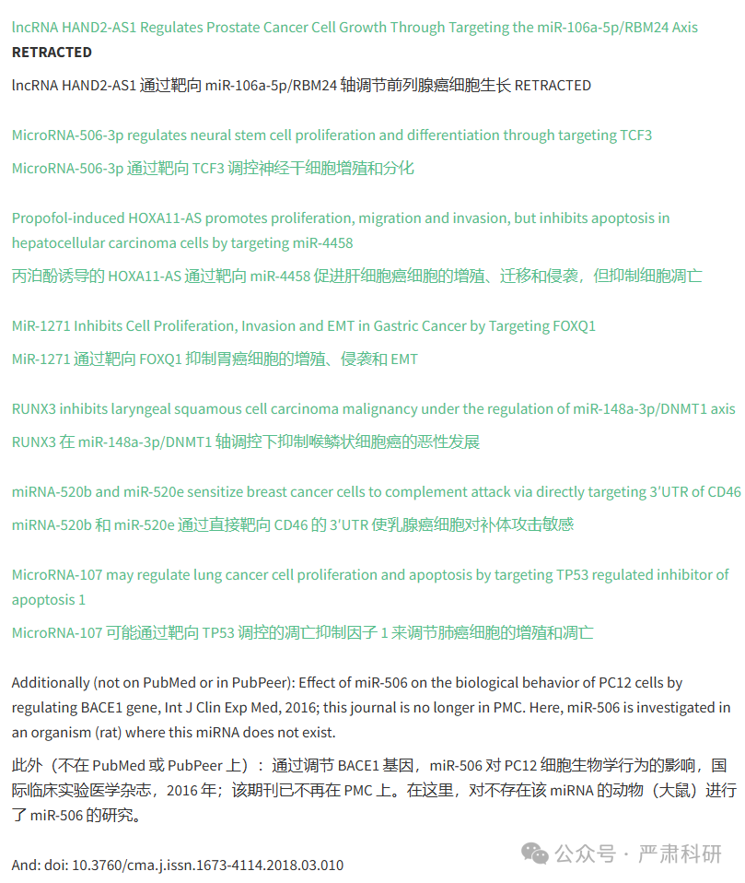

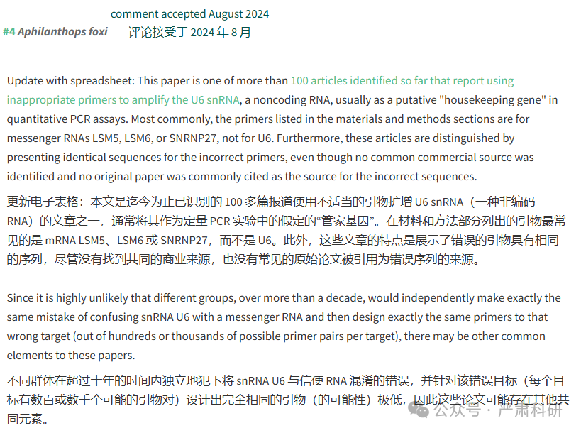

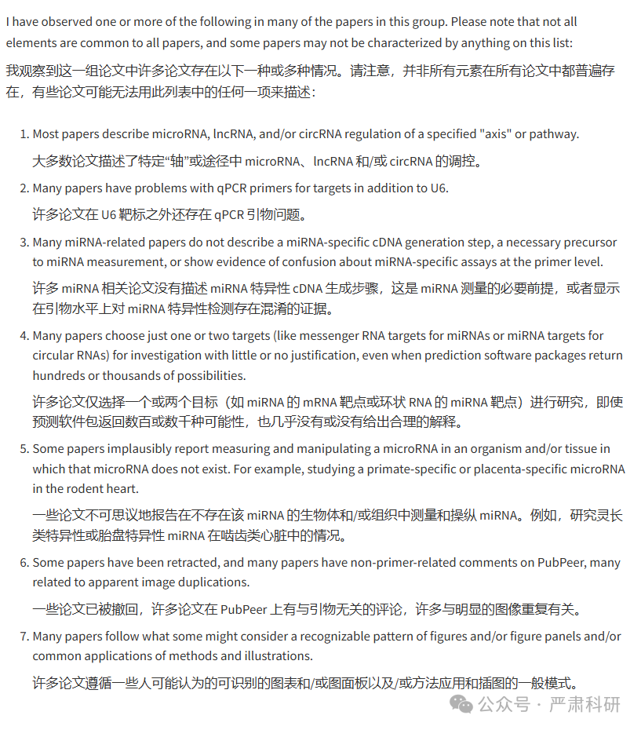

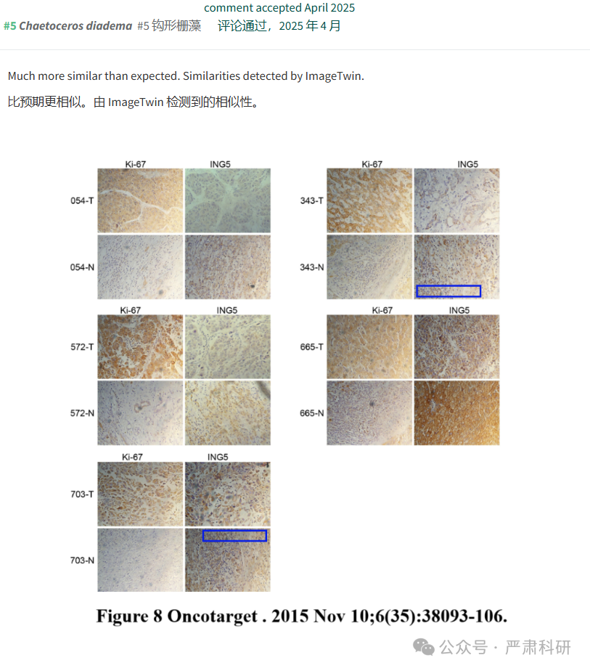

**参考信息  
https://pubmed.ncbi.nlm.nih.gov/26497554/**

**https://pubpeer.com/publications/20CCDA70878ED0068EADBD3AE80AB4#0**

本平台对于科研问题的探讨，始终保持严谨、深入、持续、开放和创新的态度。所有推文信源，均来源于pubpeer、For Better Science等网站公开质疑。我们从来没有、也永远不会主动查重论文并去pubpeer上质疑。我们尊重他人的研究成果和贡献，通过交流和合作，共同推动科研领域的进步和发展。