[绷不住！眼花缭乱！蚌埠医学院知名学者论文图片重复](https://mp.weixin.qq.com/s?__biz=Mzg5MTg0MDc4NQ==&mid=2247493378&idx=1&sn=8baf03b37329008838840da01d3e2829&chksm=cedc324a6ac63bfd56b557de01c36889274741f96bea9252912005d225fbe660a6e14898e83f&scene=126&sessionid=1743872399)

F[图片重复](javascript:void(0);)2025-04-05 23:00:54广东

**Antitumour activity of the recombination polypeptide GST-NT21MP is mediated by inhibition of CXCR4 pathway in breast cancer**

**British Journal of Cancer (2014)**

**PMID:**24448360

**DOI:**10.1038/bjc.2014.1

**AUTHORS**

**Q Yang1,F Zhang2,Y Ding3,J Huang2,S Chen1,Q Wu4,Z Wang2,Z Wang5,C Chen1**

**AFFILIATIONS**

1Department of Biochemistry and Molecular Biology, Bengbu Medical College, Anhui 233030, China.

2Clinical Testing and Diagnose Experimental Center of Bengbu Medical College, Anhui 233000, China.

3Branch of Tumour of the Center Hospital of Bengbu, Anhui 233000, China.

4Department of Medical Oncology, First Affiliated Hospital of Bengbu Medical College, Bengbu, Anhui 233004, China.

51] Department of Pathology, Beth Israel Deaconess Medical Center, Harvard Medical School, Boston, MA 02215, USA [2] Cyrus Tang Hematology Center, Jiangsu Institute of Hematology, First Affiliated Hospital of Soochow University, Suzhou, Jiangsu 215123, China.

**#1Sholto David**

**7 hours ago**

**Figure 3**: There are numerous overlapping areas. Identified and annotated with coloured rectangles by ImageTwin.ai. Would the authors please check and comment?

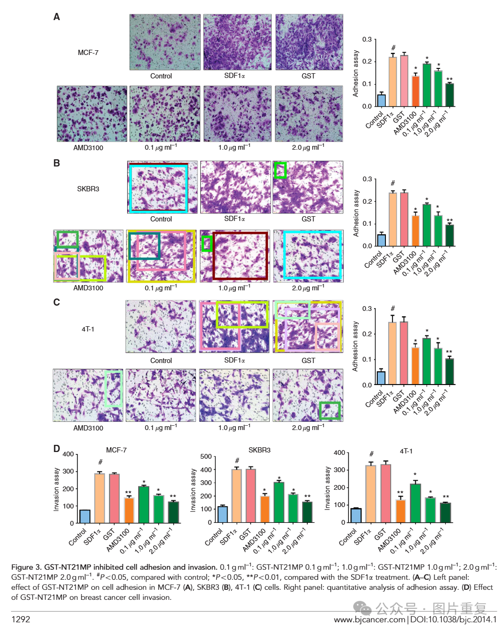Rotations are not indicated.

**#2Sholto David**

**7 hours ago**

Also see **Figure 1**:

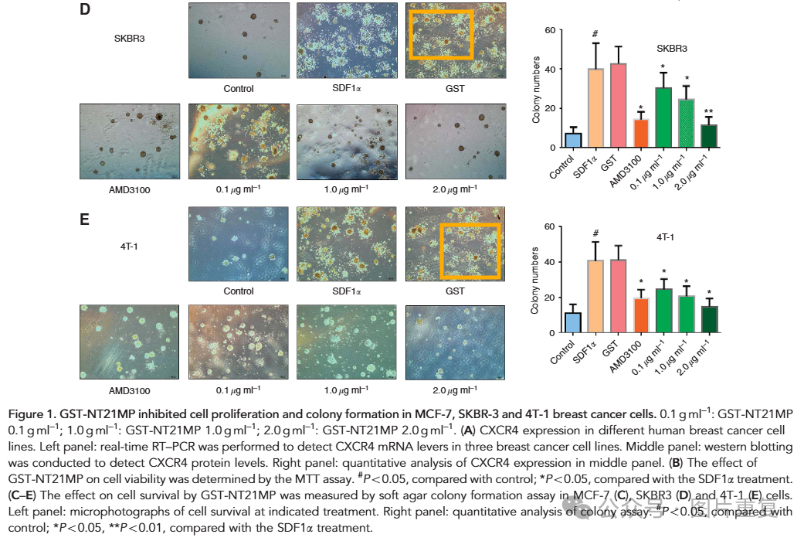

**#3Sholto David**

**7 hours ago**

**Figure 5**:

