[江苏大学知名附属医院论文图片重复](https://mp.weixin.qq.com/s?__biz=Mzg5MTg0MDc4NQ==&mid=2247493372&idx=1&sn=5fbd97bd4c9b3c727411983a9482b872&chksm=ce34ed1c14bb53bc8d50049b84cc812f1b43b6b3981dd6387db380fcd5bdf0c3be6dccbf0be6&scene=126&sessionid=1743872399)

F[图片重复](javascript:void(0);)2025-04-05 08:25:48广东

**Methyl-CpG-binding domain 3 inhibits epithelial–mesenchymal transition in pancreatic cancer cells via TGF-β/Smad signalling**

**British Journal of Cancer (2017)**

**PMID:**27898661

**DOI:**10.1038/bjc.2016.397

**AUTHORS**

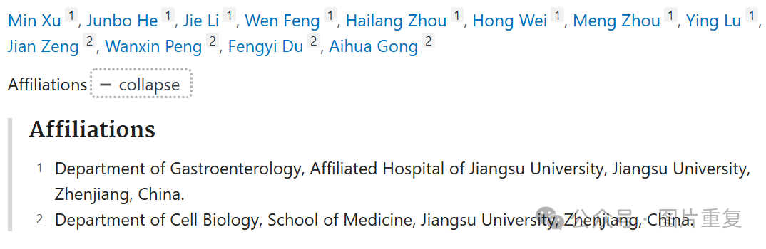

**#1Sholto David**

**8 hours ago**

**Figure 4A and Figure 5A**: According to my reading of the figure legend I think these overlapping areas are unexpected. I've added the red rectangles to show where I mean. Would the authors please double-check?

