[厦门大学知名附属医院论文图片重复](https://mp.weixin.qq.com/s?__biz=Mzg5MTg0MDc4NQ==&mid=2247493374&idx=1&sn=d6759dc0d071bd0a86a91bd7c89395d8&chksm=ce50e0a0e10d901df44d9b0623268f3d65b087925bbb9fd96844bc14902c31e663b950636299&scene=126&sessionid=1743872399)

f[图片重复](javascript:void(0);)2025-04-05 16:21:50广东

**KIF4A promotes tumor progression of bladder cancer via CXCL5 dependent myeloid-derived suppressor cells recruitment**

**Scientific Reports (2022)**

**PMID:**35399116

**DOI:**10.1038/s41598-022-10029-x

**AUTHORS**

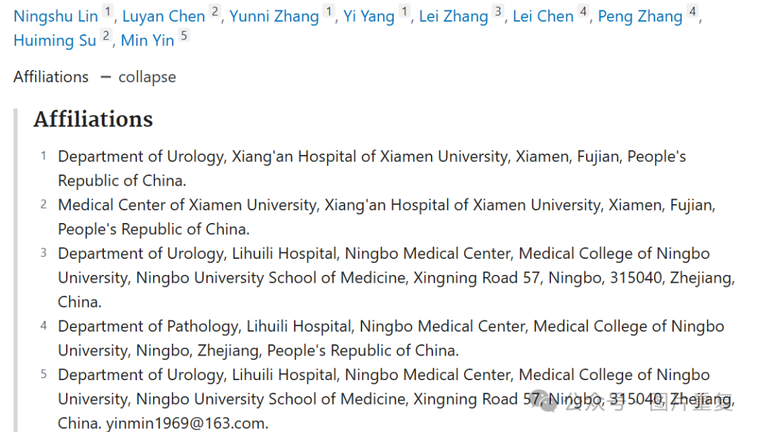

**#1Sholto David 9 hours ago**

**Figure 5**: Multiple overlapping areas. Identified and annotated with coloured rectangles with the help of ImageTwin.ai. Rotations are not indicated. Would the authors please check and comment?

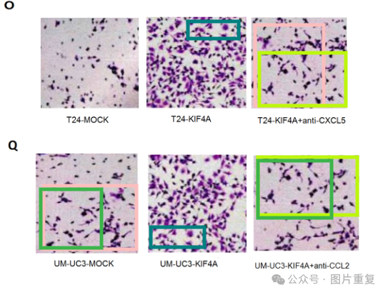**#2Sholto David**

**9 hours ago**

Also see **Figure 1G**:

