[浙江医院Hang Lin（第一兼通讯）论文被撤稿，蛋白印迹以及病理图面板重复](https://mp.weixin.qq.com/s?__biz=MzkwMjY4ODQ5Mw==&mid=2247496498&idx=1&sn=8847a1deaca03a1e8ebfc966d0acffe9&chksm=c17c8b2591b160eb28e009c39ad0551f8107c845ccf349d559a98dd76789ffd3e0b46805734d&scene=126&sessionid=1743785572)

R2[Reviewer 2](javascript:void(0);)2025-03-07 17:46:31浙江

一

点击蓝字关注我们



**论文信息**

2019年10月18日，浙江省人民医院骨科的Hang Lin(第一作者&通讯作者 音译 林杭）在Biochemistry and Cell Biology（中科院三区 IF=2.4）期刊上在线发表题为"Long noncoding RNA HIF1A-AS2 facilitates cell survival and migration by sponging miR-33b-5p to modulate SIRT6 expression in osteosarcoma"(长非编码 RNA HIF1A-AS2 通过海绵状 miR-33b-5p 调节骨肉瘤中 SIRT6 的表达，促进细胞存活和迁移)的论文。

0这项工作得到了浙江省基础公益研究项目（项目编号：LY18H160045）和浙江省中医药科技项目（项目编号：2018ZB007）的支持。

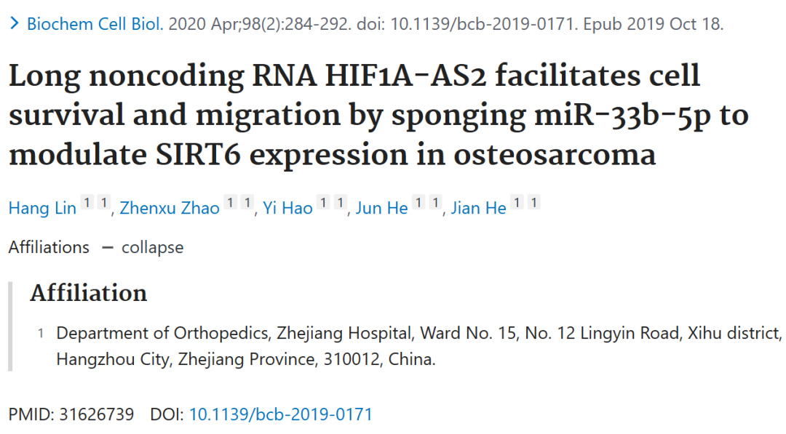





**质疑信息**

* **图3B图像面板重复。**

Two images in Figure 3B seem to overlap, but are described differently.

This paper was identified with 'The Clear Skies Papermill Alarm.'

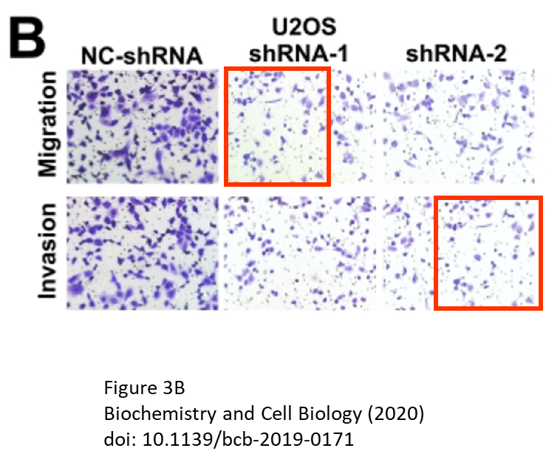

* **图3C与他文WB印迹重复。**

There may also be some overlaps within Figure 3C, and also between Figure 3C and Figure 2f of a BioMed Research International paper.

The cropping of the gel strip images seems tighter in the earlier paper, suggesting that perhaps the involvement of a party who prepared both papers from a larger original image.

Biochemistry and Cell Biology (2020), doi: 10.1139/bcb-2019-0171, discussed here: https://pubpeer.com/publications/5DCCCED0787614A62F955AD9C86F18

BioMed Research International (2021), doi: 10.1155/2021/6622342, discussed here: https://pubpeer.com/publications/3EDC86BCDCE8C5C695BC277A169002

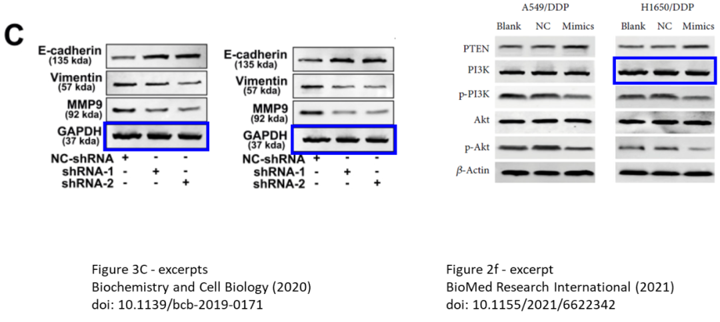

* **图9a与另一篇包含共同作者文章中的图7A图像面板重复。**

In Figure 2E? There seem to be some bands that appear very similar, with only a difference in vertical dimensions.

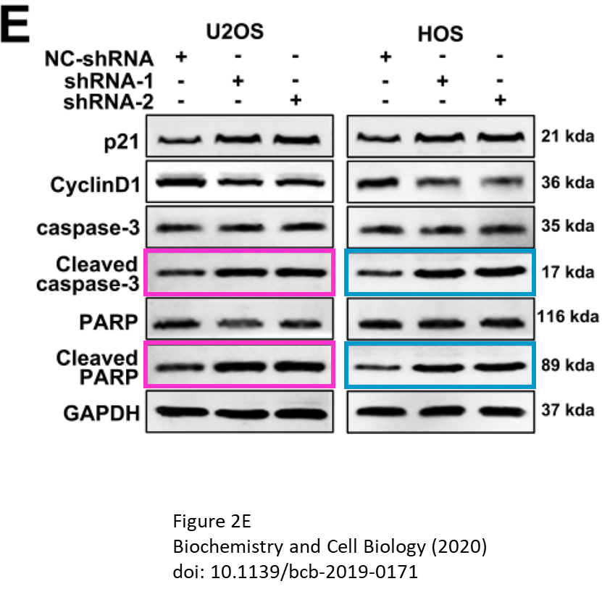



**撤稿原因**

**本文已于2025年2月26日被撤回：**本文因图像重复问题已被撤回。该文章中存在一行凝胶图像完全重复和一个面板部分重复的情况。具体而言：

? 在图4E的“HOS”列中，“Cleaved caspase-3”（裂解的半胱天冬酶-3）行的蛋白条带与该图“Cleaved PARP”（裂解的聚腺苷二磷酸核糖聚合酶）行的蛋白条带完全相同。

? 在图3B的迁移面板“U2OS shRNA-1”的左上角部分，与同一图中“shRNA-1”侵袭面板的左下角部分存在部分重复。

鉴于这些图像问题，主编们对该研究的结论失去了信心，并决定撤回该文章。

此次撤回符合《Biochemistry and Cell Biology》杂志及其出版商加拿大科学出版公司的出版政策。

作者无法联系到以对此撤回声明作出回应。



**参考信息**

https://pubpeer.com/publications/5DCCCED0787614A62F955AD9C86F18

https://pubmed.ncbi.nlm.nih.gov/31626739/

https://cdnsciencepub.com/doi/full/10.1139/bcb-2025-0019