[中国药科大学药学院与华中科技大学化学化工学院合作发表于《Nature Communications》的论文被质疑存在图像重复问题](https://mp.weixin.qq.com/s?__biz=MzkzMzc1Nzg1OQ==&mid=2247486344&idx=1&sn=9e69e604862dc35c89c8b4e28bc5d2fe&chksm=c3efcbfb191c0a2a0dde0a4f7c78241b681f11fe3454a77ba25fb6c4ec85d32c61f0bd8da895&scene=126&sessionid=1743790098)

Figure 查重[Figure查重](javascript:void(0);)2025-03-30 10:45:35上海

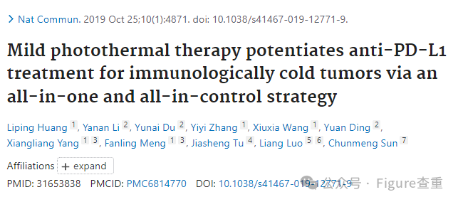

Mild photothermal therapy potentiates anti-PD-L1 treatment for immunologically cold tumors via an all-in-one and all-in-control strategy

Nature Communications (2019) - 1 Comment  
pubmed: 31653838  doi: 10.1038/s41467-019-12771-9  issn: 2041-1723

Liping Huang , Yanan Li , Yunai Du , Yiyi Zhang , Xiuxia Wang , Yuan Ding , Xiangliang Yang , Fanling Meng , Jiasheng Tu author has email , Liang Luo author has email , Chunmeng Sun

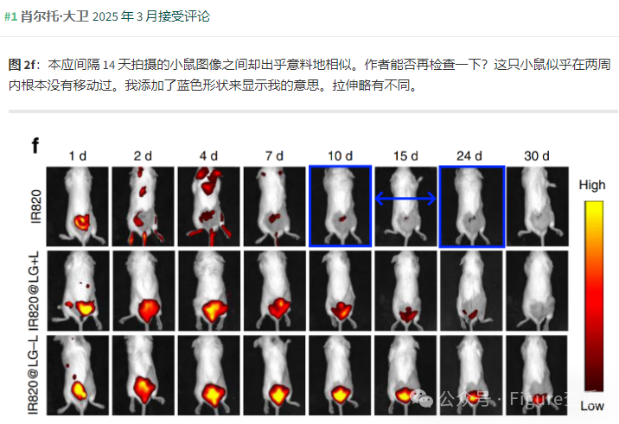

**消息来源：**

https://www.pubpeer.org/publications/EBDD71FB96B54842B6EEFC54B1966F#1

**联系我们：**

如果您需要使用Figure查重服务，请扫描下方二维码，添加客服微信，了解更多详情。我们将竭诚为您服务，确保您的科研工作更加高效、可信。

