[淄博市中心医院副院长李良&山东省立医院统计与病案管理科论文图像重复遭质疑](https://mp.weixin.qq.com/s?__biz=MzkzMzc1Nzg1OQ==&mid=2247486305&idx=2&sn=2130548cd450bd9dda5e654f5658c732&chksm=c37f40d6640cd443b0857422b6d8d0df368742383469543179565fc776f7c0005ed70f624a0a&scene=126&sessionid=1743790098)

Figure 查重[Figure查重](javascript:void(0);)2025-03-27 11:15:04上海

**Part.1**



**论文简介**

**标题：Resveratrol potentiates the anti-tumor effects of rapamycin in papillary thyroid cancer: PI3K/AKT/mTOR pathway involved**

**日期：**2020年6月10日

**单位与作者：**

山东省立医院统计与病案管理科Peng Bian

淄博市中心医院乳腺甲状腺外科Liang Li(通讯作者 音译 李良)

期刊：***Archives of biochemistry and biophysics***

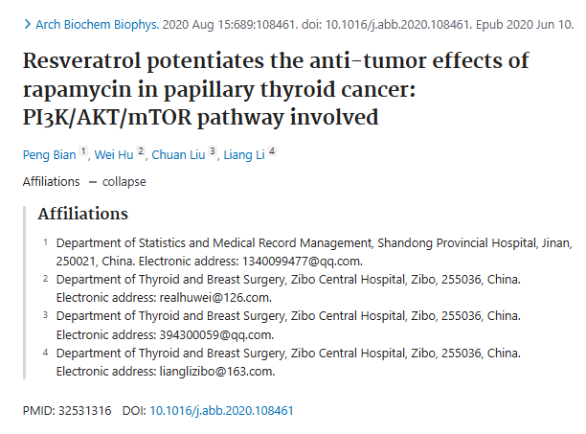

**Part.2**



**图像重复问题**

**#1 本文的图4c的5张小图与另外三篇论文出现重复。**

Figure 4c, Archives of Biochemistry and Biophysics (2020), doi: 10.1016/j.abb.2020.108461, discussed here: https://pubpeer.com/publications/D9A8C9A719188DDE00229D535217FF

Figure 7B and Figure 7D, BMC Endocrine Disorders (2023) doi: 10.1186/s12902-023-01416-0, discussed here: https://pubpeer.com/publications/67EBB4772A7378E0B95FBB29B298CD

Figure 5b, Journal of International Medical Research (2021), doi: 10.1177/03000605211016562, discussed here: https://pubpeer.com/publications/D6EB2AE9F759B56C937F39D01DC1D4

Figure 5b – excerpt, BioMed Research International (2022), doi: 10.1155/2022/5509346, Retracted, discussed here: https://pubpeer.com/publications/DEA3E3E2EA1180535F7CB778C1C0AD

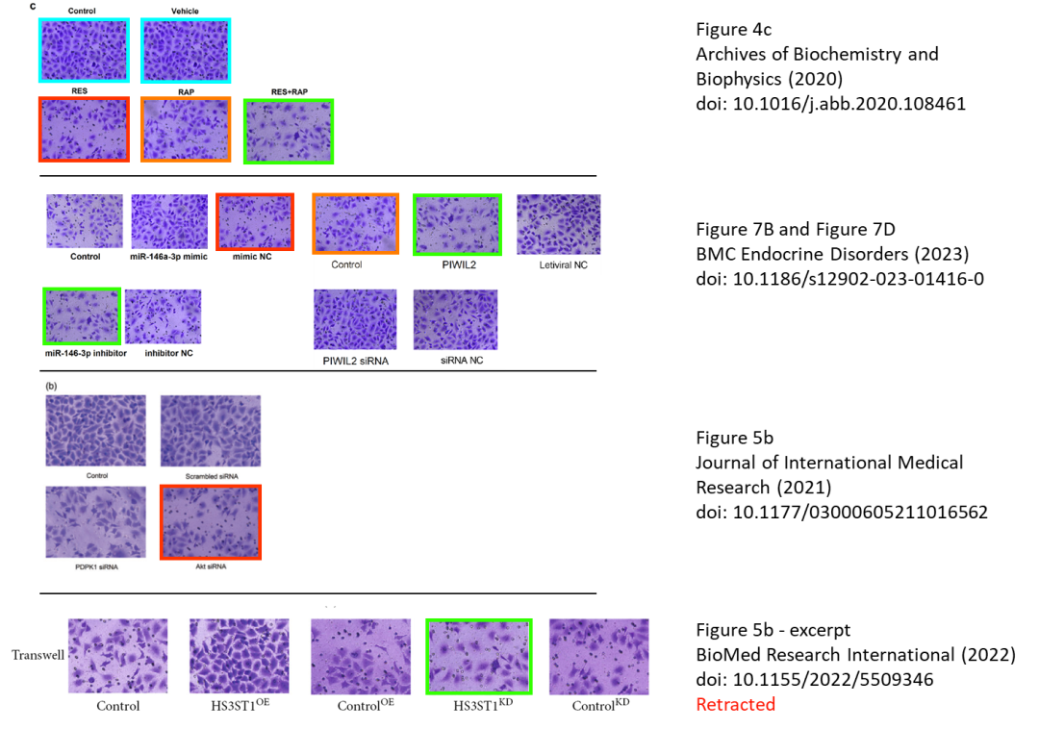

**#2 图63a的的条带图与同期刊发表的另一篇论文相似（水平翻转后），大约在同一时间，尽管没有共同的作者。**

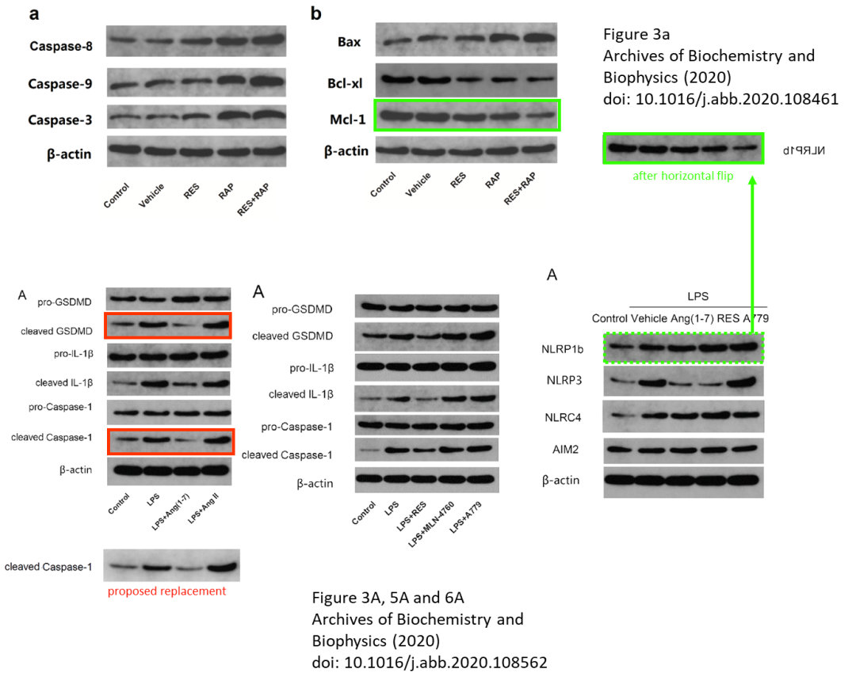

**参考信息：**

https://pubpeer.com/publications/D9A8C9A719188DDE00229D535217FF

https://pubmed.ncbi.nlm.nih.gov/32531316/

**联系我们：**

如果您需要使用Figure查重服务，请扫描下方二维码，添加客服微信，了解更多详情。我们将竭诚为您服务，确保您的科研工作更加高效、可信。

